

TRABAJO DE FIN DE GRADO
Doble grado en Educación Primaria y Educación Infantil

Programación didáctica anual de Aprendizaje Integrado de Contenido y Lengua (AICLE)
4º de Educación Primaria

Science has always had women

Adrián Rodríguez López
Director: Magdalena Custodio Espinar
2025-2026
Date: April 21, 2026

Programación didáctica anual de Aprendizaje Integrado de Contenido y Lengua
(AICLE)

Área: Ciencias de la Naturaleza

4º de Educación Primaria

Author: Adrián Rodríguez López
Directora: Dra. Magdalena Custodio Espinar (PhD)
Date: April 21, 2026

ACKNOWLEDGEMENTS
I would like to express my gratitude to Dra. Magdalena Custodio for having been a constant support throughout this very tough year. Without your help, none of this would have been possible. Furthermore, my CLIL partners. Ana and Inés, we were afraid of this journey but together, we made it real.
My family were my key pillars. Mum, dad, thank you for giving me the opportunity to study in this prestigious university, Comillas Pontifical University, and to support me in every decision I have made. Thank you to my sister Claudia for bringing out the best of me.
Last but not least, I want to say thank you to Atlético de Madrid for remembering me to never stop believing and for showing me that with heart and courage, everything is possible.

ABSTRACT
The educational program “Science has always had women” is designed as a year-long proposal for the 4rd grade of Primary Education, integrated into the bilingual program of the Community of Madrid. Its aim is to offer students a learning experience in which English and natural sciences are intertwined through a CLIL approach.
This Final Degree Project aims to use English as a foreign language and as the language of instruction.
The project is structured around the central idea that science has also been built by women. Through 15 teaching units, each dedicated to a relevant woman, students discover how these women changed our way of seeing the world. This journey allows students to approach science from a human and relatable perspective, facilitating accessibility within the framework of Universal Design for Learning (UDL).
Each unit starts with reference to a woman scientist that introduces the different Natural Science content from the curriculum. In this way, the biographies become bridges to scientific learning, allowing the content to be presented in a contextualized manner.
The project also incorporates an important social and emotional dimension. Giving visibility to female role models in science helps to build a more equal and fair school culture. Presenting students with real examples of women scientists challenges stereotypes and broadens the possibilities for identification, especially for girls. In this way, the programme not only conveys scientific knowledge but also fosters values and promotes attitudes of respect and equality.

Keywords: CLIL, Natural Science, Primary Education, Equality.

RESUMEN
La programación didáctica “Science has always had women” se plantea como una propuesta anual para el curso de 4º de Educación Primaria, integrada en el programa bilingüe de la Comunidad de Madrid. Su finalidad es ofrecer al alumnado una experiencia de aprendizaje en la que el inglés y las ciencias naturales se entrelazan mediante un enfoque CLIL.
Este Trabajo de Fin de Grado tiene como objetivo utilizar el inglés como lengua extranjera y como medio de instrucción.
El proyecto se articula en torno a una idea central de que la ciencia también ha sido construida por mujeres. A través de 15 unidades didácticas, cada una dedicada a una mujer relevante, el alumnado descubre cómo estas mujeres cambiaron nuestra forma de ver el mundo. Este recorrido permite a los alumnos acercarse a la ciencia desde una perspectiva humana y cercana facilitando la accesibilidad desde el marco del Diseño Universal para el Aprendizaje (DUA).
Cada unidad parte de la figura de una científica para introducir un contenido científico adaptado a la etapa. De esta manera, las biografías se convierten en puentes hacia el aprendizaje científico, permitiendo que los contenidos se presenten de una manera contextualizada.
El proyecto también incorpora una dimensión social y emocional importante. Dar visibilidad a referentes femeninos en la ciencia contribuye a formar una cultura escolar más igualitaria y justa. El hecho de presentar al alumnado modelos reales de mujeres científicas rompe los estereotipos ampliando las posibilidades de identificación, especialmente entre las niñas. De este modo, la programación no solo trasmite conocimientos científicos, sino que educa valores y promueve actitudes de respeto y equidad.

Palabras clave: CLIL, Ciencias Naturales, Educación Primaria, Igualdad.

INDEX

1. INTRODUCTION 8
1.1 Justification 8
1.2 Objetives 9
1.2.1 General objectives 9
1.2.2 Personal objectives 9
2. THEORETICAL FOUNDATION 9
2.1 CLIL approach 9
2.2 Roles of student and teacher in CLIL 10
2.3 Natural Science 11
2.4 Natural Science CLIL 11
2.5 The presence of women in science 11
3. ANNUAL SYLLABUS 12
3.1 Contextualization 12
3.1.1 School context 12
3.1.2 Classroom context 12
3.2 Objetives 13
3.1.1 Stage objectives 13
3.2.2 Syllabus learning goals 13
3.3 Contents 14
3.4 Competences 14
3.4.1 Key competences 14
3.4.2 Specific competences and assessment criteria 14
3.5 Methodology 15
3.6 Evaluation 15
3.8 Contribution of the CLIL syllabus to the development of other plans 16
4. LEARNING SITUATIONS 17
4.1 Learning situation 1: Scientific explorers mission 18
4.1.1 Challenge 1: Metrodora 19
4.1.2 Challenge 2: Hildegard of Bingen 20
4.1.3 Challenge 3: Maria Sibylla Merian 21
4.1.4 Challenge 4: Jeanne Baret 21
4.1.5 Challenge 5: Mary Anning 21
4.2 Learning situation 2: The Great Discovery Quest 21
4.2.1 Challenge 6: Florence Nightingale 22
4.2.2 Challenge 7: Beatrix Potter 22
4.2.3 Challenge 8: Marie Curie 22
4.2.4 Challenge 9: Lise Meitner 22
4.2.5 Challenge 10: Barbara McClintock 22
4.3 Learning situation 3: Secrets of the Scientific Explorers 22
4.3.1 Challenge 11: Rachel Carson 23
4.3.2 Challenge 12: Rosalind Franklin 23
4.3.3 Challenge 13: Jane Goodall 23
4.3.4 Challenge 14: Margarita Salas 23
4.3.5 Challenge 15: Sylvia Earle 23
5. CONCLUSION 24
6. BIBLIOGRAPHY AND REFERENCES 24
7. ANNEXES 25
7.1 Annex 1. Stage objectives from Decree 61/2022 25
7.2 Annex 2. Second cycle Natural Science content distribution. 26
7.3 Annex 3. Specific competences and assessment criteria from Decree xxx 28
8. APPENDICES 29

1. INTRODUCTION

1.1 Justification
The increasing implementation of bilingual education in the Community of Madrid makes it necessary to adequate teacher training in Content and Language Integrated Learning (CLIL). Currently, more than 50% of schools in the Community of Madrid provide bilingual education through the Programa Colegios Bilingües de la Comunidad de Madrid, where subjects such as Natural Science are taught in English.
The present didactic proposal, based on the design of fifteen didactic units focused on highlighting relevant women in the field of Natural Science is based in the current regulatory framework established by Ley Orgánica 2/2006, de educación, modified by Ley Orgánica 3/2020 (LOMLOE), Real Decreto 157/2022, which establishes the organization and minimum requirements for Primary Education, and Decreto 61/2022, which regulates the Primary Education curriculum in the corresponding autonomous community.
From a personal point of view, the reason that led me to introduce myself in this adventure of doing a CLIL TFG is because in these past years, during my student teaching experience, I have realized that some women are passionate about science but they end up choosing some other thing to study just because they do not have that many women references in science. In that way, if I can put my bit to start changing this aspect, I will do it.
Moreover, I have a little sister, so I am always looking for what is best for her. In this way, I empathize with those girls as if they were my sister and I would love for them to be free to choose what they want and to break the stereotype that there are only men in science.
Choosing to use the CLIL approach with this topic was something that I was afraid of because of its difficulty, but it is something that will be worth it at the end of it. As I have loved English since I can remember, CLIL was a challenge that I wanted to accept. I also know the importance of bilingualism in education, so I found the perfect opportunity for me to deepen in all of its advantages.
Furthermore, as I imagine myself as an English teacher and CLIL approach is something that I am really looking for so I think that for my future, this is the best decision I could have made.

1.2 Objetives
This proposal is designed in accordance with both general and personal objectives.

1.2.1 General objectives
- Present a didactic proposal consisting of fifteen didactic units for the subject of Natural Science in 4º grade of Primary Education focusing on the contributions of the women to science.
- To promote meaningful and competence-based learning, based on observation and experimentation in line with the methodological principles established by the LOMLOE.
- To integrate cross-curricular values such as environmental awareness, medical science, or astronomy within Natural Science´s curriculum.
- To contribute to the development of critical thinking and scientific curiosity.
- To integrate CLIL methodologies by teaching Natural Science content through English, promoting both scientific and foreign language competences.
- To reduce the gender gap in Natural Science jobs.

1.2.2 Personal objectives
- To promote teamwork and collaboration through group methodologies to help students grow both in social and cognitive skills.
- To boost students´ motivation for science, especially for those women who feel that science is not their place.
- To improve my capacity to create motivating and meaningful learning experiences.
- To increase my awareness of the importance of role models in education.

THEORETICAL FOUNDATION

2.1 CLIL approach
Content and Language Integrated Learning (CLIL) is an approach in which curricular content is taught through a foreign language, English in this case. Its aim is to promote both subject knowledge and language development. Instead of teaching language as a separate subject, CLIL allows students to learn and use the foreign language naturally while working with meaningful and real content.
According to Coyle, Hood and Marsh (2010), CLIL is based on the 4 C´s framework, which integrates four elements: content, communication, culture and cognition.
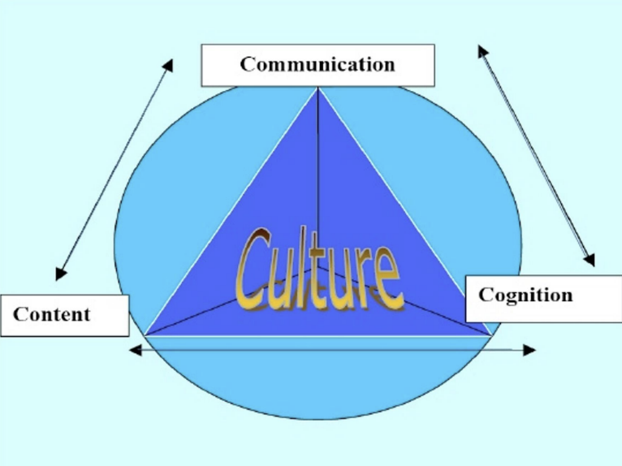

Figure 1: The 4 C´s framework.
Coyle (1999, 2005)
- Content: content is not just about gaining knowledge and skills; it also involves learners constructing their own understanding and developing abilities in a personal way Meyer, Oliver (2010).
- Communication: learners need language that fits in their learning context. This language must be clear and accessible. Interaction within the learning environment is essential Myer, Oliver (2010).
- Culture: intercultural awareness is a key element in CLIL Meyer, Oliver (2010).
- Cognition: content is related to learning and thinking processes. Cognition focuses on both Lower Order Thinking Skills (LOTS) and Higer Order Thinking Skills (HOTS)
Furthermore, the Basic Interpersonal Communicative Skills (BICS) are the skills that we use in social interactions and casual conversations. On the other hand, the Cognitive Academic Language Proficiency (CALP) refers to those skills that need to be understood for academic language Cummins (1979).
Teachers play an essential role in CLIL in order to create a creative, communicative and supportive environment.

2.2 Roles of student and teacher in CLIL
According to Dale and Tanner (2012), in a CLIL classroom, teachers rather than teaching a subject in another language in the same way as if it was a monolingual class, it is suggested to teach the subject through another language. Because of this, teacher will act more as a facilitator guiding students through the content.
At the same time, students take a more active role when it comes to learning in CLIL. As the classes are more collaborative, students will develop language skills through interacting with others. Furthermore, students will boost their communicative skills. Those skills will be evaluated with the cooperative groups and oral presentations.

2.3 Natural Science
According to Decree 61/2022, the main goal of the area of Natural Science in Primary education is to help students develop respectful attitudes towards the world they live in. The subject promotes the understanding of global challenges and encourages students to get skills and attitudes related to the environmental care.
The curriculum promotes the development of a scientific based on inquiry, where students formulate hypothesis and search for explanations about the natural world. In this way, students will understand in a better way their environment and it will make them a more responsible citizens capable of making decisions in different situations.
The curriculum is organized around the progressive development of specific competences, each associated with an evaluation criteria and content for each cycle. Regarding the content, the curriculum is structured into two main blocks: scientific culture and technology and digitalization. The first one focuses on scientific inquiry such as health, human body and living beings while the second one focuses on basic digital skills and introduces students to computational thinking.

2.4 Natural Science CLIL
In the context of Natural Science, CLIL approach offers significant benefits for teaching Natural Science. Bye learning scientific content through a foreign language, students develop both subject knowledge and linguistic competence. CLIL also provides meaningful learning as students use language as a tool explore concepts. Moreover, this methodology encourages the development of critical thinking and communication skills.
What is more is that integrating CLIL into the teaching of Natural Science contributes to a more dynamic and interactive learning environment. In this way, students participate in a more active way while improving their language skills and developing a more meaningful understanding of the natural world.

2.5 The presence of women in science
Promoting the visibility of women in science is an important step towards achieving gender equality in education. Historically, women have been underrated in terms of science. Because of this, schools play a key role in presenting diverse scientific role models that inspires all students and challenges traditional perceptions about who can become a scientist.
In the context of Primary Education, integrating the contributions of women scientists into the Natural Science helps students develop more inclusive understanding of scientific knowledge. In the second cycle of Primary Education, where students begin to explore ecosystems, living beings and the environment, learning about female scientists allows students to link those discoveries with female scientists.
Moreover, including the achievements of women in science contributes to the promotion of gender equality and equal opportunities, encouraging both girls and boys to develop interest in science.
This perspective is also supported by current Spanish educational framework established by the Royal Decree 157/2022, which emphasize the importance of promoting equality between men and women and eliminating gender stereotypes in the curriculum.

ANNUAL SYLLABUS

3.1 Contextualization

3.1.1 School context
This syllabus has been designed for Colegio Villaeuropa, a bilingual semiprivate school located in Móstoles, in the Community of Madrid, offering education from early childhood through primary and secondary education. The school has two groups per grade level. The school has some projects such as the bilingual one.
Therefore, English instruction is integrated into more than one third of the school day through CLIL. Moreover, there are some classes which are facilitated by two qualified teachers per classroom, one of whom is a native English speaker. This organization promotes language immersion and communicative competence in real academic context.
In primary education, the curriculum is designed to encourage students´ comprehensive development while also attending to individual learning needs and diversity. The school also encourages systematic assessment of students´ English language levels as it is an authorized center for ESOL examinations.
The school has various facilities in which school activities can be done. It has a huge indoor gym where lots of different activities take place such as sports competitions, music events or external activities like conferences. Outside, the school has two soccer fields and four basketball courts. The school also has a library, computer rooms, a nursing service and a laboratory. It also has a nursery inside the school for those students who feel sick.

3.1.2 Classroom context
The didactic proposal is designed for a 4th grade Primary Education classroom consisting of 28 students with diverse learning needs. The group is heterogenous, which requires the implementation of inclusive strategies to ensure equal learning and opportunities for every student. There is one student with visual difficulties, one with high cognitive abilities and another one with dyslexia.
The classroom is organized in a flexible way in order to support different teaching and learning situations. Students are placed in small cooperative groups, which encourages interaction and communication between students. The classroom space allows for the possibility of some changes in seating arrangements depending on the type of activity being carried out.
A science corner is available for experiments and visual resources related to the Natural Science curriculum. In addition, walls and boards are displayed as visual supports, such as key vocabulary in English with posters and students’ projects to help reinforce both content and language learning. Digital resources are also included in the classroom. It is equipped with a digital whiteboard, used to present visual content and interactive activities.
Attention to diversity is addressed using adapted activities which includes different learning paces and interests. Visual support with materials and cooperative learning strategies are incorporated to facilitate understanding and engagement. The classroom environment promotes respect, collaboration and positive interactions among students.
What we can highlight about the characteristic of the students is that most of the students began their academic life in this school, when they were three years old. That is why teachers know most of the students and there are strong relationships between the students and the teachers.

3.2 Objetives

3.1.1 Stage objectives
Decree 61/2022, based on the Royal Decree 157/2022, sets out the stage objectives. Students are expected to achieve by the end of Primary Education. These stage objectives of Primary Education are in Annex 1.

3.2.2 Syllabus learning goals
Operational objectives have been designed to ensure that students…
Furthermore, it is crucial to develop lower order thinking skills (LOTS) such as remembering, understanding and applying. Furthermore, it is also essential to develop and higher-order thinking skills (HOTS) such as analyzing, evaluating and creating (Bloom, 1956).
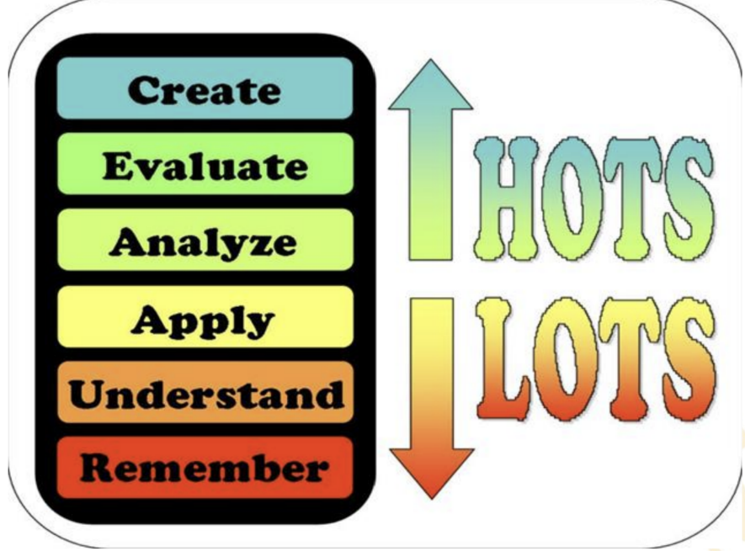

Figure 2. Classification of cognitive skills
Source: https://category5tcinquirylearning.files.wordpress.com/

3.3 Contents
The curriculum is regulated by the Royal Decree 157/2022, which establishes the organization and minimum teachings of Primary Education in Spain. This decree defines the basic curricular elements, including the key competences, specific competences and evaluation criteria. According to this regulation, Primary Education is organized into three cycles: the first cycle (1st and 2nd grade), the second cycle (3rd and 4th grade), and the third cycle (5th and 6th grade).
The national curriculum is adapted to the specific educational context of the region through the Decree 61/2022, which regulates the curriculum of Primary Education in the Community of Madrid. Within this framework, the present didactic proposal focuses on the Natural Science area in the second cycle of Primary Education. The selected content is related to different thematic areas of Natural Sciences, such as living beings, ecosystems, matter, energy, health and environmental protection.
Finally, a detailed distribution of the content for the cycle, organized through the fifteen learning situations proposed in this project, is presented in Annex 2.

3.4 Competences

3.4.1 Key competences
Firstly, the key competences are established at a national level in the Royal Decree 157/2022, where the descriptors are defined. These competences represent the essential learning that all students must acquire during compulsory education in order to successfully face personal, academic and social challenges. The Royal Decree and the Decree include the following key competences: linguistic competence, multilingual competence, mathematical competence and competence in science, technology and engineering (STEM), digital competence, personal, social and learning to learn competence, civic competence, entrepreneurship competence, and cultural awareness and expression competence.
With this syllabus, these competences will be done through three lesson plans on which students will develop many competences doing experiments, oral presentation, cooperative work and organized activities.

3.4.2 Specific competences and assessment criteria
Secondly, the specific competences are defined at the regional level in the Decree 61/2022, which regulates the curriculum of Primary Education in the Community of Madrid. These competences are directly linked to each curricular area and are connected to the corresponding evaluation criteria and knowledge for each educational cycle. In the area of Natural Sciences, the specific competences aim to help students understand the natural world, develop scientific thinking, and apply inquiry processes to explore and explain natural phenomena.
Finally, a detailed distribution of the specific competences and their assessment criteria addressed throughout the cycle, organized according to the fifteen learning situations proposed in this project, is presented in Annex 3

3.5 Methodology
My didactic unit will use different methodologies. The main methodology that I will use is cooperative learning. In this way, students will be able to work in small groups to reach a common goal (Johnson and Johnson, 1994). By working in groups, students will be able to improve their communication as well as their critical thinking. Furthermore, students will boost their academic performance. This methodology allows students to help the ones that need help and to learn from each other.
Another methodology used in this syllabus is thinking-based learning (TBL), as the aim is to allow students to think carefully and creatively more than just memorizing something. As argued by Perkins (2008), thinking was often treated as a “black box”. Teachers see the answers, but not the reasoning behind them. He insisted on making thinking something visible.
Finally, project-based learning (PBL) will also play an important role. This methodology allows students to learn by designing and completing a meaningful project Chillón (2013). In this syllabus, every learning situation has its own project so the students can take advantage of the many benefits of this methodology. These benefits go from deeper understanding because students apply their knowledge to meaningful tasks to boosting students’ creativity and communication.

3.6 Evaluation
Grading criteria: criterios de calificación.

  - Attention to diversity
Attention to diversity is a key pillar in education to ensure that every student have access to quality education. It does not matter their learning abilities or specific needs; every student will be part of the classroom. In this case, as there are three students with special needs, inclusive strategies and supportive materials are needed to make every student feel comfortable. Furthermore, when talking of CLIL learning, it is essential to design inclusive strategies to facilitate the understanding of scientific contents in English.
To achieve all of this, Universal Design for Learning (UDL) takes a very important role to make it real. UDL is an educational framework designed to create inclusive learning environments. It is based in three principles:
- UDL provides multiple means of engagement (the “why” of learning). The aim of this principle is to motivate and engage students, recognizing their interests and emotional responses. These are some examples of strategies:
- Using collaborative activities.
- Providing different levels of learning.
- Connecting learning with students’ interests.

- UDL provides multiple means of representation (the “what” of learning). This principle focuses on how the information is presented as students understand information in a different way. These are some examples of strategies:
- Presenting content through text, images or videos.
- Using visual organizers such as mind maps.
- Providing simplified explanations.

- UDL provides multiple means of action and expression (the “how” of learning). The main objective of this principle is how students demonstrate what they know. These are some examples of strategies:
- Providing scaffolding and continue support.
- Offering different ways of completing assessments.
- Using different ways of evaluation such as written work, presentations or videos.
According to Dale and Tanner (2012), scaffolding is critical for students’ success, supporting them as they develop the skills they need to become independent. Scaffolding also help students to build their confidence. In general, it challenges students to challenge them at the right level (gradually).

3.8 Contribution of the CLIL syllabus to the development of other school plans
The CLIL syllabus designed for this school contributes to the development of several institutional plans at Colegio Villaeuropa. Because the proposal combines science learning, English and gender equality, it boosts the school’s main educational goals.
The syllabus contributes to the following school plans:
- Contribution to the school´s Bilingual Program
As a CLIL-based proposal, the syllabus raises the school bilingual program by integrating content learning in a meaningful way and encouraging the use of English as the main language for experimentation and project work.
- Contribution to the Reading promotion Plan
The project includes biographical narratives and scientific explanations that require reading comprehension in English. This contributes to the school´s reading plan by encouraging reading for learning and developing strategies such as skimming and scanning.
- Contribution to the Digital Plan
Colegio Villaeuropa´s digital plan arises the need to address de digitalization of the school, as the spread of technology is unstoppable. A series of resources and tools have been consolidated, allowing teachers to develop students’ digital competences. This process is linked to the implementation of active methodologies such as gamification which rely on digital devices and software applications.

LEARNING SITUATIONS
The entire syllabus is built around the biographies and scientific contributions of fifteen women who have had a huge impact in history, and they do not have the value they deserve. Throughout this project, students will learn the importance of women in science, and they will realize that science is not just for men but also for women. Science is for everyone.
The syllabus is organized in three learning situations. Table 1 describes their distribution in the three terms of the academic year 2025/26.
Table 1. Temporalization of the learning situations and their challenges
First term
Learning situation | Dates | Sessions
Metrodora | Sept 8–Sept 19 | 5 sessions
Hildegard of Bingen | Sept 22–Oct 3 | 4 sessions
Maria Sibylla Merian | Oct 6–Oct 17 | 4 sessions
Jeanne Baret | Oct 20–Oct 31 | 4 sessions
Mary Anning | Nov 3–Dec 12 | 5 sessions
Second term
Learning situation | Dates | Sessions
Florence Nightingale | Jan 8–Jan 22 | 4 sessions
Beatrix Potter | Jan 23–Feb 4 | 4 sessions
Marie Curie | Feb 5–Feb 18 | 5 sessions
Lise Meitner | Feb 19–Mar 4 | 4 sessions
Barbara McClintock | Mar 5–Mar 24 | 5 sessions
Third term
Learning situation | Dates | Sessions
Rachel Carson | Apr 7–Apr 20 | 4 sessions
Rosalind Franklin | Apr 21–May 4 | 4 sessions
Jane Goodall | May 5–May 18 | 4 sessions
Margarita Salas | May 19–Jun 1 | 4 sessions
Sylvia Earle | Jun 2–Jun 19 | 6 sessions

Table 1. Temporalization of the learning situations and their challenges
The first day of class the following a letter will be sent to students (Appendix 1).

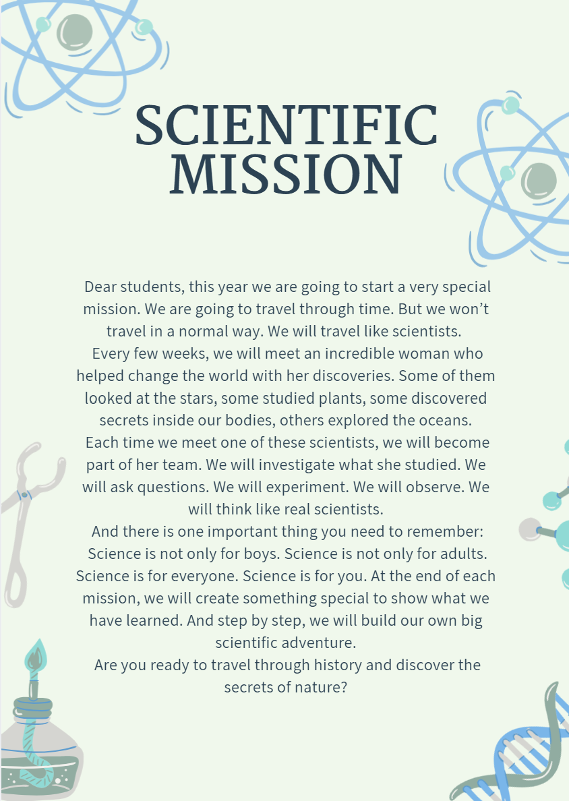

Figure 3. Scientific mission letter
Source: own creation made with “Canva”: https://www.canva.com/

4.1 Learning situation 1: Scientific explorers mission
LEARNING SITUATION I: SCIENTIFIC EXPLORERS MISSION
xxxx
In this learning situation, students will begin their mission as young scientific explorers. Dr. Minola, a scientist from the future, has sent them a very important message: many important scientific discoveries made by woman are being forgotten. To solve this problem, students must learn different scientific fields and rediscover them. By completing these missions, they will help rebuild the science knowledge archive including these women scientist!
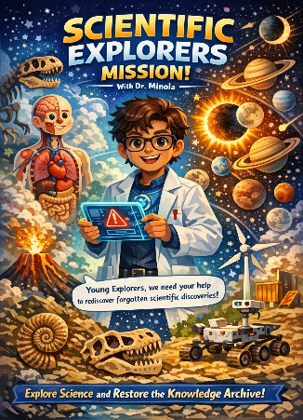

Figure 4: Dr. Minola´s poster 1
Source: own creation made by artificial intelligence with
“Copilot”. https://copilot.microsoft.com/
Content area | Natural Science/ English (CLIL)  Year/Group:
Cycle/level | Second cycle Level 4 Primary Education
Timing | September-December
Place | It will take place in the main classroom, using the science corner.
Final product | A young scientist discovery fair to allow students to present their experiments to other students.
Genres | Explanatory texts
Challenges | Challenge 1: Metrodora  Challenge 2: Hildegard of Bingen  Challenge 3: Maria Sibylla Merian  Challenge 4: Jeanne Baret  Challenge 5: Mary Anning

4.1.1 Challenge 1: Metrodora
TITLE 1: Taking care of our bodies
Content area(s): Natural Science/ English (CLIL)
Year/Group: 4º Grade
Timing: Sept 8–Sept 19, 4 sessions.
Description (aim): this learning challenge introduces students to the basic systems of the human body through the figure of Metrodora, one of the first known female physicians in Ancient Greece. Through practical activities, students will identify main body systems and understand basic healthy habits. At the same time, they will develop scientific vocabulary, and oral communication skills, and literacy skills about explanatory texts in English following a CLIL approach.
Final product: a group poster about the human body systems and a short oral explanation of one system and a healthy habit related to it.
CONTENT
Curricular content (Decree 61/2022)
A. Cultura científica | La vida en nuestro  planeta |  |  |  |  | - Las funciones vitales del ser humano: características generales de los sistemas del cuerpo humano.  - Hábitos de vida saludables.
B. Tecnología y  digitalización | Proyectos de  diseño y  pensamiento  computacional |  |  |  |  | - Materiales, herramientas y objetos adecuados a la consecución de un proyecto  de diseño.  - Técnicas sencillas de trabajo en equipo.
Contribution to key competences (RD 157/2022):  CCL, CPSAA |  |  | Operational descriptors (RD 157/2022):  CCL1, CCL5, CPSAA1, CPSAA3, CPSAA5
Contribution to specific competences (Decree 61/2022):  2, 3 |  |  | Evaluation criteria (Decree 61/2022):  2.1, 2.4, 3.1, 3.2
Language content
Key language for describing explaining how body systems function and describing healthy habits.
Genre type: Explanation.
COGNITION
Learning goals  1.To remember the main parts of the human body and to understand their simple functions.  2. To apply this knowledge by relating body systems to everyday actions and to analyze the relationship between habits and body health.  To evaluate different daily habits identifying which ones are healthy and unhealthy and explaining how they affect the human body.  3. Metacognition: to reflect on their own habits using a simple KWL chart.  4. Language: to describe body systems and explain healthy habits using simple sentences and basic scientific vocabulary. |  |  |  | Learning outcomes (standards)  1.1 Students will be able to name the main parts of human body.  1.2 Students will be able to describe the basic functions of the main body systems.  2.1 Students will be able to use their knowledge to relate body systems to everyday actions.  2.2 Students will be able to examine the relationship between daily habits and human health.  2.3 Students will be able to judge how different habits affect human health.  3.1 Students will be able to identify what they know about the human body.  4.1 Students will be able to explain healthy habits orally using simple structures and key vocabulary.
CULTURE
Learning goals  To recognize how different ancient cultures, such as Ancient Greece, contributed to early medical knowledge and healthcare practices. |  |  |  | Learning outcomes (standards)  Students compare basic health practices from Ancient Greece with modern healthy habits.
COMMUNICATION
Coyle, Hood and Marsh (2010)
Language of learning |  | Language for learning |  |  |  |  | Language through learning
Key language: human body, system, organ, function, health, habit, hygiene, digest.  Language content:  Academic content: |  | Language for describing body systems and functions: “The digestive system helps us get nutrients”.  Language for giving health advice: We should wash our hands”.  Language for explaining cause and effect: “If we exercise, our heart becomes stronger”.  Classroom language  Group work: Can you explain this part?  Activities: Match the system with its function.  Classroom interaction: What did you learn today? |  |  |  |  | Learning through personal experiences.  Learning through peer interaction during the group poster creation.  Learning through visual materials.  Learning through
MATERIALS AND RESOURCES
Flashcards (body parts, organs)
Worksheets
Poster template
KWL chart
EVALUATION
Natural Science content evaluation (Decree 61/2022)
2.1 Formulate questions and make reasoned predictions, showing curiosity about the immediate environment.
2.4 Propose possible answers to the questions by interpreting the information and results obtained.
3.1 Work as a team to build a simple final product that provides a solution to a problem of need, use, or design, proposing possible solutions, testing different prototypes, and using appropriate tools, techniques, and materials safely.
3.2 Present the final product of the design projects in different formats, explaining the steps followed.
Language evaluation criteria (CEFR, 2018)
(YOU WILL LEARN HOW TO DO THIS IN MODULE 3). Complete this part then.

Assessment tools
- For interaction: oral questioning in class and group discussions during cooperative tasks.
- For active observation: observation checklist with for the assessment of active participation and cooperative work. and the use of vocabulary.
- For peer/self-evaluation: peer feedback and KWL chart.
- For summative assessment: rubric for the final poster and for the oral presentation.
Grading criteria
FORMATIVE ASSESSMENT
Cooperative work (20 %)
KWL chart (10%) (metacognition)
Active participation (10%)

SUMMATIVE ASSESSMENT
- Final product and oral presentation RUBRIC (60 %) (content and language integrated assessment)
- Use of English language (25 %)
- Understanding of body systems and its functions (15 %)

ATTENTION TO DIVERSITY
DUA - General measures
The use of different resources: videos, images or tactile diagrams to explain the human body systems. Images with high-contrasted materials or pictograms to facilitate understanding.
LOTS to HOTS  Ask students identify and put basic organs on a body diagram. |  |  |  |  | HOTS to LOTS  Ask students to analyze a daily routine and classify habits as healthy or unhealthy.

4.1.2 Challenge 2: Hildegard of Bingen

4.1.3 Challenge 3: Maria Sibylla Merian

4.1.4 Challenge 4: Jeanne Baret

4.1.5 Challenge 5: Mary Anning

4.2 Learning situation 2: The Great Discovery Quest
LEARNING SITUATION II: THE GREAT DISCOVERY QUEST
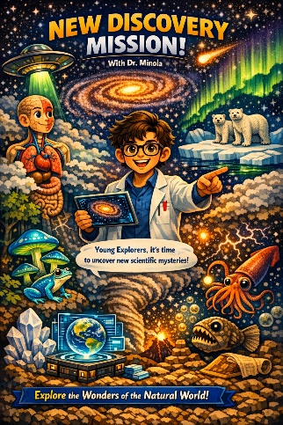
After completing the first exploration mission, Dr. Minola sends a new message to the young explorers. He explains that there are still many scientific mysteries waiting to be discovered. For their next mission, students will continue their journey by investigating new phenomena of the natural world. Each new discovery will help them add more knowledge to the science knowledge archive.

Figure 5: Poster de Dr. Minola 2
Source: own creation made by artificial intelligence with
“Copilot”. https://copilot.microsoft.com/
Timing | January-March
Where? | It will take place in the main classroom, using the science corner. The IT room will be used for some activities.
Final product | The great book of life, which shows everything they have learnt in the different challenges.
Genres
Challenges
Challenge 6: Florence Nightingale
Challenge 7: Beatrix Potter
Challenge 8: Marie Curie
Challenge 9: Lise Meitner
Challenge 10: Barbara McClintock

4.2.1 Challenge 6: Florence Nightingale

4.2.2 Challenge 7: Beatrix Potter

4.2.3 Challenge 8: Marie Curie

4.2.4 Challenge 9: Lise Meitner

4.2.5 Challenge 10: Barbara McClintock

4.3 Learning situation 3: Secrets of the Scientific Explorers
LEARNING SITUATION III: SECRETS OF THE SCIENTIFIC EXPLORERS
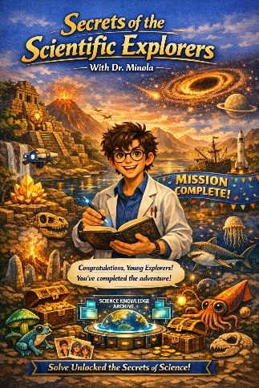
Dr. Minola congratulates students for the discoveries and experiments they have made during these months. However, he informs that the exploration is not finished yet. They will have to continue investigating but this time as real scientists. They are not young scientists anymore.

Figure 6: Poster de Dr. Minola 3
Source: own creation made by artificial intelligence with
“Copilot”. https://copilot.microsoft.com/
Timing | April-June
Where? | This will take place in the main classroom, using the science corner. It will also take place in the laboratory for some challenges.
Final product | Guardians of the planet exhibition where students present solutions to protect the planet.
Genres
Challenges
Challenge 11: Rachel Carson
Challenge 12: Rosalind Franklin
Challenge 13: Jane Goodall
Challenge 14: Margarita Salas
Challenge 15: Sylvia Earle

4.3.1 Challenge 11: Rachel Carson

4.3.2 Challenge 12: Rosalind Franklin

4.3.3 Challenge 13: Jane Goodall

4.3.4 Challenge 14: Margarita Salas

4.3.5 Challenge 15: Sylvia Earle

CONCLUSION

BIBLIOGRAPHY AND REFERENCES
https://colegio-villaeuropa.com/oferta-educativa/bilinguismo/
https://actosenlaescuela.com/la-pedagogia-de-david-perkins/
https://udlguidelines.cast.org/
- Coyle, Hood and Marsh (2010): CLIL: Content and Language Integrated Learning.
- Coyle (1999, 2005): Developing CLIL: Towards a theory of practice. APAC Monographs.
- Meyer, Oliver (2010)
- Cummins (1979): BICS & CALP.
- Dale and Tanner (2012): CLIL Activities.
- Bloom (1956): Bloom´s taxonomy.
- Johnson and Johnson (1994): Cooperation in the Classroom.
- Perkins (2008): Making learning whole: How seven principles of teaching
- can transform education. Jossey-Bass.
- Chillón (2013): Aprender a través de proyectos: Una metodología activa
- para la escuela del siglo XXI. Narcea Ediciones.
- Custodio-Espinar,M (2019): Didactics’ unit table

Tabla unidades didácticas basada en Magdalena Custodio

ANNEXES

7.1 Annex 1. Stage objectives from Decree 61/2022
To understand and value the principles and norms of coexistence, to learn to act in accordance with them in an empathetic way, to prepare for active citizenship, and to respect human rights as well as the pluralism inherent in a democratic society.
To develop habits of individual and group work, effort, and responsibility in study, as well as attitudes of self‑confidence, critical thinking, personal initiative, curiosity, interest, creativity in learning, and an entrepreneurial spirit.
To acquire skills for the peaceful resolution of conflicts and the prevention of violence, enabling students to act autonomously in school and family environments, as well as within the social groups they interact with.
To know, understand, and respect different cultures and individual differences; to uphold equal rights and opportunities for men and women; and to reject discrimination based on ethnicity, sexual orientation or identity, religion or beliefs, disability, or other conditions.
To know and use the Spanish language appropriately, and, where applicable, the co‑official language of the autonomous community, and to develop reading habits.
To acquire basic communicative competence in at least one foreign language, enabling them to express and understand simple messages and manage everyday situations.
To develop basic mathematical competencies and begin solving problems that require elementary calculations, geometric knowledge, and estimations, as well as being able to apply them to everyday life situations.
To learn the fundamental aspects of Natural Sciences, Social Sciences, Geography, History, and Culture.
To develop basic technological competencies and begin using them for learning, fostering a critical attitude toward how technologies work and the messages they receive and produce.
To use different artistic representations and expressions and begin creating visual and audiovisual works.
To value hygiene and health, accept their own body and that of others, respect differences, and use physical education, sports, and healthy eating as means to promote personal and social development.
To know and appreciate the animals closest to human beings and adopt behaviors that promote empathy and care for them.

To develop their emotional capacities in all areas of their personality and in their relationships with others, as well as an attitude against violence, prejudice of any kind, and sexist stereotypes.
To develop daily habits of autonomous, active, and healthy mobility, promoting road safety education and respectful attitudes that contribute to preventing traffic accidents.

7.2 Annex 2. Second cycle Natural Science content distribution.
2nd Cycle | Subject block | Block item | Content
Year 3 | A. Cultura científica | Iniciación en la actividad científica | - Instrumentos y apropiados para realizar observaciones y mediciones precisas, usados con seguridad, de acuerdo con las necesidades de la investigación.  - El ensayo y error como parte de los inicios de la actividad científica.  - Avances en el pasado relacionados con la ciencia mostrando modelos que incorporen  la igualdad entre hombres y mujeres.  - La importancia del uso de la ciencia.
Year 3 | A. Cultura científica | La vida en nuestro planeta | - Los reinos de la naturaleza desde un punto de vista general.  - Características propias de los animales que permiten su clasificación y  diferenciación en subgrupos.  - Características propias de las plantas que permiten su clasificación en relación con  su capacidad adaptativa al medio.  - Las funciones y servicios de los ecosistemas.  - Hábitos de vida saludables.
Year 3 | A. Cultura científica | Materia, fuerzas y energía | - El calor y la temperatura. Cambios de estado.  - Los cambios reversibles e irreversibles que experimenta la materia desde un  estado inicial a uno final.
Year 3 | B. Tecnología y digitalización | Uso de los recursos digitales con responsabilidad | - Dispositivos y recursos digitales. Estrategias de búsqueda guiada de  información segura y eficiente en internet.  - Reglas básicas de seguridad y privacidad para navegar por internet.
Year 3 | B. Tecnología y digitalización | Proyectos de diseño y pensamiento computacional | - Fases de los proyectos de diseño: diseño, prototipado, prueba y comunicación.  - Técnicas sencillas de trabajo en equipo y estrategias para la gestión de  conflictos.
Year 3 | B. Tecnología y digitalización | Evolución de la tecnología y la digitalización en las diversas etapas de la historia de la humanidad | - Beneficios y perjuicios de algunas herramientas, máquinas e instrumentos a lo largo de la historia.
Year 4 | A. Cultura científica | Iniciación en la actividad científica | -Procedimientos de indagación y formulación de hipótesis adecuados a las necesidades de la investigación  -Vocabulario científico básico y adecuado a su edad  -Fomento de la curiosidad
Year 4 | A. Cultura científica | La vida en nuestro planeta | - Ejemplos de buenos y malos usos de los recursos naturales de nuestro planeta  y sus consecuencias.  - Las formas del relieve más relevantes.  - Clasificación elemental de las rocas.  - Las funciones vitales del ser humano.  - La relación entre las emociones y los principales sistemas del cuerpo.
Year 4 | A. Cultura científica | Materia, fuerzas y energía | - Fuerzas de contacto y a distancia.  - Herramientas, máquinas e instrumentos.  - Las sustancias puras y las mezclas.
Year 4 | B. Tecnología y digitalización | Uso de los recursos digitales con responsabilidad | - Recursos y plataformas digitales restringidas y seguras para comunicarse con otras personas.  - Estrategias para fomentar un buen uso digital.
Year 4 | B. Tecnología y digitalización | Proyectos de diseño y pensamiento computacional | - Materiales, herramientas y objetos adecuados a la consecución de un proyecto  de diseño.  - Iniciación en la programación a través de recursos analógicos o digitales.
Year 4 | B. Tecnología y digitalización | Evolución de la tecnología y la digitalización en las diversas etapas de la historia de la humanidad | - Hitos tecnológicos en cada etapa de la historia de la humanidad.

7.3 Annex 3. Specific competences and assessment criteria from Decree xxx
First term
Learning situation | Key competences | Specific competences | Evaluation criteria
Taking care of our bodies | CCL, CPSAA | 2, 3 | 2.1, 2.4, 3.1, 3.2
Healing plants from nature | CCL, CC | 2, 3, 6 | 2.1, 3.2, 6.1
From caterpillar to butterfly | CCL | 2, 3 | 2.1, 3.2
Plants from all around the world | CCL, CPSAA | 2, 3, 5 | 2.1, 2.4, 3.1, 3.2, 5.1
Secrets hidden in fossils | CCL | 2, 3 | 2.3, 3.2
Second term
Learning situation | Key competences | Specific competences | Evaluation criteria
Little actions, big health | CCL, CPSAA | 2, 3, 4 | 2.1, 2.4, 3.1, 3.2, 4.3
The important job of mushrooms | CCL | 2, 3, 5 | 2.4, 3.2, 5.2
Invisible science that helps people | CCL | 2, 3 | 2.1, 2.3, 3.2
Understanding energy around us | CCL | 2, 3 | 2.3, 2.5, 3.2
Why we look like our family | CCL | 2, 3 | 2.1, 2.4, 3.2
Third term
Learning situation | Key competences | Specific competences | Evaluation criteria
Protecting nature from pollution | CCL, CPSAA, CC | 2, 3, 5, 6 | 2.4, 3.1, 3.2, 5.1, 5.3, 6.1
The instructions of life | CCL, CPSAA | 1, 2, 3 | 1.1, 2.4, 3.1, 3.2
How animals live and learn | CCL | 2, 3 | 2.1, 2.4, 3.2
The invisible living beings | CCL | 2, 3, | 2.4, 3.2,
Life under the sea | CCL, CC | 2, 3, 5, 6 | 2.4, 3.1, 3.2, 5.1, 6.1

APPENDICES
8.1. Appendix 1. Scientific mission letter.

