

TRABAJO DE FIN DE GRADO
Grado en Educación Primaria y Educación Infantil

Innovación didáctica para 3º de Educación Infantil

“Happily ever after…: Disney tales of magic in pre-primary education”

Autor: Aldara Dios Rial
Director: Alfonso López Hernández
Curso académico: 5º EP + EI
Fecha: 21 abril 2026

4. Justification of the chosen topic
This end-of-degree project presents an educational innovation proposal designed for the third year of early Childhood Education. The project seeks to explore new ways of introducing English as a foreign language through storytelling, emotional engagement and narrative continuity, placing children at the centre of the learning process.
This TFG focuses on an Early Childhood Education class and seeks to create an innovation proposal for children aged 5-6 to learn English in a different way, using Disney stories as the axis of all learning activities. The idea is that English is not seen as something boring or difficult, but as something that is part of stories that they like and that make them engaged.
I chose this topic because I believe that at this age children learn best through close and meaningful situations. For them, playing, getting excited and experimenting is the most important thing, and that is why English must be integrated into these experiences, not taught as something isolated or separate from the rest of what they experience in class.
I think storytelling is the best strategy to achieve this aim. Storytelling allows students to understand the language without realizing that they are learning English. In addition, Disney stories work very well since children already know them, know who the characters are and understand the scenarios. That makes them feel comfortable, participate from the beginning, and can focus on using the language instead of struggling with the difficulty of English. And yes, it also motivates me, because it is the way of teaching English that I would have liked to have had as a child: fun, close and meaningful.
The proposal consists of working on different Disney stories throughout the course, using adaptations or small reinterpretations for the classroom, always connected by a narrative thread that unites them. Each story acts as the starting point of a complete didactic unit, made up of several chapters that correspond to the different sessions of the unit. Each chapter has its own vocabulary and situations, but all of them follow the same framework, so children know what to expect and can learn progressively and safely.
Each session corresponds to a chapter of the book that is being built in the classroom and is an extension of the content worked on in the previous sessions. In this way, in the first sessions the main vocabulary is introduced, in the following sessions what is reinforced from the previous sessions and new lexicon is added, and in the following sessions new lexicon is reinforced and added, and in the last one’s simple grammatical structures and the production of simple sentences are integrated. Although each unit focuses on a different story, they all follow the same narrative structure, which helps children to know what is expected in each session and to learn progressively and safely.
The methodology is very practical and fun: children not only listen to the stories but are part of them. Through challenges or problems that appear in the stories, they use English to help the characters and advance the story. In addition, there are visual, manipulative and auditory resources that make everyone participate, respecting the rhythms and learning styles of each one, on this respect, this proposal also follows the principles of Universal Design for Learning (UDL).
In short, this project was born from my interest in creating real proposals, which can be used in an actual classroom and not just remain on a beautiful piece of paper. As a future teacher, I want children to learn English in a motivating, fun and meaningful way, being the protagonists of their own learning. I think this proposal can provide a very useful educational alternative, because it puts children at the centre and uses storytelling to make learning English natural and meaningful.

5. Theoretical framework
To provide pedagogical coherence and academic grounding to this innovation proposal, the following theoretical framework outlines the main educational approaches that support its design. These perspectives are particularly relevant in early Childhood Education, where learning is closely to emotion, play and meaningful interaction.
This innovation project is guided by a specific theoretical framework that includes the main educational methods and approaches supported by this proposal, focusing on active, meaningful and motivating methodologies, especially suitable for the preschool stage and the teaching of foreign languages. In Early Childhood Education, learning is closely linked to symbolic play, repetition, emotional development, and familiar contexts, which makes these approaches especially effective. Throughout this section, theories related to storytelling, experiential learning, gamification, motivation, interaction and the Content and Language Integrated Learning (CLIL) approach are discussed, all of them connected to the importance of creating close, emotional and meaningful learning contexts for students. These theoretical bases justify the use of a proposal set in the Disney universe as an educational resource that helps involvement, understanding and meaningful learning.
Therefore, this theoretical framework serves for the design of an innovation proposal supported by Disney storytelling, since it combines active participation, emotional involvement and meaningful learning in the early teaching of English. This approach is particularly suitable for young learners in pre-primary education, where learning happens mainly through play, repetition, and familiar contexts, helping children construct knowledge in a meaningful way
Storytelling and meaningful learning
Storytelling as an educational tool is based on a very simple idea: people learn better when information is presented in the form of stories. Bruner explains that narrative thinking helps us organize experience and make sense of what we experience, which is especially important in childhood, when children need to understand the world through close and meaningful situations (Bruner, 1996). That's why storytelling in the classroom is not only a way to motivate, but also a way to structure and facilitate learning.
Along the same lines, imagination and narrative play a key in education, as they allow emotion to be combined with curricular content. Through stories, students become emotionally involved, which promotes deeper and more lasting learning (Egan, 1988).
In the field of foreign language teaching, different studies highlight the benefits of storytelling. García-Carbonell and Watts (2007)point out that the use of stories in the foreign language classroom fosters vocabulary acquisition, oral comprehension, and active participation, by placing learning in a meaningful context for children Similarly, Wright (1995)states that stories are fundamental in the teaching of English as a foreign language, as they allow vocabulary and grammatical structures to be introduced naturally within a specific context. This idea is also shared by Ellis and Brewster, who highlight that story repetition facilitates the internalization of language and the progressive learning of linguistic structures (Ellis & Brewster, 2014).
In relation to the different ways of learning, Gardner proposes the theory of multiple intelligences, which suggests that learners access knowledge throught different learning styles, such as visual-spatial, interpersonal or intrapersonal (Gardner, 1983). Although this theory has not been scientifically proven, it is interesting from a pedagogical perspective, as it allows for the design of more varied educational proposals adapted to classroom diversity and different learning styles. In early childhood education, taking into account different learning styles helps to design activities that fit the needs and preferences of young children.
In this proposal, storytelling is used as the axis that organizes the didactic units, using Disney stories to create close, understandable and motivating learning situations for students
Experiential learning and challenge-based learning
Experiential learning is based on the idea that knowledge is built from direct experience. According to Kolb (1984), learning involves going through a cyclical process that includes experience, reflection, understanding, and application of what has been learned. This approach is well suited at this stage, where learning occurs primarily through action, manipulation, and experimentation.
Related to this same approach, Barron and Darling-Hammond (2008) highlight that challenge-based learning environments, such as Challenge Based Learning (CBL), promote student autonomy and promote more meaningful learning. Faced with situations in which children have to think, decide and act, they become more actively involved in their own learning process.
This approach is reflected in the proposal through practical activities and small challenges linked to the stories, encouraging students to learn through experience and action.
Gamification and motivation
Gamification, understood as the use of elements of play in educational contexts, contributes to increasing the motivation and involvement of students when it is designed appropriately. Kapp points out that well-planned gamification can improve learning retention and active participation, if it is aligned with clear pedagogical objectives (Kapp, 2012)
From a motivational point of view, Deci and Ryan's theory of self-determination explains that intrinsic motivation, understood as the internal interest in carrying out an activity, increases when the activities connect with the interests of the students and promote their autonomy and sense of competence (Deci & Ryan, 2000) In this sense, the use of characters that are close and attractive to children, such as Disney characters, helps to arouse interest and increase their motivation to learn.

Social Learning and Symbolic Models
Bandura argues that much learning occurs through the observation of models. According to his theory of social learning, children learn behaviours, attitudes, and knowledge by observing other people, including the symbolic models present in tales and stories (Bandura, 1977). The characters known and valued by the students act as references that facilitate understanding and learning.
In this proposal, Disney characters function as symbolic models that help students understand behaviors, values and uses of language in a close and motivating way.
Cognitive load, CLIL and interaction
The design of classroom activities should consider how children process information and how much cognitive effort each task requires of them. In this sense, Sweller's theory of cognitive load explains that learning improves when unnecessary cognitive load is reduced and students can focus on the relevant aspects of the activity (Sweller, 1988). Using familiar contexts and familiar materials, such as a Disney-based setting, makes it easier to understand the context and reduces additional cognitive effort.
From the CLIL approach, Coyle, Hood, and Marsh highlight that content and foreign language integrated learning requires motivating, visual, and purposeful activities that allow students to use the foreign language in a meaningful way (Coyle et al., 2010). This is especially relevant in early years education, where learning needs to be active, contextualized and closely connected to children’s reality.
For Pre-primary Education, where learning depends on visual support, repetition and emotional security, the use of familiar characters and contexts facilitates the understanding of the input and favours a more spontaneous and confident participation in English.
Along these lines, Krashen argues that language learning occurs when students receive understandable and contextualized input, that reduces the affective filter (Krashen, 1985). Stories and characters facilitate this type of input by offering visual and narrative scaffolding that helps young learners understand and use the foreign language with confidence.
It is essential in infants since children depend on repetition, play and family references to children in order to learn a new language.
For this reason, the use of stories and characters, such as those of Disney, facilitates the understanding of the content and reduces the cognitive load, favoring the learning of the foreign language in a CLIL context.

In conclusion, the theoretical framework presented supports the design of this innovation proposal based on Disney's storytelling. The approaches analysed highlight the importance of creating active, significant and motivating learning contexts, adapted to the characteristics of Early Childhood Education students and to the early teaching of foreign languages such as, in this case, English.

6. Innovation/intervention proposal
After stablishing the theoretical foundations that support this project, the following section presents the practical implementation of the innovation proposal. This part translates the previous analysed approaches into a structured and realistic classroom intervention adapted to a 5-year-old group.
Submission of the proposal
The proposal for educational innovation presented in this Final Degree Project comes with the intention of bringing the learning of English closer to Early Childhood Education students in a fun, meaningful way adapted to their interests. It is designed for a group of 5-year-olds and uses Disney stories as a common thread, transforming the classroom into an engaging and playful space where children are the protagonists of their learning. The project is based on the idea that English is best learned within stories that are engaging and familiar, rather than isolated content.
The proposal is divided into different Disney stories or adaptations created for the classroom. Each story becomes a different stop on the tour, and within each story there are chapters that represent the different sessions. In this way, children advance physically through the classroom moving on the floor, the blackboard, the walls or corners following a visual and manipulative path that shows them their progress.
Each session is a leap in the journey, where students solve small tasks or challenges related to the story and vocabulary they have worked on. To reinforce their involvement and allow for a more visual follow-up, the children place stickers on the diary (tengo que darle unas vueltas a cómo le voy a llamar (al final hay un ejemplo de cómo sería)además en la parte de evaluación al alumno estará major detallado y explicado) personalized by the teacher, which represent what they have learned or experienced in that season. But to put ourselves in context, an example could be the following: In unit 4, on the theme of Frozen, if on December 2 we give winter vocabulary, then one of the stickers may be a snowflake (explained below) This approach makes learning tangible, motivating, and fun, while also helping students see their progress clearly and consistenly. This makes learning tangible, motivating and fun, while also helping them to see their progress clearly and consistently.
Throughout the project, the stories will be accompanied by different visual, auditory and manipulative resources, as well as songs, flashcards, objects and surprise elements of each story, which allows for multisensory learning aligned with the Universal Design of Learning (UDL). In addition, at the end of each story, the children will complete a physical book or notebook that collects the chapters worked on, consolidating the story and offering a final product that they can teach their families, reinforcing the connection between the school and the family.
In short, this proposal turns learning English into a narrative adventure where children actively participate, enjoy the process, see their own progress and build knowledge in a meaningful way. It is a project close to the reality of the classroom, manipulative, visual and playful, aligned with the principles UDL and with current educational regulations.
Objectives
The objectives that appear in this section were designed specifically for this proposal for educational innovation, considering the characteristics of the Early Childhood Education students and the real context of the classroom. These objectives are aligned with the regulations in force in the Autonomous Community of Galicia, but they are made to respond to the needs of the students and give meaning to the proposal based on storytelling, the use of Disney stories and gamification. These objectives aim to promote significant learning of English, promote student motivation and participation, and foster positive values and attitudes within the group-class.
- To promote the learning of English as a foreign language through storytelling, using Disney stories as the common thread of the different teaching units
- To develop communicative competence in English through playful, meaningful and contextualised activities that promote oral comprehension and expression
- Increase student motivation and involvement through a gamified, visual and manipulative proposal, which includes tasks, challenges and the classroom tour with stickers
- Facilitate active, experiential learning through exploration of classroom spaces, movement, and material manipulation
- Encourage cooperative learning and collective recognition through group activities and shared challenges
- Stimulate creativity and imagination using the narrative, characters, and worlds of Disney tales
- To make the learning process visible and tangible, helping children to perceive their achievements and reinforcing their involvement with the proposal

Context of implementation
To ensure that the proposal is realistic and applicable, it is essential to contextualise it´s implementation. The following section describes the educational setting, the characteristics of the group and the regulatory framework that supports the intervention.
This proposal will be carried out in an Early Childhood Education School on Illa de Arousa, Pontevedra, Galicia.. The center is located in a rural environment and serves approximately 80 students in Early Childhood Education, with students from different socioeconomic realities. The school has themed corners, outdoor spaces and well-equipped classrooms.
The school is a small school, two lines per year (first of infant, second of infant and third of infant) with around 12/15 students per class. In addition, the center also has education from 0 years old, so there are students from babies to 5-6 years old
The school has several spaces for different activities. The normal classrooms are equipped with computers, digital screens, chalkboard, classroom library and assembly corner. There is also "the living room", a large space with a stage where the plays are done, such as the Christmas function or the farewell of the children in the last year of infant school in June. In that same space, psychomotor skills are done if the weather is bad, in addition to using it for sporadic activities.
The playground is divided into two areas: one for the youngest and the other for the older ones in the second cycle of infants. In addition, the center has a dining room with a kitchen and a main hall with murals of the themes that are worked on in all classes or on special days, as well as the day of peace, Christmas, carnival...
These spaces are important because some of them will be used for project activities, especially to move, explore and learn in a practical and manipulative way.
As for the legislature, the school follows the curricular framework of the Early Childhood Education stage established at the state and regional level. At the national level, the organisation and minimum teaching of Early Childhood Education are regulated by Royal Decree 95/2022, which sets out the principles, objectives and bases of the curriculum for this educational stage.
In the Autonomous Community of Galicia, the curriculum is specified in Decree 150/2022, which establishes the organisation and curriculum of Early Childhood Education, adapting the minimum teachings to the educational characteristics of Galicia.
It will be applied in a 5-year-old classroom (third year of Early Childhood Education) with 12 children, taking into account their characteristics, interests and needs. There is an ASD student in the classroom. It is a context where children have a weekly English session (1 hour and a half per week), although this proposal is designed to be integrated into the daily routine and at different times in the classroom, using spaces such as the floor, walls, blackboard and thematic corners to promote active and manipulative learning. The project adapts to the level of development of the students and their individual learning rhythms, promoting participation, motivation and cooperative learning, and allows them to work on English in a meaningful way within a safe and emotionally positive environment.
The centre carries out various activities and projects to enrich children's learning. They work on different ways of learning (multiple intelligences) through games, movement, music, plastic expression and dynamics adapted to the needs of each child.
The spaces of the centre, such as the thematic corners, the playground and the psychomotor area, are used to hold workshops and manipulative activities that encourage exploration and creativity as well as the garden in the courtyard.
Special activities are also offered in summer and other periods, with themed workshops, creative projects and games that combine learning and fun, helping children to participate and motivate themselves while developing cognitive, social and emotional skills.

Methodology and resources,
The methodological design of this proposal responds directly to the developmental characteristics of Early Childhood Education students. It combines storytelling, experiential learning, gamification and cooperative work within a structured yet flexible framework that allows English to be integrated naturally into classroom routines.
This proposal focuses on a proposal for educational innovation for the area of foreign language (English) in the 3rd year of the 2nd cycle of early childhood education, which would correspond to a 5-year-old class. This project is based on the use of Disney stories as a central axis to work on English in a playful, meaningful way adapted to the characteristics of the students at this stage.
During the school year (from September 9 to June 16), the learning of English is organized into 10 different units, each of them focused on a different Disney story. Each story is developed through several chapters, which correspond to the different sessions. In each session, students are faced with a small learning situation or challenge related to history, which allows them to work on vocabulary, simple structures and listening comprehension within a close and understandable context.
Each unit begins with the presentation of a simple narrative linked to the story. In each Disney tale, an important object or character is lost, and the students assume the role of helpers who must solve the situation. Throughout the sessions, children complete cooperative challenges that allow them to get clues or pieces they need to solve the problem. The final session of each unit closes with a cooperative gymkhana where students work together to find the lost piece or achieve the final mission, giving an emotional closure with real meaning to close the story (the unit).
The project is a visual and manipulative journey that is gradually built in the classroom. In this way, children can see very clearly where they are along the route, which stories they have already worked on and which ones they still have to discover. This approach favours the temporal orientation, motivation and active involvement of the students, since each advance has a meaning within the general history of the project.
The methodology is active and participatory and places the students as the protagonists of learning. The sessions are supported by stories, songs, games, gestures, images and manipulative materials, allowing children to learn English through experience, movement and emotion. This approach is supported by theories such as experiential learning and storytelling, which highlight the importance of learning through action, emotion and meaningful contexts, especially in the Early Childhood Education stage. This methodological approach is supported by storytelling and experiential learning theories, which emphasize that children learn more effectively through meaningful narratives, emotional involvement and direct experience, particularly in Early Childhood Education (Bruner, 1996; Kolb, 1984)
Cooperative work plays a fundamental role in the proposal. The students are organised into small groups, favouring interaction, peer help and the development of social and emotional skills. Through these dynamics, learning English also becomes an opportunity to work on values such as respect, collaboration and responsibility. This type of organization is especially appropriate at this educational stage, as interaction with peers, observation and shared experiences play a key role in children´s social, emotional and language development (Bandura, 1977)
In addition, this proposal has certain elements of gamification in an integrated and coherent way. Throughout the sessions, the groups overcome challenges and advance in the project journey. At the end of each story, a positive closing is made in which different attitudes and achievements of the groups are recognized, always from an inclusive and motivating perspective, avoiding comparisons and promoting the self-esteem of the students. The cooperative gymkhana that closes each unit reinforces this gamified structure, as it allows students to apply the vocabular and structures learned throughout the story in a dynamic, meaningful and motivating context. Gamification is understood as a motivating and inclusive tool, focused on the progress and involvement of students and not on competition, something especially appropriate in Early Childhood Education. This perspective is aligned with self-determination theory, which highlights the importance of intrinsic motivation in learning processes, especially when activities are meaningful, connected to student´s interests and focused on progress rather than competition (Deci & Ryan, 2000). In addition, students will have a prize passport where they can see personally which ones they have, which ones they would like to have, etc.
In terms of resources, visual, auditory and manipulative materials are mainly used, as well as the classroom space itself, which is transformed to accompany the development of the project. All activities and materials are designed following the principles of Universal Design for Learning (UDL), offering multiple forms of representation, participation and expression.
The proposal uses visual, auditory and manipulative materials such as stories, vocabulary cards, songs, puppets, stickers and materials related to each Disney story. The classroom space itself also becomes a key resource, using the floor, walls, blackboard and corners to accompany the visual and narrative journey of the project.
As for human resources, the proposal is developed by the teacher in charge of the group, taking into account the attention to the diversity of the classroom and adapting the activities to the different rhythms and needs of the students.
In this Project, Universal Design for Learning is not understood as an added element, but as a principle that guides the entire proposal from its initial design. The use of stories, visual aids, songs, movement, symbolic play and manipulative materials offers different ways of presenting information, facilitating students' understanding at a stage in which learning is fundamentally sensory and experiential. In this sense, the proposal follows the principles of Universal Design for Learning, aiming to reduce barriers from the initial design and to provide flexible learning environments that respond to the diversity of the class in an inclusive way.
In addition, the proposal incorporates a "Reader Challenge" integrated into each teaching unit, adapted to the evolutionary level of 5-year-old students. Although in Early Childhood Education the learning of English focuses primarily on orality, this proposal progressively introduces the visual recognition of key words worked on in each story.
In each unit, between 5 and 6 significant words from the main vocabulary will be chosen (for example in Unit 1: lion, monkey, elephant...). These words are not worked on from a formal reading, but from global visual identification, always supported by image, gesture and contextualized repetition.
Throughout the unit, the students will carry out small individual guided readings with the teacher, in a calm and safe environment. Each time the student visually recognizes a word, they can place a stamp on their "Reader Passport".
This reader passport will be a small individual document independent of the session diary, designed in a visual and motivating way. The use of a separate document allows the reading process to be given greater prominence and makes it easier for students to visualize all the words they have been able to recognize at the end of the course.
The objective is not to evaluate reading in a traditional way, but to promote initial phonological awareness, visual memory of frequent words, word-image association, and intrinsic motivation towards reading in English.
At the end of the year, students will be able to observe their complete passport with all the words recognized during the narrative route of the project, thus reinforcing their self-concept as English learners and making visible a progress that, at these ages, is usually difficult to perceive in that way.
The Reader Challenge will be structured in 4 progressive levels of difficulty, allowing the diversity of the classroom to be attended to and the different learning rhythms of Early Childhood Education to be respected.
-Level 1: Visual recognition with full support: Students identify the word only when it is accompanied by its corresponding image. Priority is given to the global word-image association and visual recognition without phonological requirements
-Level 2: The word appears with a smaller or separate image and the student must join the word with the image among several options. The visual memory of the word begins to be reinforced
-Level 3: The word appears without an image, but within a worked context (mini phrase, flashcard, classroom poster...). Students must identify it autonomously based on their visual memory and previous repetition.
-Level 4: Integration in a small structure (It's a... / I see a...). In addition, the progressive mixture of words worked on in previous units. In this way, students not only recognise current vocabulary, but also recover previously learned words in a spaced manner, favouring consolidation in long-term memory and avoiding isolated learning by units.
Es importante aclarar que el Reader Challenge se plantea como una propuesta flexible y adaptada a los distintos ritmos de aprendizaje del aula. Todo el alumnado participará al menos una vez por semana en un pequeño momento de lectura guiada, centrado en el reconocimiento visual de las palabras trabajadas en la unidad.
The most advanced levels are specially designed for those children who show greater security or interest, being able to access them voluntarily when they finish the common task. Thus, the activity serves as reinforcement for the whole group and as an application for those who need it, without generating pressure or comparisons between classmates.
This active recovery reinforces the continuity of the narrative project and gives coherence to the annual journey of the "Disney Story Journey", where learning is not fragmented, but built cumulatively.
This multilevel structure allows the principles of Universal Design for Learning to be applied, offering different forms of access and expression of reading learning in a foreign language. fAccess to the different levels will be flexible and adapted to the children's rhythms, avoiding any type of comparison or evaluative pressure.
In the same way, the structure of the project, based on challenges, gamification and cooperative work, provides many forms of involvement, favouring the motivation and active participation of all children, regardless of their learning pace. Finally, children have different ways of expressing what they learn, through oral language, play, dramatization, drawing or visual records, which is very appropriate in Early Childhood Education and allows the diversity of the classroom to be addressed from an inclusive approach.
Overall, this methodology allows us to work on English in a globalized, coherent and meaningful way, integrating language, play, narrative and emotion in a proposal designed specifically for the needs and motivations of my pre-school students. The methodological decisions adopted in this proposal are grounded on the theoretical framework presented, particularly in relation to storytelling, experiential learning, motivation and Universal Design for Learning applied to Early Childhood Education
Activities
The activities proposed throughout the school year follow a common narrative and pedagogical structure. Although ten different units are presented, UNIT 9 will be described in greater detail as a model of reference on the Annex (Desarollar la tabla bien completa en los anexos y ver si tengo que poner todos los cuentos etc a modo link ¿o en los anexos también?, por el tema del espacio). The remaining units maintains the same internal organization, adapting vocabulary and narrative elements according to each Disney story.
UNIT 1: THE LION KING
This unit introduces basic animal vocabulary through a familiar and visual story. Development at the beginning of the school year, facilitates classroom cohesion while working on meaningful oral interaction in English. The narrative structure supports motivation, comprehension and emotional engagement
Main Challenge: Simba has lost the Royal Paw Print that symbolizes his responsibility as future king. Students must complete cooperative challenges to help him find it and restore balance in the savannah
Learning Objectives (L.O.) | - Understand and recognise animal vocabulary  - Follow simple oral instructions related to movement and play  - Produce isolated animal words in guided situations  - Participate cooperatively in narrative-based challenges  - Develop a positive attitude towards learning English
Key competences (K.C) | CCL: Competencia en comunicación lingüística (Mediante la escucha de historias, identificar vocabulario y producir mensajes orales simples)  CPSAA: Competencia personal, social y de aprender a aprender (Mediante challenges cooperativos, turn taking and gropup problema-solving)  CCEC: Competencia en Conciencia y Expresion Culturales (Mediante el contacto con estructuras narrativas y juego simbólico)  CE: Competencia emprendedora (Mediante la participación en challenges aimed at solving shared mission)
Specific competences (S.C) | Area: laguajes: comunicación y representación de la realidad-Lengua extranjera  - CE1: Understand simple oral messages in familiar contexts supported by visual elements  - CE2: Express simple oral messages in guided communicative situations  - CE3: Participate in communicative exchanges through play and interaction
Basic knowledges | - Basic vocabulary related to animals  - Listening comprehension supported by gestures, images and routines
Evaluation Criteria | - Recognise and identify basic vocabulary in oral input supported by images  - Participate actively in oral interaction through play and movement  - Use isolated words or simple chunks in guided communicative situations  - Show interest and confidence when using English
Key vocabulary | Cat, Dog, Horse, Lion, Cow, Fish, Pig, Turtle, Mouse, Deer, Elephant, Monkey, Rabbit, Tiger, Bird, Lizard
Receptive Skills | -Identify animal vocabulary in storytelling and songs  - Recognise animals through visual prompts  - Understand simple instructions (“Touch the lion”, “Jump like a rabbit”)
Productive Skills | -Produce isolated words (lion, dog…)  - Use simple chunks: “It´s a…”; “I can see a…”; “It´s big /small”
Session Challenges (chapters) | 1: Discovering the savannah and the problem  2: Wild or farm animals classification challenge  3: Move like an animal (TPR game)  4: Big or small? Sorting Challenge  5: Animal sounds recognition game  6: Cooperative animal bingo  7: Clue hunt around the classroom  8: Final Gymkhana: Find the Royal Paw Print

UNIT 2: COCO
This unit is focused on family members and relationships. Developed in October, ir connects with Halloween traditions, giving children familiar cultural contexts. The story is visual and musical, which motivates participation, supports comprehension, and encourages meaningful oral interaction in English
Main Challenge: Miguel has lost his family photos in the Land of the Deas. Students must complete cooperative challenges to find the missing family items and help Miguel reunite with his relatives
L.O. | -Understand and recognise basic family vocabulary  -Use simple oral phrases to identify family members  - Follow instructions in cooperative games related to the story  - Participate in role-play or dramatizations of family situations  - Develop confidence and enjoyment when communication in English
K.C. | CCL (Through songs, story comprehension and oral naming off family members)  CPSAA (Cooperative challenges and turn-taking while playing and solving tasks)  CCEC (Engaging with a cultural story and traditional family context)  CE (Problem-solving during narrative challenges)
S.C | Area: lenguaje: comunicación y representación de la realidad-Lengua extranjera  CE1: Understand simple oral messages in familiar contexts with visual support  CE2: Express simple oral messages using basic vocabulary (family members) in guided situations  CE3: Participate actively in communicative exchanges through play, songs and movement
Basic knowledges | -Basic vocabulary related to family  - Listening comprehension supported by gestures, images and songs  - Positive attitude towards using English
Evaluation Criteria | -Identifies family vocabulary in oral input  - Uses vocabulary to produce short oral messages  -Participates actively in cooperative activities and games  - Demonstrates understanding through movement, drawing or repetition
Key vocabulary | Mum, dad, baby, brother, sister, grandma, grandpa, son, daughter, siblings, pet, family
Receptive Skills | -Recognise family members in songs, story and visual prompts  - Follow simple instructions using family vocabulary  - Listen and respond to classmates during cooperative tasks
Productive Skills | -Produce isolated words and short phrases “This is my (mum.dad…)”; “I have a (sister/brother…)”; “My pet is…”
Session Challenges (chapters) | 1: Introduction to Miguel´s family and problem  2: Vocabulary game: Match family word with images  3: Song and dance: Family chant  4: Role-play: Introducing family members  5: Memory game: find the missins family items  6: Cooperative storytelling: Complete Miguel´s family tree  7: Clue hunt around class: Help Miguel recover items  8: Final gymkhana: Reunite Miguel with his family, show learning in a playful way

UNIT 3: MONSTERS, INC.
This unit is focused on body parts. The story provides fun, visual, and humorous context, which motivates children to learn English through play, movement, and creativity. Students engage in activities that combine listening, recognition, and production of body parts in a playful and manipulative way
Main Challenge: Mike and Sully have a new monster friend who is missing body parts! Students must help complete the monster by naming and placing the correct parts through cooperative and creative challenges
L.O. | -Recognise body parts vocabulary in oral and visual input  - Use vocabulary to label or describe body parts in games and activities  - Participate actively in group challenges  - Show curiosity, engagement, and confidence in using English
K.C. | CCL: Through songs, story comprehension, and vocabulary games with body parts  CPSAA: Cooperation during group games and creation of a collaborative monster  CCEC: Engaging with creative play and narrative contexts  CE: Problem-solving and decision-making while designing their monsters and completing challenges
S.C | Area: lenguaje: comunicación y representación de la realidad-Lengua extranjera  CE1: Understand simple oral instructions related to body parts  CE2: Produce simple words or short sentences to describe body parts  CE3: Participate actively in cooperative games, role-plays, and creative tasks
Basic knowledges | -Basic vocabulary related to body parts  - Listening comprehension supported by gestures and visual aids  - Oral production through imitations, repetition, and creative play  -Cooperative play, problem-solving, and symbolic use of materials
Evaluation Criteria | -Recognise body parts vocabulary in oral and visual input  - Use vocabulary to label or describe body parts in games and activities  -Participate actively in group creative challenges  -Show curiosity, engagement, and confidence in using English
Key vocabulary | Head, nose, hair, mouth, eyes, arms, ears, hands, feet, legs, fingers, shoulders, belly, back, knees, face
Receptive Skills | -Identify body parts in songs, story, and flashcards  - Understand instructions such as “Touch your nose”; “Put the eyes on the monster”  -recognise and differentiate singular and plural body parts when necessary
Productive Skills | -Produce isolated words or short sentences as “This is my nose”; “The monster has big eyes”  -Use vocabulary in manipulatives-based creations  - Participate in songs, chants, and role-play
Session Challenges (chapters) | 1: Introduction to Monsters and body parts; and explain the challenge  2: Song + movement “Point to the…”; “Touch the…” (TPR game)  3: Flashcards and matching game: body parts with pictures  4: Completing our own body  5: Creative monster game: Students use play-doh to add body parts to a blank monster using flashcards as guidance  6: Bingo and board game with body parts vocabulary  7: Cooperative storytelling “Our monster adventure”  8: Final gymkhana: Complete the monster

UNIT 4: FROZEN
This unit is focused on winter and weather vocabulary. Is developed in December, it connects naturally with the seasonal context and children´s prior experiences. The visuals and musical elements of the story enhance motivation and facilitate meaningful oral interaction in English
Main Challenge: Elsa´s winter magic
L.O. | -Recognise and name winter vocabulary  - Understand simple instructions related to seasonal contexts  - Use basic vocabulary in songs ang games  -Participate cooperatively in narrative-based challenges  - Develop positive attitudes towards using English
K.C. | CCL: Through identification and use of winter and weather vocabulary  CPSAA: Cooperative seasonal challenges and participation in group activities  CCEC: Contact with seasonal traditions and symbolic winter elements  CE: Participation in problem-solving tasks within the narrative mission
S.C | Area: lenguaje: comunicación y representación de la realidad-Lengua extranjera  CE1: Understand simple oral messages related to weather and seasons with visual support  CE2: Express simple oral vocabulary elated to winter contexts  CE3: Participate actively in communicative situations through songs, games and movement
Basic knowledges | -Basic vocabulary related to winter and weather  - Listening comprehension supported by gestures and visuals.
Evaluation Criteria | - Recognise winter vocabulary in oral input  - Use isolated words or simple chunks in guided activities  - Follow instructions related to movement and seasonal games  - Show motivation and active participation
Key vocabulary | Snowman, snowflake, snow, rain, ice, wind, snowing, cloud, snowball, winter, storm, skiing
Receptive Skills | -Identiffy weather vocabulary in storytelling and songs  Understand instructions such as “Make a snowball”, “Touch the snowflake”, “It´s snowing”  -Recognise vocabulary through flashcards and visual prompts
Productive Skills | -Produce isolated words (snow, snowman, winter…)  -Use simple sentences as “It´s snowing”, “I see a snowman”
Session Challenges (chapters) | 1-Introduction to winter and Elsa´s problem  2.Weather flascards matching gam  3- Movement games (TPR)  4- Snow cooperative yhrowing game  5- Sensory tray: ice and snow exploration with vocabulary  6- Weather sorting activity  7-Clue hunt: find Olaf´s missing parts  8- Final gymkhana: rescue Olaf from the storm

UNIT 5: Toy Story
This unit is focused on toys vocabulary. Developed in January, after Chritmas holidays, it connects directly with children´s real experiences, making learning meaningful and motivating. The narrative context allows students to use English to describe, identify and interact with familiar objects in a playful way
Main Challenge: Andy´s toys are lost in the classroom and cannot return to their box! Students must complete cooperative toy challenges to help Woody and Buzz find all the missing toys
L.O. | -Recognise and name common toys  Understand simple questions such as “What is this?”  Use basic structures “It´s a…”, “I have (a)…”  -Participate in cooperative games and role-play  -Reinforce vocabulary through manipulation and symbolic play
K.C. | CCL: Though naming and describing toys in oral interactions  CPSAA: Sharing, turn-taking and cooperative play  CCEC: Symbnolic play and storytelling as forms of expression  CE: Problem-solving tasks related to the narrative challenge
S.C | Area: laguajes: comunicación y representación de la realidad-Lengua extranjera  CE1: Understand simple oral messages related to everyday objects  CE2: Express simple vocabulary in guided communicative situations  CE3: Participate actively in symbolic and cooperative play using English
Basic knowledges | -Basic vocabulary related to toys  -Listening comprehension supported by real objects and gestures  -Use formulaic expressions: “I have…”, “It´s a…”  -participation in symbolic play in English
Evaluation Criteria | -Recognise and identify toys vocabulary in oral input  -Use isolated words or short phrases when describing toys  -Participate actively in cooperative and symbolic play  -Demonstrate motivation and confidence when using English
Key vocabulary | Robot, Car, Teddy, Bubbles, Puzzle, Doll, Ball, Blocks
Receptive Skills | -Identify toys through visual prompts and realia  -Understand instruction such as “Pick up the ball”, “Find the teddy”  -Follow simple classroom routines in English
Productive Skills | -Produce isolated vocabulary  -Use short sentences as “I have…”, “It´s a…”, “My favourite toy is…”  -Participate in short role-play dialogues
Session Challenges (chapters) | 1-Introduction to Toy Story and the problem  2- Toy realia identification game  3- “What´s missing?” memory game  4- Toy´s characteristics activity (big/small, soft/hard)  5-Cooperative building with blocks using English instructions  6-Role-play: Toy shop game  7- Clue hunt: Find the lost toys around the class  8-Final gymkhana: Rescue all toys and return them to the box

UNIT 6: Cars
This unit is focused on transport vocabulary. The story provides a dynamic and motivating context that allows children to explore different means of transport through play and movement. The topic connects with children´s everyday experiences.
Main Challenge: Lightning McQueen has lost the Piston Cup, and the only way to find it is by travelling though different transport situations. Students must complete cooperative transport challenges to help him recover the trophy
L.O. | -Recognise and name common means of transport  - Understand simple instructions related to movement  -Use short chunks such as “It´s a plane”, “I go by bus”  -Participate in cooperative activities  -Reinforce vocabulary through manipulation and symbolic play
K.C. | CCL: Through identification and naming of transport vocabulary  CPSAA: Cooperative games and shared problem-solving  CE: Completing narrative challenges related to the mission  CCEC: Symbolic representation of real-world transport context
S.C | Area: lenguaje: comunicación y representación de la realidad-Lengua extranjera  CE1: Understand simple oral messages in everyday contexts  CE2: Use simple vocabulary in guided communicative situations  CE3: Participate actively in games and dramatizations in English
Basic knowledges | -Basic vocabulary related to transport  -Listening comprehension supported by gestures and realia  -Use of simple structures such as “It´s a…”, “I go by…”  -Participation in movement-based activities
Evaluation Criteria | -Recognise transport vocabulary in oral input  -Use basic vocabulary in short oral responses  -Follow simple instructions in movement-based games  -Participate cooperatively and confidently
Key vocabulary | Car, Bus, Bike, Motorbike, Train, Plane, Helicopter, Boat, Submarine, Truck, Fire truck, Rocket
Receptive Skills | -Identify transport vocabulary through flashcards and realia  -Understand instructions such as “Drive the car”, “Fly the plane”  -Recognise vocabulary in songs and storytelling
Productive Skills | -Produce isolated words and short phrases  -Use basic structures such as” It´s a truck”, “I go by bike”  -Participate in guided dialogues and role-play (transport station game)
Session Challenges (chapters) | 1-Introduction to the mission and transport vocabulary  2-Flshcard recognition and sorting game (Land/ air/ sea)  3- Movement game: drive, fly, sail  4-Classroom circuit: transport obstacle course  5-Cooperative board game: reach the finish line  6-Role-play: transport station (Tickets and destinations)  7-Clue hunt: Follow transport instruction to find the trophy  8-Final gymkhana: Recover the Piston cup and celebrate

UNIT 7: Alice in Wonderland
This unit introduces vocabulary related to celebrations and fantasy elements. The magical world of Wonderland provides a creative and imaginative context where children can explore English through symbolic play, costumes and cooperative challenges. The theme promotes creativity, curiosity and expressive communication
Main Challenge: The Mad Hatter´s cannot begin because his hat is missing. Students must complete cooperative missions throughout the sessions to recover the hat to the final Wonderland celebration.
L.O. | -Recognise and name carnival-related vocabulary  -Understand simple oral instructions supported by gestures and visuals  -Produce isolated words and simple sentences in guided texts  -Participate actively in cooperative activities  -Develop imagination and confidence using English
K.C. | CCL: Understand simple oral texts in meaningful contexts and express basic ideas using simple language  CPSAA: Participate cooperatively in group activities and develop confidence and positive self-image  CCEC: Express creativity through artistic and dramatic activities  CE1: Show initiative in cooperative challenges
S.C | Area: laguajes: comunicación y representación de la realidad-Lengua extranjera  CE1: Understand simple oral texts with visual support  CE2: Produce basic oral messages in familiar contexts  CE3: Participate in symbolic play and dramatization using English
Basic knowledges | -Basic vocabulary related to carnival and celebrations  -Use simple structures such as “It´s a…”, “I have…”
Evaluation Criteria | -Recognise and identify vocabulary orally  -Respond appropriately to simple instructions  -Use isolated words or chunks during guided activities  - Participate actively and cooperatively in dramatization tasks
Key vocabulary | Crown, ballon, confetti, parade, music, hat, mask, costume, wand, wings, float, fireworks
Receptive Skills | -Identify vocabulary through flashcards and storytelling  -Understand simple instructions such as: “Put on the…”, “Show me the…”, “Find the…”  -Recognise vocabulary in songs and role-play situations
Productive Skills | -Produce isolated vocabulary words  -Use simple structures such as: “It´s a…”, “I have…”, “I´m wearing…”  -Participate in short guided role-play interactions
Session Challenges (chapters) | 1.Introduction to Wonderland and the Mad Hatter´s missing hat  2.Wonderland vocabulary flashcards matching game  3. TPR movement game: follow the White Rabbit (run, jump, stop…)  4.Creative workshop: design your own crown or magical hat  5. Cooperative costume corner: masks, wings and wands role-play  6.Parade simulation with music, ballons and confetti  7. Clue hunt and Gymkhana: find the Mad Hatter´s lost around the school

UNIT 8: TANGLED
This unit is focused on daily routines. Through Rapunzel´s daily life in the tower, students work on sequencing, autonomy and basic oral production. The unit culminates in a special narrative event: the Lantern plan with Flynn, which provides an emotional and cooperative closure to the learning process
Main Challenge: Rapunzel cannot organise her day in the tower, and the magical lanterns are missing. Stundents must complete cooperative challenges to help Rapunzel rebuild her daily routine and finally light up the lanterns with Flynn Rider
L.O. | -Understand and recognise daily routine vocabulary  -Understand and follow simple oral instructions  -Produce short structures such as “I wake up”, “I play”  -Participate cooperatively in narrative challenges  - Experience English learning through emotional and sensory storytelling
K.C. | CCL: By listening to stories and gestures, identifying vocabulary and producing simple oral messages  CPSAA: Through contact with narrative and dramatization  CCEC: Through contact with narrative and dramatization  CE: Mediante participación en challenges aimed at solving shared mission
S.C | Area: lenguaje: comunicación y representación de la realidad-Lengua extranjera  CE1: Understand simple oral messages in familiar contexts supported by visual elements  CE2: Express simple oral messages in guided communicative situations  CE3: Participate in communicative exchanges through playa¡ and interaction
Basic knowledges | -Basic vocabulary related to daily routines  -Listening comprehension supported by gestures, images and sequences
Evaluation Criteria | -Recognise and identify daily routine vocabulary in oral input supported by images and gestures  -Participate actively in oral interaction through play, TPR and cooperative challenges  - Use isolated words or simple sentences in guided communicative situations  -Show confidence and enjoyment when using English
Key vocabulary | Wake up, brush, eat, drink, clean paint sing, play, sleep, lantern, night, boat
Receptive Skills | -Identify routine vocabulary in storytelling, songs and gestures  -Understand simple instructions “Wake up”, “Tidy up”…  -Recognise sequencing phrases (First, then…)
Productive Skills | -Produce isolated vocabulary words  -Use simple oral chunks: “I wake up”, “I play”, “It´s night”  -Participate in guided dramatizations and Lantern plan activity
Session Challenges (chapters) | 1.Introduction to Rapunzel and her messy day  2. Morning routine circuit (TPR stations: wake up, brush, eat…)  3.Creative workshop (Create their lanterns)  4.Tidy up cooperative mission  5.Sequencing Rapunzel´s day (Visual cards + “First”,”Then”)  6.Finishing the lanterns of session 3  7.Clue hunt + gymkhana: Create lantern´s night day with Rapunzel

UNIT 9: MOANA
This unit is focused on adventure, nature and cooperation. Through Moana´s journey across the ocean, students explore island elements, emotions and team work. The unit culminates in a cooperative gymkhana where students return the heart to Te Fiti and restore balance in Motonui
Main Challenge: The heart of Te Fiti is lost and the island (Motonui) is in danger. Students must complete cooperative challenges to help Moana across the ocean and restore the heart.
L.O. | -Understand and recognise basic vocabulary related to nature and adventure  -Understand and follow simple oral instructions supported by gestures  - Produce short oral structures as “It´s the ocean”, “I see a boat”
K.C. | CCL: Through listening to storytelling and identifying key vocabulary  CPSAA: Through cooperative adventure challenges  CCEC: Through artistic creation and cultural exploration  CE: Through active participation in a shared mission
S.C | Area: lenguaje: comunicación y representación de la realidad-Lengua extranjera  CE1: Understand simple oral messages in familiar contexts supported by visual elements  CE2: Express simple oral message in guided communicative situations  CE3: Participate in communicative exchanges through play and interaction
Basic knowledges | -Basic vocabulary related to the island and the ocean  - Listening comprehension supported by visual, movement and storytelling
Evaluation Criteria | -Recognise and identify key vocabulary in oral input supported by gestures and images  - Use isolated words or simple guided sentences  - Show motivation and engagement during narrative challenges
Key vocabulary | Ocean, island, boat, heart, flower, wave, sun, sand, crab, strong, brave, tattoo.
Receptive Skills | -Identify nature vocabulary in storytelling and movement activities  -Understand simple instructions “Go to the island”, “Touch the ocean”, “Find the heart”  -Recognise emotional vocabulary (brave, stong) in context
Productive Skills | -Produce isolated vocabulary words  - Use simple sentences such as “I´m brave”, “I see a crab”, “It´s the ocean”
Session Challenges (chapters) | 1-Introduction to Moana and the island  2-Movement session (TPR)  3- Island nature workshop: create and decorate the “island”  4-Dramatisation of feeling scared or brave  5- Preparing the Moana and Maui´s boat to follow instructions as “go forward”, “Stop”, “Turn”  6- Storytelling: the heart is missing and clue hunt  7-Final gymkhana: return the heart to Te Fiti

UNIT 10: LILO & STITCH
This unit is focused on summer and beach vocabulaty. It connects with children´s real-life experiences and culminates in a meaningful outdoor learning experience: a school trip to the beach, where students will complete a cooperative summer mission inspired by Lilo & Stitch
Main Challenge: Stitch caused chaos at the beach and summer cannot begin properly. Students must prepare during the unit and finally complete a cooperative beach mission during the school trip to restore the summer harmony
L.O. | -Recognise and name basic summer and beach vocabulary  -Understand simple oral instructions related to beach contexts  -Use isolated words and short oral chunks in guided situations  -Participate cooperatively in narrative and movement-based challenges
K.C. | CCL: Through identification, comprehension and oral production of summer vocabulary in meaningful context  CPSAA: Through cooperative beach challenges, group problem-solving and outdoor learning  CCEC: Through contact with seasonal traditions and symbolic summer elements  CE: Through participation in problem-solving tasks within the narrative beach mission
S.C | Area: lenguaje: comunicación y representación de la realidad-Lengua extranjera  CE1: Understand simple oral messages related to summer and beach contexts with visual and contextual support  CE2: Express simple oral vocabulary and short guided chunks in familiar communicative situations  CE3: Participate actively in communicative exchanges through songs, games, movement and cooperative activities
Basic knowledges | -Basic vocabulary related to summer and beach environments  -Listening comprehension supported by gestures, visual aids and real objects  -Oral interaction in guided and contextualised communicative situations  -Participation in cooperative and movement-based activities
Evaluation Criteria | -Recognise and identify summer vocabulary in oral input supported by gestures and visuals  -Use isolated words or short oral sentences in guided communicative situations  -Follow simple actively and cooperatively in narrative challenges  -Show motivation, confidence and enjoyment when using English
Key vocabulary | Summer, sun, beach, sand, sea, wave, shell, fish, towel, sunglasses, ice cream, surf
Receptive Skills | -Identify summer vocabulary in storytelling, songs and real contexts  -Understand simple instructions such as: “Touch the sand”, “Find the shell”  -Recognise vocabulary through flashcards, real onjects and outdoor experiences
Productive Skills | -Produce isolated vocabulary words  -Use simple sentences such as “It´s summer”, “I see the sea”…  -Participate in guided role-play situations
Session Challenges (chapters) | 1-Storytelling and introduction to Stitch messy beach  2- Beach vocabulary discovery (TPR game)  3- Sensory beach corner  4- Prepare summer bag *  5- School trip and gymkhana
During the last unit, a small symbolic moment will be dedicated to reviewing the Reader Passport and celebrating the reading journey made throughout the year, reinforcing self-esteem and the feeling of personal achievement.
Application Timeline
To ensure organizational coherence and temporal distribution, the following timeline presents how the units are structured throughout the academic year. The sequencing takes into account the Galician School calendar and seasonal contextualization of each story.
The innovation proposal is developed over a full school year, with a total of 70 sessions, considering the holidays and non-teaching days established in the school calendar proposed by the Xunta de Galicia for the 2025-26 academic year in Early Childhood Education.
The target class has two weekly 45 minute sessions of English, which, to make it a little more realistic, the English lessons take place twice a week, on Tuesday and Fridays.
The number of sessions per unit may vary depending on the story and the time of the school year. Some units are developed in six sessions, while others are developed in 8 sessions, taking into account specific periods such as December and January, when school calendar y affected by Christmas holidays.
Despite the variation in the number of sessions, all units follow the same internal structure: an initial session in which the narrative problem is introduces, several intermediate sessions focused on cooperative challenges and language development, and a final session dedicated to the resolution of the mission through a gymkhana or cooperative search activity.
This project is divided into 10 different units, each of them focused on a different Disney story. These units are divided throughout the course, trying to make each story as much as possible related to the time of year in which we are, so that learning English is even more meaningful and close to my class.
ESTA TABLA LA BORRO PARA QUE NO ME QUITE MÁS ESPACIO?Ya que en las tablas de las unidades de arriba ya puse todas las sesiones
DISNEY TALE | SESSIONS
Lion King (1994) | 9th ,12th , 16th ,19th , 23rd ,26th , 30th September
Coco (2017) | 3rd ,7th,10th , 14th , 17th , 21st ,24th , 28th October
Monsters Inc. (2001) | 4th ,7th , 11th ,14th , 18th , 21st , 25th , 28th November
Frozen (2013) | 2nd 5th, 9th , 12th , 16th , 19th December
Toy Story (1996) | 9th , 13th , 16th , 20th , 23rd , 27th January
Cars (2006) | 3rd , 6th , 10th , 13th , 20th , 24th February
Alice in Wonderland (1954) | 3rd , 6th , 10th , 13th , 17th , 20th , 24th March
Tangled (2011) | 7th , 10th , 14th , 17th, 21st , 24th ,28th April
Moana (2016) | 5th , 8th ,12th , 15th ,19th 22nd , 26th May
Lilo & Stitch (2002) | 2nd , 5th , 9th 12th , 16th June
English lessons based on Galician school calendar

For example, in relation to the above, in October we will work on the story of Coco, taking the opportunity to introduce vocabulary related to Halloween and traditions; in December, the project focuses on the story of Frozen, to work on the vocabulary of winter; after the Christmas holidays, in January, we will work with the story of Toy Story, working on vocabulary related to toys; in May, we will work on the story of Moana to take advantage of the good weather (also taking advantage of the fact that we live on an island and can do activities on the beach); and, in June, Lilo and Stitch, coinciding with the arrival of summer and the end of the school year.
The fact that the project is divided in this way also makes the contents a little more real and adapted to the moment and the real context of the children, favouring the union between the learning of English and their closest reality. In this way, the project has a temporal and thematic coherence throughout the course, facilitating understanding, motivation and continuity of learning.

Evaluación de la propuesta
Evaluation in this Project for students is understood as continuous, reflective and formative process. It not only focuses on students´ learning outcomes, but also on emotional experience, cooperative development and the effectiveness of the proposal itself.
In this section we find the different aspects of the evaluation of the project and who these evaluations are aimed at:
Evaluación mía del resultado final:
Evaluación de los niños al proyecto:
Evaluation of the children during the project: As for the weekly diary, it is proposed as a visual and manipulative instrument to monitor the learning process. After each session, the student will place a symbolic sticker related to the content worked on (for example, a character from Toy Story in a session of that unit). This diary does not have a qualifying evaluative function, but rather a motivating and metacognitive one, allowing the child to visualize his progress and anticipate progress within the story. Its design is simple, with a lot of visual support and minimal written load, adapted to all students in this class.
In addition, students have an end-of-unit diary, in this diary, the evaluation of the students will be made at the end of each unit, it will not focus on the acquisition of the contents, but on the emotional and social self-evaluation of the process. A small end-of-unit diary adapted to the Early Childhood Education stage will be used, based on visual supports and guided questions such as: "How have I felt during the story (emotional faces)"; "How I have worked with my group"; "What activity did I like the most?"
Evaluación de la profe hacia mi puesta en marcha del proyecto:

Conclusiones

8.Referencias bibliográficas
Aquí me queda por poner todas las referencias de los autores, ley, etc, pero también debería de poner los cuentos de Disney? Y si los adapto y reescribo yo?

ANEXOS
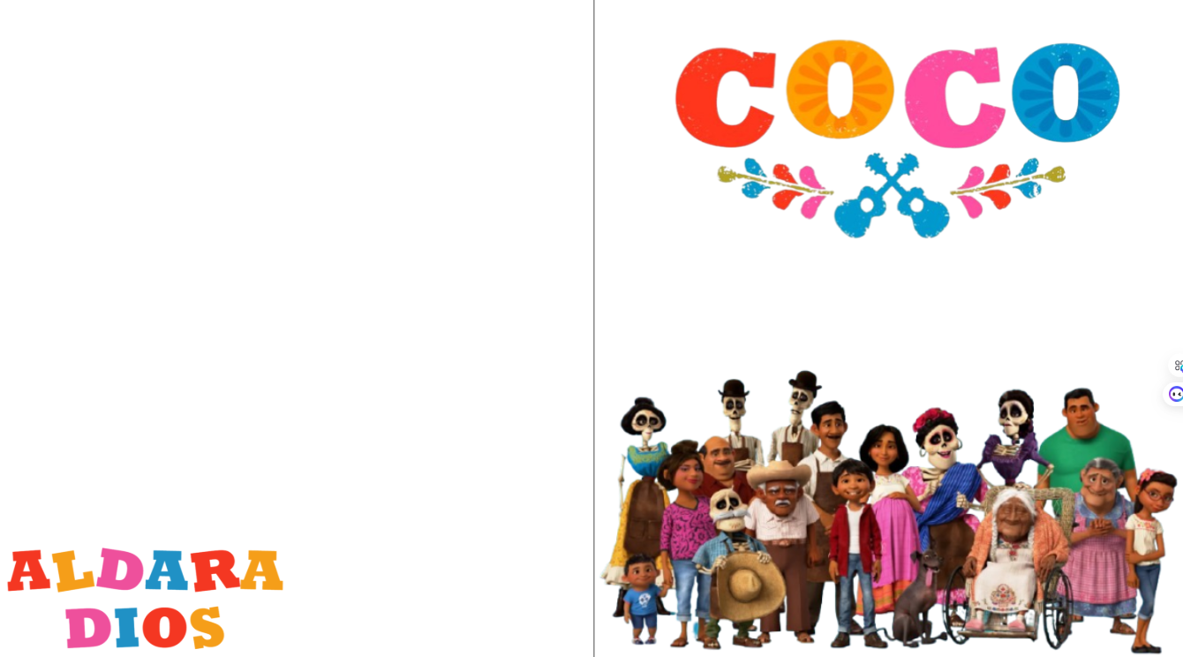

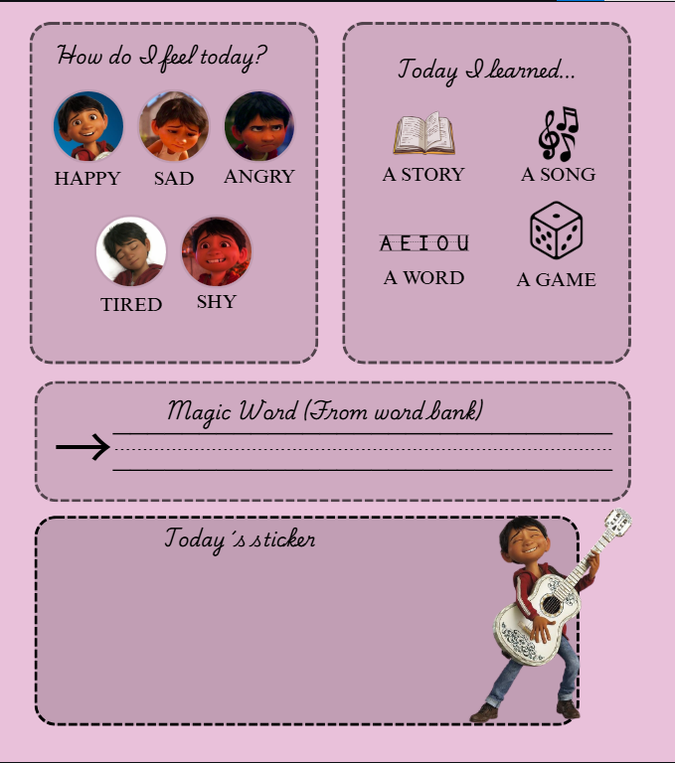

Este es un ejemplo de la autoevaluación de cada sesión de los niños, debería de poner todo? O solamente la portada con hipervínculos como hice en el TFG anterior? Es que sino, no me llegan las páginas

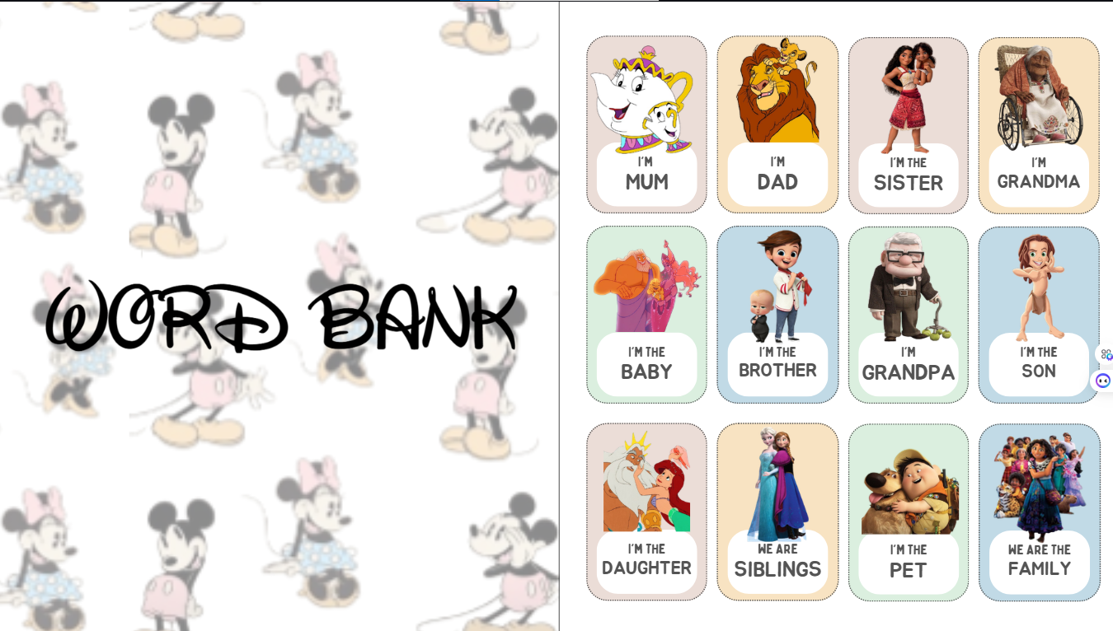

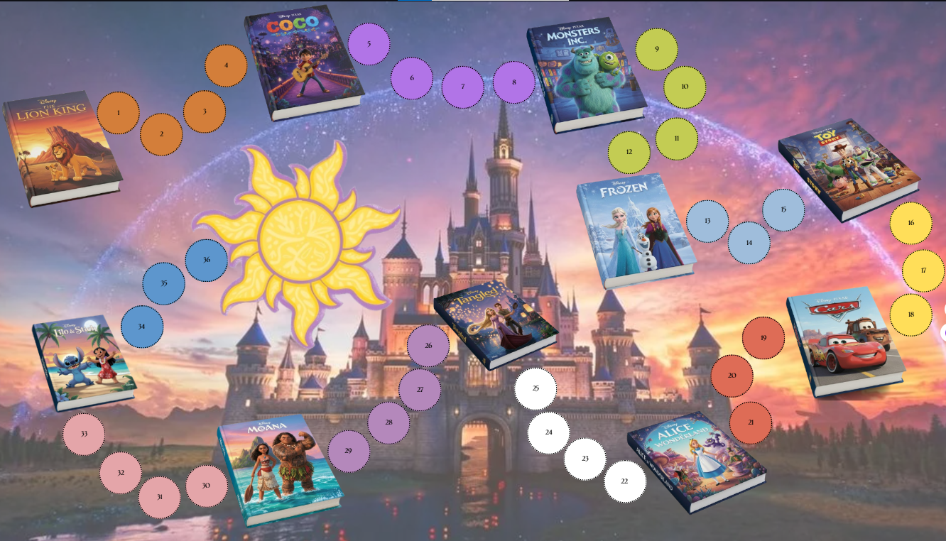
(This would be the table that the students will go through with the sessions that would be in total, here you can see the stories that we would work on throughout the course but the children would not see directly what the next story is, but with the chapters that are told, clues will appear, in the first story they will appear for example, a guitar, a Mexican flag, a catrina and flowers; from the second story Sulli's fur, a helmet of monsters inc., Boo's stuffed animal or the boo costume will appear; and so with the rest of the stories as clues, they go from the least obvious to the most obvious... )

