Fiscal union, monetary policy normalization and populism in the Eurozone

Alfredo Arahuetes García – Universidad Pontificia Comillas
Gonzalo Gómez Bengoechea – Universidad Pontificia Comillas

November 2018

This paper studies the different scenarios for the fiscal union in the Eurozone beyond 2018. It explains the different alternatives that the literature has explored to ensure fiscal transfers within Eurozone estates as well as for common debt issuance. It also describes the role that the monetary policy has played as a backstop for sovereign defaults and highlights the limits that inflation and anti-euro backlash impose on public debt sustainability.

Keywords: Fiscal Union, Debt Mutualization, Monetary Policy normalization, Populism
JEL classification: E63, F36

- Introduction
After the election of Emmanuel Macron as French president, the debate about the future of the Eurozone regained momentum. The pro-European policies supported by the French administration found a perfect complement in the German government coalition. On the other side, the Italian government is pushing from more national autonomy and a weaker Eurozone. Policy-makers and researchers are publishing new proposals on how to enhance Eurozone’s institutional framework to transform it into an optimal currency area (Mundell, 1961).
Among the different policy alternatives currently under discussion, debt mutualization seems to be losing political interest in favor of other proposals, like tax reform or the creation of the so-called European Monetary Fund (EMF). Although we welcome those efforts, we believe that the current economic and institutional environment demands some form of solution from the center to ease sovereign market conditions and to reduce dependence from the European Central Bank (ECB).
This paper studies the different scenarios for debt mutualization in the Eurozone beyond 2018. The main question that we try to answer is whether the current sovereign debt stability is sustainable, given the lack of political consensus about further fiscal integration and the inflation target that the European Central Bank (ECB) is committed to.
This question is particularly relevant for two reasons. The first one is that there is an increasing threat to the European integration project on the newly-born populist movements in Europe. The second one is that monetary policy is currently playing a fiscal role in the Eurozone. For how long will the ECB be able to play it is a question that remains unanswered.
The current stability in sovereign debt markets, shown in Figure 1, is the result of better macroeconomic fundamentals in the Eurozone and the active role that the ECB has been playing in debt markets. Because of this, sovereign yields are now lower and more stable than in previous years.
Figure 1. 10-year sovereign bond yields. Eurozone 12

Source: European Central Bank.
There is huge homogeneity on the evolution of default risk, as De Grauwe and Moesen (2009) define it, in the years 2000 to 2009. After that period, there is a group of countries (Portugal, Ireland, Italy and, specially, Greece) that experienced a dramatic surge in their yields. From the second quarter of the year 2012 on, all countries but Greece returned to the pre-crisis homogeneity. Italy started to threaten this stability soon after the election of Matteo Salvini as Deputy Prime Minister of the country.
The reduction in sovereign yields is correlated with the announcement, from the ECB, of the Outright Monetary Transactions (OMT) program and other monetary stimuli designed to alleviate the sovereign debt burden. The stability achieved by ECB's intervention is very fragile, however. First, because of the ECB's commitment with its inflation targeting. If inflation rises above two percent per year over, sovereign debt buying could be reduced or even stopped, as it has been already announced (ECB, 2018).
Second, because populist and anti-European forces are limiting the scope of new reforms and further integration in the Eurozone. The support that the ECB is providing to the sovereign debt markets has reduced the need for a fiscal union and for a common debt issuance mechanism. In case of monetary normalization, eurobonds and fiscal union would probably be the only solution to keep sovereign markets stability.
Is it possible to achieve a common fiscal policy or to create a mutual public debt asset under the current political pressures? What are the different alternatives under this extraordinary set of circumstances? This paper assess these questions following these steps. First, we analyze the literature on fiscal unions and eurobonds. In section 3, we explain ECB's role as a backstop for sovereign defaults. We also study the limitations that this approach may have and its connection with the political climate in Europe. In section 4, we stress the relationship between adjustment costs and populism. In section 5, we study the different scenarios that the Eurozone faces on the creation of a fiscal union. Finally, section 6 concludes.
- Eurobonds: Literature Review and Alternatives
This section examines the different alternatives that the literature and the policy makers have proposed for common sovereign debt issuance in the Eurozone. The International Monetary Fund (Allard et al., 2013) has highlighted the need of a fiscal union as a prior step before the issuance of a common European debt asset.
According to the Fund's view, there are four conditions that must be fulfilled to close the institutional gap that the Eurozone is still suffering from: better design of fiscal policies, discipline and accountability, enforcement of agreements from central authorities and the creation of a mechanism for fiscal transfers. The four of them will be briefly analyzed in the following section.

2.1 Minimal Elements for a Fiscal Union
2.1.1. Fiscal Policy Design
Fiscal rules and policies at the estate-level should be coordinated from the center. Common rules and goals are essential. The fiscal compact is a step into this direction, but the enforcement of fiscal plans is a critical element for the success of the fiscal union. The IMF proposes four policy changes in order to enhance the current fiscal framework.
First, the concept of structural fiscal balance targets, instead of headline ones should be applied more systemically. All the adjustment paths proposed by member estates, as well as policy recommendations from European authorities, should be designed in terms of structural goals. Second, the use of structural targets require from careful estimates of the output gap. Independent regional agencies would provide those estimations, in coordination with central oversight, to assess fiscal policy design and its implementation.
Third, fiscal rules must be flexible, but they should be accompanied by medium-term fiscal plans that clearly highlight the path to lower debt levels. They should also include automatic corrective mechanisms designed at the national level and made consistent across countries. Finally, the harmonization of budget presentation, fiscal reporting and accounting, at all levels of government, would increase transparency and accountability. It would also send a message to the markets about the unity of the fiscal framework in the Eurozone.
    - Discipline and accountability
It is essential to increase the accountability of fiscal plans and to enhance the mechanisms already operating in its design. There are two ways of doing that: first, through a center-based approach complementary to market discipline. This approach, that could take the form a new common fiscal institution, would also provide technical assistance in case of being necessary and prevent fiscal imbalances to appear.
Second, while the new design of fiscal policies and common debt issuance in the Eurozone is ready, the European Stability Mechanism (ESM) still stands as the main tool for fighting against sovereign market disturbances. It is necessary to clarify bailout rules and conditionality to make sure that the necessary reforms are implemented after interventions.
Cottarelli (2013) stresses that the main goal of a fiscal union is “to prevent unsustainable fiscal behavior at the local level from exerting negative effects over the entire union”, an idea also included in the following condition from the IMF's proposal.
2.1.3. Enforcement
It would be necessary to increase the involvement of central authorities in fiscal decisions to make its design more homogeneous. Deeper relation between national and central authorities could take three forms:
- Since fiscal rules are expected to be part of national legal bodies, non-compliance could also be prosecuted at domestic courts. In addition, as the IMF points, “EU court jurisdiction over national domestic rules could also be considered”. In all cases, changes in treaties would be necessary, which makes this possibility hard to implement.

- The existence of a central budget would make enforcement easier to achieve. Let's suppose that a given country does not fulfill some of the fiscal targets that have been agreed or that have been imposed from the center. In that case, it could be possible to reduce transfers until compliance with the established goals.
- A veto power from the center is an alternative that would allow a common fiscal authority to revise and to overrule domestic budgets when they do not fulfill fiscal targets or agreements. This mechanism would probably be the most effective one, but it would require from member estates to previously give up a big part of its sovereignty, which is unlikely under current political circumstances.

    - Fiscal transfers mechanism
According to Mundell (1961), currency unions need fiscal transfers as a way to protect countries suffering from asymmetric shocks. Following Allard et al. (2013), there are three ways to achieve this goal. First, the creation of a “rainy-day fund” as the one contained in Padoa-Schioppa (2012). The fund would collect revenues from Eurozone countries and make transfers to those economies affected by an asymmetric shock. It would provide an ex ante support and a cross-country insurance without the need of establishing new institutions, which could reduce the political cost of it.
Second, a common unemployment insurance. It would be a socially acceptable way for deeper risk and fiscal sharing in the Eurozone. A common unemployment insurance would require of a higher degree of legal harmonization on labor market policies and the overcoming of some technical difficulties; the fund would probably need to be focused on short-term unemployment, given the huge heterogeneity that the Eurozone experiences on long-term rates.
Finally, the deepest way of fiscal risk sharing would be the implementation of a common budget for all Eurozone countries. Risk sharing would come from the expenditure and from the revenue sides at the same time. The high degree of risk sharing that this alternative requires from should generate a deeper involvement in the responsibilities attached to the budget management. Coordination would be easier and the impact on Eurozone's economy would be potentially higher.
There would be two additional strategies to make fiscal risk sharing possible in the Eurozone. The first one would be a single resolution mechanism covering all financial systems in the Eurozone capable to disentangle the relationship between sovereign debt and financial institutions. This backstop would be funded both from national governments and from the industry. This possibility goes beyond the scope of this paper since it has a strong connection with the banking union proposals and it should be addressed separately. The second one would be borrowing from the center. This is an option that will be analyzed in the following pages. Debt issuance from the center, as has been previously pointed, would require from an adequate governance, as well as a high degree of social and political support.
2.2 Eurobonds: the next step
From the theoretical point of view, borrowing at the center would be an option not necessarily proceeded by the existence of some degree of fiscal risk sharing. Nevertheless, a fiscal union, in any of the forms previously described, would be a good test for the political and social willingness of deeper political and economic integration; some of the technical difficulties that would arise from common debt issuance could be solved ex ante.
Given the fact that the European Stability Mechanism (ESM) issues bonds with a guarantee proportional to each estate participation on the capital of the ECB, some form of Eurobonds already exist. There is not, however, a joint guarantee. De la Dehesa (2011) grouped the main proposals contained in the literature in a briefing note published by the European Parliament. According to his view, there are four different proposals for common debt issuance in the Eurozone. Two other alternatives will also be included in this section: the ones from di Mauro (2011) and Brunnermeier et al. (2016).
2.2.1. The Gros / Micossi Proposal
Since the financial crisis bust in 2008, economic agents developed a strong preference towards public debt. Gros and Micossi (2008) proposed the creation of a European fund as an answer to American Troubled Assets Relief Program (TARP). This fund would issue bonds with the explicit guarantee of all Eurozone member states. According to Gros and Micossi, the fund would be operative only during a limited time; as long as there was demand for this newly created instrument.
From the moral hazard point of view, this proposal does not necessarily imply that stronger states would have to cover for the mistakes of others, since losses could be distributed according to each case. This is one of the reasons that explains the interest of core Eurozone countries on this mechanism. Gros and Micossi proposal was partially adopted by European authorities. On May 24th 2010, the European Financial Stability Facility (EFSF) was officially created. The EFSF is authorized to borrow up to 440 billion euros, a similar amount that the one proposed by Gros and Micossi.
2.2.2. De Grauwe and Moesen: Market perception
The increasing pressure on sovereign bond yields of the years 2009 and 2010 is behind De Grauwe and Moesen (2009) proposal. The goal of their common debt issuance alternative was to reduce the pressure that was affecting market perception on sovereign risk in the Eurozone. They expected to create enough fiscal space for public stimuli and to control the side effects generated by the reduction of sovereign debt quality in the financial system.
There would be two ways to achieve this: by opening the door to the ECB's intervention in sovereign debt markets or by implementing their Eurobonds proposal. The institution in charge of public debt issuance would be the European Investment Bank (EIB) or, alternatively, national governments.
To fulfill its targets, debt issuance should satisfy the following four conditions, as De la Dehesa (2011) summarizes: “first, each euro area government would participate in the issue on the basis of its equity shares in the EIB. Second, the coupon on the Eurobond would be a weighted average of the yields observed in each government bond market at the moment of the issue weighted also by their equity shares in the EIB. Third, the proceeds of the bonds would be channeled to each member government according to the same EIB share weights. Fourth, each government would pay the yearly interest rate on its part of the bond, using the same national interest rate used to compute the average interest of the euro bond”.

2.2.3. Delpla and Von Weizsäcker: blue bond proposal
According to Weizsacker and Delpla (2011), the only possible solution to the moral hazard problems hidden in previous proposals is be a double-tranche European public debt asset. The senior tranche (blue bond) would be constructed by pooling 60 per cent of the national sovereign debt of the euro area member states, under joint liability and common responsibility.
The junior tranche (red bond) would be constructed with the public debt of member estates above 60 per cent of GDP. Interest would be higher and it would work as an incentive to reduce their leverage in order to enjoy the conditions granted on the senior tranche (Weizsacker and Delpla, 2011)
This proposal has several strong points. First, it splits responsibilities within the euro area, making the “no-bailout” clause of the Lisbon Treaty more credible, not only de jure but also de facto. The higher cost of borrowing would act as an alarm sign; countries would need to adjust their public balances to gain access to the blue tranche.
Second, it is a politically feasible proposal since the borrowing capacity of the blue tranche would not be polluted by the weak performance of some specific countries. Countries meeting their budget balance and public debt commitments would be less affected by free-riding problems and by asymmetrical shocks.
Third, ECB's intervention in the market would be limited to blue bonds. This should act as secondary incentive for countries to achieve public debt issuance in the senior tranche. ECB's intervention would depend, however, on the evolution of future inflation and on the political fragmentation that could hit Eurozone countries, as it will be shown in Section 3.
Financial Times published the evolution of the Blue/Red Bond proposal in December 2010. According to Juncker and Tremonti (2010), Eurobonds should be issued by a new institution, the European Debt Agency (EDA). The EDA would finance up to 50 per cent of issuance by member states. It would offer a switch between existing national bonds and newly created eurobonds. The EDA would have a mandate to issue eurobonds up to a total equivalent to 40 per cent of the total GDP of the European Union and of each member's state GDP.
    - Eurobills, not Eurobonds
Eurobills proposal (Philippon and Hellwig, 2011) is based on the idea that the introduction of eurobills – common debt with maturity of less than a year – “could provide a large part of the benefits” of other assets with longer maturities, “while allowing for significant checks on the risks, both in terms of magnitudes, and in terms of effective control”.
The original proposal includes the creation of a new institution that the authors call Debt Management Office (DMO). This office would be the only issuer of short-term bills for all Eurozone countries. The DMO should also manage debt issuance, redemption and debt auctions. It would conduct them in order to satisfy the needs of all EZ countries, subject to the constraint that no country can have more than 10% of its GDP in eurobills at any given time. eurobills would be “the joint-and-several liabilities of the Eurozone” as the authors highlight.

Participation in Eurobills emissions would be conditional to the achievement of the different economic convergence goals established by European authorities. Countries could not issue any more short-term debt on their own. They would continue to issue their own debt for maturities longer than two years.
Eurobills would be senior to other debts. All market participants (investors and governments) should understand this point, since it is a key feature to reduce moral hazard. Philippon and Hellwig (2011) highlight that their proposal would be complementary to budgetary discipline and fiscal surveillance.
They recognize, however, that “it is important to understand that effective market discipline requires that jointly issued debt be credibly senior to any other debt. Enforcing this is difficult and risky”.
    - A debt redemption fund?
Following di Mauro (2011), the debt redemption pact would act as a temporary mechanism formed by a pact and funding scheme. The pact would entail a country specific plan for reforms and public adjustment. It would follow the demands set by the Treaty on Stability, Coordination and Governance (TSCG) and act as a safeguard against moral hazard.
Each country would service its own debt financed via the new fund until it is completely redeemed and the new fund expires. Participant estates would be jointly responsible for debt, which should make refinancing costs affordable.
The Redemption Fund allows countries to refinance public debt in excess of 60 per cent of GDP. Repayment obligations are set as a percentage of nominal GDP to provide some automatic stabilization and backload redemption of debt when growth picks up. By design, the countries with the largest participation would be those which now have the highest debt burden.
Alternative designs of the fund could envisage a higher threshold for mutualization (e.g. 75 per cent of GDP), or setting an equal share of joint issuance at 20 per cent of GDP of every participating country. The redemption fund first accumulates during the “roll-in” phase and is then gradually drawn down. A fund for all debt above 60 per cent would reach a maximum size of 2.85 trillion after 5 years and the repayment phase would be 20 years.
    - ESBies: European Safe Bonds
The most complete proposal so far published is the one developed by Brunnermeier et al. (2016). The main advantage of this proposal is that it does not require from major changes in current treaties, which would make it easier to implement.
Mutualized bonds would be issued by a new agency, the so-called European Debt Agency (EDA). It could buy debt from different eurozone countries and issue, in exchange, two different categories of assets: senior debt, with lower risk, and junior debt, for investors looking for a higher return.
According to the authors, “the first security, ESBies, would grant the right to a senior claim to the payments from the bonds held in the portfolio. If the tranching cut-off is X per cent, then the first X per cent lost in the pool of bonds because of potential European sovereign defaults would have no effect on the payment of the ESBies”.
The second security would be sold to willing investors in the market. Any risk that a sovereign state may fail to honor debts would be reflected in yields' evolution. Realized losses would be absorbed by the holders and not by the EDA nor by the European Union nor by its member States. This security should be more appealing for those investors wanting to hedge with the ability of European member states to repay their debt.
ESBies offer three important advantages to the different proposals so far discussed. First, they satisfy the demand for safe assets; banks and investment funds are asking for a European asset, as safe as possible, that can minimize default risks. Second, ESBies do not require further fiscal integration. It is a solution that could help to stabilize the Eurozone without an important political cost. Finally, ESBies can help to erode the diabolic loop between banks and states, as described by Altavilla et al. (2015).
- The Fiscal Role of the Monetary Policy
Figure 2 shows the relationship between public administrations, commercial banks and the ECB under the current conditions of public debt issuance. Each country is responsible for its own debt with no guarantee from the center. Budget deficit from one independent estate is issued in euros with no common guarantee.
When a country runs a budget deficit, it needs to finance it through public debt issuance, which generates higher interests and, then again, more expenditure and a deeper budget deficit. When that situation turned into explosive in the years 2010-2012 for some Eurozone member estates, commercial banks started to buy sovereign debt with the incentives provided by the European Central Bank through its different quantitative easing programs. That eased market conditions for a while but soon it was evident that it was not enough.
Figure 2. The fiscal role of monetary policy
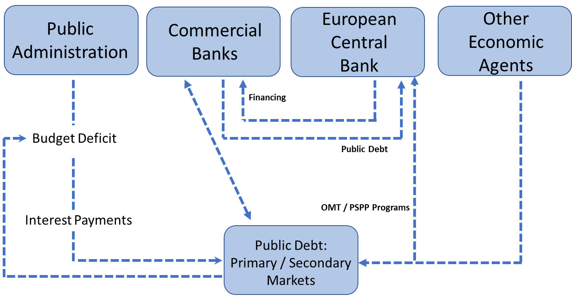
Source: Own research.

As De Grauwe and Moesen (2009) point, the absence of a common backstop mechanism for each country's public debt was a major issue that needed to be tackled. The ECB, through its OMT and Public Sector Purchase Programme (PSPP) programs, started to intervene in public debt markets. This reduced market pressures and sovereign yields. Member estates started to enjoy cheap borrowing and the risk of default was averted in most European economies.
By the end of February 2017, the ECB had bought 1.412 billion euros of bonds under its Public Sector Purchase Program (PSPP), of which 155 billion were supranational bonds and 1.3 trillion were national government and agency bonds. Purchases of asset-backed securities reached 24 billion euros by the end of February, while holdings under the third Covered Bond Purchase Programme (CBPP3) amounted to 213 billion euros (see here for breakdowns). Starting in June 2016, the ECB also added a Corporate Sector Purchase Programme (CSPP), which now stands at 67 billion.
In February 2017, the purchases under the asset purchase programme amounted 81 billion euros. As previously discussed, the implementation of this 81 billion euros of purchases is split between the ECB and the national central banks. This is reflected in Figure 3, which shows an increasing trend in central banks’ sovereign bond holdings since the start of the PSPP.
Figure 3. Public debt holdings by the European Central Bank

Source: Bruegel sovereign bond holdings dataset.
According to ECB's view, through the PSPP the Eurosystem “intends to conduct purchases in a gradual and broad-based manner, aiming to achieve market neutrality in order to avoid interfering with the market price formation mechanism”.
The PSPP is part of a broader strategy. Asset purchases provide monetary stimulus to the economy in a context where key ECB interest rates are at the lower bound. They further ease monetary and financial conditions, making access to finance cheaper for firms and households. This tends to support investment and consumption, and ultimately contributes to a return of inflation rates towards 2 per cent.
Figure 4 suggests that inflation is not a threat for the ECB's price stability goal at the moment. Prices are growing below the two per cent threshold established by the monetary authorities. Even though, headline inflation has been growing since March 2016 while core inflation has been steadily increasing since the beginning of 2014.
Figure 4. Harmonized monthly index of consumer prices. Seasonally adjusted data. 2015=100

Source: European Central Bank.

According to ECB’s October 2018 statement: “The underlying strength of the economy continues to support our confidence that the sustained convergence of inflation to our aim will proceed and will be maintained even after a gradual winding-down of our net asset purchases. At the same time, uncertainties relating to protectionism, vulnerabilities in emerging markets and financial market volatility remain prominent. Significant monetary policy stimulus is still needed to support the further build-up of domestic price pressures and headline inflation developments over the medium term” (ECB, 2018).
If inflation rises in the mid-term the ECB will be forced to react and to reduce its market interventions, including those focused on sovereign stability. Therefore, the first risk that could prevent the ECB to keep implementing fiscal policies through monetary instruments could be the rise of inflation.
There is a second risk associated with political instability and the anti-euro backlash that is currently appearing in some European countries like France, Germany or Italy: the rise of anti-European parties willing to promote exit votes for leaving the monetary and economic unions.
Those parties are being capable of attracting the growing Euroscepticism that has been expanding in member states since 2006 until the end of 2016. Figure 5 shows the percentage of citizens in each country with a “fairly negative” or “very negative” view of the European Union.

Figure 5. Percentage of citizens with a fairly negative or very negative view about the EU

Source: Eurobarometer.
Negative views about the European Union experienced its lowest point in the years 2003 to 2007. After that, once the crisis began, they grew dramatically to moderate after 2013. Even though, the animosity against the European project was, at the end of 2016, higher than in 2000 in most Eurozone countries. There are two cases were negative views were particularly high at that moment: Greece (47.5 per cent) and Austria (35.8 per cent).
There is also group of countries where negative views are close to 30 per cent of the population: Netherlands, Italy, France and Belgium. Even after the increase in support shown from 2016 to 2018, in one half of the original Eurozone member countries, there is a strong opposition to the European project that needs to be managed and that could limit the scope of policies.
It is important to highlight that the current public debt holdings in the Eurozone represent an important vulnerability to the Eurozone stability, even after the increase in ECB's holdings previously described.
Total public debt holdings by economic agents other than the ECB are relatively stable for the period 2014 - 2016, moving between 1.600 and 1.800 million euros. This fact suggests even if the impact of ECB's role on sovereign markets has been enough to curb yields, there is still a public debt problem that needs to be seriously addressed. ECB's monetary support to fiscal policy needs to be complemented by some kind of guarantee from the center, as the literature has pointed (Gros and Micossi, 2008).

- The Adjustment-Populism Loop
Pro-European parties face an important challenge regarding debt mutualization. States with lower financial needs find that any borrowing at the center mechanism would require from their generosity, since it would mean covering highly indebted states for their excessive risk.
Countries with higher public debt to GDP ratios find that any of the mechanisms currently under discussion could increase the pressure on them to accelerate economic reforms, in exchange for the protection received, through some kind of implicit or explicit conditionality. There is a high social pressure on both sides. Countries need to transfer financial sovereignty in a politically feasible way.
Anti-European parties, both from debtor and creditor states, try to take advantage of this situation. The nonexistence of some kind of debt mutualization mechanism increases the cost of the adjustment for member states; economic adjustment is harder to develop in a monetary union without the appropriate institutional framework since it can only be done through spending-switching mechanisms.
The recovery process of the great recession has eased the conditions for the appearance of populist movements in Europe. First, because it was not immediate. Figure 7 shows the evolution of real GDP growth in the period 2007 to 2020.
Figure 7. Recovery: GDP Growth

Source: IMF, World Economic Outlook. Note: Ireland has been excluded due to its extraordinary GDP growth in the year 2015 (above 25% increase).

All the observed countries experienced a w-shaped crisis. After an initial recovery from the financial crisis of the years 2008 and 2009, the sovereign crises that hit the Eurozone from 2010 on, negatively affected economic activity even in counties like France and Germany. Recovery after 2011 has been uneven. Growth in most dynamic countries (like Spain or Ireland) is the consequence of unpopular political reforms and demanding internal adjustments. Figure 8 shows the evolution of nominal unit labor costs between 2007 and 2017.
Figure 8. Nominal unit labor cost – 3 years percent change

Source: Eurostat.
The comparison between pre-crisis labor costs and post-crisis labor costs shows that workers in the Eurozone experienced a dramatic income change between the years 2007 and 2010. For the case of Ireland, labor costs mostly grew at a 20 per cent rate in the year 2008 and fell below that threshold between 2010 and 2017. In Spain and Portugal, labor costs also fell in the period 2011 to 2015, as it can be seen in Figure 8.
The evolution of nominal labor costs, as well as the low inflation experienced in the Eurozone peripheral counties, transformed their current account balances from deficit to surplus. Figure 9 shows the evolution of this indicator, as a percentage of GDP, from 2007 to 2020. For the first time in their recent history, countries like Spain were growing with a surplus in their current account balance.

Figure 9. Recovery: Current Account Balance

Source: IMF, World Economic Outlook.
The negative impact of the recession on public income and government spending, through automatic stabilizers, generated budget deficits and explosive public debt dynamics. Figure 10 shows the evolution of both indicators from 2007 to 2020.
The different paths of public debt between core and peripheral countries eased the conditions for populist parties to emerge. Lender countries pushed for austerity reforms in debtor countries as the only possible solution for their excessive debt. Citizens in debtor states felt over-demanded by their Eurozone associates, while citizens in lender states felt that debtor states were not doing enough to solve their economic struggles.

Figure 10. Public Debt (left axis) and Budget Balance (right axis). Percentage of GDP.
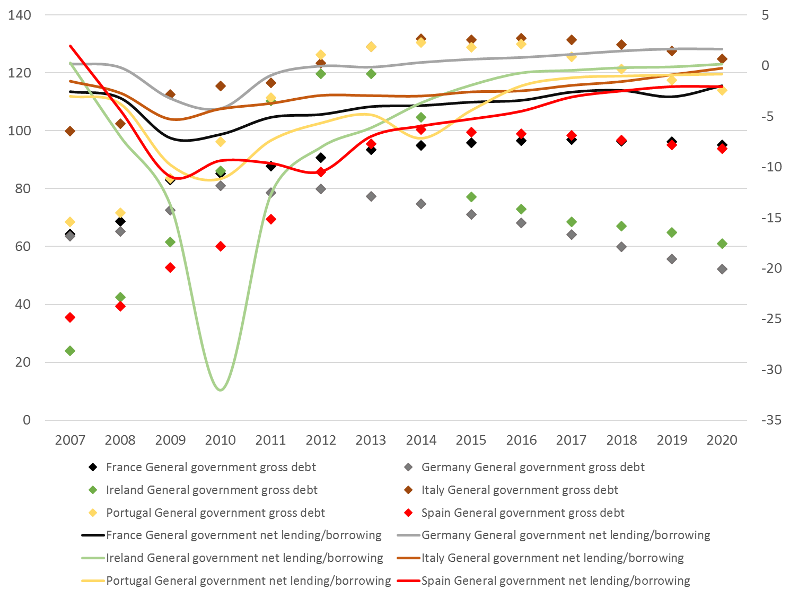
Source: IMF, World Economic Outlook.
Populist parties in debtor countries use the extra burden of public debt and reforms to undermine the credibility of the European project and to blame the European institutional architecture for the economic situation of their countries. Populisms in creditor countries use the fragility in debtor states as an alibi for avoiding further integration; differences are huge, they argue, and convergence is virtually impossible to achieve. Figure 11 shows this populist-debt-adjustment loop.
Figure 11. The populist-debt-adjustment loop.
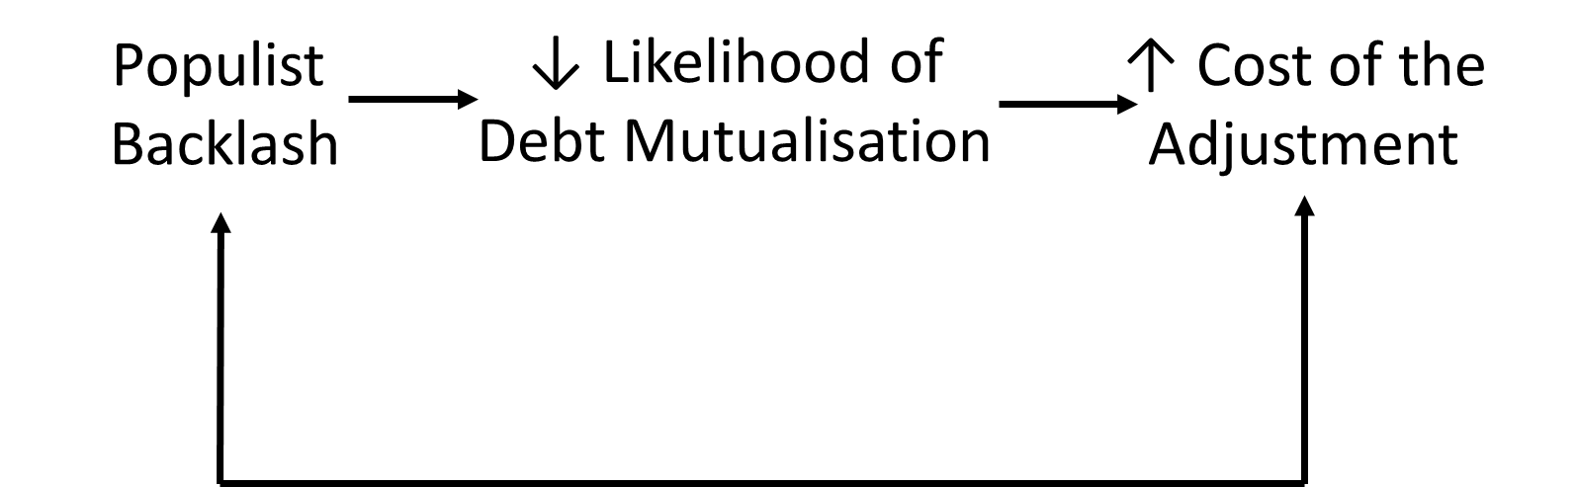
Source: Own research.

- Scenarios for the Fiscal Union
There are two important limitations for the ECB’s role in sovereign markets, as we have previously mentioned. The first one is the appearance of high inflation that may lead to a monetary normalization faster than expected. The second one is the awakening and development of anti-EU parties that can limit ECB’s market interventions or prevent further sovereign integration.
The joint analysis of both threats offers four scenarios for the future of debt mutualization. Figure 12 shows those alternatives. The vertical axis stresses two possible outcomes for inflation in the following quarters: inflation rates can rise above ECB's target or stay below the 2 per cent threshold. Latest data show that inflation remains subdued in the short run, but that it could accelerate during the first half of the year 2019.
The horizontal axis is the political one. It shows the cases of an anti-Euro backlash capable of stopping debt mutualization or ECB’s market interventions. During the first months of 2017, there was a huge concern about the possibility that several anti-European parties could win the elections in the Netherlands, France or even Germany.
The first weeks of 2018 revealed a more stable political landscape, with pro-European forces dominating the agenda. After the election of a stable government in Germany, a three-year window suddenly opened for deeper economic integration. Elections in Italy slowed that positive momentum, though.
Figure 12. Scenarios for the future of the Fiscal Union.
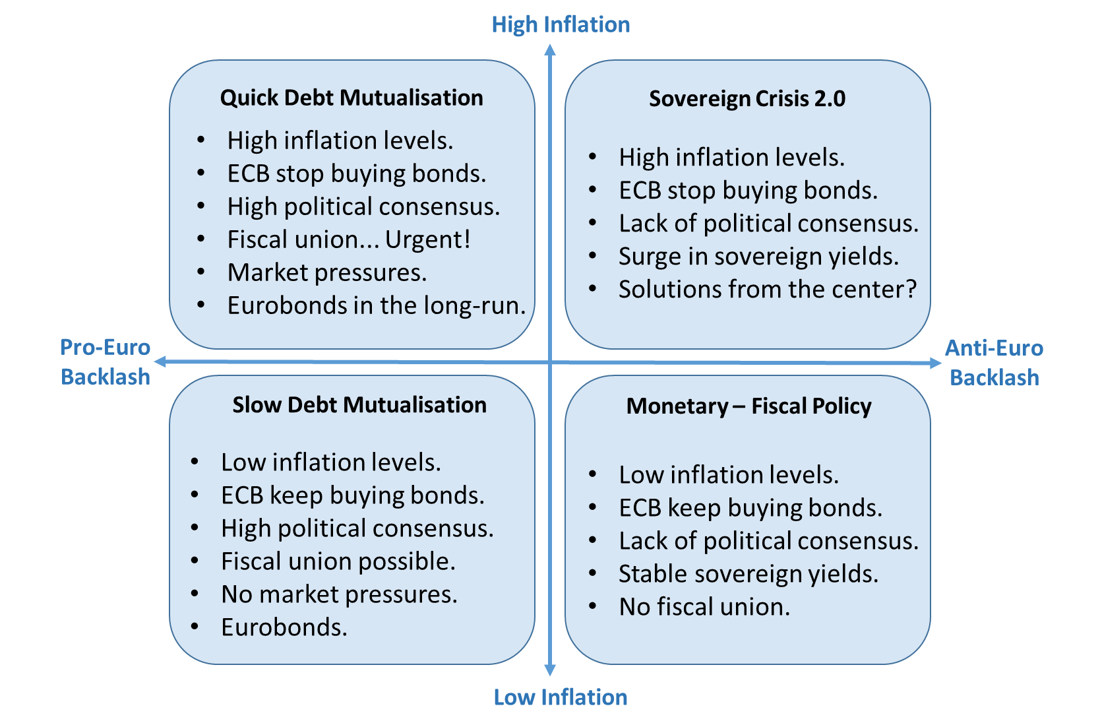
Source: Own research.

In the “Quick Debt Mutualization” scenario, inflation rises above ECB's target and pro-Euro resurgence allows policy makers to deepen fiscal integration without high political costs. Inflation asks for an alternative to the fiscal role that the ECB has been playing since 2012. Eventually, the ECB must abandon its bond-buying strategy. However, thanks to the political consensus, a long-term solution for the public debt problem could be easily achieved. Market pressures would also help to do it. The case for Eurobonds would be more plausible.
Top-right scenario shows a sovereign crisis renaissance. In this case, inflation is again above its target but there is not enough political consensus for implementing any borrowing at the center mechanism or some form of fiscal union. The lack of action from the ECB plus the absence of solutions from the center would ease the conditions for a new sovereign crisis.
In the bottom-right scenario anti-European backlash dominates. This would be the case of a failed German government or a “Five Star plus Legga” long dominance in Italy, with exacerbated anti-establishment policies. In this “Monetary-Fiscal policy” case, there are no short-term inflationary pressures. This would be the continuity scenario. The lack of political consensus would not permit the creation of a long-term solution from the center, but the ECB could continue with its bond-buying strategy. This scenario would prevail as long as inflation remained subdued. Instability would be high, since monetary normalization would move the Eurozone to the “Sovereign Crisis 2.0” alternative.
In the “Slow Debt Mutualization” scenario, we find low inflation and a high degree of political consensus. The ECB could maintain its bond-buying strategy without price-stability concerns. Social acceptance would offer a perfect environment for a slowly cooked debt mutualization process, without market pressures. Under these circumstances, the creation of some common debt security would be more possible.
- Conclusions
This joint analysis takes into account only price stability and popular support to reforms. It disregards other limitations such as political willingness, technical difficulties and other negotiating barriers. From our point of view, the most desirable scenario would be the last one, the so-called “Slow Debt Mutualization”. It would make the negotiating processes softer and allow member states to reach an agreement without market pressures. At the same time, it would allow the ECB to normalize monetary policy at the right time, when a political solution from the center would be operational.
Monetary normalization is unstoppable. The ECB needs to create monetary space. Inflation will eventually rise and get closer to its threshold. Policy-makers need to find a solution from the center to sovereign debt markets stability that does not rely only on ECB’s policies. There is a real risk of a new sovereign crisis if the ECB withdraws from debt markets without the implementation of any alternative from the fiscal side. We do not expect the “Sovereign Crisis 2.0” to dominate during the following years, though.
There is room for optimism for at least two reasons. First, it seems that policy makers understand the relevance of the debate contained in this paper and are working on an efficient and sustainable solution. Second, inflation remains subdued and populism relatively under control, with the exception of the Italian case.
Even if “Italexit” was again part of the agenda, France and Germany still have a two years window to push for deeper integration. The need for some kind of solution from the center to sovereign debt markets stability is no longer questioned. The “Slow Debt Mutualization” scenario is the more desirable and likely, at this moment. The depth and the scope of that common solution will depend on the evolution of political debate during the following months.
References
Allard, C., P. Koeva Brooks, J. Bluedorn, F. Bornhorst, F. Ohnsorge, and K. M. Christopherson Puh (2013): “Toward A Fiscal Union for the Euro Area,” IMF Staff Discussion Notes 13/9, International Monetary Fund.
Altavilla, C., M. Pagano, and S. Simonelli (2015): “Bank Exposures and Sovereign Stress Transmission,” CSEF Working Papers 410, Centre for Studies in Economics and Finance (CSEF), University of Naples, Italy.
Brunnermeier, M. K., L. Garicano, P. R. Lane, M. Pagano, R. Reis, T. San- tos, D. Thesmar, S. V. Nieuwerburgh, and D. Vayanos (2016): “The Sovereign-Bank Diabolic Loop and ESBies,” CEP Discussion Papers dp1414, Centre for Economic Performance, LSE.
Claeys, G. and A. Leandro (2016): “The European Central Bank’s Quantitative Easing Programme: Limits and Risks,” Bruegel Policy Contribution. 2016/04
Cottarelli, C. (2013): “European Fiscal Union: A Vision for the Long Run,” Swiss Journal of Economics and Statistics (SJES), 149, 167–174.
De Grauwe, P. and W. Moesen (2009): “Common Euro Bonds: Necessary, Wise or to be Avoided?” Intereconomics. Volume 44. May / June.
De la Dehesa, G. (2011): “Eurobonds - concepts and implications,” Briefing Note IP/A/ECON/NT/2011-01.
di Mauro, B. (2011): “A European Redemption Pact,” Voxeu.
ECB (2018): “Press Conference” by Mario Draghi and Luis de Guindos. October 2018. European Central Bank.
Gros, D. and S. Micossi (2008): “A call for a European Financial Stability Fund,” CEPS Commentary. October.
Juncker, J.-C. and G. Tremonti (2010): “E-bonds would end the crisis,” Financial Times.
Mundell, R. (1961): “A Theory of Optimal Currency Areas,” American Economic Review, 51, 657–665.
Otero-Iglesias, M. (2014): “Germany and political union in Europe: nothing moves without France,” Elcano Royal Institute, 8.
Padoa-Schioppa, T. (2012): “Completing the Euro: a roadmap toward fiscal union in Europe,” The Padoa-Schioppa Group.
Philippon, T. and C. Hellwig (2011): “Eurobills, not Eurobonds,” Voxeu.
Weizsacker, J. V. and J. Delpla (2010): “The Blue Bond Proposal,” Policy Contributions 509, Bruegel.
——— (2011): “Eurobonds: The blue bond concept and its implications,” Policy Contributions 509, Bruegel.

