6as Jornadas “Matemáticas Everywhere”
Distribución justa de escaños utilizando ponderaciones
Fair allocation of seats by means of weights
Javier Rodrigo, Mariló López y Chang Liu

Organizan:
Centro Internacional de Encuentros Matemáticos
Castro Urdiales, España
15 y 16 de mayo de 2020
Resumen
En este artículo se reducen las desproporcionalidades (sobre representación y baja representación) inherente en algunas fórmulas electorales como la ley D'Hont que se aplica en las elecciones españolas. Para ello, se crea un sistema de escaños ponderados que corrige dichas desviaciones. Se aplican los escaños ponderados en el contexto global, para luego distribuir los pesos conseguidos por los partidos entre las circunscripciones de manera que se minimiza una función de error, minimizándose así la desproporcionalidad.
Palabras Clave: Fórmulas electorales, Ponderaciones, Optimización, Método de Lagrange.

Abstract
This research paper aims to reduce and minimize the disproportions (overrepresentation or underrepresentation) involved in some Proportional Representation (PR) rules such as D’Hondt Law, applied in the Spanish elections. To do this, we create a system of weighted seats that corrects these deviations. These weighted seats give a proportional allocation of seats in the global realm. Next, we distribute the weights of the parties among the constituencies in a way that minimizes a predetermined measure of disproportionality
Keywords: Electoral formulas, weights, optimization, Lagrange method.

1. Introduction
Electoral systems are necessary in order to map votes to parliament seats. They are, therefore, the set of rules that enable the conversion of votes for assigned seats to the members of the parliament.
The discontent of “small” parties is well known at the current system of plotting parliamentary seats followed by different countries, which mostly favor large parties and local parties that concentrate their votes in one dominating constituency. So much so that the majority of these small or medium-sized parties included in their electoral programs are in need of changes to the current electoral system that would distribute the seats more proportionally to the number of actual votes.
An attempt to reduce this discontent was made by some of the authors of the present paper, Rodrigo and López (2017). According to Rodrigo and López (2017), a method of allocation of seats was made under which a global distribution of seats for the parties was initialized at a first stage; allocation of the seats of each party along the constituencies was performed as a second stage. This method was applied in the Spanish case.
The Proportional Representation (PR) rule is utilized in the Spanish General Elections, where the D’Hondt Law is employed to allocate the seats corresponding to the number of votes. However, D’Hondt Law might have a poor performance in especially the small parties with fewer and dispersed votes, leading to inequity of seat acquisition; hence the overrepresentation or underrepresentation may occur.
This research aims to reduce and minimize the disproportions (overrepresentation or underrepresentation) involved in the PR rules of the Spanish General Elections. To do this, after the integer allocation of seats for the parties, we perform a reallocation by means of a set of weights that corrects the disproportions. Then we distribute the weights of each party among the constituencies in such a way that an adequate measure of error is minimized over the distributions that render each constituency its required number of seats.
This proposal is not entirely new. Reid (2018) provides a precedent by means of an analysis of the use of weights for the elections in Canada, but she does not try to minimize the error.
The outline of the rest of the paper is as follows: In section 2 we visit the main electoral formulas and the philosophy of how they work; in section 3 we provide the mathematical notations; in section 4 we explain the method and the full implementation; in section 5 we apply our proposal to some examples of elections in Spain and in section 6 some concluding remarks are discussed.

2. Review of the Principal Electoral Formulas
The electoral formula is the mathematical calculation on which, in an election, seats are distributed in an assembly in accordance with the electoral votes. They are classified into two big groups: proportional and majority. Some of the most known electoral formulas, see Norris (1997), are:
Under the majority formulas:
- Relative majority formula
• Absolute majority formula
Under the proportional formulas:
• Largest remainder formulas (or quotient formulas):
  - Quotient of Hare or Hare-Niemeyer
  - Imperiali quota
- Formulas of higher average (or divisor formulas):
  - Formula D'Hondt
  - Formula of Sainte-Lague
Some brief comments on characteristics:
a) Majority formulas:
This type of formula improves the hegemony of the principal parties in the parliament. The United States is the paradigm of the majority systems, even though France and Germany use them too. In the majority systems, governability wins but representativeness loses, which propagates that the government control stays in the hands of just one party.
b) Proportional formulas:
The seats are distributed in a more equal way, giving credit to the strength of each party in the elections. We should highlight that even though the proportionality is one of the most important parts of the system, the choice of the electoral formula could still be influenced negatively.
In the proportional systems the plurality that usually envelopes complex societies nowadays is better reflected, and a better representativeness is obtained than in the majority systems. The power is not obsessed with just one party but instead it is shared, which makes negotiations and consensus necessary.
The derived consequences, both in the majority system and proportional system are complex and it is difficult to determine which of the two systems is better, so it primarily depends on what we pre-decided to be the most important aspect: governability, the capability of the system to represent diversity, etc.
The details of some of the proportional systems are shown here. We are going to focus on them specifically for being the most used currently in occidental Europe, and therefore culturally closer to the sensibility of the authors. For more information about distinct electoral systems, consult Colomer (2004) and Brambor et al. (2005).

2.1 D’Hondt Law
This is the system currently in use in Spain. The utilization of this along with the reduced size of electoral constituencies, equipping Spain with a barely proportional system.
Other countries such as Belgium, Croatia, Czech Republic, Japan, among others, also use this system.
Like all higher average systems, it is characterized by using distinct divisors to divide the obtained votes for different parties, producing sequences by decreasing quotients for each party and assigning the seats to those with the highest averages.
The number of votes received by every list divides successively for each one of the divisors, from 1 until the number of seats to assign. The assignment of seats organizes the major and minor quotients and assigns a seat to each one until there are none left. A major difference from other systems is that the total number of votes does not affect the computation.

2.2 Largest remainder formulas
In this system, after scrutinizing all the votes, the number of votes in each list is divided by a quotient that represents the number of votes required to obtain a seat. So the result for every party (its quota) compounds into one whole part and one fractional part. In the first place they assign to each list a number of seats equal to the whole part. This typically leaves a few seats unassigned. So, the parties are organized by the leftover fractions, and the parties with the largest remainders each receive a single seat until there are none left.
A few of those largest remainder systems are:
a) Hare quotient
For m seats with v votes one calculates the quotient , with q approximated to the nearest whole number.
This quotient can be considered the most exact from a mathematical point of view, and to be more proportional since it does not leave out smaller parties.
b) Imperiali Quotient
For m seats with v votes the quotient formula is calculated, with q approximated to the nearest whole number. This quotient heavily favors larger parties.
Example: We see the differences between these formulas in an example whose data was obtained from https://es.wikipedia.org/wiki/Sistema_d%27Hondt.
8 parties were considered, A, B, C, D, E, F, and G with the following numbers of votes (in thousands): A has 392, B has 311, C has 184, D has 73, E has 27, F has 12, and G has 2, for a total of 1000. 21 seats are to be assigned.
The quotients for majority remainder in this case are:
Hare:
Imperiali:
This gives the following assignment of seats. Hare: 8, 6, 4, 2, 1, 0, 0; Imperiali: 9, 7, 4, 1, 0, 0, 0. Note that the smaller the quotient is the more it favors large parties, because by dividing by a smaller number a greater weight is given to the larger number of votes those parties have. So the Imperiali quotient most favors the large parties while the Hare quotient is the fairest, with more parties gaining seats in the government.

3. Notation
The following notation applies along the paper:
- The number of parties with a positive number of seats after the global integer allocation of seats (see Rodrigo and López, 2016): P
- The number of constituencies: R $R$
- Total number of seats: m
- Total number of votes: v
- The number of seats in constituency j: $m_{j}$ ($m_{1}+…+m_{R}=m)$
- The number of votes of party i: $v_{i}$ ($v_{1}+…+v_{P}=v)$
- The number of votes of party I in constituency j: $v_{ij}$
- The number of seats of party i in constituency j after the integer allocation of seats: $m_{ij}$
4. The method
First, we initialize an integer allocation of the seats among the parties applying a given system (this preliminary distribution only decides which parties will have representation. It does not give the final number of seats for each party)
Next we arrange a weighted allocation of seats in the global setting that nulls an error measure as the Gallagher index (see Gallagher, 1991): we assign to the party $i$ the weight $\frac{m v_{i}}{v}$ (quota of the party according to the Hare system)
Now we distribute the weights of each party along the constituencies, taking into account the total number of seats per constituency and minimizing the quadratic error by the Gallagher index defined above.
So, if $x_{ij}$ is the number of weighted seats assigned to party $i$ in constituency $j$, then the problem (assuming that $m_{ij}>0$ for every $i$, $j$) is mathematically implemented as:
$$\left\{\begin{aligned}\min\left({\left(x_{11}-\frac{m_{1 }v_{11} }{\sum_{i=1}^{P}{v_{i1}}}\right)}^{2}+…+{\left(x_{P1}-\frac{m_{1 }v_{P1} }{\sum_{i=1}^{P}{v_{i1}}}\right)}^{2}+…+{\left(x_{1R}-\frac{m_{R }v_{1R} }{\sum_{i=1}^{P}{v_{iR}}}\right)}^{2}+…+{\left(x_{PR}-\frac{m_{R }v_{PR} }{\sum_{i=1}^{P}{v_{iR}}}\right)}^{2}\right) \\ x_{11}+…+x_{P1}=m_{1} \\ ………… \\ x_{1R}+…+x_{PR}=m_{R} \\ x_{11}+…+x_{1R}=\frac{m v_{1}}{v} \\ ………… \\ x_{P1}+…+x_{PR}=\frac{m v_{P}}{v} \\ x_{ij}≥0 ∀i, j\end{aligned}\right.$$
The minimum is obtained by means of Lagrange Multipliers method.
The resultant linear system is:
$\left.\begin{aligned}F_{x_{11}}=2 \left(x_{11}-\frac{m_{1 }v_{11} }{\sum_{i=1}^{P}{v_{i1}}}\right)+λ_{1}+λ_{R+1}=0 \\ …… \\ F_{x_{1R}}=2 \left(x_{1R}-\frac{m_{R }v_{1R} }{\sum_{i=1}^{P}{v_{iR}}}\right)+λ_{R}+λ_{R+1}=0 \\ …… \\ F_{x_{P1}}=2 \left(x_{P1}-\frac{m_{1 }v_{P1} }{\sum_{i=1}^{P}{v_{i1}}}\right)+λ_{1}+λ_{R+P}=0 \\ …… \\ F_{x_{PR}}=2 \left(x_{PR}-\frac{m_{R }v_{PR} }{\sum_{i=1}^{P}{v_{iR}}}\right)+λ_{R}+λ_{R+P}=0 \\ F_{λ_{1}}=x_{11}+…+x_{P1}-m_{1}=0 \\ …… \\ F_{λ_{R}}=x_{1R}+…+x_{PR}-m_{R}=0 \\ …… \\ F_{λ_{R+1}}=x_{11}+…+x_{1R}-\frac{m v_{1}}{v}=0 \\ …… \\ F_{λ_{R+P}}=x_{P1}+…+x_{PR}-\frac{m v_{P}}{v}=0\end{aligned}\right\}$ (2)
For the unique solution of this system:
$\left(x_{11}, …, x_{1R}, …,x_{P1},…, x_{PR},λ_{1},…,λ_{R,}λ_{R+1}, …, λ_{R+P}\right)=A^{-1} C$, where A is the matrix of coefficients of the system and C is the independent term, we have that $\left(x_{11}, …, x_{1R}, …,x_{P1},…, x_{PR}\right)$ gives the weighted number of seats of party $i$ in constituency $j$ (provided that $x_{ij}>0$ for every $i$, $j$. In other case we have to study the boundary: $x_{ij}=0$). The weight of each seat of party $i$ in constituency $j$ would be $\frac{x_{ij}}{m_{ij}}$.
Remark 1: If the party $i$ has been overrepresented in the integer allocation of seats for constituency $j$, then we have that $\frac{x_{ij}}{m_{ij}}<1$; similarly, the underrepresented party $i$ in the integer allocation of seats for constituency $j$ yields $\frac{x_{ij}}{m_{ij}}>1$.
Remark 2: If $m_{ij}=0$ for some $i$, $j$, (so party i has not representation in constituency j) then the problem must be rewritten as:
$$\left\{\begin{aligned}\min\left(\sum_{i/m_{i1}>0}{{\left(x_{i1}-\frac{m_{1 }v_{i1} }{\sum_{j/m_{j1}>0}{v_{j1}}}\right)}^{2}}+…+\sum_{i/m_{iR}>0}{{\left(x_{iR}-\frac{m_{1 }v_{iR} }{\sum_{j/m_{jR}>0}{v_{jR}}}\right)}^{2}}\right) \\ \sum_{i/m_{i1}>0}{x_{i1}}=m_{1} \\ ………… \\ \sum_{i/m_{i1}>0}{x_{iR}}=m_{R} \\ \sum_{j/m_{1j}>0}{x_{1j}}=\frac{m v_{1}}{v} \\ ………… \\ \sum_{j/m_{Pj}>0}{x_{Pj}}=\frac{m v_{P}}{v} \\ x_{ij}≥0 ∀i, j\end{aligned}\right.$$

5. Examples
Andalucía 2015
In the case of the elections in Andalucía we only consider the parties that obtained seats in that elections and had the following preliminary data and results (Figure 1):
$P=6$, $R=8$, $m=109$, $m_{1}=12$, $m_{2}=15$, $m_{3}=12$, $m_{4}=13$, $m_{5}=11$, $m_{6}=11$, $m_{7}=17$, $m_{8}=18$, $v=3782789$, $v_{1}=1409042$, $v_{2}=1064168$, $v_{3}=590011$, $v_{4}=368988$, $v_{5}=273927$, $v_{6}=76653$.
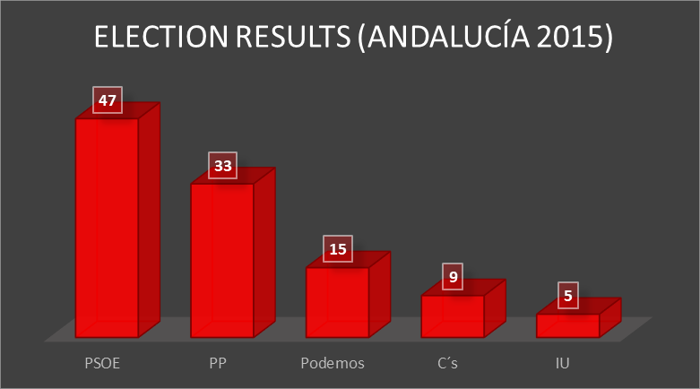
Figure 1: Election results breakdown (Andalucía 2015)
Based in these data, the global distribution of weighted seats is:

$$PSOE: \frac{153585578}{3782789}≈40.60, PP: \frac{115994312}{3782789}≈30.66,$$
$$Podemos: \frac{64311199}{3782789}≈17.001, Ciudadanos: \frac{40219692}{3782789}≈10.63,$$
$$IU: \frac{29858043}{3782789}≈7.89, UPyD: \frac{491481}{222517}≈2.21$$
Figure 2 shows the comparison of the two methods.
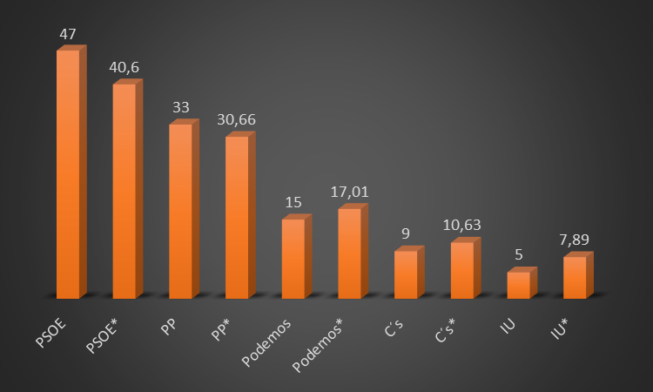
Figure 2: Comparison of the two methods (Andalucía 2015)
With the distribution of seats given in Rodrigo and Lopez (2016), we identify the i,j such that m_ij>0 to solve the Lagrange problem (3) and we obtain the following rounded share of weighted seats per constituency:
$$\{x11→4.14,x12→4.89,x13→4.58,x14→4.75,x15→4.76,x16→4.94,x17→5.19,x18→7.35,$$
$$x21→4.57,x22→3.57,x23→3.37,x24→4.01,x25→2.96,x26→3.25,x27→4.78,x28→4.13,$$
$$x31→1.47,x32→2.95,x33→1.69,x34→1.99,x35→1.61,x36→1.365,x37→2.63,x38→3.29,$$
$$x41→1.23,x42→1.57,x43→1.03,x44→1.36,x45→0.89,x46→0.73,x47→2.002,x48→1.81,$$
$$x51→0.58,x52→0.97,x53→1.33,x54→0.88,x55→0.77,x56→0.71,x57→1.22,x58→1.41,$$
$$x62→1.04,x67→1.17\}$$

The error with respect to the Gallagher index is approximately $1.41$. This is lower than the $≈36$-error of the integer allocation of sets of Rodrigo and Lopez (2016).
Remarks:
1) The global allocation of seats given by our method does not change the results of the elections with respect to the real situation: a coalition between PP and Ciudadanos would not have defeated to the PSOE party as in the allocation made by the D’Hont method.
2) Despite that UPyD did not obtain seats with D’Hondt law, we have included it into our discussion because we have applied the integer distribution of seats performed in Rodrigo and Lopez (2016) for which UPyD gained seats.
Cataluña 2017
The elections of 2017 in Cataluña were critical because of the delicate situation of the region. There were several parties that wished the separation of Cataluña from the rest of the state. The political situation was: three independence parties; JuntsxCat (right wing), ERC (left wing) and CUP (extreme left wing), three constitutionalist parties; C’s (center-right wing), PSC (center-left wing) and PP (right wing) and an equidistant party; CatComu-Podem (left wing). The data and the results of the election were (Figure 3):
$P=7$, $R=4$, $m=135$, $m_{1}=85$, $m_{2}=17$, $m_{3}=15$, $m_{4}=18$, $v=4307761$, $v_{1}=1109732$, $v_{2}=948233$, $v_{3}=935861$, $v_{4}=606659$, $v_{5}=326360$, $v_{6}=195246$, $v_{7}=185670$ .
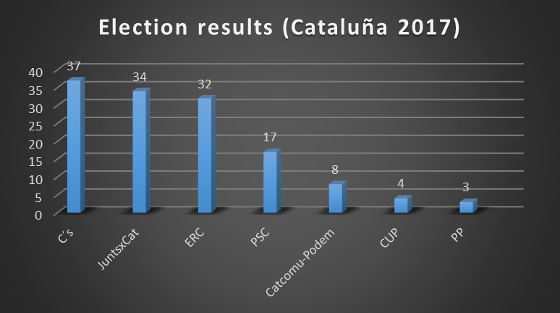
Figure 3: Election results breakdown (Cataluña 2017)
Where the four constituencies were (in alphabetical order by initial): Barcelona, Lleida, Girona, Tarragona.
So, the global distribution of weighted seats is:
$$C^{'}s: \frac{1109732}{4307761}135≈34.78, JuntsxCat: \frac{948233}{4307761}135≈29.72,$$
$$ERC: \frac{935861}{4307761}135≈29.33, PSC: \frac{606659}{4307761}135≈19.01,$$
$$CatComu-Podem: \frac{326360}{4307761}135≈10.23, CUP: \frac{195246}{4307761}135≈6.12,$$
$$PP: \frac{185670}{4307761}135≈5.82$$
With respect to the allocation with the D’Hondt method, our distribution penalizes the three parties with more votes and benefit to the other parties (see Figure 4).
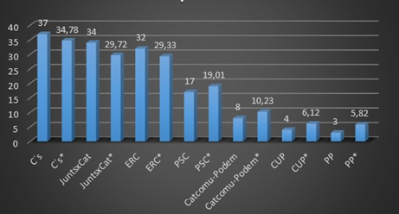
Figure 4: Comparison of the two methods (Cataluña 2017)
We identify the $i, j$ such that $m_{ij}>0$ to solve the Lagrange problem (3) and we have obtained the following rounded share of weighted seats per constituency:
$$\{x11→22.67,x12→3.71,x13→3.38,x14→5.02,$$
$$x21→15.51,x22→5.93,x23→5.01,x24→3.26,$$
$$x31→17.25,x32→3.67,x33→4.45,x34→3.95,$$
$$x41→12.89,x42→1.81,x43→2.15,x44→2.15,$$
$$x51→8.16,x54→2.06,$$
$$x61→4.23,x62→1.885,$$
$$x71→4.27,x74→1.54\}$$
The error with respect to Gallagher index is $7.53$. This is higher than the error with respect to Gallagher index of the former example.
Remark: the global allocation of seats given by our method does not change the results of the elections with respect to the real situation except for a (improbable) coalition between all the constitutionalist parties. As an example, a coalition with Ciudadanos, PSC and PP would have an aggregated of $59.61$ seats, lower than the $65.17$ seats of a coalition with $JuntsxCat$, $ERC$ and $CUP$.
Spain 2016
In the previous examples there is no change of situation with respect to the current one if we apply weights to allocate the seats. This could be due to the small number of seats to allocate in the case of the elections in Cataluña. For the big size of one constituency (Barcelona) with respect to the other ones, however, the situation is comparable to a unique administration. This situation may change in a general election in Spain.
A Spanish general election was held on Jun.26 2016 to elect the 12th Cortes Generales del Reino de España. All 350 seats in the Congress of Deputies were up for election within 19 constituencies (17 autonomic communities and 2 autonomic cities) in Spain. As a result, 9 of the parties obtained at least one seat out of 350. The distribution of seats with the D’Hondt method was shown in Figure 5:

Figure 5: Election results breakdown (Spain 2016)
The data of the election, where the constituencies are sorted by alphabetical order, were (see http://www.infoelectoral.mir.es/infoelectoral/min/ for more details):
$P=9$, $R=52$, $m=350$, $m_{1}=6$, $m_{2}=9$, $m_{3}=6$ $m_{4}=7$, $m_{5}=5$, $m_{6}=5$, $m_{7}=11$, $m_{8}=12$, $m_{9}=3$, $m_{10}=3$, $m_{11}=7$, $m_{12}=8$, $m_{13}=8$, $m_{14}=4$, $m_{15}=8$, $m_{16}=6$, $m_{17}=8$, $m_{18}=7$, $m_{19}=5$, $m_{20}=4$, $m_{21}=5$, $m_{22}=3$, $m_{23}=3$, $m_{24}=6$, $m_{25}=3$, $m_{26}=4$, $m_{27}=4$ $m_{28}=3$, $m_{29}=4$, $m_{30}=3$, $m_{31}=2$, $m_{32}=5$, $m_{33}=3$, $m_{34}=31$, $m_{35}=6$ $m_{36}=4$, $m_{37}=6$, $m_{38}=6$,$m_{39}=4$, $m_{40}=8$, $m_{41}=4$, $m_{42}=4$, $m_{43}=7$, $m_{44}=4$, $m_{45}=36$, $m_{46}=10$, $m_{47}=12$, $m_{48}=5$, $m_{49}=16$, $m_{50}=5$, $m_{51}=1$, $m_{52}=1$, $v= 23279892$, $v_{1}=7941236$, $v_{2}=5443846$, $v_{3}=5087538$, $v_{4}=3141570$, $v_{5}=632234$, $v_{6}=483488$, $v_{7}=287014$, $v_{8}=184713$, $v_{9}=78253$
So, the global distribution of weighted seats is:
$$PP: \frac{7941236}{23279892}350≈119.39, PSOE: \frac{5443846}{23279892}350≈81.85,$$
$$Unidos Podemos: \frac{5087538}{23279892}350≈76.49, { C}^{'}s: \frac{3141570}{23279892}350≈47.23,$$
$$ERC–CatSí: \frac{632234}{23279892}350≈9.51, CDC: \frac{853102}{23279892}350≈7.27,$$
$$PNV: \frac{287014}{23279892}350≈4.32, EH Bildu: \frac{184713}{23279892}350≈2.78,$$
$$CC: \frac{78253}{23279892}350≈1.18$$
With respect to the allocation with the D’Hondt method, our distribution punishes two parties with more votes, especially to the $PP$, and benefit to the other generalist parties, especially to C’s. Surprisingly, our method does not specially penalize the local parties that concentrate their votes in small regions (see Figure 6).

Figure 6: Comparison of the two methods (Spain 2016)

6. Discussion and Conclusions
In countries with proportional electoral systems such as the D’Hondt Law, there is a discontent of certain minority parties of state implementation. It is because in the integer rounding, these parties often lose seats in the different constituencies; hence were often cast to disadvantage in the global settings.
This paper presents a system that improves these disproportionalities by not rounding to integer number of seats but considering the weighted seats. This proposal minimizes the overall error and when the distribution is made by constituencies, it also minimizes the deviation from the perfect proportionality, according to the Gallagher index.
A remarkable fact is that every system of allocation of seats has been associated with a measure of disproportionality that is minimized by the said system. The Gallagher index is the measure of disproportionality associated to the Hare quotient. We are confident to believe that the Hare quotient is the fairest system, so we have chosen the Gallagher index as objective function to minimize.
This proposal has been applied to different examples of elections in Spain over recent years. The examples show that the nationalist parties (parties that concentrate their votes in few constituencies) are not specially benefited by the D’Hondt law with respect to our proposal. Despite this, we note that the small parties, with implantation in all the constituencies, are punished by D’Hondt law via the presented method. As an example, PACMA obtained 284848 votes in the Spanish elections of 2016 and a quota about $4.13$, but 0 seats with the D’Hondt. With our proposal it would have obtained $4.13$ seats.
The method has been proven as effective in assigning fairer distribution of seats, because there is less lack of proportionality and therefore less damage to small parties.
As an example, taking the constituency Andalucía (see section 5), we can easily judge that the variance has been reduced since intuitively the seats are distributed more evenly to the parties.
Despite that this method could minimize the variance or disproportions involved in the seats allocation, there are two negative effects that must be analyzed in future works. These effects are:
• The results obtained by our proposal would surely increase the bias of the electoral system.
• In this research, every party was treated without any discriminant. That is to say, every constituency has the same probability to vote for any party. Actually, it was not always such a thing. Some party is unique in a certain constituency and only this constituency would exclusively vote for it. In this way, the conditions are actually not evenly distributed for every constituency. The results will surely have some bias. Therefore, an evaluation standard to judge the trade-off is required to deal with specific issues.

Referencias
- Brambor T., Clark W.R. and Golder M. Understanding Interaction Models: Improving Empirical Analyses. Political Analysis, 14 (1), 63-82, 2006.
- Colomer J.M. Cómo votamos. Los sistemas electorales del mundo: pasado, presente y futuro, Gedisa, Barcelona, 2004.
- Gallagher, M. Proportionality, disproportionality and electoral systems. Electoral Studies, 10 (1), 33-51, 1991.
- Norris, P. Choosing Electoral Systems: Proportional, Majoritarian and Mixed Systems, International Political Science Review, 18 (3), 297-312, 1997.
- Reid, M. Applying Proportional Representation (PR) through a Regional Weighted Voting System, https://www.ourcommons.ca/Content/Committee/421/ERRE/Brief/BR8474581/br-external/ReidMarilyn-e.pdf, 2018
- Rodrigo J., López M. Una propuesta de fórmula electoral matemáticamente justa, Pensamiento Matemático, VII (1), 2017.
- Web page of the Spanish electoral results:
www.infoelectoral.mir.es/infoelectoral/min / .

Sobre el/los autor/es:
Nombre: Javier Rodrigo Hitos
Correo Electrónico: jrodrigo@comillas.edu
Institución: Universidad Pontificia Comillas

Nombre: Mariló López González
Correo Electrónico: marilo.lopez@upm.es
Institución: Universidad Politécnica de Madrid

Nombre: Chang Liu.
Correo Electrónico: changl3@illinois.edu
Institución: Dartmouth College. USA

