

TRABAJO FIN DE GRADO

UNIVERSIDAD PONTIFICIA COMILLAS

EDUCACIÓN INFANTIL

Curso: 2019/2020

Candela Guitart Igea
Directora: María Mercedes Pérez Agustín
Grado en Educación Primaria y Educación Infantil
Universidad Pontificia Comillas

“PROPUESTA INNOVADORA DEL USO DE LOS ÁLBUMES ILUSTRADOS PARA LA ENSEÑANZA DEL INGLÉS Y LA EDUCACIÓN INCLUSIVA”

EDUCACIÓN INFANTIL

ÁREA DE INGLÉS

CANDELA GUITART IGEA
Directora: María Mercedes Pérez Agustín

To Carolina, my niece. I wish that these books can help you and other children to understand how diverse and wonderful this world is.

Thank you Mercedes for your marvelous guidance.
Thank you Mom and Dad for making me understand the value of being different and for filling my childhood with wonderful stories.

INDEX
1. RESUMEN 4
1. ABSTRACT 5
2. INTRODUCTION AND JUSTIFICATION OF THE TOPIC 6
3. OBJECTIVES 8
4. THEORETICAL FRAMEWORK 9
4.1 The Importance of Teaching and Learning English in Infant Education 9
4.2.1 Storytelling and Picture Books 11
4.2.2.1 Benefits of Storytelling and Picture Books in the Second Language Teaching and Learning Acquisition 13
4.2.3 The Importance of Using Storytelling Techniques 18
4.3 The Role of Inclusion and Diversity in the Classroom. 19
4.3.1 Inclusion and Attention to Diversity in Spanish Legislation 19
4.3.2 The value of Inclusive Education 21
4.3.3 The Advantages of Storytelling and Picture Books for Inclusive Environments 23
4.3.4 The selection of Inclusive Picture Books 24
5. INNOVATION PROPOSAL 25
A. Proposal Presentation 25
B. Specific Objectives of the Proposal 27
C. Context in Which the Proposal Could be Developed 27
D. Methodology and Resources 30
E. Activities/Sessions 32
Lesson One: Welcome to Storyville! (This is How We Do It) 34
Lesson 2: Boys and Girls (Jamie is Jamie) 37
Lesson 3: Different I love You (My Brother Charlie) 39
Lesson 4: There is Room for Everybody (The Big Umbrella) 41
Lesson 5: Our Own Pet Club (Strictly No Elephants) 43
Lesson 6: Following Dreams (Emmanuel’s Dream) 45
Lesson 7: Which Color are You (Red a Crayon’s story) 48
Lesson 8: Everybody is Welcomed in our Classroom (All are Welcome) 50
Lesson 9: Our Own Story (Storytelling Workshop) 52
F. Chronogram to Apply the Proposal 54
G. Proposal Evaluation 55
6. CONCLUSIONS 59
7. REFERENCES 61
8. ANNEXES 65

RESUMEN

Este trabajo de fin de grado se fundamenta en una propuesta de innovación para la enseñanza del inglés a través del storytelling y especialmente los álbumes ilustrados. Además, se pretende combinar la enseñanza del inglés con la transmisión de valores inclusivos relacionados con los siguientes aspectos: multiculturalidad, discapacidades, igualdad, diversidad, etc.

Se han escogido ocho álbumes ilustrados para guiar ocho de las nueve lecciones que conforman la propuesta. Cada uno de ellos trata un tema inclusivo diferente y además dan pie a trabajar diversos contenidos de inglés apropiados para la etapa de infantil. Las actividades que se han diseñado cuentan con metodologías y recursos que las hacen innovadoras y significativas. El curso escogido para desarrollar la propuesta ha sido el tercer año de educación infantil (5 años) pero puede ser aplicado en diferentes ámbitos y para públicos de diversa índole.

Para fundamentar la propuesta se ha realizado un estudio conciso sobre los temas principales que se tratan en el trabajo por medio de: teorías de autores expertos en el tema, investigaciones previas, publicaciones, artículos de revistas y la ley española. Los tres temas principales son: la enseñanza del inglés; el storytelling, los álbumes ilustrados y sus beneficios; la inclusión y la relación que guardan todos ellos entre sí.

Palabras Clave: Inglés, Álbumes Ilustrados, Storytelling, Inclusión y Educación Infantil.

ABSTRACT

This final degree essay is based on an innovative proposal to teach English through storytelling and especially picture books. In addition, the aim is to combine teaching English with the transmission of inclusive values related to the following aspects: multiculturalism, disabilities, equality, diversity, etc.

Eight picture books have been chosen to guide eight of the nine lessons that make up the proposal. Each of them deals with a different inclusive topic and also gives raise to various English contents suitable for the children’s age. The activities that have been designed have methodologies and resources that make them innovative and meaningful. The grade chosen to develop the proposal is the third year of pre-school education (5 year old children) but can be applied in different fields and for different audiences.

To substantiate the proposal, a concise study has been carried out on the main topics dealt with in the project, meaning: theories of authors with expertise in the subjects, previous research, publications, journal articles and the Spanish law. The three main themes are: teaching English; storytelling; picture books and their benefits; inclusion and the relationship between all of them.

Key Words: English, Picture Books, Storytelling, Inclusion and Infant education.

2. INTRODUCTION AND JUSTIFICATION OF THE TOPIC

“Storytelling is the most powerful way to put ideas into the world” (Robert Mckee).

This project is based on the desire to bring back all the best aspects of storytelling and picture books to the English classroom. There will be a few points made in relation to how the benefits of both of them affect English teaching education. This topic has been chosen because of the importance that stories should play in the life of young children and their development. According to Puchta (2015): “Stories are important because they allow us to simulate intense experiences without actually having to live through them. They teach us lessons that help us to survive and make sense of the word. They also help us in a social sense. By identifying with protagonists, children experience things as if they really happened to them. They learn right and wrong, and they learn to put themselves in other people’s shoes (p.1). To ensure that this project has value there will be some previous investigations about the diverse topics throughout the theoretical framework to provide backup.

First of all, since this is an innovation project specifically thought for an English learning and acquisition process, a few arguments about how this language can be a turning point in our infant students life will be discussed. As well as these arguments, it is necessary to expose different points of view from diverse authors that will set an example on how to teach English to young learners properly taking into account the advantages and challenges that it entails.

Another main element of this study is inclusion and the role that it plays nowadays in children education. This will be introduced through a series of books that deal with the subject from different perspectives. In an article of Open Society Foundations (2019, p.1) the value of this is set in the following paragraph: “Inclusive systems provide a better quality education for all children and are instrumental in changing discriminatory attitudes. Schools provide the context for a child’s first relationship with the world outside their families, enabling the development of social relationships and interactions. Respect and understanding grow when students of diverse abilities and backgrounds play, socialize, and learn together”.
What underpins this innovation project is the intention to bring all of the above together and create a proposal that can be applied in a class or any educative environment. This proposal will be based on the uses of storytelling and picture books which will be listed below. Storytelling allows teachers to explain content in an attractive way and this can lead the student to develop active listening, it also stimulates their creativity and encourages their motivation by presenting characters with similar life experiences or characteristics. Furthermore, it helps to approach more easily difficult topics such as immigration and empathy. In addition, it is beneficial for group work and it helps to create a special bond between the teacher and the students (Educación 3.0, 2019).

On the other hand, picture books, as a recent tool to introduce storytelling in the classroom, have some different uses and these are a few of them. Children understand the story without necessarily having the skill of reading; in order for them to understand the illustrations they need the presence of an adult so they associate the moment of reading with a special moment of bonding; if there is any text on the picture book the child will ask naturally about it and this creates an opportunity for the adult to introduce learning; finally if there is no text, imagination and creativity will guide the students to invent a story through the illustrations (Moncada, 2018).

It is well known that neither of the previous topics, English, storytelling, picture books or inclusion are innovative or rare subjects nowadays, but what it is really an innovation is to see them work together to develop proposals whose main goal is to create an atmosphere of respect and appreciation of every single aspect that makes us different and valuable. Therefore, this objective will guide the project and will be kept in mind when selecting the different resources.

In conclusion this innovation project pretends to establish some strategies that will make stories, picture books, drama, and other forms of storytelling attractive again for children and also for teachers. In order to achieve this, we have selected an important value to society such as inclusion and others that arise from it, so we are not only educating their minds but also their souls. Stories should play a key role in the life of every child of this era and also in their English learning process.

3. OBJECTIVES
The objectives of this project can be divided into general and specific. The general objectives describe the importance that storytelling and picture books should have in second language teaching. They also describe how to introduce inclusive values in the classroom through them. Moreover, the specific objectives are related with the pursuit of different proposals and activities developed for this project.

General Objective
The general objective of the innovative proposal is to connect storytelling and picture books to teach English and instill inclusive values in the classroom.

Specific Objectives
We now enumerate the specific objectives that will be carried out in the proposal.

-To present a selection of books that have an inclusive theme and are used to transmit contents related to the foreign language teaching: English in the Early childhood stage

-To establish a background on previous research that allows to develop truly innovative proposals based on successful applications.

-Apply the benefits of storytelling and picture books extracted from grounded theories through activities specifically created for this project.

4. THEORETICAL FRAMEWORK
Through the theoretical framework we will cover the different points that will be addressed in this project and are as follows: storytelling and picture books, the benefits of both of them in English teaching, the role of inclusion in the classroom and some previous research on the subject.

4.1 The Importance of Teaching and Learning English in Infant Education

Nowadays English is taking a very important role in our students education. Some parents now start to speak to their children in English since they are very young, which was not very common a few years ago and also at schools there is an increase of subjects that are thought exclusively in this language, such as: Natural Science, Social Science, Arts and Crafts, etc. The importance of this language also comes from the fact that it is a lingua franca. Rodriguez (2012) explains that English became a lingua franca firstly because of the wide expansion and immigration of the English civilization throughout history and then because it was the chosen language to be used in several areas such as: international politics, commercial trades, international films, science, popular songs, etc. In infant education is taking place slowly and sometimes it can be tricky to find a specific time to introduce English in the class since there are not defined subjects. However, it is very important that English finds its place in the students process of learning, since it has a great impact on them. In this section there will be arguments made about why it is important and also about the advantages and challenges that can be encountered when teaching English to young learners.

Moon (2005) talks about why it is better to teach English to young learners and also about some difficulties that can appear during the process. It is said that there is a specific time when children are very young that is the best time for them to learn a language; starting early also means more time of English overall during the child’s life so they have time to refine and improve it and it also puts them ahead of those who did not start that young; the third reason to start learning English as soon as possible is because of the meaning that this language has globally and the opportunities it can offer.

In spite of the advantages that this has there are also some challenges that can appear along the way. Young learners can be bored very easily because they are still learning to regulate themselves and this can make difficult for teachers the task of catching attention. Children need to understand what they are doing in every situation and also make sense of it, in a situation in which their usual language changes they will be more focused on understanding what is going on that in learning the language itself. Young learners are proved to learn more easily through experiences or activities that require their participation, for example if they are making a craft and the teacher gives the instructions in English they may not realize that they are, in a way, learning vocabulary or grammar structures but by repeating this mechanism over and over they will slowly acquire the language. This can make their learning process longer than adults or teenager’s process because this latter group can learn both analytically and experimentally (Moon, 2005).

Are these enough reasons to give up on the task of teaching English to young learners? According to Moon (2005) the answer is no and to overcome these challenges she offers the following benefits and advices. The key to be successful when teaching English to young learners can be found in the teachers, who should set realistic goals for their students taking into account their age and cognitive capacity; they should also be fluent and have a wide knowledge in English, foreign language pedagogy and children’s overall development. The methodology and assessment should be revised too. Methodology should be based on activities that demand the participation of the students, it should be contextualized with strong oral emphasis at the beginning, etc. Assessment needs to be developmental and take into account the progression of the children rather than only the final results. Having taken care of all the previous aspects the author provides a series of benefits that will make this whole experience worth it. Children’s confidence and motivation towards the language will increase; it can expand children cultural knowledge and horizons; it can improve the understanding of the own language and finally, it develops learning strategies.

To complement Moon theories, Álvarez (2010) states that learning a second language in the early years of childhood is indeed beneficial. It is said that it is in these years when the brain of the children is developing and establishing connections between the different neurons. Besides that fact, children also learn faster and easily when learning two languages at the same time, the native one and English in this case. That is because when learning a second language, creativity, mind flexibility and critical thinking, improve.

4.2.1 Storytelling and Picture Books

As a response to the importance of English as a Second Language, picture books and storytelling are a very suitable resource specially for students at early stages.
Storytelling should be described as the oldest form of teaching the world has known. Even in prehistoric times walls on the caves were used by men and women to tell stories that last until this day and thanks to that we are able to learn about their customs and habits. Jesus used parables to teach his disciples. Stories have been really important in the education process of all the different generations and the ways of telling them has evolved and changed but never disappeared. We will now see the main requirements for a successful storytelling which main aims are to entertain and to teach an audience.

The Oxford Cambridge Dictionary defines “storytelling” as the act of writing, telling or reading stories and “picture book” as a book, specially for young children, that has a lot of images and not many words. Storytelling is defined according to Aparicio & Pérez (2019, p.1) as “the ability to tell a story using a dramatized body language, so that the audience feels involved in the narration. It is also known as the art of telling stories, which had its heyday a really long time ago to entertain and educate members of each community”. In the same vein, Vieira (2019, p.1) states that “storytelling is the art of telling, developing and adapting stories using specific elements such as characters, atmosphere, conflict and message in events that have a beginning, knot and ending. All of these are used in order to convey an unforgettable message to connect with the reader on an emotional level”.

In his article he also enumerates the essential elements of storytelling and this are the following. The first element is a powerful message, according to Vieira (2019, p.1) “the art of storytelling has two parts, the “story” (the message and the story that will be transmitted) and the “telling” (the way in which this message will be presented)”. If the message is strong it can have an effect even if the way of presenting it is not very good and it is the key factor that can make a difference in the listener’s life. The second element is the setting, the events have to take place in a location and if this is well described it can facilitate the listeners to be actually transported to it. The third element is the character, those who suffer the consequences of the story and are transformed by it. The fourth and final element is the conflict, without which the characters would not suffer any transformation. The latter is the main factor of interest for the audience, it is presented as a challenge that motivates the character to make a trip and it does not have to be of simple resolution since then it does not generate identification. The last of the points that the author of this article reflects on is whether every storytelling consists of using narration. The answer to this question is no, there is no need to link narration with storytelling. The idea of “show don’t tell” is a clear example of this, since the necessary elements are integrated but there is no narrative.

One of the many ways of storytelling are picture books. The first picture book ever written was Millions of Cats by Wanda Gag, but there are other examples of this era such as: Where do Monsters Live? by Sendak and Babar by Brunhoff. These are stories that have text and illustrations but these last ones have more protagonism. In this kind of books the reader needs to do a visual reading, which means that it is needed to interpret the story by not only what is written in the text but more importantly by what the illustrations transmit. (Arteneo, 2015).

As exposed in Sallybooks (2019) the characteristics of the picture books are as varied as picture books exists, but there are some common aspects among them. A picture book must have illustrations, they can also present an independent, parallel or complementary text that gives coherence to the pictures but they are not fundamental for the illustrations to tell a story by themselves. The third essential element is the communicative character that illustrations must have in order to transmit a message.

The illustrated albums topics can be various, they can be related to everyday aspects of children’s lives (family, school, friends, etc) or more complicated issues such as death. The student’s cognitive stage tends to be taken into account when selecting the illustrations or the text so they are appropriate for the audience age.

It is crucial to distinguish between books with pictures and picture books , since in the former one the text remains protagonist and in the latter the main aspect is always the illustration or image and there is no need for text.

4.2.2.1 Benefits of Storytelling and Picture Books in the Second Language Teaching and Learning Acquisition

This section is a continuation of the benefits of storytelling and picture books but in this part they will be related to the second language teaching and acquisition. Some of the benefits of storytelling when teaching the foreign language are the following ones: the oral skills needed to carry it out develop the acquisition of vocabulary, it improves the articulation of language, hearing perception and skills in all literacies. Listening to stories also helps to develop child awareness and language musicality as well to acquire communication strategies (Collins & Cooper, 1997). According to Tobias (2008):

“Listening to and telling stories develops an awareness of the rhythm and music
of language which in turn leads to higher skills. The oral skills of vocabulary
development, expressive language articulate speech, auditory perception and
competencies in all literacies are important for the developing child”. (p.4)

Stories can provide a very motivating, attractive and realistic source of linguistic interaction in the classroom. They are “living language” in which the teacher (or storyteller) becomes the source of language, and listeners actively participate in understanding (Morgan and Rinvolucri, 1983).

Here are some of the most important points of storytelling according to Ellis and Brewster (1991). The stories serve to acquire new vocabulary; through them can motivate, amuse and develop attitudes favorable to the learning of the foreign language; it exercises the imagination; fosters a collaborative exchange of feelings and emotions that apart from being enjoyed by the children helps them to have more confidence, courage and emotional resources; finally telling stories is useful to focus development on children.

Rezende (2011) states that storytelling is one of the most effective ways to carry out language teaching compared to traditional methods that are carried out through textbooks. Storytelling works with language skills in a fun, close-knit and contextualized way, which makes students more interested in hearing stories, reading them, writing them or talking about them (Atta-Alla, 2012). It is also said to be more meaningful for students when it comes to learning and retaining vocabulary, grammatical structures or good pronunciation.

As storytelling benefits in second language teaching and acquisition have been set, picture books benefits will be explained in this next part. These are general benefits but they can also be applied to second language teaching and acquisition. According to Velez (2019) picture books foster a taste for reading long before the child acquires reading skills; they leave more room for imagination than stories with text; they produce great astonishment and enthusiasm in readers; having only illustrations, students have to pay more attention and this produces a great capacity for concentration and observation; it promotes the autonomy of the child; they also leave a great deal of room to interpret, suppose or feel what is happening in the story and so the teacher can observe what emotions each student presents; it creates a fantastic opportunity to establish a moment of conversation and finally, if we let them tell the story, we can lead to the development of language skills and an increase of vocabulary.

Other benefits of picture books according to Tay (2016) are as follows. The first of these is that picture books without text help children understand and explore stories from different perspectives, because the small details of the illustrations, which an adult reader may not notice, allow them to give shape to a multitude of possible scenarios. The second benefit is that in absence of text, students must use the vocabulary obtained through previous readings to give shape and coherence to the story. The third one is that a good sequencing of the illustrations makes it easier for the student to understand better the fundamental parts of the story: beginning, knot and ending. The fourth benefit is that picture books encourage students to direct their narrative skills towards a productive goal, such as creating a story. The last of all is that by eliminating the constraining elements of a book with text students give vent to their creative thinking.

Picture books can be used as a tool to introduce certain values in the classroom and one of the goals of this project is to transmit inclusive values to children. Cengiz & Duran (2017) affirm that tale books and stories are two of the best ways for children to gain values. The presence of children as characters in this form of storytelling make it easier for students to connect with the message of the story and also creates an effective connection between the fictional and real world. The fact that they are reading about a character in third person gives them perspective and they understand better what they go through, this facilitates the task of applying the different values that the character acquires in the story to their own life, given that now they have meaning and context.

These two authors Cengiz & Duran (2017) carried out a research study where they tried to find out which values appeared in the favorite tale books of students, parents and teachers. To narrow it down they selected a series of lists with values from UNESCO, Rokeach value classification and Living values’ list. Some of the values on those lists are: happiness, peace, honesty, tolerance, collaboration, humbleness, freedom, respect, compassion, friendship, kindship, aesthetics, etc. The results based on the preferences of books selected by the surveyed showed that the values that were more emphasized are: aesthetics, happiness, kindness, friendship, compassion and cleanliness. On the other hand, values such as: respect, humbleness, honesty, hospitality, peace, collaboration and tolerance didn’t appear as much. These last values are essential for students to learn how to be part of society, so what is pursued with this project is to give them more relevance by presenting books that enhance them more.

4.2.2.2 The multiple advantages of picture books and storytelling in education.

Once benefits of picture books and storytelling have been presented, we can discuss how these have affected education in real life situations.
In order to provide substance to this study it is necessary to learn from previous research made about the topic. Advantages, disadvantages, successful and unsuccessful results should be discussed in this part of the theoretical framework so they can be avoided or applied to our own proposals if necessary.
A research about how a group of Chinese children respond to bilingual books and how biliteracy is developed, by Hu, Chen & Li (2012), showed the following results that can support the intentions of this project. By reading about multicultural issues on the books, children acquire certain awareness about the diversity that exists on the world and society, and when they read about their own culture and language, they see themselves represented which motivates them to keep learning. This discovery supports the objective on this project of introducing inclusion values through storytelling and picture books, given that understanding and caring for multiculturalism is a big part of it. Another of the results was that by learning through bilingual Chinese/English picture books, children became more engaged and showed more interest in the subject of English than in the past. Teachers asked for the participation and feedback of the students while reading, which lead them to share their opinions and thoughts starting meaningful conversations that made them learn. One example of this affirmation could be a discussion between two children where they talked about how everyone is different and friendship. The participants also enjoyed creating their own stories which immediately starts an opportunity for them to introduce new vocabulary and grammar structures of the other language in a fun and engaging way. It also favors students to discover some talents that they didn’t have the opportunity of showing before.

Picture books can not only introduce inclusive values as mentioned in the last paragraph, it can be used as a tool to create an inclusive environment in the classroom. A research by Calvo & Tabernero (2015) that studied the effect of picture books on students with Autism Spectrum Disorder (ASD) talks about the following aspects that can be useful. In their article they mention a few well known authors such as Bruner (2002) and Petit (2001) who confirm through different studies that literature and narrative can be a means of getting to know yourself and others and also as an integration in the community weapon. The researchers took into account the fact that children with ASD tend to like activities that involve images, so picture books are the most suitable resource. They gathered information through journals of the teachers who worked with the students, transcriptions of the conversations that took place in the reading sessions and written bits of the children. The information collected after reading Sendak’s picture book Where Do Monsters Live showed that students were more eager to write about the experience of reading than usually with other type of activities where the teacher needs to give verbal reinforcement. When reading picture book Little Bear the teachers explained that reading this type of books first motivates the ASD students to read more complicated books that include text, they start a taste for reading. This research shows how picture books work as a way of introducing children with special educational needs into an English classroom through an activity as simple as reading.

O’Neill (2008) is another author that through her own study proved how much difference storytelling can make in education, not only for students but also for teachers. She noticed that the methods that were being used to promote integration in early childhood classrooms were unsuccessful, so she decided to give storytelling a chance. It was proven that storytelling created a perfect environment for every student to participate in an activity that involved the whole group. It promoted the integration of special needs children as well which did not happen with other type of activities. Finally, she discovered that teachers changed their teaching techniques, from those that were more traditional and not so motivating to the ones that took into account storytelling and drama aspects, therefore it became engaging and gave a chance to interaction.

Until now all of the previous arguments supporting storytelling and picture books were made from a spectator perspective. In a research by Del Moral, Neira & Villalustre (2016) a digital storytelling project called CINEMA was used to bring storytelling to rural schools. In this process the students were supposed to create their own storytelling in a collaborative way. To carry out the investigation a collection of books were selected, all related to specific and important topics such as: feelings, emotions, conflict resolution, self-improvement, creativity and confidence. Students were supposed to take those books as an example and developed their own digital story. The researchers found out that by using this tool children acquired in most cases a high level of social skills and also they improved their creativity abilities. The participants were also able to identify and solve problems as a group, apply different languages in their creation process and adapt to new situations. This shows that storytelling is not only useful for students when they are acting as listeners but also creating it helps them to be a part of their own learning process.

To conclude with this section Yüksel (2011) made some good points in his study about how digital storytelling in early childhood education affected teaching. In this study a digital storytelling workshop was organised in order to find out how it affected the teaching process of the teachers in this stage. Some perspectives of different authors were acknowledged by the researcher, such as Vygotsky’s social constructivist theory in which learning is seen as a social activity and students should be involved in the whole process and not only a small part of it. What it is interesting about this specific study is that the surveyed were teachers of different ages and what is pursued is their vision on taking digital storytelling into their practice. What they had to say about this experience was that storytelling facilitates discussing general daily problems with students; it also lets students experience success; it can affect misbehaviour in a good way and of course in this scenario it moved them to learn more about digital techniques. Yüksel had a great impact through his study by showing how much good storytelling can bring into a classroom and how it can change a teacher’s work by making it entertaining, motivating and interactive.

4.2.3 The Importance of Using Storytelling Techniques
Taking into account the multiple benefits and advantages of storytelling through picture books we present the requirements to tell a story to be successful, some of these are explained by Ellis and Brewster (2014). They presented the following steps to make the process of lesson planning with storytelling easier on teachers.

-Setting a specific environment is really important. Storytelling should take place in a calmed space where students can gather together next to the teacher, preferably in a semicircle so everyone can see and listen properly to the storyteller.

-The teacher should prepare and practice the story beforehand so it is possible to establish eye contact and conversation through different questions with the children. This keeps them focused and engaged. It is also good to practice out loud reading, pauses, comments on illustrations and meaning of unknown words students may have doubts on.

-When storytelling is taking place in a different language, students tend to get lost or pay too much attention to the language and not so much to the story or the message, that is why sometimes visual or audio support should be used. Some elements that can be used as visual support are: masks, puppets, flashcards, games, moveable pictures, real objects or speech bubbles. On the other hand, we also can use songs or videos as audio support.

As seen in the previous investigation section there are multiple ways in which storytelling and picture books can be used in classroom activities. Storytelling offers a great deal of possibilities, like for example dramatizing a book, students creating their own story, using the technological advances with digital storytelling, students drawing their own picture book, etc. The teacher can also lead these type of activities or students may take over. There are a multiple variants but this will be developed in depth through our own proposals in the lesson part of this research.

4.3 The Role of Inclusion and Diversity in the Classroom.

4.3.1 Inclusion and Attention to Diversity in Spanish Legislation
As we said in the previous sections one of the main advantages of picture books is the importance of values. It is a perfect response for the role of inclusion and diversity in the classroom according to the Spanish legislation.

The Organic Law, of December 9, for the improvement of Education Quality is developed from the Organic Law, of May 3, of Education. This new law builds on the second and implements some changes for its improvement. Some of these changes affect what is established in relation to inclusive education and attention to diversity.

In article one of LOMCE paragraph b) is modified, stating the following: “Equity, guaranteeing equal opportunities for the full development of the personality through education, educational inclusion, equal rights and opportunities that help overcome any discrimination and universal access to education, and acting as a compensating element for personal, cultural, economic and social inequalities, with particular attention to those resulting from any type of disability” (p.97866)

Article 8 of the Royal Decree 1630/2006 of December 29th establishing the minimum levels of education for the second cycle of early childhood education provides as follows.

- Education intervention should take into account the personal characteristics of pupils, their needs and their rhythm and maturation process.

- It is mandatory for education authorities to discover and identify any aspects that may difficulty the education process of the students. If necessary they will provide and ensure the coordination of the resources needed by these students

- Children with special educational needs should have the educational support tools that they need at school and measures should be applied in their educative centers.

- Students with special educational needs should count with a varied range of educational responses that facilitates their education process.

The community of Madrid states in Article 17 of the BOCM (Community of Madrid Official Bulletin) that educational inclusion is one of the main principles of the Madrid education system. It is established that educational inclusion affects aspects such as: organization, curriculum and attention to diversity. The last one involves the interests, motivations, individual and sociocultural circumstances of the students.

The groups of students that stand out are those with special educational needs, students with learning difficulties, students with Attention Deficit and Hyperactivity Disorder (ADHD), students with high intellectual capacities, late enrolment to the education system students or finally, students with a personal record or school history that demands special treatment.

In particular, at the infant education stage, there is a special focus on diversity, individualized care, the prevention of difficulties and the implementation of reinforcement mechanisms as soon as these difficulties are identified.

Some of the specific measures proposed for the previous mentioned groups in the community of Madrid are:

- Students with special educational needs: The curriculum will be adapted to the needs of these type of children by making modifications or adapting the necessary elements. Always taking into consideration the different learning rhythms and promoting teamwork and autonomy.

- Students with high intellectual capacities: Same as before the curriculum will be adapted to fulfill the needs that these students may have, but this time with the goal of taking their level of capacity and potential to the maximum.

- Late enrolment in the education system students: This refers to those students who have a late entry to the education system. Special measures will be applied to facilitate their educative process. These measures will take into account the circumstances that caused the late enrolment, their previous knowledge, age and background. If the measures improve their academic level they could be reinstalled in their correspondent grade.

4.3.2 The value of Inclusive Education
The law defines what groups of people are considered diverse and also offers some measures that can be applied to these groups, but the value of inclusive education goes beyond the law and it plays an important role in society. In this subsection we will try to give a definition based on its history and some arguments about why it is important to promote it.

Inclusive education was born as a way of fighting the concept of exclusion that affected certain groups of people such as people with disabilities, from different cultures or even women in some countries. It started by giving the chance of being educated in special institutions to blind, deaf or with mental deficiency students. In the 1994 World Conference about Special Educational Needs celebrated in Salamanca by UNESCO the concept of inclusive education was discussed as the right of all children to receive an education independently of their personal characteristics. This concept led to the introduction of students with special educational needs in ordinary schools. However, we need to differentiate between integration and inclusion. The first one consists on introducing children with special educational needs in an ordinary school without changing its policies or making a substantial change. On the other hand, inclusion means changing structures, systems or whatever is necessary in the school to facilitate the process of adaptation of all children.

What we would like to focus on is inclusion as a valuable factor to the education system and these are some of the advantages that it entails. Borquaye, Burque, Freeman, Grindal, Hehir and Lamoreau (2016) compiled in a report multiple benefits of inclusive education and also described the Contact Hypothesis: “a term referring to the reduction of hostility, prejudice, and discrimination between groups (e.g. non-disabled versus disabled) through increased inter-group contact (p.12)”. This hypothesis is one of the goals of the proposal, to situate students in an inclusive environment by establishing contact with not only the diversity in their life but also the one that stories in picture books describe. In the report they focus on the benefits that inclusion can have on disabled and non-disabled students through their interaction, but they can be understood as benefits of inclusion from a general perspective as well. It is said that inclusion reduces fear and increases awareness on human differences; their social cognition and self-esteem improve and students become more tolerant towards others and better communicators; their ethical principles develop and they establish caring and warm friendships. The report also mentions that inclusion can be beneficial for disabled students academically “students with disabilities who were educated in general education classes academically outperform their peers who had been educated in segregated settings (Baker, Wang, & Walberg, 1995; Katz & Mirenda, 2002. p.13)”. These benefits should be enough reason to promote inclusive education in all settings, but to make it more appealing to teachers and students, the advantages of storytelling and picture books in relation to inclusion will be discussed below.

4.3.3 The Advantages of Storytelling and Picture Books for Inclusive Environments
The previous sections describe how inclusion and diversity are considered key points in today’s education law and also what inclusive education is. It is important that we are aware of the aspects that make our students different, but we need to know how to introduce the topic of diversity and inclusion into the classroom. This project was born from the firm belief that storytelling and specially picture books can make this introduction easier on children and also teachers. There have been some points made about this topic previously in the theoretical framework, but in this part there will be some specific information on how to use picture books to create or promote an inclusive environment.

We have the point of view of different authors that claim that picture books are an excellent tool to promote inclusion among children, and not only that, they demand that the content on this type of books that approaches diversity increases. Matthew and Clow (2007) wrote about their concern on how disabled people needed to be more represented in picture books and the labor of a charity in the UK that is working on pointing out the issue of these people being invisible to writers, illustrators and publishing houses. Lobron and Selman (2007) argue that social awareness should be an important part of children education and explain how stories that emphasize issues such as racism or prejudice can help children to develop an opinion and discuss with each other about social justice. All of these authors agree that this type of books could cover a gap that exists in education nowadays and that is the need of children to learn how to treat and act respectfully towards everybody, regardless of their personal characteristics.

Earlier in the project the benefits of picture books and storytelling were exposed, one of them was the fact that children can relate their own personal experiences to the characters and what they are going through in the story. This benefit could be used to present inclusive situations and inclusive behaviour to children. Two supporters of this statement are Gavigan and Kurtts (2011) who believe that picture books that portray a respectful and meaningful relationship between children that have a disability with children who don’t, can be a good influence on students. But this doesn’t apply only to the disability aspect of diversity, it could be beneficial to present stories with children from different nationalities and with different types of family or backgrounds as protagonists who interact with the world and other people. Picture books have been described as a type of book which main element are illustrations, the latter tend to give children the opportunity to create their own interpretation of the story and therefore share them with their peers, creating a wide, enriching and diverse range of perspectives on inclusion.

4.3.4 The selection of Inclusive Picture Books
The advantages of picture books when it comes to creating an inclusive environment can be helpful when selecting a proper inclusive picture book alongside the following indications. As discussed previously, inclusion is based on accepting everybody and embracing what makes each one different from the rest, that is why we need to make a wide and diverse selection of picture books that address multiple aspects of diversity.

According to Rodríguez (2017) if the goal is to discuss diversity through picture books there is a necessity to include books with the following themes: multiculturalism (the need that the world has of it and its value); gender equality (men and women have to be equal within their condition as human beings); disabilities (physic or psychic) and other differences (this includes every difference that difficulties the introduction of a person in society). These themes discuss the reality of a world that children are part of and which they need to be aware. However, the theme selection should be meaningful for the specific group of children that we are dealing with and therefore it is recommended to choose picture books that refer personally to them. In order to make it happen the teacher or adult in charge of making the selection should pay attention to what makes special of concerns each child. For example, if we have in our group a child with visual deficiency we could find a book that describes this topic from the point of view of a character that has the same condition. This way the whole group would learn how to deal with this matter. Of course, the teacher should take measures and take into account the sensibility of the children involved so they don’t feel embarrassed or uncomfortable.

There are also other factors to take into account when selecting picture books which are: the age of the group of children; the quality of the illustrations and their connection to the text; the level of difficulty of the narrative and the possibility of the reader to establish different perspectives of the story.

5. INNOVATION PROPOSAL

Proposal Presentation

After having explained the benefits of storytelling, the importance of teaching English to young learners and the role of inclusion in today’s education a proposal has been developed in order to apply all of this to real life.
The Cambridge Dictionary defines innovation as the use of a new idea or method. Through all the information, statements and previous investigations gathered in the theoretical framework it may appear as if the following proposal is not very innovative given that storytelling is the oldest form of teaching and inclusion has been around for quite a while now. However, what is innovative about this proposal is the final goal which is to unite important values related to inclusion and English concepts of infant education and also the use that is made of storytelling, which works as a medium to carry out an English learning process in the early stage phase of education. It should also be mentioned that picture books are a quite recent genre which makes this proposal innovative by introducing them as an educative method. Tales and books have been present in the life of children for a long time but using picture books can give their perspective on reading a new meaning. They represent the changes that education is experiencing these days such as: the importance of images; the value of discussion and the participation of the children in their own learning process; the chance to elaborate different perspectives, etc. These are all chances that picture books offer and that we would like to highlight as a positive addition to education.

The proposal consists in presenting 9 lessons of English learning that will be developed using storytelling and picture books as a common thread to explain both didactic and inclusion concepts. There will be a selection of specific books and activities that have an inclusive thematic and also give the person carrying out a chance to present important aspects of a second language acquisition. These sessions have been planned taking into account the needs of those teaching and children and also making use of important tools such as technological devices and updated methods such as: peer and collaborative work, self-assessment activities, project based learning ,etc.

The intention behind this proposal as mentioned before is to create awareness of the importance of inclusion since a young age in order for children to be respectful and validate the value of diversity as early as possible so they can have more time to work on these aspects. Yet, it is not an easy task, and that is why storytelling and picture books have been selected to carry out the proposal. These are very present in the daily life of an infant and they are one of the most important ways to transmit a message and influence children from a positive perspective. The characters that appear on them can be a reflection of their own experiences, and stories create motivation and therefore interest, so concepts can be acquired more easily when listening to them.

Finally this proposal pursues the objective of making English relevant again. It feels like since the appearance of Content and Language Integrating Learning (CLIL) this has been already accomplished by changing the way of teaching and giving English a new meaning as a language that is worth teaching and learning. But at the same time English needs a push so it doesn’t disappear as a valuable thing itself and becomes merely a language to explain other subjects. This statement is not trying to diminish CLIL, since it is a huge step into the right direction when it comes to bilingual teaching, but English as a whole needs to be transformed so children feel intrigued and motivated to learn it. It is believed that storytelling and picture books can make that change possible.”Storytelling encourages the learners to continue studying the language because it affects students positively when considering its motivating role in foreign language teaching.” (Bala, 2015, p.22)

Specific Objectives of the Proposal
We now present the specific objectives of the proposal developed for children of infant education:

-To create motivating and innovative activities using storytelling and picture books in diverse ways to teach English concepts and inclusive values.

-To present and teach important aspects of diversity.

-To engage students in the learning of EFL by making them protagonist of the process.

-To establish collaborative procedures among the student by using peer work.

-To give teacher alternatives to work differently in an English class.

-To make students aware of the relevance of inclusion and diversity.

Context in Which the Proposal Could be Developed
As mentioned previously this entire study is based on the effects of storytelling and picture books on English learning on infant education but it is also focused on creating awareness of inclusion and diversity. That is why this proposal should take place in an environment where all of this is viable, where there is actual diversity. Thankfully the world we live in is becoming more diverse so the possibilities are endless when selecting a context to teach children about inclusion, and even though our minds go directly to a classroom when talking about teaching English, there is a wide range of scenarios where this proposal can be carried out, and these will be explained below.

The year selected to implement this proposal is third of infant education (5 year- old students) so there are more possibilities of action when it comes to developing activities that may imply literary techniques or demand a higher level of understanding. However, this proposal can be adapted to several stages of the infant period of life.

- Classroom of Infant Education
This is the context that has been selected to explain and contextualize the proposal but it is not the only option to apply this proposal. The environment of a classroom is usually the one children associate learning with but this is changing day by day. Here the teacher has established a dynamic in which students know that he or she is the one in charge and this gives them the power to focus attention on them and guide the different activities. A classroom is also a place where diversity can be found, since usually schools have a wide range of families and students that come from different backgrounds, places or have diverse abilities, of course this depends on the school. To carry out this proposal the school needs to count with this diverse range of students so inclusion and diversity values can be discussed in a favorable context.

A classroom is also ideal to work because there is material that can’t be found in other environments and peer work is usually part of their day. In addition, an infant classroom tends to have a moment dedicated to reading tales and picture books which will make easier and familiar this type of working. Another advantage of taking this proposal to the classroom in a school is the fact that teachers from different classes and grades can share knowledge and ideas that will improve and guarantee the success of it. Finally, the group of children have the same age so you can choose a topic that has meaning to what they are experiencing on that specific phase.

- Homes

Homes are experiencing an evolution nowadays and they are becoming a very important place for children to learn in. Some parents are getting more involved in their children’s process of learning and want to be a part of it, and it is specially increasing when talking about English as a language. Homes are probably the context in which students feel the safest and where learning can be turned into something comfortable and real. The fact that the parents are the main educators can give them a head start when teaching different concepts given that children tend to look up to them and apply their ways to their own life, especially when they are this young. It is also crucial when talking about inclusion that parents work hard to introduce respectful practices towards diversity and including others for who they are.

Picture books are also very present in households with infant children and they are a great tool to teach new concepts when you don’t master other teaching techniques since you are not a professional educator. They are always motivating for children, create intrigue and eagerness for learning and also sets a special moment to create a parent-children bond. To introduce this proposal to parents and make it attractive for them, the different activities that will be developed below can be collected into one book or document that will work as a guide to teach English through picture books and storytelling at home. Having instructions and already planned activities will facilitate the process of taking second language acquisition to their daily life.

- Institutions for Children at Risk of Social Exclusion

This context represents a fantastic opportunity to apply the proposal. There are plenty of centers to which children in this situation go to study, play or have reinforcement in their education because sadly that is not an option in their homes. In these centers the volunteers tend to focus on reinforcing the basic subjects and the language of the country they live in, given that most of these children are immigrants and they need to learn how to communicate properly. Teaching them English can be a step ahead in their education and it is a big opportunity for them to, not only master the basic subjects, but also improve in other areas such as a second language acquisition process. They usually attend these centers after their regular school, so teaching them using picture books or storytelling can be a good change in the dynamic and make them interested in learning.

Equally as important is the inclusion factor of this proposal. For children in this situation exclusion and unappreciation of diversity by a section of society is sadly a reality, so teaching them inclusive values through stories that include characters that may be a reflection of themselves can be a turning point. It is necessary that they learn how to treat others properly in spite of their personal characteristics, abilities or background but also how they deserve to be treated and that is with respect and always equally. They need to learn this as soon as possible.

- Recreational Activities

One of the benefits of storytelling and picture books is that besides being a teaching tool or method they are also a perfect fun activity for children to enjoy in their free time. Children are constantly learning, they learn when they read, watch tv or play with their friends so these should be taken advantage of as well. The activities that shape the proposal may as well be used in contexts such as: birthday companies events, summer camps, kids tv program, etc. It is quite ambitious but also feasible given that is getting more common to implement English in these activities anyway and inclusion should be taught as a fundamental value to society in all of the aspects and moments that are shaping a children’s minds. Finally, one of the main advantages of this context is to take English into the real world and making it meaningful by using it in authentic activities.

D. Methodology and Resources
These two aspects will be mentioned in every session because they may vary depending on the activities that will be performed. However, they can be explained briefly in this section.
The main resources to carry out the proposal are naturally picture books, narrative and storytelling, but there are multiple methodology resources that can complement them.

- Workshops

Workshops are educative spaces where a group of people meet to discuss and perform a practical work in a subject or activity.
This resource can be very helpful given that it is a hands on activity and it gives the people involved in them the chance to apply the knowledge previously gained by an explanation into a final product. The final product is the warranty that the theory works and it is also a good opportunity to develop creativity. In our specific case it is a good resource for children to apply the correct order and select the necessary elements of a story by creating their own. One of the necessary steps of workshops is to work and discuss with others, which will teach children to listen to their peers and express their own ideas with respect to achieve a common goal.

- Random Selection Tool

This is a helpful resource to make sure that everyone involved in an activity participates. In an infant environment it is very common that some of the children are not eager to share their thoughts or perform an activity because of shyness. By being selected randomly by the teacher or the person guiding an activity we ensure that everybody gets their chance to participate and learn. It is very simple and effective, the name of the participants are written in sticks and put into a cup or box where the teacher picks from. Once a name has already come out it is removed from the rest.

- Intelligence BITS

This is didactic method created by Glenn Doman to improve concentration, stimulate the brain and develop memory skills. It is based on showing quick and short information through visual resources which have to be related to real life ideally. Showing these repeatedly through various periods of time make students learn without even noticing it. It improves their learning skills in the long term.

- Games

By introducing games into a lesson we make sure that students enjoy the activities, which leads to motivation and a better learning process. It is also a great opportunity for people involved to interact and get to know each other creating connections between them. In this proposal there are several games dedicated to learn vocabulary and work on the message of some of the books in a different way. Specially with infants it is essential that they are engaged and entertained as much as possible and with games this tends to happen. Some of the games that will be used in the proposal are: Memory, Find the Treasure

- Story Corner

In this specific proposal stories are an essential element and that is why we have created a specific space for them so children can benefit from it. In the upper grades there is usually a book corner where children count with different books, comics or magazines that they can read in the specific times dedicated to this task. However, given that we are focusing on younger children we thought of an alternative that adapts to their needs. This would be called a story corner and it would have picture books that they will enjoy individually or in groups and also this will be the place where stories will be told by the teacher or by themselves. It will count with cushions and stuffed animals so they feel more comfortable.

- ICT Resources

Since this is an innovation proposal ICT resources could not lack in the activities designed to carry it out. Tablets, interactive blackboards and computers will be used in order for students to develop a greater interest and motivation for the proposal. It is essential that they learn how to make use of those tools since a young age, specially in this era where technology is present in almost every aspect of the educative process and life. We will also use special programs and applications that will enrich the different activities, such as Pixton an app to create your own digital stories.

E. Activities/Sessions

In this part of the study the proposal is developed and in this specific case there will be 9 lessons with different activities that have picture books and diverse forms of storytelling as a common thread. A 5 year old infant education classroom has been selected to explain the proposal in this occasion but as mentioned previously it can be applied to multiple types of contexts by making a few adjustments. Each lesson revolves around a book that deals with a specific theme on diversity and inclusion and also contextualized English content. The lessons will lead the children to “write” the story of the class with the aspects that they learn in these sessions with the help of the teacher. They will be divided in three sections: pre-storytelling, while storytelling and after storytelling. The picture books selected will now be described.

- “This is How We Do It: One Day in the Lives of Seven Kids from around the World” by Matt Lamothe (2017, 36 pages): This picture book describes how seven kids (Kian, Oleg, Kei, Ribaldo, Daphine, Ananya & Romeo) from different parts of the world (Iran, Russia, Japan, Perú, Uganda, India & Italy) do life (where do they live, what are their families like, what do they dress to school, etc.)

- “Jamie is Jamie” by Afsaneh Moradian (Author) and Maria Bogade (Illustrator) (2018, 32 pages): This picture book is about a little boy called Jamie that wants to play with different toys independently of their consideration as boy’s toys or girl’s toys. He deals with the confusion among his friends and shows them that you should be able to play with what you have interest in and not with what the gender implies

- “My Brother Charlie” by Holly Robinson Peete (Author) and Shane Evans (Illustrator) (2010, 40 pages): This is the story of two twin siblings Callie and Charlie. Callie describes how his brother who has autism and the relationship between them is. She also explains how Charlie interacts with the world and gives some advice on how to act around him if you ever get to meet him.

- “The Big Umbrella” by Amy Junes Bates (Author and Illustrator) and Juniper Bates (Author) (2018, 40 pages): This is a picture book about a big umbrella that represents the concept of inclusion. This red umbrella loves to give shelter to everybody, it doesn’t matter if you are tall, hairy, you have four legs or you like to dance, you will have room underneath it.

- “Strictly No Elephants” by Lisa Mantchev (Author) and Taeeun Yoo (Illustrator) (2015, 32 pages): This book is about a boy and his elephant pet. They want to attend a pet club but they are not allowed to join. This situation gives them the opportunity to create a new pet club with all the other kids and their pets who didn’t make the cut either.

- “Emmanuel’s Dream: The True Story of Emmanuel Ofosu Yeboah” by Laurie Thompson (Author) and Sean Qualls (Illustrator) (2015, 40 pages): This is a picture book based on the true story of Emmanuel Ofosu, an African man with only one leg. It tells his experience as a child with a disability and how he overcomes the different difficulties that he encounters up until his mother dies when he decides to go on the adventure of riding a bike across his country. He follows his dream and gets the people to accept him and his disability in the process and also demonstrates that having a disability doesn’t mean being unable.

- “Red: A Crayon’s Story” by Michael Hall (2015, 40 pages): This is the story of a red crayon that couldn’t paint red as he is supposed to, he could only paint blue. He deals with the rejection of some of the other crayons, his family trying to fix his “problem” and the frustration of not being able of doing the only thing that he is supposed to: paint red. But is it truly his mission to paint red just because he came that way from the factory? Soon he will discover that is okay to be different and so will his family and friends.

- “All are Welcome” by Alexandra Penfold (Author) & Suzanne Kaufman (Illustrator) (2018, 44 pages): This books talks about a welcoming class of children who love and accept each other for who they are and enjoy learning and going to school together. A story about true inclusion that borns from pure acceptance of the individuals as equal and important parts of a group.

Lesson One: Welcome to Storyville! (This is How We Do It)

Contents of the Session | - Story Definition  - Vocabulary about Story elements: Characters, Title, Beginning, Ending, Problem, Solution.  - Clothes Vocabulary: Uniform, Dress, Socks, Jacket, Shirt, Sweater, Trousers, T-Shirt, Belt, Suit, Tie & Shorts.  - Family Vocabulary: Mom, Dad, Sister & Brother  - Living Spaces Vocabulary: House, Apartment, Backyard, Village.
Objectives of the Session | -To understand the vocabulary of the Lesson and associate it with their correspondent image.  -To understand the meaning of Story and Inclusion  -To be able to express their thoughts in front of an audience and establish a conversation.  -To learn how to work in groups.  -To listen and understand a story.  -To engage children in diverse kind of activities  -To establish contact with diversity
Methodology | -Random Selection Tool  -Games  -Storytelling
Materials Needed | -Flashcards with story definitions  -Flashcards about How We Should Treat Others?  -Banners with story elements  -Random Selection Tool  -Book: “This is How We Do It:One Day in the Lives of Seven Kids from around the World” by Matt Lamothe  -Paper  -Colour Pencils  -Vocabulary Memory Game.  -Interactive Whiteboard
Duration | Two sessions and one extra activity:  First session Pre-Storytelling (30 min)  Second Session (40 min)  Extra activity (40 min)
Inclusive Topic | Multiculturalism
Table 1: Lesson 1 Element’s Description. Source: Own Elaboration

Lesson Description

- Pre-Storytelling (30min): In this first session children should be asked about stories, what they are, what they know about them, which are their favorites, etc, in order to find out how familiar they are with storytelling. We will do this by asking them to sit in a half circle looking to the teacher in assembly. The random selection tool (sticks with children’s names on them to be picked randomly) to ask them the questions Annex 1. We will listen to their answers and let them discuss with their peers. (10 min)

After having a moment of discussion we will explain briefly what stories are. There will be flashcards made with several definitions, some of them will be wrong and just one of them will be correct Annex 2. The definitions will be: a) a real or imagined description of several events b)a little store c)the name of a star d) what we tell our parents when we don’t want to have a bath. The teacher will show the flashcards with the answers and the children will have to raise their hands when they think it is the correct one. The one with more hands wins. When finished the teacher will reveal the correct answer and explain briefly. (5 minutes)

After revealing the definitions we will explain the basic elements of a story by hiding around the class in green banners the different elements of a story Annex 3: characters, title, beginning, ending, middle, problems, solutions & scenarios. They will have to find them and stick them on the blackboard with blue-tack. (10 min)

To follow up we will do the same definition activity but this time asking them “How should we treat others?”. We will have the following answers written in flashcards accompanied by an image Annex 4: a) We should treat them badly b)We should be nice to them c) we should make fun of them d) We should not talk to them. We will follow the same procedure as before and let them discuss. (5 min)

- While-Storytelling (10 min): Session 2. Reading of “This is How We Do It: One Day in the Lives of Seven Kids from around the World” by Matt Lamothe. This will serve as an example to introduce our project presentation. We will go to the story corner and let them be comfortable while reading. To introduce this moment we will sing the storytime song. Annex 5. The teacher will ask questions during the reading: And what do you have for breakfast? What is your family like? Do you also live in an apartment or in a house? We let them take turns to answer and share thoughts. (10 min)

- Post-Storytelling (30 min): Part 2 of Session 2. Introducing Storyville which will be the name of the class moving forward. A place where diversity is appreciated, valued and every citizen is different. They will have to paint themselves as the kids in the book and add an element that represents what makes them different Annex 6. These paintings will be hung in the classroom wall dedicated to the Storyville story for the rest of the year (15 min)

Finally we will proceed to explain a vocabulary activity to work on the words that appear on the picture book. The illustrations of the book will be printed and also their correspondent word in flashcards and they will have to play memory to match the picture with the correct word Annex 7. The words are: House, Apartment, Backyard, Village, Mom, Dad, Sister, Brother, Uniform, Dress, Socks, Jacket, Shirt, Sweater, Trousers, T-Shirt, Belt, Suit, Tie & Shorts. (10 min)

Say Goodbye Dance. Annex 5 (5 min)

Extra activity to motivate students: The kids in the book come from different parts of the world and cultures. We will ask the students to ask at home what their cultural heritage is and then they will have to present it in a cardboard with pictures in front of the class.(40 min)

Lesson 2: Boys and Girls (Jamie is Jamie)

Contents of the Session | -Vocabulary about Toys: Toy, Racing Cars, wheels, play, ballerina, leotard, tutu, tights, dance shoes, baby doll, action figure, superhero, puzzle, toy kitchen
Objectives of the Session | -To understand the vocabulary of the Lesson and being able to recognize it in an activity.  -To understand that boys and girls are equal  -To be able to express their thoughts in front of an audience and establish a conversation.  -To learn how to work in groups.  -To listen and understand a story.  -To engage children in diverse kind of activities  -To establish contact with diversity
Methodology | -Random Selection Tool  -Storytelling
Materials Needed | -Picture book “Jamie is Jamie” by Afsaneh Moradian  -Large Piece of paper  -Colour Pencils and markers  -Pictures of vocabulary  -Interactive Whiteboard
Duration | 1 Session of 50 minutes
Inclusive Topic | Gender Equality
Table 2: Lesson 2 Element’s Description. Source: Own Elaboration

Lesson Description

- Pre-Storytelling (15 min): This session begins by asking the children to gather in assembly doing a semicircle in front of the blackboard. Today we are going to talk about toys and we will ask them, using the random selection tool, about their favorite toys. There will be a second question where we will ask them if they think that their favorite toy is a toy for boys or a toy for girls. We will let them discuss with each other and start a conversation. (10 min)

After the assembly time we will take some toys of the class and ask them to divide them in two boxes where it says boys and girls. (5 min)

- While-storytelling (10 min): We will continue the session by going to the story corner and singing the storytime song. Then the teacher will read the “Jamie is Jamie” picture book. While reading the teacher will make several questions about what is going on in the story: Would you let Jamie play with you if you were Alicia? Should Jamie play just with the cars and action figures? At the end all the children play together, do you prefer to play just with the boys/girls in the class? (10 min)

- Post-Storytelling (25 min): After reading the picture book the teacher remembers that we are in Storyville and here the citizens are all like Jamie, they like to play with all kind of toys. That is why we are going to create our own Storyville toy which has to be for boys and girls. We will take a large piece of paper and all together taking turns will give ideas to create our class toy and will start drawing it. We will add the drawing to our Storyville story wall(10 min)

To work on the vocabulary of the lesson we will give some students a picture of the following words: Toy, Racing Cars, wheels, play, ballerina, leotard, tutu, tights, dance shoes, baby doll, action figure, superhero, puzzle, toy kitchen. Annex 8 When the teacher says the word out loud the student with the correspondent image will have to stand up. (10 min)

Say Goodbye Dance: Boys and Girls Song (5 min)

Lesson 3: Different I love You (My Brother Charlie)

Contents of the Session | -Comparative Adjectives
Objectives of the Session | -To understand comparative adjectives and use them to compare objects and people.  -To understand certain characteristics about autism  -To be able to express their thoughts in front of an audience and establish a conversation.  -To learn how to work in groups.  -To listen and understand a story.  -To engage children in diverse kind of activities  -To establish contact with diversity
Methodology | -Random Selection Tool  -Storytelling  -Games
Materials Needed | -Video “My Brother Charlie” by Holly Robinson Peete & Shane Evans: https://youtu.be/vHe1jcT4A_I  -Interactive Whiteboard  -Comparative adjectives cards  -Disney Characters Pictures
Duration | 1 session: 50 min
Inclusive Topic | Disabilities: Autism
Table 3: Lesson 3 Element’s Description Source: Own Elaboration

Lesson Description
- Pre-Storytelling (15 min): The teacher gathers the children in assembly and informs them that today they are going to talk about a boy named Charlie who acts a bit different than the rest. For example he likes to repeat the same word or sentence several times or doesn’t enjoy giving hugs to his family. We will ask them using the random selection tool: Do you know someone that does things different? What do they do? We let them answer and discuss with each other (5 min)

To understand that it is okay to act different we are going to play a game. The game is called Orchestra Director. In this game one child has to go outside the class for a little bit. The rest of the students select one member of the group who will be the Orchestra Director. This student will make different moves that the rest of the class has to copy, except another member who will act differently. Then we ask the first student who went outside to come back and he or she needs to find out who is the one acting differently. (10 min)

- While-Storytelling (10 min): In this occasion we will situate the students in front of the interactive blackboard and play “My Brother Charlie” storytelling video. We sing the storytime song before the video begins. The teacher will make some pauses on the reproduction of the video and make some questions: Do you do something differently like Charlie? How do you say I love you to your family? When do you get quiet like Charlie?. We let them answer and discuss with each other (10 min)

- Post-Storytelling (25 min): After reading the story we talk to the children about Callie who tells the story and is the sister of Charlie. Callie uses some words to describe her brother: younger, goofier, skinnier, quiet, curly hair, brown eyes, etc. These are called adjectives and we can use them to describe people or things. We will present them some cards with the world both in english and spanish and these are: taller (más alto), smaller (más bajo), younger (más joven), older (más mayor), bigger (más grande), smaller (más pequeño). To prevent from creating competition among students the teacher will show them pictures of disney characters and will read aloud the previous cards and children will have to make connections between them. Annex 9. (10 min)

Finally we will talk about how Charlie at the beginning of the story had difficulty to say I love you to his family and how this is usually a problem for children with autism. Together students need to create a new sign that means I love you but it has to be performed without touching. This will always be used in Storyville instead of the words I love you. (10 mins)

Say Goodbye Dance (5 min)

Lesson 4: There is Room for Everybody (The Big Umbrella)

Contents of the Session | -The Weather concepts: sunny, cloudy, rainy, stormy, windy or snowy.  -The verb I like to
Objectives of the Session | -To understand the verb I like and use it to create sentences about their personal tastes  -To understand the weather concepts and use them to describe the day  -To be able to express their thoughts in front of an audience and establish a conversation.  -To validate the importance of accepting everybody and including them in the class dynamic.  -To learn how to work in groups.  -To listen and understand a story.  -To engage children in diverse kind of activities  -To establish contact with diversity and inclusion
Methodology | -Random Selection Tool  -Storytelling  -Games
Materials Needed | -Picture book “The Big Umbrella” by Amy June Bates and Juniper Bates  -I like to and action cards  -Parachute  -Interactive Whiteboard
Duration | 1 session: 45 min
Inclusive Topic | Inclusion and accepting others
Table 4: Lesson 4 Element’s Description Source: Own Elaboration

Lesson Description:

- Pre-Storytelling (10 min): The teacher gathers the children outside in the playground and asks them to sit down in the floor in assembly. When they are ready the teacher asks them what is in the sky today? Sun, Clouds, Both? To help them understand the teacher will show pictures of the different elements of the weather and their names: sunny, cloudy, stormy, rainy, windy, snowy. Annex 10. He/She will read them out loud and when the image that corresponds with the weather of that day appears they will have to raise their hands. We will explain that depending on what is in the sky we say different things, if there is sun we say that today is a sunny day, if there is rain we say today is a rainy day, etc. To make this moment more entertaining we are going to sing the Weather song. Annex 11 (10 min)

- While-Storytelling (10 min): We go back to the classroom and gather the children in the story corner. We have been talking about the weather; Do you know what do we need if it is a rainy day? We use the random selection tool to get an answer from them and hope that they say that we need an umbrella. If they don’t the teacher will say it. Then the teacher explains that today we are going to talk about a special umbrella. We sing the storytime song. The teacher reads “The Big Umbrella” by Amy June Bates and Juniper Bates. While reading she asks the following questions: How would you feel if you were left out of the umbrella? Is the umbrella doing the right thing by letting everybody in? Are you like the umbrella and accept everybody? We let them answer and discuss.

- Post-Storytelling (25 min): After reading the picture book we sit down in front of the blackboard in a semicircle. The teacher remembers that in the picture book they describe what the big umbrella liked: it likes to help, spread its arms wide, give shelter, etc. Now we are going to talk about what we like. Each student will have a card with the words I like to Annex 12 in their forehead and some cards with different actions (swimming, eating, sleeping, playing, reading, etc) Annex 13 . The children will have to speak to each other and exchange the cards of actions that they don’t like doing for the ones that they do like to do. When they have the final set of cards with their favorite things to do they will describe them to the class, These will be next to the picture of themselves of the first lesson in the Storyville wall. (10 min)

To simulate the big umbrella we will play a game with a parachute. The teacher explains that this is the big umbrella and that we are going to play to “Who Is Missing?” To play, children have to close their eyes and the teacher touches one student’s head and he or she hides under the parachute. Then the rest of the class has to find out who is missing. We will repeat this several times and finally we will all go together under the parachute. (10 min)

Say Goodbye Dance: Everybody is different Song (5 min)

Lesson 5: Our Own Pet Club (Strictly No Elephants)

Contents of the Session | -Animals Vocabulary: elephant, skunk, giraffe, dog, cat, bat, penguin, fish and hedgehog
Objectives of the Session | -To understand the vocabulary of animals and use it to solve a special activity  -To understand the concept of diversity applied to a context  -To be able to express their thoughts in front of an audience and establish a conversation.  -To validate the importance of accepting everybody and including them in the class dynamic.  -To learn how to work in groups.  -To listen and understand a story.  -To engage children in diverse kind of activities  -To establish contact with diversity and inclusion
Methodology | -Random Selection Tool  -Storytelling  -Riddles
Materials Needed | -Picture book “Strictly No Elephants” by Lisa Mantchev and Taeeun Yoo  -Paper plates, wool, watercolors, markers, straws, scissors and buttons  -Interactive Whiteboard
Duration | 1 session: 55 min
Inclusive Topic | Diversity
Table 5: Lesson 5 Element’s Description Source: Own Elaboration

Lesson Description:

- Pre-Storytelling (10 min): In this session we will address diversity. Children will gather as usual in front of the blackboard in a semicircle. The teacher will inform them that today we are going to talk about animals and pets. She will use the random selection tool to ask students if they have or not a pet. If they have one they will have to describe it to the rest of the class and if they don’t they will have to explain which pet they would like to have. We let them answer and discuss by raising their hands. The teacher will also ask what is the thing that makes their pets special. (10 min)

- While-Storytelling (10 min): We gather the children in the story corner, sing the storytime song and the teacher reads “Strictly no elephants” by Lisa Mantchev and Taeeun Yoo. Meanwhile the teacher will make questions in order for the children to answer and discuss with each other: Why do you think that they don’t let the elephant in the club? How would you feel if they didn’t let you be a part of the pet club? Would you ever let someone out of your pet club? (10 min)

- Post-Storytelling (35 Min): Given that it is a book about special pets we are going to create our own Storyville pets masks. Storyville citizens need the company of some nice pets but the only condition is that each pet has to be unique. There cannot be two pets that are the same and that is why each student will create their own personal pet. The masks will be made by using paper plates, wool, watercolors, markers, straws, scissors and buttons. They will be hung in the Storyville Wall (20 min)

To learn the vocabulary of the lesson which is animals we are going to tell students riddles. These are riddles about the animals that appeared in the book. The teacher will read them aloud and students will form two teams. The first team to guess the riddle gets one point. When it’s over the team with more points wins. (10 min)

Riddles:

-What’s Black and white and red all over? An Embarrassed Skunk
-I’m a kind of pet. I’m small. I live in a bowl and I can swim. FISH

-I have four legs. I don’t like cats. I say woof DOG

-I have four legs. I don’t like dogs. I say miau. CATS

-I live in Africa. I’m very big. I’m grey. I stamp my feet. ELEPHANT

-I live in Africa. I’m yellow and brown. I have a very long neck. GIRAFFE

-I’m black. I can fly. I’m not a bird. I sleep during the day. BAT

-I have four legs. I’m brown. My hairs are like needles. HEDGEHOG

-Even though I have two wings I’m a bird that cannot fly. I often like to swim though and on ice is where I dry. PENGUIN

Say Goodbye Dance (5 min)

Lesson 6: Following Dreams (Emmanuel’s Dream)

Contents of the Session | -Parts of the Body Vocabulary; Head, Legs, Arms, Hands, Fingers, Toes, Face, Nose, Ears, Mouth, Eyes.  -Action verbs: Touch, Hop, Jump, Sit, Stand, Run.
Objectives of the Session | -To understand the vocabulary of the body parts and use it to solve a special activity  -To understand the concept of having a disability applied to a context  -To be able to express their thoughts in front of an audience and establish a conversation.  -To validate the importance of accepting everybody and including them in the class dynamic.  -To learn how to work in groups.  -To listen and understand a story  -To be able to use action verbs  -To engage children in diverse kind of activities  -To establish contact with diversity and inclusion
Methodology | -Random Selection Tool  -Storytelling  -Games
Materials Needed | -Picture book “Emmanuel’s Dream” by Laurie Thompson and Sean Qualls  -Mats  -Interactive whiteboard
Duration | 1 session: 50 min
Inclusive Topic | Disabilities
Table 6: Lesson 6 Element’s Description Source: Own Elaboration

Lesson Description

- Pre-Storytelling (10 min): We gather the children in assembly as usual in front of the blackboard. In this session we are going to talk about a very special kid who has a big dream. The teacher will ask the children if they know what dreams are. Using the random selection tool we will give them different options and they will have to choose the correct answer. Answer options: a) dreams are the things that we see when we sleep b) dreams are the things that we see in our sleep and also something that you want to do or get very badly c) dreams are a type of flower d) dreams are the things that we see when we are awake. Once they have selected option (b) we are going to ask them if they have a dream of their own. They will raise their hands to answer. We give them time to discuss and talk to each other. (10 min)

- While-Storytelling (10 min): We change the setting and go to our story corner to listen to today’s picture book which is “Emmanuel’s Dream” by Laurie Thompson and Sean Qualls. We sing the storytime song and the reading begins. Meanwhile the teacher will ask some questions: Emmanuel is missing one of his legs, Do you know someone who is missing a part of his body? What do they do differently? How would you feel if you were Emmanuel and people treated you that way? We let them answer and talk to each other briefly (15) min)

- Post-Storytelling (30 min): At the beginning of the book the author describes which body parts Emmanuel do has and what actions he can perform. We will focus on this first part of the book to present children with the most important body parts vocabulary and some action verbs. To make it more entertaining for them we are going to play “Simon Says”. The teacher will give some instructions such as: “Simon says touch your nose”. The children will have to repeat the action but only if the phrase “Simon Says” is said. If a student repeats when the teacher hasn’t said the phrase they have to sit down in the floor and wait to the next round. Once they have played a few times one student will step in as Simon to make sure that they have understood the body parts and their situation. (10 min)

After that we gather the children again and we focus on the fact that Emmanuel had one of his body parts missing but that didn’t stop him from fulfilling his dream. To teach children that having a disability doesn’t make you unable we are going to play a game. The game is called “Supportive Races”. The students will be in pairs and they will have to race from one point to another, but the catch is that in every round the teacher will ban a limb from being used so the pairs have to find a way to help each other to finish the race. For example: the teacher says that using the right leg is forbidden so each member of the pair will make the race hopping and grabbing each other’s arms. We will place mats so nobody gets hurt. The key point of this activity is to cooperate. Each week in Storyville we will experience different losses of body parts or senses through games to step into the shoes of people who live with that condition every day and empathize with them. (15 min)

Say Goodbye Dance: This is Me! Song (Parts of the Body) (5 min)

Lesson 7: Which Color are You (Red a Crayon’s story)

Contents of the Session | -The colors: Red, Blue, Yellow, Green, Orange, Pink, and Black
Objectives of the Session | -To understand the vocabulary of the colors and use it to solve a special activity  -To understand the concept of being different and not being able of doing something like the rest  -To be able to express their thoughts in front of an audience and establish a conversation.  -To validate the importance of accepting everybody and including them in the class dynamic.  -To learn how to work in groups.  -To listen and understand a story.  -To engage children in diverse kind of activities  -To establish contact with diversity and inclusion
Methodology | -Random Selection Tool  -Storytelling and Drama  -Games
Materials Needed | -Picture book “Red a Crayon’s Story” by Michael Hall.  -Hat  -Pieces of Paper with the names of the characters
Duration | 1 session of 45 min  Extra preparation time for the play  1 hour to represent the play
Inclusive Topic | Accept differences and Include everybody
Table 7: Lesson 7 Element’s Description Source: Own elaboration

Lesson Description:

- Pre-Storytelling (15 min): Today we are going to talk about the story of a special color and we are going to plan a very fun activity. But first I have some questions for you. The teacher uses the random selection tool to choose different students that will answer the following questions: Do you have a favorite color? Can you name something that has that color? We let them talk to each other and discuss. (5 min)

To make sure that children learn the different colors we are going to play a game. Each child will have balls of different colors and there will be a cardboard with holes circled by those same colors. They will have to introduce the balls through their correspondent hole. Annex 14.(10 min)

- While-Storytelling (10 min): We gather the children in the story corner and we let them know that this time they have to pay special attention to the story because after reading it we are going to plan and prepare a play about it. We sing the storytime song. The teacher reads “Red a Crayon’s Story” by Michael Hall. While reading he will ask the following questions: What is red’s matter? Have you ever had the same problem as red? What color did the right thing by helping red? What should we do if someone in the class has the same problem as red? We let them answer and talk to each other.(10 min)

- Post-Storytelling (30 min and extra preparation time spread in two weeks): After the reading we tell the children that we are going to prepare a play about Red’s story to show their families and the rest of the grade what we have been learning about treating others properly. (10 min)

We will put the different character’s names in a piece of paper and inside a hat, then one by one the children will come and pick one. The teacher will give them the lines that they have to learn. Annex 15. All together we prepare the play and help each other to learn our lines. End of this session. (20 min)

The play will be prepared in different moments of the next two weeks. The costumes and the decorations will also be made by the children. (15 minutes every day for two weeks)

We present the play to the children of the other classes and the families (1 hour)

Lesson 8: Everybody is Welcomed in our Classroom (All are Welcome)

Contents of the Session | -Vocabulary about the classroom: blackboard, table, pencil, pencil colors, markers, books, toys, paper, scissors, backpack, eraser.
Objectives of the Session | -To understand the vocabulary about the classroom and apply it to solve an activity  -To be able to make questions and listen to the answers of their peers  -To be able to express their thoughts in front of an audience and establish a conversation.  -To apply the concepts learned about inclusion into a story of their own making  -To learn how to work in pairs.  -To listen and understand a story.  -To engage children in diverse kind of activities  -To establish contact with diversity and inclusion
Methodology | -Random Selection Tool  -Storytelling  -Intelligence Bits
Materials Needed | -Intelligence Bits Flashcards  -Objects of the Classroom  -Interactive Whiteboard
Duration | 1 session of 50 min
Inclusive Topic | To Welcome
Table 8: Lesson 8 Element’s Description Source: Own Elaboration

Lesson Description

- Pre-Storytelling (20 min): We gather all the children in a semicircle in front of the blackboard and ask them to sit down. The teacher will explain that today’s story happens in a very special classroom like ours, but first we need to learn what things make our classroom a proper classroom. The teacher will use the random selection tool to choose some students and ask them the following question: What things can be found in a classroom? We let them answer and complete each others answers. (5 min)

After they have named several objects of the classroom we are going to use the intelligence bits. These are flashcards with a picture of an object or a person and their names written behind. These are usually grouped because of their relation to a context. In this occasion the context is the classroom and the flashcards are pictures of objects that can be found in it. Annex 16 We pass the flashcards saying the name of the objects at loud and quickly. When the teacher finishes the children will have to raise their hands and repeat the names of the ones that they remember. (5 min)

To make it more entertaining we will also play a game. Using the intelligence bits flashcards and the random selection tool we are going to play a game. We use the random selection tool to choose a student and the teacher will pick a flashcard from the pile, the student will have to run and situate next to or grab the object that appears on the image (10 min)

- While -Storytelling (10 min): We said that today we were going to talk about a very special class. Do you want to hear their story? We go together to the story corner and sing the Storytime song. The teacher reads “All are Welcome” by Alexandra Penfold and Suzanne Kaufman. Meanwhile the teacher will ask the following questions: Do you feel welcome in class? What do you like doing together? What is your favorite activity to do in school? We let them answer and discuss with one another. (10 min)

- Post-Storytelling (20 min): After reading the picture book we discuss how nice is to have a class like the one in the book where all kids are welcome. The kids in the book are really good friends because they know each other very well. Because we want to be a class like the one in the book, we are going to do an activity to know our friends better. The children will get in pairs and ask each other questions about aspects that appear in the book: How do you start your day? What is your favorite game? What is your favorite food? What is your family like? When both of the members of the pairs have answered the questions they will present each other to the class by sharing their answers. Finally all the children will draw a You are welcome here! sign for the Storyville wall. (15 min)

Say Goodbye Dance: Welcome Song (5 min)

Lesson 9: Our Own Story (Storytelling Workshop)

Contents of the Session | -Review of the content seen in the previous lessons
Objectives of the Session | -To understand the vocabulary learned throughout the year and apply it to tell a story  -To be able to invent a story and create a picture book  -To participate actively in a Workshop  -To be able to express their thoughts in front of an audience and establish a conversation.  -To apply the concepts learned about inclusion into a story of their own making  -To learn how to work in groups.  -To listen and understand a story.  -To engage children in diverse kind of activities  -To establish contact with diversity and inclusion
Methodology | -Random Selection Tool  -Storytelling  -Workshops
Materials Needed | -Paper, crayons, markers, scissors, pencil colors, glue.  -Pixton app  -Tablets  -Interactive Whiteboard  -Cards with options for the workshop  -Tables for the stations  -Food and Decorations
Duration | First session of 45 min  Second session of 50 min  Third session of 45 min
Inclusive Topic | The one chosen by the groups for each picture book
Table 9: Lesson 9 Element’s Description Source: Own Elaboration

Lesson Description

- Pre-Storytelling (1 session of 45 min and another session of 50 min): We will gather the children in assembly and let them know that the Storyville project is going to end. We will ask them through the random selection tool what has been their favorite story of the year and which character did they loved the most. We let them answer and talk to each other. (5 min)

In this final lesson the story is going to be very special because this time the children are in charge of the storytelling. We will divide the class in 4 groups of five. The teacher explains that each group is going to create their own picture book about a citizen of storyville, but in order to create those characters and their stories we are going to have a workshop. The workshop will have 4 stations in which there will be some options already placed in them so the children only have to choose some of them. The first station is where the creation of the character happens, they will have to give it a physical appearance: brown skin, blue hair, etc. The second station will be destined to choose a personality for the character: what things the character likes to do and what things the character doesn’t like to do; is it friendly or rude, etc. In the third station the groups will pick a special condition for their characters, they will be related to the ones we have seen in the different lessons and also new ones: the character has a body part missing; the character is from another culture, etc. In the final station they will pick and create the scenario for the story. Each station will be controlled by a teacher that will be in charge of helping the kids. When all the groups have completed the four stations we will leave them time to discuss and start giving shape to the story with the Pixton program.(35 min)

End of session one of lesson 9. Say Goodbye dance. (5min)

Session two begins. We gather the children in their groups and ask them to continue with their stories and start creating their picture books with Pixton in the tablets. Annex 17.The teacher will help them. They will finish the picture books and have some time to rehearse how they are going to tell their story to the rest of the class. (50 min)

- While-Storytelling (20 min): Session three begins. We welcome the children of the different classes to ours. We sing the storytime song. The teacher presents the different groups and their stories names. Each group tells their story taking turns. (20)

- Post-Storytelling (25 min): We celebrate a party to say goodbye to Storyville and hung our picture books (which will be printed) in the Storyville wall. (20 min)

Say Goodbye dance.(5 min)

F. Chronogram to Apply the Proposal
After having described the proposal in detail, we will now explain how it will be organized throughout the year. The time that each lesson and session lasts has already been explained previously so we will set ourselves in a more general schedule. This specific example of the proposal takes place in a school classroom and there are 9 lessons, so it has been divided in the following chronogram:

First Term | Second Term | Third term
Lesson One: Welcome to Storyville! (This is How We Do It)  -September: final week  -Extra activity: December week one | Lesson Four: There is Room for Everybody (The Big Umbrella)  –January: second week | Lesson 7: Which Color are You? (Red: A Crayon’s Story) -April: weeks 1, 2 & 3
Lesson Two: Boys and Girls (Jamie is Jamie)  -October: third week | Lesson Five: Our Own Pet Club (Strictly no Elephants)  -February: second week | Lesson 8: Everybody is Welcomed in our Classroom (All are Welcome)  -May: second week
Lesson three: Different I Love You (My brother Charlie)  -November: first week | Lesson Six: Following Dreams (Emmanuel’s Dream)  -March: third week | Lesson 9: Our Own Story (Storytelling Workshop) –June: weeks 1,2 & 3
Table 10: Chronogram of the Proposal Source: Own Elaboration

G. Proposal Evaluation
Evaluation has not been mentioned until this point in the proposal but it is a key element for a storytelling and picture book project to be successful and meaningful. Evaluation is an important mechanism in education because it gives students the opportunity to know if they have acquired knowledge or not and also get feedback on their educative performance. The teacher must evaluate the proposal objectives, the picture books and more importantly his or her own task. The picture books selected for the proposal were chosen taking into account their inclusive message, but there are more factors that need to be reviewed by the teacher and also the children such us: their illustrations, if they engage or not the reader, if they are good to start a discussion, etc. The different moments of evaluation will depend on what is being evaluated, but evaluation will happen at the end of the lessons and also at the end of the year. The tools selected to evaluate this project are rubrics and checklists.

- Rubrics: Rubrics allow the teacher or the person in charge of developing the proposal to establish goals to be reached with the activities and also specify to what level they have been reached and if they need to keep working on certain aspects. The proposal activities and the time that we let the students discuss between them about the different topics may lead to think that objective evaluation will be a complicated task. In order to achieve and ensure the content being assumed and learned we have created evaluation rubrics for the lessons and the proposal in general. Even Though we are working with children of infant education we consider self-evaluation an important measure for them to participate in their own learning, however this can be a difficult task for them and maybe they will need the help of an adult to complete them.

- Checklist: These are an effective and quick resource to evaluate if the elements or picture books selected to carry out the proposal meet our expectations and get the objectives of the project to be fulfilled.

Some of these evaluation tools have be developed as an example in order to give guidance to the teacher or person in charge of the evaluation. There will be one rubric of self-evaluation for the students, a checklist to evaluate a picture book, a rubric to evaluate a lesson and a general rubric for the proposal.

- Rubric of Self-Evaluation for the Students:

How Did I work Today? | Amazing!  | Well  | So-So 
I completed the activity

I worked in group with my friends
I listened to the story
Table 11: Self-evaluation Rubric Source: Own Elaboration
This will be completed by the children using different emoticon faces which they will associate with their performance on the activities.
- Checklist to Evaluate a Picture Book by the teacher:

(Picture Book’s Name) | Yes ✅ | No ✘ | Observations
Can the title give children an idea of what the story is going to be about?
Is the story engaging?
Does it facilitate a discussion among children?
Do the illustrations catch the attention of children?
Are the illustrations clear and tell a story by themselves?
Does it have an inclusive message?
Can children relate to the characters of the story?
Table 12: Picture Book Checklist Source: Own Elaboration

- Rubric to Evaluate a Lesson for teachers:

Objective | Accomplished | In Process | Not Accomplished
Students understand and apply the English content | Students understand perfectly the English content and apply it to solve the different activities and also to use it in their daily life. | Students understand the English content but they need help to apply it to the activities and they are not able to use it in their daily life | Students didn’t understand the English content.
Students participate actively in the activities | Students participate in the activities and motivates others to do the same. | Students participate in the activities but have trouble focusing | Students don’t participate in the activities
Students understand the inclusive topic of the lesson and apply it to their lives | Students understand the inclusive topic perfectly and develop inclusive attitudes in their daily life | Students understand the inclusive topic but have trouble applying it to their daily life | Students don’t understand the inclusive topic
Students work in groups | Students always work in groups perfectly and offer to help others if needed | Students sometimes work in groups and tend to help others but only on demand | Students don’t know how to work in groups
Students reflect on the story and understand the message | Students understand the message, make a deep reflection to their own experiences and share it with the rest of the class. | Students understand the message but have trouble making connections to their own experiences | Students do not understand the message of the story
Table 13: Lesson Evaluation Rubric Source: Own Elaboration

- Rubric to Evaluate the Proposal for teachers:

Goal | Accomplished | In process | Not accomplished
Picture Books helped the teaching and learning of English content | Picture Books made both the teaching and the learning of English easier on students and the teacher | Picture books made easier the learning on children but not the teaching, | Picture Books were not helpful for the teaching or the learning of English Content
Picture Books helped the transmission of inclusive topics | Picture Books were always very helpful to transmit inclusive topics | Picture Books sometimes facilitated the transmission of inclusive topics | Picture Books were not helpful at all in the transmission of inclusive topics
Inclusive Attitudes were installed in the classroom dynamic | Inclusive attitudes were installed in the classroom dynamic by all the students | Inclusive attitudes were installed in the classroom by some of the students | Inclusive attitudes were not installed in the classroom
The activities improved the level of English among the students. | The activities improved the level of English compared to the beginning of the school year in every student | The activities improved the level of English compared to the beginning of the school year in some students | The activities did not improved the level of English
Table 14: Proposal Evaluation Rubric Source: Own Elaboration

6. CONCLUSIONS
In this final part of the final degree project I will review the process of creation of the proposal and the lessons I have learned while carrying it out.
This project has made a significant impact on my view and understanding of teaching, not only English, but all subjects. The challenge of using picture books as a tool to transmit content was appealing since the beginning but I was able to increase my eager to learn more about them while working on this project. They are a great tool to create interest and motivation on children and also the fact that illustrations are the protagonists on this kind of book gives children the chance to interpret and discuss several realities and their perspectives on them, enriching their thinking and learning process.

On the other hand, trying to make it innovative was harsh since there are already a lot of methods that are making a great change on education. I discussed with my tutor some possibilities to make it happen and we came to the conclusion that speaking about inclusion to young children could be a good option. I’m aware that inclusion is not a recent topic but I believe that working on this aspect with children of infant education through picture books could be very positive for them and their future.

I consider that the proposal has fulfilled and exceeded my expectations. The picture books selected have made possible the smooth combination of English content and inclusive topics. They all are varied and discuss different matters that will make children apply inclusive attitudes to their daily life and how they treat others. We live in a world where difference is not always seen as something positive and that change needs to start on the education of young children. I as a teacher have developed the need to make children aware of the value of accepting themselves and other by who they are and that combines physical personal and cultural characteristics. This proposal is my small contribution to this task and that is why I chose different books that approach diverse topics about inclusion. This helps to give children a wide perspective of the reality that surrounds them from different points of view.

The activities designed have been created thinking of the abilities that can be found among infant children, and their goal is to increase their English knowledge as well as their team work skills and inclusive attitudes. They try to be motivating, engaging and meaningful for both children and adults in charge of developing the teaching. As a result of this intention, I have included games and activities that force students to interact between them. The methods and resources used implement both storytelling techniques and innovative tools. The evaluation has as a goal to give constructive feedback on how this proposal works and which aspects have good effects on the learning process and which aspects need to be changed or improved.

Another strength of the project are the lesson plans and sessions which follow the same structure in order to give students a sense of security while maintaining routines which are so important for them at this moment of their life. They include useful dynamics for infant education such as: repetition, singing and dancing, review of English content and vocabulary on the post-storytelling section after having explained it in the pre-storytelling section, visual resources, etc.

Finally I would like to highlight the amazing opportunity of doing this end of degree project as it has made me discover the benefits of teaching differently and my new found love of picture books as a teaching tool. I believe that there is great potential on using stories as a way of making children understand new concepts. I could not forget to include my gratitude for Mercedes as a companion on this journey and for lending me her time and knowledge on this topic in order to give the project quality and the value of experience.

7. REFERENCES

Álvarez, V. (2010) El inglés mejor a edades tempranas. Retrieved from: https://dialnet.unirioja.es/servlet/articulo?código=3391524

Animal Riddles (22 of May 2020). ISLCOLLECTIVE. Retrieved from: https://en.islcollective.com/english-esl-worksheets/vocabulary/animals/animal-riddles-2-medium/715

Aparicio, Y. y Pérez, M. (2020) La lectura de álbumes ilustrados en la enseñanza de la lengua inglesa. Madrid: Ediciones Pirámide

Arteneo (2015) Libro ilustrado y álbum ilustrado ¿cuál es la diferencia?
Retrieved from: https://www.arteneo.com/blog/libro-ilustrado-album-ilustrado-cual-es-la-diferencia/

Atta-Alla, M. (2012). Integrating Language Skills through Storytelling. English Language Teaching, 5, (No12), 1-13. Retrieved from: https://pdfs.semanticscholar.org/0b4a/a226d6cdc426ff6c4a5a5f36fe30825e2138.pdf?_ga=2.157101938.856577939.1588683747-1833053820.1588683747

Baker, E. T., Wang, M., & Walberg, H. (1995). The Effects of Inclusion on Learning. Educational Leadership, 52(4), 33–35.

Bala, E.(2015) Storytelling in EFL classes. International Journal of Social Sciences & Educational Studies, 2, (Nº2),20-23. Retrieved from: https://ijsses.tiu.edu.iq/

Bates, A.J. & Bates, J. (2018) The Big Umbrella. New York: Simon & Schuster

Borquaye, Y., Burque,S., Freeman, B., Grindal, T., Hehir, T. & Lamoreau, R. (2016) A Summary on the Evidence of Inclusive Education. Cambridge, Massachusetts: ABT Associates

Calvo, V. & Tabernero, R. (2015) El álbum ilustrado en contextos inclusivos: Estudio de caso en niños con trastorno del espectro autista. Revista nacional e internacional de educación inclusiva, 8, (No3),47-64. Retrieved from: https://revistaeducacioninclusiva.es/index.php/REI/article/view/90

Cengiz, S. & Duran, E. (2017). Analysis of values on preschool period children story and tale books (Thesis. Uʂak University, Turkey) Retrieved from: https://www.researchgate.net/publication/318253331_Analysis_of_Values_on_Preschool_Period_Children_Story_and_Tale_Books

Decret 89/2014, July 24, of Government Council. BOCM núm. 175. (2014)

Del Moral, M.E. & Villalustre, L. & Neira,M.R. (2016) Social and creative skills promoted with the collaborative design of digital storytelling in the classroom. (Trabajo de fin de grado. Universidad de Oviedo, Oviedo, España) Retrieved from: https://dialnet.unirioja.es/servlet/articulo?código=5772438

Ellis, G. & Brewster, J. (2014). Tell it again! The Storytelling Handbook for Primary English Language Teachers. London: British Council

Gavigan, K.W. & Kurtts, S. (2011). Using children’s and young adult literature in teaching acceptance and understanding of individual differences. The Delta Kappa Gamma Bulletin, Winter, 11-16.

Hall, M. (2015). Red: A Crayon’s Story. New York: Greenwillow Books

Hu, R. & Chen, X. & Li,X. (2012) Exploring bilingual books with five chinese first graders: Children’s responses and biliteracy development. Retrieved from: https://pdfs.semanticscholar.org/e6c3/314b7a2e9896b2d428e883e76e2b55866d11.pdf

Innovation Definition. Cambridge Dictionary. Retrieved from: https://dictionary.cambridge.org/es/diccionario/ingles/innovation

Introducción al álbum ilustrado. Sallybooks. Retrieved from: https://www.sallybooks.es/narrativa-grafica/intro-album-ilustrado/

Katz, J., & Mirenda, P. (2002). Including students with developmental disabilities in general education classrooms: Social benefits. Retrieved from http://www.internationalsped.com/magazines_ articles/172full.pdf#page=27

Lamothe, M. (2017) “This is How We Do It: One day in the Lives of Seven Kids from around the World”. San Francisco: Chronicle Books

Lobron, A. & Selman, R. (2007) The interdependence of social awareness and literacy instruction. The Reading Teacher, 60, 528-537. doi: 10.1598/RT.60.6.3

Mantchev, L. & Yoo, T. (2015) Strictly no Elephants. New York: Simon & Schuster

Matthew, N. & Clow, S. (2007). Putting disabled children in the picture: Promoting inclusive children’s books and media. International Journal of Early Childhood, 39(2), 65-78.

Minarik, E. & Sendak, M. (1957) Little Bear. New York: Harper & Brothers

Moncada, J.M. (2018, 2 of February) ¿Sabes que es un álbum ilustrado? Te enseñamos las diez claves para saberlo todo. [Blog Entry].Retrieved from: https://ladiversiva.com/sabes-album-ilustrado-te-ensenamos-las-10-claves-saberlo

Moon, J. (2005). Teaching English to Young Learners: the challenges and the benefits. London: British Council.

Moradian, A. & Bogade, M. (2018) Jamie is Jamie: A Book about Being Yourself and Playing your Way. Minnesota: Free Spirit Publishing

Morgan, J. & Rinvolucri, M. (1983) Once upon a time: Using Stories in the Language Classroom. Cambridge: Cambridge University Press.

O’Neill, B. (2008) Storytelling and Creative Drama: A dynamic approach to inclusive early childhood education. New York: Columbia University Press.

Organic Law 2/2006, May 3, of Education.BOE núm. 106 (2006)

Organic Law 8/2013, December 9th, for the Improvement of Education Quality. BOE núm.295(2013)

Penfold, A. & Kaufman, S. (2018) All are Welcome. New York: Knopf Books for Young Readers

Penguin Riddle (22 of May 2020) Riddles for Kids. Recuperado de: https://riddles-for-kids.org/penguin-riddles/

Picture Book definition. Cambridge Dictionary. Retrieved from: https://dictionary.cambridge.org/es-LA/dictionary/English/picture-book

Images. Pixabay.Retrieved from: https://pixabay.com/es/

Puchta, H. (2015, September 4th) Teaching Preschool Children: The Importance of Stories. [Blog Entry]. Retrieved from: https://www.cambridge.org/elt/blog/2015/09/04/teaching-pre-school-children-importance-stories/

Rezende, C. (2016). The role of Storytelling in language learning: A literature review. Retrieved from: https://journals.uvic.ca/index.php/WPLC/article/view/15309

Robinson, H. & Evans, S. (2010) My Brother Charlie. New York: Scholastic Press

Rodriguez, L. (2012) Establecimiento del Inglés como Lengua Franca. (Trabajo de Fin de Máster, Universidad de Almería, Almería, España). Retrieved from: http://repositorio.ual.es/bitstream/handle/10835/2081/Establecimineto%20del%20Ingles%20como%20lenguaLeticia%20Rodriguez%20Rodriguez.pdf?sequence=1

Royal Decree 1630/2006, December 29th. BOE núm.4 (2007)

Storytelling definition. Cambridge Dictionary. Retrieved from: https://dictionary.cambridge.org/es-LA/dictionary/English/storytelling

Tay, E. (2016) The Little Known Benefits of Picture Books. Retrieved from: https://www.owlreadersclub.sg/blogs/news/the-little-known-benefits-of-picture-books

The Value of Inclusive Education (2019) Retrieved April 13th 2020 from: https://www.opensocietyfoundations.org/explainers/value-inclusive-education

Thompson, L. & Qualls, S. (2015) Emmanuel’s Dream: The True Story of Emmanuel Ofosu Yeboah. New York: Penguin Random House

Tobias, B. (2008). Teaching through storytelling: storytelling for children aged
3 to 5. Gran Bretaña, Brighton: User friendly resources Enterprises.

Storytelling: el potencial educativo de contar historias. (2019) Retrieved April 12 2020 from: https://www.educaciontrespuntocero.com/noticias/storytelling-educacion-historias/

Vélez, L. (2019 September 24th) 8 beneficios de los cuentos ilustrados sin texto para los niños. [Blog Entry]. Retrieved from: https://www.guiainfantil.com/educacion/lectura/8-beneficios-de-los-cuentos-ilustrados-sin-texto-para-los-ninos/

Vieira, D. (2019, February 2) ¿Qué es el storytelling? La guía completa para dominar el arte de contar historias. [Blog Entry]. Retrieved from: https://rockcontent.com/es/blog/que-es-storytelling/

Workshop definition. Cambridge Dictionary. Retrieved from:
https://dictionary.cambridge.org/es-LA/dictionary/English/workshop?q=workshops

Yüksel, P. (2011). Using digital storytelling in early childhood education: A phenomenological study of teachers’ experiences. (Thesis.Middle East Technical University, Ankara, Turkey) Recovered from: http://etd.lib.metu.edu.tr/upload/12613502/index.pdf

8. ANNEXES
Annex 1: Random Selection Tool
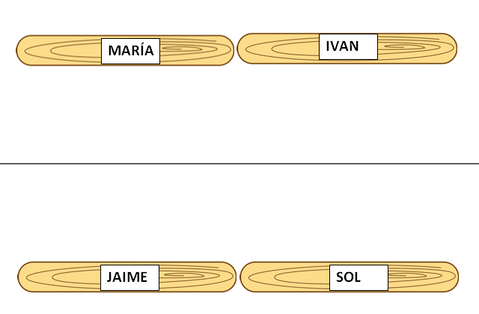
Image 1: Random selection tool Source: Own Elaboration

Annex 2: Story Definition Flashcards

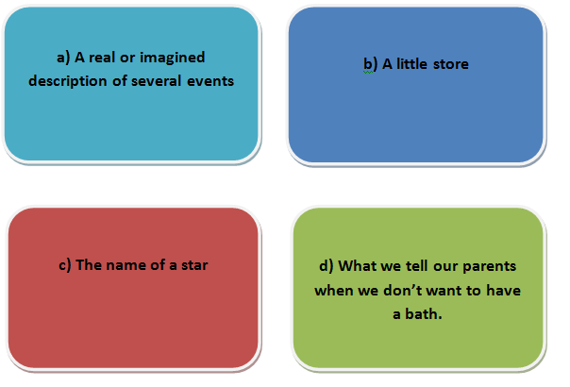
Image 2: Story Definition Flashcards Source: Own Elaboration

Annex 3: Elements of the Story Banners
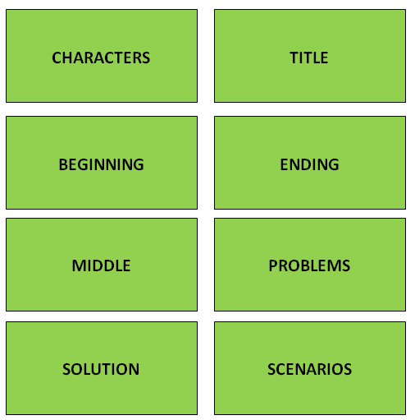
Image 3: Elements of the Story Banners Source: Own Elaboration
Annex 4: “How we should treat others?” Flashcards
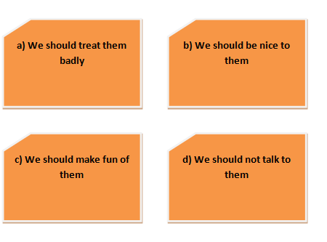
Image 4: “How we should treat others?” Flashcards Source: Own Elaboration

Annex 5: Storytime Song, Say Goodbye Dance Video and Topic Songs
- https://youtu.be/gwBoXWVlYCk (STORYTIME SONG)
- https://youtu.be/mflC2gxa2fU (GOODBYE DANCE)
- https://youtu.be/LWQn3mbignQ (EVERYBODY IS DIFFERENT SONG)
- https://youtu.be/QkHQ0CYwjaI (THIS IS ME! SONG)
- https://youtu.be/kfxr_A5jle4 (BOYS AND GIRLS)
- https://youtu.be/TL7mtIaW97U (WELCOME SONG)

Annex 6: This is How We Do It Portrait Illustrations
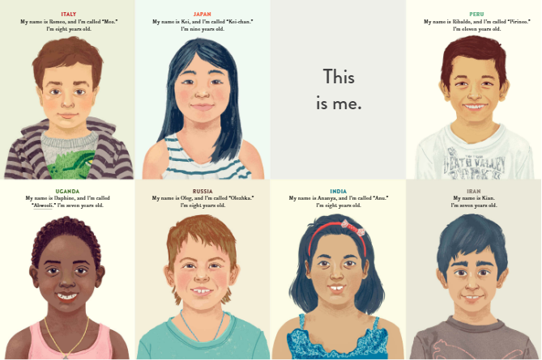

Image 5: “This is How We Do It” Portrait Illustrations Source: Lamothe, M. “This is How We Do It: One day in the Lives of Seven Kids from around the World”.

Annex 7: Lesson One Memory Game
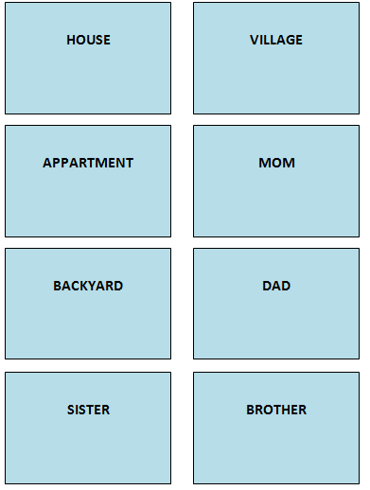
Image 6: Memory Game Part 1 Source: Own Elaboration

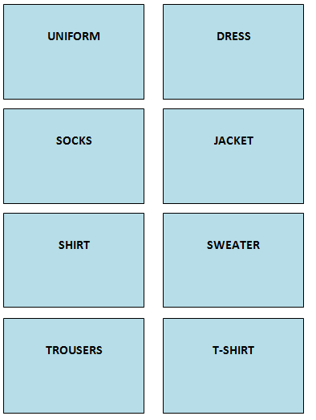
Image 7: Memory Game Part 2 Source: Own Elaboration

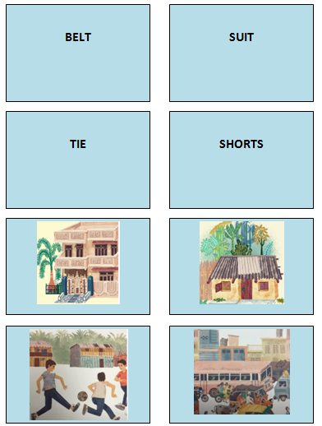
Image 8: Memory Game Part 3 Source: Own Elaboration

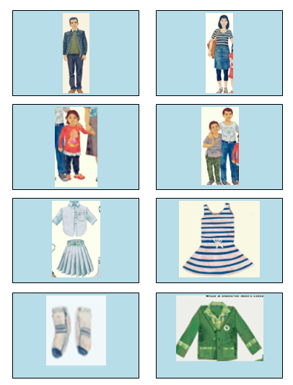
Image 9: Memory Game Part 4 Source: Own Elaboration

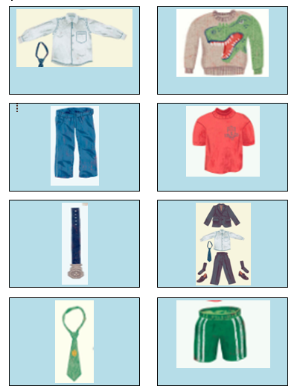
Image 10: Memory Game Part 5 Source: Own Elaboration

Annex 8: Lesson 2 Vocabulary Game
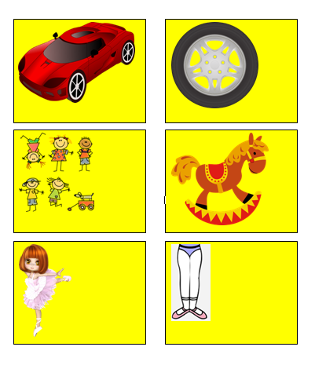
Image 11: Lesson 2 Vocabulary Game part 1 Source: Own Elaboration

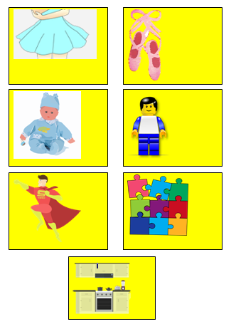
Image 12: Lesson 2 Vocabulary Game part 2 Source: Own Elaboration

Annex 9: Comparative Adjectives Activity Lesson 3

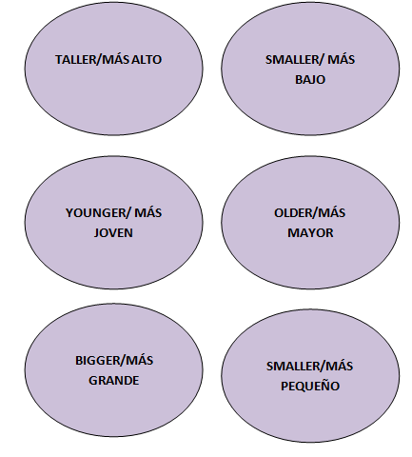
Image 13: Disney Comparative Adjectives Game Part 1 Source: Own Elaboration

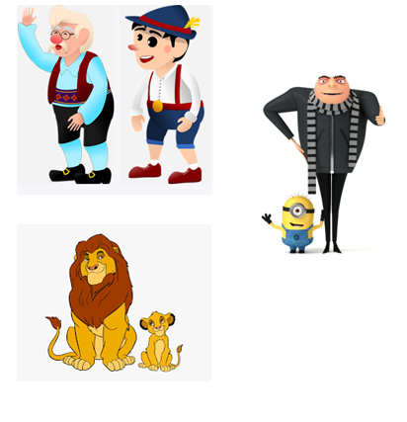
Image 14: Disney Comparative Adjectives Game Part 2 Source: Own Elaboration

Annex 10: Weather Vocabulary and Images

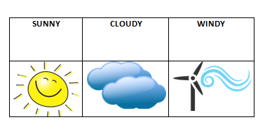
Image 15: Weather Vocabulary and Images part 1 Source: Own Elaboration

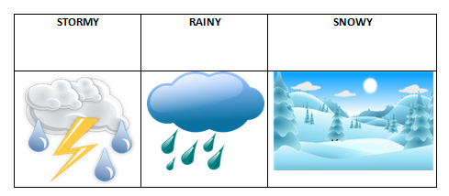
Image 16: Weather Vocabulary and Images part 2 Source: Own Elaboration

Annex 11: Weather Song
- https://www.youtube.com/watch?v=Jn7uAsLWXpk (WEATHER SONG)

Annexes 12 & 13: I Like to Activity

Image 17: I like to activity part 1 (Annex 12) Source: Own Elaboration

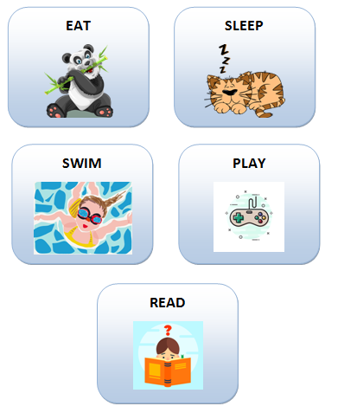
Image 18: I like to activity part 2 (Annex 13) Source: Own Elaboration

Annex 14: Color Balls Game


Image 19: Color Balls Game Source: Own Elaboration

Annex 15: “Red: A Crayon’s Story” Play Script
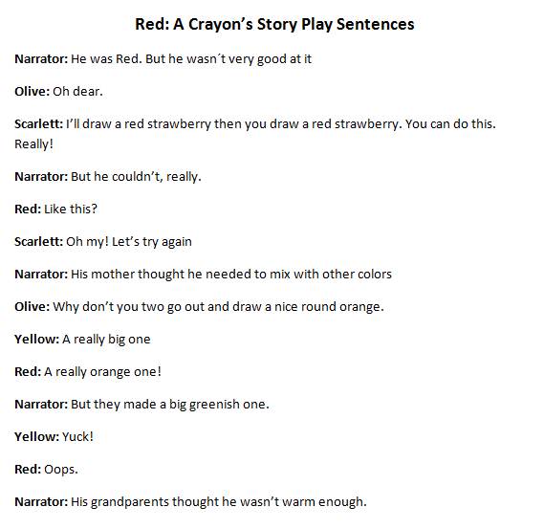
Image 20: Red: A Crayon’s Story Script part 1 Source: Own Elaboration from the picture book “Red: A Crayon’s Story” by Hall, M.

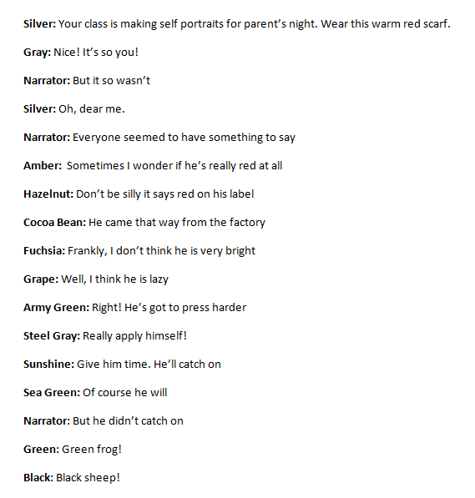
Image 21: Red: A Crayon’s Story Script part 2 Source: Own Elaboration from the picture book “Red: A Crayon’s Story” by Hall, M.

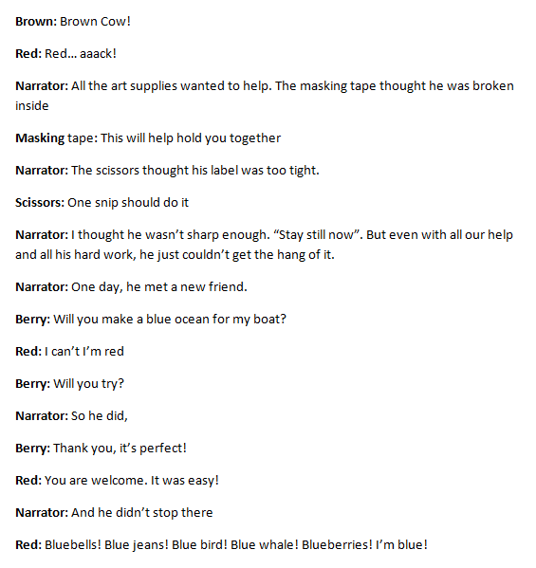
Image 22: Red: A Crayon’s Story Script part 3 Source: Own Elaboration from the picture book “Red: A Crayon’s Story” by Hall, M.

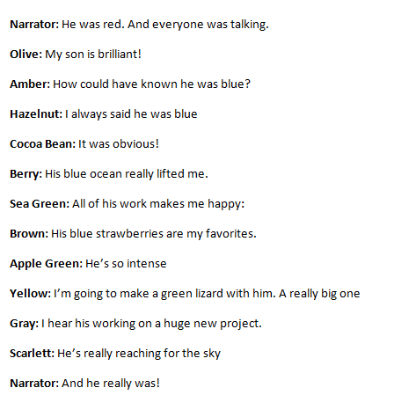
Image 23: Red: A Crayon’s Story Script part 4 Source: Own Elaboration from the picture book “Red: A Crayon’s Story” by Hall, M.

Annex 16: Classroom Objects Intelligence Bits

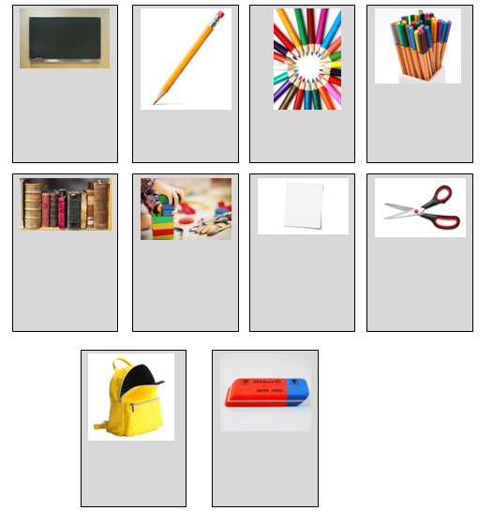
Image 23: Classroom objects Intelligence Bits Source: Own Elaboration

Annex 17: Pixton (Storytelling Creation App)

Pixton: https://www.pixton.com/es/

