

Facultad de Ciencias Humanas y Sociales
Bachelor in Global Communication / Grado en Comunicación Internacional

Trabajo Fin de Grado

K-Pop Idols, Social Media, and the Reinvention of the Fan Phenomenon
A case study on BTS (방탄소년단)

Estudiante: Blanca Lucía Ginés Fenoll

Director: Prof. Patricia Martín Matas

Madrid, Mayo 2021
INDEX
ABSTRACT 1
CHAPTER 1: THEORY AND METHODOLOGY 2
1. INTRODUCTION: AIMS AND REASONS 2
2. STATE OF THE QUESTION 3
3. THEORETICAL FRAMEWORK 6
4. RESEARCH QUESTION, OBJECTIVES AND HYPOTHESIS 8
5. METHODOLOGY 9
CHAPTER 2: ANALYSIS OF SELECTED CASE STUDY 12
1. THE FAN PHENOMENON: THEN AND NOW, K-POP 12
1.1. The “Beatlemania”, the “Bieber Fever”, and the “One Direction infection” 12
1.2. K-Pop: the new way to do fandom 15
2. SELECTED CASE STUDY: BTS 17
2.1. BTS: “The world’s biggest boyband” 17
2.2. BTS’s devoted fanbase: ARMY 20
2.3. BTS’s use of social media 24
CHAPTER 3: DISCUSSION 31
CHAPTER 4: CONCLUSIONS 37
REFERENCE LIST 39
ANNEXES I
Annex 1 I
Annex 2 II
Annex 3 III
Annex 4 IV
Annex 5 V
Annex 6 VI
Annex 7 VII
Annex 8 VIII
Annex 9 XIII
Annex 10 XIV
Annex 11 XV
Annex 12 XVI
Annex 13 XVII
Annex 14 XVIII
Annex 15 XIX
Annex 16 XX
Annex 17 XXI

ABSTRACT
In the era of globalization, no matter where something has originated, it may have the potential to become global, or even viral. This has been the case of K-Pop, or Korean popular music, an umbrella term to refer to several genres of mainstream music that were born in South Korea in the 1990s. In the past few years, thanks to the social media and streaming revolution, Korean artists or “idols” have begun to “conquer” the Western music industry, by first conquering the hearts of their devoted fans, and then, the music charts and awards. This study dives into the relations and the intersection of the elements of a triad: K-Pop, social media, and the fan phenomenon, to analyze how these three interact, and to study whether the use of social media by K-Pop idols is reinventing the fan phenomenon, creating close bonds between fans and idols thanks to the tone and type of content shared. For such purpose, this text carries a case study on one of the biggest K-Pop band at the moment, BTS (방탄소년단) and analyzes their interaction with their fans in three different social media (Twitter, YouTube and VLIVE).

Key words
K-Pop, BTS, social media, fan phenomenon, fandom, Twitter, VLIVE, YouTube, non-reciprocal familiarity.

CHAPTER 1: THEORY AND METHODOLOGY

1. INTRODUCTION: AIMS AND REASONS
In the academic field, and as a fairly new phenomenon, Korean popular music or K-Pop has mostly been studied in relation to the Korean wave or “Hallyu”, a term used to refer to the exponential growth of popularity of Korean popular culture (music, movies, series, cuisine, make-up, skincare, etc.) in the rest of the world. However, and even with its never-ending rising popularity, K-Pop remains a widely unstudied phenomenon in the field of Communication Studies.
It is nevertheless in the field of Communication studies where we could find answers to pervasive and current questions such as why K-Pop has become viral and globally popular. In line with the hypothesis presented in this study, the response to this question could be found, in part, in the social media strategies used by K-Pop groups. Hence, the objective of this work will be to study the success of the phenomenon of K-Pop concerning the new ways in which K-Pop “idols” use social media, and how this social media use is reinventing the fan phenomenon. To carry out the study, we will focus on three main elements, that will create our “triad” of study: K-Pop – use of social media by K-Pop groups or “idols” – fan phenomenon. Arguably, the best way to study the phenomenon of K-Pop is by studying one of the most famous K-Pop groups nowadays, BTS, in hangul “방탄소년단”, romanized as Bangtan Sonyeondan, translated as “Bulletproof Boyscouts”, hereinafter “BTS”. Therefore, this academic work will be developed as a case study on BTS, and how the use of social media by this K-Pop group as a case study is completely reinventing the fan phenomenon, at the same time as it makes K-Pop per se widely and globally popular, with regard to the aforementioned triad.
The reasons why this specific subject was chosen was because as a soon-to-be graduated student of Global Communication and a fan of K-Pop and BTS, the researcher believes there is much to be uncovered about the fascinating world of K-Pop in relation to social media and the fan phenomenon, in the field of Communication studies. This study aims to be a brief analysis on the triad K-Pop – use of social media by BTS – fan phenomenon, so further research is carried out in the future in this same direction, with applicability to other K-Pop groups.

2. STATE OF THE QUESTION
The triad this dissertation aims to relate and come to conclusions about, K-Pop – social media use by famous people (in this case K-Pop groups, more specifically BTS) – fan phenomenon, is a widely unstudied one, given the newness of some of its elements, and the lack of academic interest some of them arouse, given the little academic value they are perceived to have. In this section, we will explore the state of the question of the three elements of the triad, explaining each of them separately in terms of what has been written so far, in so as to be able to go in-depth about them and create a relationship among them in the later sections of this thesis.
First of all, we will address the most unknown element of the triad, K-Pop. K-Pop, short for Korean popular music, is the mainstream music that originated in South Korea in 1992, when the first K-Pop group ever, Seo Taiji & Boys, had their television debut. The term does not only include pop but functions as an umbrella term for many other types of music, as K-Pop songs normally mash more than one musical genre in one track. K-Pop is made up of “idols”, which can be solo artists and music groups created by a process akin to manufacturing by entertainment companies. South Korea has many entertainment companies, but since the beginning of this process of “K-Pop manufacturing”, the monopoly is disputed between the “big three” companies, which are SM Entertainment, JYP Entertainment, and YG Entertainment. In this process of K-Pop manufacturing, new talent is constantly auditioning for these entertainment companies, which train young men and women in singing, dancing, rapping, and acting, and after a period that can go from months to years, assemble these now idols into “incredibly polished and well-rounded groups” (Posner, 2018) where each member fulfils a specific role.
In the past ten years, K-Pop has become a truly global phenomenon, with a “distinctive blend of addictive melodies, slick choreography, production values, and an endless parade of attractive South Korean [or other nationalities] performers” (Romano, 2018). In addition to this, a distinctive characteristic of K-Pop idols, which could be useful for our study, is that they are meant to be perfect, not only physically speaking. They must be polite, they must never be involved in any kind of scandal, and they must never talk about their love lives, sometimes not even being allowed to have one publicly. This is because the image of K-Pop idols is that they are “meant for the fans” (Posner, 2018)
Around the internet and according to databases such as dbkpop.com, there are currently 134 active K-Pop boybands (dbkpop, n.d.) and 101 active K-Pop girlbands (dbkpop, n.d.) These 235 groups do not include solo artists or mixed girl and boy groups, but the figure is enough to make us understand just how much variety there is in K-Pop, and how many groups are manufactured each year, even each month. This massive number of artists and groups can bring us to the following question: why only focus on one group, and why only study BTS? First of all, because given the massive number of groups and the limited space in this thesis it is best to study in-depth one group than to try to cover such a massive phenomenon in its entirety. Second of all, BTS is considered nowadays one of the most famous and most global groups in K-Pop, and thus, it makes a perfect case study.
BTS debuted in 2012 under the entertainment agency Big Hit Entertainment (now known as HYBE) and is made up of seven members: RM (Kim Namjoon), Jin (Kim Seokjin), SUGA (Min Yoongi), j-hope, (Jung Hoseok), Jimin (Park Jimin), V (Kim Taehyung) and Jung Kook (Jeon Jungkook). BTS’s history is one of struggle and hard work in the extremely competitive world of K-Pop, as these seven men started as complete nobodies and underdogs coming from a very small entertainment agency on the verge of bankruptcy, and year after year, worked hard until they became the global phenomenon they are nowadays. We can pinpoint the beginning of their global stardom in 2017 when BTS became an uncontested global phenomenon after three main events that took place in the US.
Firstly, on May 22nd, 2017 BTS won the Billboard Music Award for Top Social Artist. Before them, Justin Bieber had uncontestably won this award six years in a row, as Bieber’s fandom had been going on strongly since 2009. The Billboard Top Social Artist Award is fan-voted, and the fact that as BTS’s fandom, ARMY (acronym for Adorable Representative MC for Youth) voted more than 300 million times for BTS to win the award, indicating that BTS had achieved strong audience engagement through their use of social media (Siano, 2018) Since 2017, BTS has won the Top Social Artist Award every year. Furthermore, the second event that contributed to BTS’s global stardom was the entry of two of their songs to the Billboard Hot 100 ranking. Their song “DNA” reached position #67 on October 14th and “MIC Drop” peaked at #28 on December 16th (Billboard, 2021) To close this successful year, BTS performed at well-known “Dick Clark’s New Years’ Rocking Eve” on December 31st, 2017, becoming the first-ever K-Pop group to do so. From 2017 onwards, it is incontestable that BTS has done nothing but grow and break record after record, be it in South Korea or the rest of the world, and this is why in this thesis, we will analyze BTS as the main representative of the global phenomenon that K-Pop is.
After having discussed the first element of the triad, we can go on and briefly explain what social media is. According to Kaplan and Haenlein, social media could be described as “a group of internet-based applications that build on the ideological and technological foundations of Web 2.0 that allow the creation and exchange of user-generated content” (Kaplan & Haenlein, 2009). Social media is important nowadays in everyone’s daily lives, as social media represents a way to keep up to date with friends and relatives, disconnect from our daily lives, or know what is going on in the world. Many people use social media, be it Instagram, Twitter, Facebook, YouTube, LinkedIn or Pinterest, to satisfy different needs or wants. Moreover, social media is even more important in the lives of fans, as they constitute the only way in which they can daily interact or receive content from their idols, creating close bonds between the famous figures and their fans.
Finally, the last element of the triad is the fan phenomenon. “Fan” is a term used to talk about the unconditional supporters of a given music group, famous person, or sports team (Busquet Duran, 2012). In this dissertation, we will refer to the former, the unconditional followers of a given music group, a term overflooding with negative connotations. As Joli Jenson defends, fans are pathologized in our society, meaning that the term “fan” overflows with negative connotations, as the behavior of all fans is equated to that of teenage girls crying over some pop singer, being excessive and disproportionate (Jenson, 1999). As Lewis defends in the introduction of her book, fans are the most visible, active and identifiable of audiences, but they have been overlooked, ignored, or they have downright not been taken seriously as research subjects, because of the same pathologization of fandom Jenson explores (Lewis, 1992) Fans have been discredited and branded as passive, controlled, dangerous, abnormal, silly and as social outcasts, among many other and less pleasant terms. Nevertheless, if we look around, many people are fans of something, be it an 80s rock group that is no longer active, a sportsperson or a movie saga.

3. THEORETICAL FRAMEWORK
There is a minimum quantity of research carried out in the Communication Studies field about our triad, as the huge majority of texts focus on studying one of these elements, and some of the elements of the triad can be studied in other academic fields, such as Social Studies (fan phenomenon) or Marketing and Economics (K-Pop). This may be explained given the novelty and the recent rise of popularity of the phenomenon of K-Pop, which may have not yet permitted in-depth academic research to be carried out. The majority of texts found about our triad, relating two or all three elements, are short articles in newspapers or magazines, responding to the recent necessity of giving a superficial explanation about this relation to the general public. In this line and given the newness of the phenomena we are about to study, as well as the unavailability of theories to explain relations among the elements of the triad, we will use different theoretical structures and models to help us carry out a comprehensive analysis.
This study has chosen to talk about fans with the concepts fan phenomenon and/or fandom, given that “although fans can and do enjoy the consumption activity of their choice individually, fandom takes on a more powerful form when it is engaged with collectively.” (Obiegdu et al., 2019). Given the pathologization of fans and the little academic interest found in this pervasive phenomenon, there is still no consensus on a term to use to describe the collective of fans and their engagement with different cultural texts. When describing fandom, Jenkins chooses to describe it as “those who claim a common identity and shared culture with other fans […] a more expansive subculture, whose members engage with a broad array of different media objects but who share traditions and practices built up over many years” (Jenkins, 2018). In a simpler sense, we could conclude that fandom is “a group of fans who form social networks with one another based on their common interest in reading and watching particular texts, and the fans in turn write or otherwise produce materials for that text” (Gooch, 2008). The terms fan phenomenon and fandom may be used interchangeably in the following, even if the former may give off a sense of a sociological phenomenon and the latter, a sense of the aggrupation of fans. Citing Thompson, Busquets affirms that:
The fan phenomenon (fandom) must be understood as a normal social fact that arises in the ordinary context of the daily life of many people who, at certain moments, live their hobby in a passionate and obsessive way and who organize part of their daily activity according to it. (Busquet Duran, 2012)
To study the relation between fans and the object of their adoration, in our present case, BTS, we will use John B. Thompson’s framework of relations of non-reciprocal familiarity or intimacy, as established in his work The Media and Modernity: A Social Theory of the Media. Thompson described several interactive situations created by the use of the media, the one of interest for this study being what he called “mediated quasi-interaction” (Thompson, 1992). Thompson described mediated quasi-interaction as the type of social relations that are established thanks to mass media communication, which in Thompson’s time were radio and television, but in our time could also be social media when used by famous people to communicate or interact with their fans. For him, mediated quasi-interaction was monologic or one-directional communication, which “makes possible a form of intimacy with others who do not share one’s own spatial-temporal locale: in other words, it makes possible what has been aptly described as ‘intimacy at a distance’” (Ibid.). As mediated quasi-interaction is, as we have already established, one-directional and thus non-dialogical, this intimacy at a distance between the spectator and the famous person that is established thanks to it is non-reciprocal. Thus, through concepts such as mediated quasi-interaction and intimacy at a distance, Thompson creates one of the core objects of theory for this study, named relations of non-reciprocal familiarity. Thompson related previously cited one-directional relations with mass media and what it is to be a fan by stating that “in many cases, an important part of being a fan consists in cultivating relationships of non-reciprocal familiarity with distant others” (Ibid.).
For the purpose of studying social media engagement between BTS and their fans, we will use Kietzmann et al.’s honeycomb framework of seven social media building blocks. This framework helps us understand what social media is and what forms can it take, for a better understanding of the selected audience of study and its engagement needs. Each “honeycomb” represents a specific aspect of the social media user experience and its implications, in the case of Kietzmann, for firms (Kietzmann et al., 2011), in our present case, for ARMY as a fandom. From the seven honeycombs presented by Kietzmann, which are identity, presence, relationships, reputation, groups, conversations and sharing (Ibid.) (See Annex 2), the most relevant building blocks for the purpose of this analysis would be presence, relationships, groups, conversations and sharing, as they are all paramount to understand fan-idol relationships and online engagement.
Presence refers to “the extent to which users can know if other users are accessible […] through status lines like ‘available’ or ‘hidden’” (Ibid.). This honeycomb, as the image below expounds, is of essential importance to create intimacy, in this case between BTS and ARMY, because the BTS members can show when they are active for the fans to interact with them, through for instance, a live video in the Korean VLIVE App. Secondly, relationships refer to “the extent to which users can be related to other user [sharing] a form of association that leads them to converse, share objects of sociality, meet up, or simply just list each other as a friend or fan” (Ibid.). From the previous citation, we can infer that the relationships honeycomb is the cornerstone of fan-idol relations. Furthermore, groups refer to “the extent to which users can form communities and subcommunities” (Ibid.). We could argue that ARMY on the one hand is a community, as the fans share inner jokes, “memes”, and an overall passion and love for BTS. In addition to this, we could also say that BTS and ARMY constitute a community, as they interact in social media. In addition to all these, conversations represent “the extent to which users communicate with other users in a social media setting” (Ibid.). The conversations building block represents an important part of the relation that BTS and ARMY share, as they communicate with one another even if these interactions, as we have established, are all part of a non-reciprocal way of communicating. Finally, sharing expounds “the extent to which users exchange, distribute and receive content” (Ibid.). In conjunction with the other building blocks, sharing also seems paramount to the relation BTS-ARMY, as well as any other fan with their idol.

4. RESEARCH QUESTION, OBJECTIVES AND HYPOTHESIS
The following pages will analyze the phenomenon of K-Pop, in relation to the use of social media by BTS and the fan phenomenon, in order to assess how the former two are impacting the latter, which has been present for as long as there have been people or objects to idolize. This study will try to do this by presenting the next research question, that will be answered in the following sections:
R.Q.: Is the fan phenomenon being reinvented by the use that K-Pop idols make of their social media?
For the purpose of shedding light on this core research question that will guide the study, this thesis will also aim to fulfill the following research objectives in the following pages and sections:
- Analyze the fan phenomenon:
- Compare how the fan phenomenon was before versus how it is now
- Analyze the use of social media by BTS and how it is different from Western musicians and pop idols
- Evaluate whether the use of social media by BTS can be representative of the use of social media by all K-Pop groups and/or idols
- Determine whether the use of social media by BTS and the fan phenomenon interact, and how the former is reinventing the latter
The initial and main hypothesis of this study is that K-Pop idols are in fact reinventing the fan phenomenon through their use of their social media. To test this hypothesis, this study will analyze the use of social media by BTS. This study believes that BTS is reinventing the fan phenomenon through their use of social media, and this belief is due to the insider knowledge that will be presented as part of the methodology of this study, and as a consequence of a very important fact for this study: even though they are not the group with the biggest number of fans, the septet keeps breaking record after record, making it difficult for this study to keep track and deciding when to stop counting. In the era of social media and engagement, records are not broken by artists alone, but with the help of their devoted fans, a point that will be further explored in the following sections, advancing an important argument forward in the scholarship about the fan phenomenon and social media, which is a widely unexplored field by academics. This study could also pave the way for further studies defending the same thesis or going against it, as the analysis carried out is by no means the only available perspective of the phenomena studied, and by no means seeks to present the absolute truth.

5. METHODOLOGY
This study will follow a comprehensive methodology. First and foremost, this study will carry out an in-depth analysis of the content posted by BTS in three of their social media (Twitter, YouTube and VLIVE) during the promotions for their album Map of the Soul: 7, which this study has narrowed down to be from January 1st, 2020 to March 17th, 2020. In addition to this, the subsequent analysis will be based on an insider ethnography, or an insider look on K-Pop fandom, social media and the world of BTS. To complement such a personal approach to the matter, an online survey with 260 respondents and 12 questions, as well as one-on-one interviews with 4 BTS fans will be presented.
Following Nichole Lamerichs’ method as established in Fan Membership: Traditional and Digital Fieldwork, this study will be based on what she calls an “insider ethnography” (Lamerichs, 2018). This refers to the fact that in this case, the researcher herself carries out this study from her situation of being an insider in the field she is about to study, being a K-Pop and BTS fan since 2017. Lamerichs’ presents her insider ethnography framework as being a combination of participant observation and auto-ethnography (Ibid.). On the one hand, participant observation refers to a type of qualitative research that “aims to gain a close and intimate familiarity with a given group of individuals and their practices through an intensive involvement with people in their natural environment” (Spradley, 1980). This study will use “opportunistic participant observation” (Adler & Adler, 1987) through which this study will conduct a research on a community that she knows well and where she is active (BTS fanbase), as Lamerichs’ does in her own study on fandom. On the other hand, this study will also be an autoethnography, which is described by Sarah Walls as an emerging way of carrying out qualitative research, allowing the researcher to personalize the study by drawing on their own experiences to generate understanding about a certain societal phenomenon (Wall, 2006). One of the most important aspects to take into account in this particular study is that the researcher herself feels represented with the following statement: “I am an insider who does not hide her alliance to the subject but instead analyzes her own investment” (Lamerichs, 2018).
Taking advantage of the network of contacts that comes from being an insider in the studied field, an online survey and a one-on-one online interview with several BTS fans will be used to get data. The online survey was left open for respondents to answer from October 28th to December 2nd, 2020. It was carried using the software Google Forms, and received 260 responses to the 12 questions proposed. The survey was shared through several social media, and the respondents were asked to share the survey with fellow BTS fans. In addition to this, the survey was sent to a Korean language academy for it to be distributed amongst the students, as many K-Pop fans take an interest in the Korean language. The questions proposed in the online survey were both in English and Spanish (see Annex 1). Survey research can be defined as "the collection of information from a sample of individuals through their responses to questions" (Check & Schutt, 2011) and in the present case, it mixed both multiple choice questions, one-choice questions, and an open-ended, voluntary question. The survey was carried out in an online manner given the advantages online surveys offer in terms of data-collection and reaching potential respondents. Wright defends the importance and usefulness of online surveys in researching internet-based communities, given how these relationships already take place online and taking into account the advantages they offer for the researcher, such as access to individuals who live far away, automatic data collection and reduced time and effort (Wright, 2005).
Finally, the last data-collection method that will be used in this study will be 30-minute to 1-hour long one-on-one online interviews with 4-5 BTS fans for further support of the survey findings, and a thorough analysis of fan attitudes and feelings for BTS. This is done as such to perfect and refine the data collected from the online survey, and because as Jamshed defends, “by adopting qualitative methodology, a prospective researcher is going to fine-tune the pre-conceived notions as well as extrapolate the thought process, analyzing and estimating the issues from an in-depth perspective” (Jamshed, 2014). Face-to-face data collection has some other advantages when used for research, such as more accurate screening and an ability to capture the respondents’ emotions as well as their attention (DeFranzo, 2014).
To conclude, it is key to highlight that by choosing to carry out this analysis from an insider perspective and through such a personalized ethnography, the author realizes that this study can produce generalizations only to a certain extent, and by no means does this study try to present an absolute or indisputable truth: it simply tries to explore an unstudied and interesting phenomenon, that has not yet been thoroughly analyzed from the presented perspective. However, it is important to note and emphasize the fact this study is carried out with an ever-present awareness of the limits of such a personalized research, taking into account how the product of the author’s analysis will be completely influenced by her, not only as a researcher but also as a person and as a BTS fan.

CHAPTER 2: ANALYSIS OF SELECTED CASE STUDY

1. THE FAN PHENOMENON: THEN AND NOW, K-POP

1.1. The “Beatlemania”, the “Bieber Fever”, and the “One Direction infection”
While there had been “hysteria” over other musicians and stars before, we can pinpoint the beginning of what is known as the fan phenomenon nowadays with the sudden appearance of the Beatlemania. The Beatles, a British rock band formed by John Lennon, Paul McCartney, Ringo Starr and George Harrison, took the world by storm, achieving a No. 1 album and three No. 1 singles in the United Kingdom in 1963, only a year after the band with the four legendary members started performing (Lynskey, 2013). In its peak years, from the “boom” in the UK in 1963 to the 1964 British invasion on the USA, Beatlemania had the force of a social movement, the devotion of religious idolatry, and sparked a reaction in the public which was normally seen only in exceptional situations such as sport matches or natural disasters (Ehrenreich et al., 1999). Nobody could understand the screeching teenage female Beatles fans, who were called exactly that, “the screamers” (Lynskey, 2013).
Freudian accounts and even psychiatric explanations were laid down: “the characteristics of Beatlemania were described as screaming, hysterical, involuntary behavior, and it was exhibited primarily by adolescent girls” (Taylor, 1966). Nobody could understand why girls could not stop screaming nor crying when John and Paul sang that they wanted to hold their hands, while George played the guitar and Ringo banged the drums in the back. The first fan phenomenon took the world by surprise, and it was branded as social collective hysteria, a symptom of immaturity, or the only way that young women had to blow off some steam (Science News Letter, 1964). In general, Beatles fans won a bad reputation for themselves, even pushing the band to stop giving live concerts. Ringo Starr ended up confessing that he never felt that people went to their concerts to listen to their music, but only to see them (Megía, 2019). While many surely hoped this type of “mania” was a one-time occurrence, but something unstoppable started with the Beatles, and continued with the Backstreet Boys, Madonna, Michael Jackson, and many others. In the 2000s and the 2010s, it was Lady Gaga, Taylor Swift, Jonas Brothers, Ariana Grande and Demi Lovato, among many others. Nevertheless, the 2010s brought with them two fan phenomena deserving of a place in history and a brief analysis in this study, given their proportions and their ability to cross borders: the “Bieber Fever” and the “One Direction Infection”.
When Justin Bieber’s hit song “Baby” was released in 2010, it seemed as if the world had been divided in a massive “love it” or “hate it” reaction, which has ended up being the tendency for the whole of the artist’s career. The recently discovered Canadian singer had debuted with the seven tracks from his My World EP in the Billboard Hot 100 in 2009, and when “Baby” was released, it peaked at No. 3 in that same list (Frankenberg, 2019). From that moment onwards, the “Bieber Fever” went, as the Canadian singer sang, “nowhere but up”. Discovered by manager Scooter Braun and a protegee of Grammy-awarded singers such as Usher, Bieber was a small-town boy who became worldwide famous when he was just a teenager. He was different, or so his hordes of fans, the self-named “Beliebers” thought: his main PR campaign was that Bieber separated himself from the manufactured teen idols, such as the Jonas Brothers, that came out of million-dollar entertainment machines, such as Nickelodeon or Disney (Barshad, 2011).
One of the characteristics of Bieber’s personal and very successful brand, which can be proven with his now 113.9M followers in Twitter, and one of the reasons for his success was his “human tonality” (Shanbag, as cited in Menon, 2017), and his lack of fear in expressing that he was just a small-town boy, who had become successful because millions of fans had given him their support. He kept a very close relationship with his fans in social media, mainly Twitter, by sharing his gratitude towards his fans and personal messages for them: “i started posting videos online 6 years ago. Every day since then u have been there for me. Always come on here and smile. Thank U. Love U :)” (Bieber, 2012). He also used his Twitter account to ask direct questions to his fans or send messages allegedly intended for his fans, creating a feeling of intimacy, such as when he tweeted in December 2012, “did u have a nice christmas?” (Bieber, 2012) or “come relax with me poolside” (Bieber, 2012). He kept the relationship “a one on one, almost sort of a texting relationship with his fans, through Twitter” (Chu, as cited in Barshad, 2012). When not directly mentioning anyone in his tweets, it was easy and attractive for the fans to believe Bieber was talking to them, further feeding the illusion of reciprocal intimacy, and attracting more fans, as Bieber was at the peak of his fame in late 2012, after having released his third studio album Believe in June 2012.
Another 2010s successful and arguably a trend-setting case was that of British-Irish band One Direction (1D). The band was formed in the audition stages of the 2010 British music show The X Factor and has been in a hiatus since 2016. The band, made at its origins of Harry Styles, Liam Payne, Zayn Malik (who left in 2015), Niall Horan and Louis Tomlinson, was dubbed “the world’s most successful boyband” (Mahia & García, 2020). In their story as a group from 2010 to 2016, the band performed more than 300 shows, toured the world four times, had four No. 1 albums on the Billboard 200 ranking, six Billboard Hot 100 top 10 hits, four Video Music Awards and 28 Teen Choice Awards, among many other achievements (Paul, 2020). The consensus is that one of the main reasons behind the success of 1D were their fans, their devotion and their determination to make the third-place finalists of The X Factor, a worldwide sensation.
What, it may be rightfully asked, made a group of teenagers so utterly devoted to 5 young men, to push them to stardom after their defeat in the British competition? The 1D members mastered, from the first moment, the critical relations of non-reciprocal familiarity with their fans through social media: during their stay at The X Factor, the quintet uploaded to YouTube what they called “video diaries” before and after each weekly performance. These videos were a “glimpse into the off-stage personalities of the 5 boys” (Paul, 2020) and a way for the fans to connect with and feel like they got to know the 5 members, as the videos were normally funny, down-to-earth testimonies of their journey through the survival show. With something as easy as videotaping themselves talking and joking around, the quintet was able to build a sustainable and devoted fanbase that would take them to stardom. As Harry Styles stated, “the reason why fans are so dedicated is because I think they feel like they can relate to us. We’re the kind of boys you go to school with… and that’s because we are” (Styles, as cited in Druce, 2017). These glimpses into the off-stage, day-to-day personality of the 5 members continued as their popularity rose and reached its peak years from 2012 to 2014, with for instance, the tour documentary This Is Us (2013) and the 1D Day (2013), an 8-hour live stream where the members played games and promoted their third album, Midnight Memories.
In addition to the variety of 1D-related content that could be found online, the 1D members were also very active in social media. First of all, they made good use of their social media for commercial matters, as a “social media frenzy” (Greenwood, 2020) appeared out of the blue every time the boyband released any type of content. In addition to this, following Bieber’s steps in fan engagement through social media, they also talked directly to their fans through their own personal accounts, as each member had an individual account along with the official, promotion-focused group account. There were tweets expressing gratitude, such as “What a night ! You are the most incredible fans to ever exist thank you so so so much !!” (Malik, 2014), tweets that fans could respond to, such as “How long does jet lag last for?” (Payne, 2014) and finally, direct interactions with fans such as “@_niallsgravity thank you so much.. Hope you enjoy listening .x” (Styles, 2014). All in all, the way that these young men had to interact with their fans, paired with their relatable songs about teen love and the personal content posted, made the fans become invested in each member, not only as an artist, but as a person. One Direction has been in an indefinite hiatus since 2016, but the group continues to make history, and each individual member has achieved some level of success as solo artists.
To conclude, we see how the fan phenomenon has been developing since its first “boom” in the 60s with the Beatles, where the “mania” of fans scared even the artists themselves and drove them away of live stages. Then, we have briefly analyzed the “Bieber Fever” and how a down-to-earth, small town boy, won the hearts of millions of fans through bubblegum pop and a close relationship to his fans, and is now one of the most followed users in Twitter. Finally, we have briefly studied the “One Direction Infection”, where 5 young men were taken to stardom by a legion of devoted fans who became obsessed with them since their first days in The X Factor, thanks to the content they shared, and their emotional closeness with fans.

1.2. K-Pop: the new way to do fandom
K-Pop functions as an umbrella term to refer to the many genres of mainstream music that originated in South Korea in the 1990s. The centerpiece of K-Pop are K-Pop idols, which can be solo artists or groups, created by a “manufacturing” process by entertainment companies. As mentioned before, the most important entertainment companies in K-Pop are SM Entertainment, that has created groups like EXO or Red Velvet, YG Entertainment, house of BLACKPINK and BIGBANG, and JYP Entertainment, which manages groups such as Twice and Stray Kids. In addition to all these, there is Big Hit/HYBE Entertainment, which started as a small company when their boy group BTS debuted and has nowadays a net value of $8.38 billion (Xu, 2020).
K-Pop has experienced an upsurge in its international popularity in the last decade. Artist PSY’s 2012 hit “Gangnam Style” broke every possible existing record and spent five years accumulating more 3 billion views on YouTube, winning the title of the most-viewed video in YouTube’s history up until 2017 (Romano, 2018). While many theories exist on the topic, this study argues that from that moment onwards, K-Pop started becoming a global phenomenon. Suddenly, it was not just PSY, but EXO, BTS, NCT, Stray Kids, Twice and BLACKPINK, among many others: in a similar manner as the Beatles carried out the “British Invasion”, K-Pop took over the West in an actual “Korean invasion”. What Bieber and One Direction started, K-Pop groups and especially BTS, learned how to use and perfect. A big part of K-Pop’s success in the West came thanks to a specific use of social media, and the streaming revolution, as “K-pop groups are encouraged to use social media to interact with their fans and spread their reach, with no platform being off limits” (Given, 2020). While the marketing capabilities of Korean entertainment companies cannot be taken for granted, neither can be the abilities and dedication of K-Pop stans.
Twitter is the central platform used by K-Pop fans to connect with their idols: normally, K-Pop groups share one group account, and they sign their tweets by adding a hashtag with their names, so the fans can know who’s the member behind each tweet. For instance, BTS youngest member, Jung Kook, has the record for being the only person in Twitter to have 2 million likes on 7 different tweets, all on the group account, @BTS_twt (Given, 2020). When talking about Twitter and K-Pop artists, we have to take into account the study carried out by T. Siano, Comparing Western and South Korean Twitter Strategies. By analyzing the Twitter use of four Western artists and four K-Pop groups during a five-week period in 2017, she concluded that K-Pop artists seemed to value having a good online and social media image, achieved through posting more consistently that Western artists (Siano, 2018) (See Annex 3). Some of the conclusions that Siano’s study presents is that Korean artists tweeted twice as often, and also their engagement seemed to be higher. In addition to this, 26% of the tweets by K-Pop artists were made to share personal information, in contrast with the 5% of Western artists (Ibid.). Taking into account that the group that tweeted the most in this study was BTS, Siano’s conclusions serve to introduce this study’s hypothesis: by sharing personal information and experiences in social media, BTS is reinventing the fan phenomenon as it was introduced by the Beatles and developed by the big fan phenomena of the 2010s, namely Justin Bieber and One Direction. This is because, as Nisbett and DeWalt put it, “sharing personal information via social networking is a way to create intimacy and approachability between fans and celebrities” (Nisbett & DeWalt, 2016).

2. SELECTED CASE STUDY: BTS

2.1. BTS: “The world’s biggest boyband”
As it has been previously mentioned, BTS (방탄소년) is a seven-member boy group made up of RM (Kim Namjoon), Jin (Kim Seokjin), SUGA (Min Yoongi), j-hope (Jung Hoseok), Jimin (Park Jimin), V (Kim Taehyung), and Jung Kook (Jeon Jungkook), who will be hereinafter referred to by their stage or artistic names RM, Jin, SUGA, j-hope, Jimin, V, and Jung Kook. These seven young men debuted in the K-Pop scene in 2012 under the small entertainment agency Big Hit/HYBE Entertainment, which could not even imagine of competing with the “big three” entertainment companies in South Korea (SM; YG, JYP). Many factors have contributed to the transformation of BTS from nobodies and underdogs in a competitive and somewhat elitist and industry, to the global sensation they are nowadays, but the fact that they were at the right time and place seems to be key:
BTS came in fresh off the heels of One Direction, the biggest band in the world for 5 years and the pioneers of social media fan interaction. In 2015, when One Direction fizzled out, BTS […] filled the desire for the next generation’s biggest boy band. (Given, 2020)
In their first years, the group made moderate success in Korea, up until 2015, when the group released their hit “I Need U”. Having debuted with an underground hip-hop image, the new aesthetic, image, and sound that came with “I Need U” changed everything for BTS. Named as one of the songs that defined the 2010s decade by Billboard, this song from their The Most Beautiful Moment in Life, Pt.1 album, “was less of a song and more of a revolution – laying the groundwork for the future of the group, and in turn their rise to international superstars” (Herman, 2019). After “I Need U” and its success, “Run”, “Save Me”, “Fire”, and “Dope” came afterwards, cementing the journey to mainstream for the septet. All of these songs were compiled in three albums, known as the Youth trilogy, and they were The Most Beautiful Moment in Life part 1 and part 2, and The Most Beautiful Moment in Life: Young Forever. The group topped Korean and international charts with this trio, while also winning their first big Korean music award, known in Korea as a “daesang” (Bacera, 2020). From that moment onwards, the success of the septet seemed non-stop, and up until this day, the group has not stopped growing, breaking record after record.
BTS has made a brand out of differentiating themselves from the widespread notion of bubbly, non-sensical, perfect K-Pop music by singing about social and youth problems, such as academic stress, inferiority complex or the uncertainty about the future, as well as mental health topics, such as depression, anxiety, and self-harm. Hence, through these lyrics, the members of BTS have won a reputation for being honest about their own struggles. In addition to this, another of the well-known topics of BTS’s songs, and what may have made the group famous, is the “journey towards loving oneself” (Kim & Kim, 2020). Indeed, it was their Love Yourself trilogy of albums, made up of Love Yourself: Her (2017), Love Yourself: Tear (2018) and Love Yourself: Answer (2018) what guaranteed the group global stardom and a collaboration with UNICEF in the #LoveMyself campaign to end violence.
As established before, 2017 was the year in which BTS started their conquest of the Western music industry market, whose heart is situated in the United States. In May 2017, BTS won the fan-voted Billboard Music Award for Top Social Artist, an award that the septet has since won four years on a row (Free Press Journal, 2020), which indicates a very strong fan engagement through social media. Then, in the last months of 2017, they became the first K-Pop group to ever perform at an American awards show, the American Music Awards (AMAs) and two of their songs entered the Billboard Hot 100 ranking, a very important feat for an overseas K-Pop group. This ranking is considered to be the standard record chart in the music industry, published weekly. Molaphy and Cornish explain the importance of the chart given how it acts as a system of checks and balances, and for a song to chart well and hit the first positions, it must perform well in three different categories, namely sales, airplay and streaming (Molanphy & Cornish, 2013)
2018 would be remembered as the year the group took over the world. In 365 days, the group released a documentary, Burn The Stage, won the Top Social Artist Awards again, and released their “Fake Love” and their “IDOL” music videos. The first one became the most viewed K-Pop music video in 24 hours, but the second broke the same record for all music videos, beating a record set by Taylor Swift. Moreover, they released their studio albums Love Yourself: Tear and Love Yourself: Answer which both got to #1 at the Billboard 200 chart, sold out every date of their Love Yourself world tour and gave a speech on the UN General Assembly (Kelly, 2018; UNICEF, 2018).
2019 and 2020 did not slow down the success of the South Korean septet: even more so, each year was crowned the most successful year for the K-Pop group, as it seemed unimaginable at the time that the group could yet again surpass themselves. Nevertheless, in 2019, BTS re-broke the record for the most viewed music video in the first 24 hours with their hit “Boy with Luv”, debuted again at the No. 1 on the Billboard 200 with their album Map of the Soul: Persona, became the first group since the Beatles to achieve three No. 1 albums in less than a year and were named one of Time’s magazine’s 100 most influential people (Bate, 2019; Tabanera, 2019). In 2020, BTS released two other award-winning studio albums, Map of the Soul: 7 and BE and topped the Billboard Hot 100 with their all-English hit “Dynamite”, becoming the first K-Pop group to do so. With the COVID-19 pandemic hitting the world unexpectedly, BTS showed great adaptation to the new situation, not letting a global pandemic hinder their success:
BTS has adapted to the new restrictions set by the coronavirus pandemic better than almost any other entertainer. Regularly releasing music in the months since COVID-19 ushered in a new normal, the South Korean act has continued its streak of breaking records for physical album sales and digital streams. (Moon, 2020)
Furthermore, the septet held an online concert on June 14th, 2020, called Bang Bang Con: The Live which broke the Guinness Record for most-viewed concert livestream, with 765,000 viewers (Guiness World Records, 2020). Moreover, in 2020, BTS and ARMY showed determination to respond to uncertainty and injustice, donating $1 million each to coronavirus relief and $1 million to the “Black Lives Matter” movement (Benjamin, 2020; Greenwood, 2020).
Even if the year was filled with uncertainty, 2020 was BTS’s most successful year yet. Time will only tell whether 2021 will see even more success from the South Korean group. Nevertheless, at the time this study is being written, BTS is still breaking records, stereotypes, limits and borders. After having presented part of the success that BTS has had on their own, thanks to their music, stage presence and marketing techniques, without mentioning yet their close and intimate use of social media, let us now talk about another of the cornerstones of the septet’s groundbreaking success: their fans. While the other top South Korean labels could rely on their name, money and power to make groups famous, Big Hit/HYBE and BTS had to rely on social media and originality to become better well-known. Their intimate use of social media and their raw lyrics attracted many fans. Gradually, the numbers began growing, and in less than 3 years, BTS had built a global fanbase of millions of loyal fans, known as ARMY.

2.2. BTS’s devoted fanbase: ARMY
ARMY (Adorable Representative MC for Youth) is the name of BTS’s fans. This “army” of fans have shown devotion and engagement levels that could parallel those shown by Justin Biebers’s Beliebers and One Direction’s Directioners, even if the K-Pop group’s fans are fewer in number. As TIME magazine expounds in an article devoted solely to unveil the mystery of ARMY, BTS’s fandom is one of the most active online communities, and it differentiates itself “through the ways it has mobilized with an unrivaled level of organization, driven by a desire to see the seven members of BTS leave their mark in territories previously uncharted by any other pop act from South Korea” (Moon, 2020). ARMY started attracting the world’s attention when in 2017, they propelled the group to win the Billboard Award for Top Social Artist, beating artists such as Justin Bieber, who had previously won the award six years in a row and has the second most followed Twitter account in the world, or Ariana Grande, who has more than 80M followers in the same social network.
“BTS' global fan base of millions of loyal followers is powerful enough to create major waves – and help the group smash music industry records” (Seo & Hollingsworth, 2019). One of the main activities in which this powerful fanbase engages in to push their idols forward, and namely one of the reasons behind BTS’s numbers, is continuously streaming BTS’s music videos and songs in different platforms. Thanks to this devoted engagement and to the fact that ARMY grows in number every day, hence being able to orchestrate an even more powerful engagement, BTS gets bigger, more relevant, every day.
When BTS announced the release date for their self-produced, self-directed album BE, which was released in November 2020, ARMY created what is commonly known as “comeback goals” (see Annex 4). “Comeback” is a common term in K-Pop, used to refer to the release of new music, normally accompanied with music videos, a new aesthetic and new content such as participation in live Korean TV music shows (SBS’s Inkigayo, Mnet’s M! Countdown, MBC Music’s Show Champion, MBC’s Show! Music Core, KBS’s Music Bank and SBS MTV’s The Show), by a K-Pop idol or idol group. These comeback goals are not exclusive of BTS’s fanbase, as it is a common occurrence in the K-Pop scene for fans to organize themselves to get their favorite artists to win awards in music shows programs in South Korea, achieved with a great number of digital and physical sales, online streaming, and different voting systems (Kelley, 2017). The release date for BE was on the same year of BTS’s seven-year anniversary. Seven has always been an important number for BTS and ARMY, as there are seven members in BTS. Thus, the fandom organized itself to “gift” BTS with unbelievable numbers when the album was released, even creating a webpage (https://bts7million.carrd.co) that explicitly stated the goals and how to achieve them, explaining new BTS’s fans how to stream efficiently.
This “disorganized organization” characteristic of ARMY seems at first sight, inexplicable. How can the millions of BTS followers on Weverse, an app and website created by Big Hit Entertainment to foster artist-to-fan communications, Twitter, Instagram, or YouTube among others, organize themselves so effectively to help the septet achieve their goals and break records, without an actual organizational structure or a leader? In their research, professors WoongJo Chang and Shin-Eui Park try to dive into this leaderless phenomenon:
The phenomenon of the ARMY of BTS is a process of organizing without a structured rationalized organization […] their social media and OTT (over the top) activities cannot be explained by conventional organisational theories. There is no leader, everyone is (nominally) a leader, and everyone can partake in the action. (Chang & Park, 2019)
Even without an organization, ARMY continues to be unrivalled in their way to organize themselves for donations, comeback goals, and online or offline actions for BTS. Nevertheless, a question about ARMY is still left unanswered. Why BTS, and why this devotion towards these seven young men? This study has already established the musical and artistic reasons behind BTS success, and the ability of their fandom to seemingly achieve every goal imaginable, but the reason behind the fandom’s devotion and dedication has not yet been tackled. For this study, it all comes down to the symbiotic, some could say special, relationship the seven idols share with their fans.
It seems clear from the interactions and the speeches at awards shows, that the fans are the reason behind the septet’s success: this is why the group does not miss a chance to thank ARMY for the success their devotion and dedication has afforded the South Korean band. This gratitude can be shown with some examples of the member’s speeches. In 2018, when awarded with the Artist of The Year “daesang” in the Mnet Asia Music Awards (MAMA), Jimin stated:
ARMY, thank you. Over the year, there could've been many hard times you know... We had times where we got together and had discussions. What we felt is that we have so many people around us. So, we want to thank you guys for always giving us encouragement. We really wanted to receive this award here again. Your pride in us is our pride. We will show a better side of us next year and show you guys this award again. (Park, as cited in Devoe, 2018)
In an interview in the Elvis Duran and the Morning Show in 2019, member j-hope said about their fans that “they are the most passionate and loving people” (Duran, 2019). Finally, the last example is from 2020, when in the famous American talk show, The Late Late Show with James Corden, member V dedicated some thoughtful words to the fans by saying “we want ARMY to be happy through our music, we’ll be there for you, with love” (The Late Late Show with James Corden, 2020).
This special relationship can also be shown in some of the actions of the members of the K-Pop group. For instance, youngest member Jung Kook got the word “ARMY” tattooed on his right hand sometime during BTS’s vacation in the summer of 2019, as a way to show the group’s devotion to the fans. There are many examples like this, but we may also cite a picture uploaded to one of the group’s Twitter accounts in July 2019, during their Love Yourself: Speak Yourself world tour. After the concert in Shizuoka, Japan, the septet uploaded a picture of themselves holding up banners that read “BTS = ARMY 천생연분”, which translates from Korean as “soulmates” (See Annex 5). Actions like this may make the BTS fanbase feel unique, special and loved by these seven young men, who seem to deeply and genuinely care about their fans. Moreover, the relationship between these artists and their fans can also be shown in some of the group songs as BTS is known for dedicating some of their songs to their fandom. We can find examples of this in for instance, their song “2!3! (Still Wishing for Better Days)” from their 2016 Wings album
It’s alright, now count 1, 2, 3 and forget, erase all sad memories, hold each other’s hands and smile
Behind the stage, I’m in the shadows, I’m in the darkness, I didn’t want to show you my pain. But I still lack so much, I only wanted to make you smile, I wanted to be good. Thanks for believing in someone like me, dealing with all these tears and wounds
Another well-known BTS song that is known to be dedicated to the fandom is “Magic Shop” from their 2018 album Love Yourself: Tear. Coming from psychology, the magic shop is a psycho-dramatic technique created by J. L. Moreno in 1948, aimed at the patient’s self-evaluation and personal growth (Shaked, 2015), in which a therapist takes on the role of a magic shop owner, who attempts to negotiate and barter with customers, in this case the patients, in an attempt to satisfy their needs constructively. The science or the magic behind the magic shop is that you may ask for anything or try to sell what you do not want, but what the customer comes in looking is not always what you leave with. Some of the lyrics of BTS’ “Magic Shop” talk about how BTS would want to replace ARMYs sadness and pain for comfort, much in the same fashion as a psychologist in the magic shop.
Don’t forget at the end of my despair, I found you
You gave me the best of me, so you’ll give you the best of you. You found me, you recognized me
When I hate being myself, when I just want to disappear forever, I open one door, and there I was, in your heart
But looking back, the truth is, I didn’t just want to become the best, I wanted to comfort you, move you, I wanted to end your sadness and pain
User “QueenGoddess” in Amino, a website and app used among K-Pop fans, affirms that BTS, as individuals and not artists, know about the fans’ struggles and are conscious of the troubles their fans may be going through, and their lyrics about not conforming to society and following one’s dreams reflect both the fans and the septet themselves (QueenGoddess, 2018, July 08). This illusion of proximity can be compared to Thompson’s relations of non-reciprocal familiarity. This study believes that this illusion of proximity to BTS as individuals and not only artists that the fans feel is one of the main reasons for the devotion of the fandom, and thus, one of the reasons behind BTS success. This illusion of proximity can be first studied through an analysis of BTS’s use of social media which will be carried out on the following section of this chapter.

2.3. BTS’s use of social media
In this section, an analysis on BTS’ use of social media will be carried out, with a focus on three distinct social media networks. While BTS is present in many other apps and networks, the length constraints of this study required a choice to be made. Thus, this section of the study will be dedicated to exploring BTS’s use of Twitter, YouTube and VLIVE, these three having been chosen as some of the most important and interesting networks among all of the choices available. This section will be focused on the time frame of the promotions for the group’s top-selling album Map of the Soul: 7, between January 1st to March 17th, 2020. It is important to study an idol’s use of social media in the present case and for the defense of this study’s hypothesis because “social media as a platform provides an immediacy and intimacy in a young person’s interactions with a celebrity” (Nisbett & DeWalt, 2016)

2.3.1. Twitter (@BTS_twt)
Twitter is a microblogging platform, meaning that a size constraint is applied to the size and length of post shared, in this case 140 characters or less per “tweet” (Croxall, 2014). This platform may arguably be one of the most important ones when it comes to fandom and fan and “stan” culture. Twitter itself, from its marketing branch and its series on cultural insights from the conversation in Twitter, created a study on the importance of fandom in the platform, stating that “sharing on a social media platform has helped forge a stronger bond between idol and fan, reinventing the meaning of fandom” (Twittter, n.d.) This study by Twitter also uncovered how fans make use of hashtags to render their favorite artists or idols more visible, or to help them win awards, competing with other fandoms. In addition to this, and with special relation to BTS, this study uncovered how empowerment through fandom had increased a 741% in the period studied (2016-2019), meaning that fans were embracing the positive messages that their idols promoted, improving their own happiness and mental health (Ibid.). As it has already been established and will be expounded from the data gathered for the purpose of this study, BTS and their uplifting messages on loving oneself are a central part of the fandom culture surrounding this K-Pop group.
BTS has two Twitter accounts. The first, @bts_bighit, where official promotions and updates are posted. We could say that this is the more marketing-centered account, while the second account, @BTS_twt, is more personal to the members. This account, shared by the seven members of BTS, is where they consistently post selfies, birthday messages to each other and messages to the fans. Given that they share one account, the BTS members normally “sign” the tweets that do not come with a selfie, using a hashtag or an emoji related to them (i.e., fans relate Jung Kook to the bunny emoji, and j-hope to the squirrel one). We could argue that the fact that each BTS member signs his own tweets may make the fans believe that it is the members themselves the ones who manage the Twitter account and are behind their tweets, something that is at times contested when it comes to idols with such a hectic schedule. Nevertheless, a simple signature in a tweet may make the fans feel closer to the BTS members, feeding the asymmetrical relation of non-reciprocal familiarity that exists between BTS and ARMY.
In the established time scope (January 1st to March 17th, 2020) BTS tweeted 83 times. From those 83 tweets, 32 were selfies or photos of the seven members, 23 were selfies with a message for the fans, 7 were videos, 3 were messages for the fans without multimedia content, or replies, and 18 were other tweets (birthday wishes among members, song covers or other tweets showing the members’ own interests). Interestingly enough, almost every time Jimin tweeted, it was to post a selfie of himself, accompanied with a message of gratitude and love for the fans and signing with a hashtag of his name (#JIMIN). For instance, on January 27th, 2020, he tweeted a selfie and shared a message for his fans: “Thank you to ARMY for always creating incredible opportunities. We will always be able to show you a better look without forgetting today. Thank you and I love you” (Park, 2020) (see Annex 6). If we add up the selfies with messages for the fans and the selfies that did not carry messages, the total of tweets in this time frame containing photos of the seven young men is 55. This means that a 66% of the content uploaded to Twitter by BTS was low-quality, non-promotional multimedia content, similar to what a normal young adult would upload to Twitter or to Instagram, which we could argue also helps the relations of non-reciprocal familiarity between BTS and their fans to develop further. Of the 18 other tweets BTS shared, 7 were birthday wishes among the members, using the same account to talk to one another. This can also help the fans feel closer to BTS, getting the illusion that they know these seven young men personally, as they are made participants of the group’s inner jokes and workings.
If we analyze BTS’s use of Twitter according to Kietzmann’s honeycomb framework of seven social media building blocks, we could say that Twitter enters in the relationships, groups, and sharing building blocks. First, we could argue that the way in which BTS uses Twitter is part of the relationships block, because they share a form of association with their fans. A big part of BTS’s tweets in the analyzed period mention ARMY, or are directed to the fans, referring to them as “our ARMY(s)” (우리 아미). This demonstrates the bond the artists share with the fandom, and the cited form of association. Then, the use of this social media could also be interpreted to be part of the groups and sharing building blocks, as BTS and ARMY function as a community, and BTS shares content for their fans to see in their Twitter account, mainly as selfies or low-quality photo content. It is debatable whether BTS’s Twitter could be considered to be part of the conversations building block, as actually, no conversation takes place, as it can be seen in the very low number of tweets directly replying to fans BTS shares. Mainly, Twitter for BTS serves as Instagram would for any other famous figure, as BTS mainly shares selfies with messages for fans, or to let them know what they are doing at the moment.

2.3.2. YouTube (BANGTANTV)
In the same fashion as Twitter, BTS content can be found in two main channels: the official Big Hit/HYBE Entertainment channel (HYBE Labels), and a more personal BTS channel (BANGTANTV). In this study, we will focus on the content uploaded to BANGTANTV, which is much more intimate to the group and is divided in several categories: BANGTAN BOMB, EPISODE, CHOREOGRAPHY, and PREVIEW among others. BANGTAN BOMB are short, less than 10-minute videos, that show behind the scenes moments of the daily lives of the seven members of BTS, as well as musical performances in which the camera does not move, but shows all members at all times, contrary to what normally happens in Korean music programs. EPISODE videos also show behind the scenes moments but tend to focus more on what happens behind the scenes of music video shootings or photoshoots, sometimes longer than 20 minutes. CHOREOGRAPHY videos show how the members practice for their dance performances and finally, PREVIEW give fans a teaser of something important, such as a documentary or a world tour.
In the studied time scope, there were 43 videos uploaded to the BANGTANTV channel (see Annex 7). Of these 43 videos, 26 were BANGTAN BOMB, 6 were EPISODE, 1 was PREVIEW, 4 were CHOREOGRAPHY, and 6 were other type of videos. As we can see, more than 60% of the videos uploaded in the chosen time scope were of the BANGTAN BOMB category, which shows a more intimate side to the group, and seem to serve for the purpose of furthering Thompson’s relationships of non-reciprocal familiarity between BTS and their fans. This is because in these videos, BTS members tend to show themselves as the real people behind their artistic names. For instance, some of the videos uploaded under this category show the youngest member Jung Kook eating various types of ice cream and saying which are his favorites, a surprise birthday party for V or the entire group reacting to a YouTube video of a dance routine for one of their songs. Thus, we could hypothesize that the content uploaded under the BANGTAN BOMB category is meant to be genuine, intimate, and means to show the fans another side of BTS. Moreover, it is important to highlight how these videos are most of the times entirely in Korean, and sometimes they do not come with subtitles in English. Nevertheless, some of the videos that are not translated can be found in the fan-based, fan-run YouTube channel Bangtan Subs, that puts English subtitles in some of these videos. In their “about” section in their YouTube channel, they describe themselves as a non-profit and fan-based subbing group dedicated to providing translations for international ARMYs, that do not understand Korean. This demonstrates the devotion and disorganized organization characteristic from BTS fans, who without a visible leader are able to organize and translate BTS content so every fan from around the world can access and engage with it.
The EPISODE videos are also important for our study, as they show BTS behind the scenes of photoshoots or music awards. On February 21st, 2020, a video showed the seven BTS member behind the scenes for the several photoshoots they did for their Map of the Soul: 7 album. BTS is well known for their image and stories or theories behind their complex music videos, so each member appears at least once in the duration of this video explaining the concept behind the photoshoot, and what the aesthetic is about, as well as being less serious and professional, more like young adults trying to have fun during their long hours of work. During one break, we can see V and Jin joking around, the latter telling the former: “Taehyung [V], you’re so handsome. How do you become handsome like you? You have to be born that way!” (BTS, 2020). In their last day, the photoshoot follows a “jacket concept” in which all members are dressed in a youthful, fun way. Member j-hope talks directly to ARMY saying “We tried on [the] uniforms that you like so much. As always, we tried new styles this time around. I think you’ll like it, can’t wait to show you” (Ibid.).
If we had to classify BTS’s use of YouTube according to Kietzmann’s honeycomb framework, we could argue that the best fits are the relationships, and the sharing building blocks. The relationships building block applies in the same way as it was established before in the Twitter section. BTS and ARMY share a form of association, as BTS talks directly to ARMY in the videos. With this argument, we could also debate whether this means that this social media should be included in the conversations building block, but the same argument as before applies. Even if the relation between BTS and ARMY is asymmetrical, there is no place for the fans to engage in a conversation with BTS in YouTube, at least in the analyzed time period and in the videos presented. BTS talks to the fans, but fans do not have an opportunity to respond and get a live response back from the group. Finally, the sharing building block is arguably the best fit, as BTS share content in YouTube with which the fans engage.

2.3.3. VLIVE
VLIVE is a South Korean and K-Pop exclusive social network that lets K-Pop idols post multimedia interactive content in video format. VLIVE offers K-Pop artists and groups the possibility of live streaming and chatting with their fans at the same time, giving the sensation of a more immediate communication them. At the time this study was carried out, BTS’s channel in VLIVE had 27 million members or followers. Their channel is comprised of a “star board” were BTS’s videos are posted, a “fan board” where fans post comments, pictures and talk with each other via a chatroom exclusive to BTS’s channel.
BTS uploads several types of videos to VLIVE. First, there are livestreams, that fans can watch live or access afterwards. These can take from no more than 10 minutes to almost an hour and involve one or more BTS members talking to the fans thanks to the live chat, perhaps while doing daily activities such as cooking or painting. Furthermore, there are compilations or highlights of moments that have taken place in the livestreams, called V PICK! as well as promotional content such as music videos. Finally, one of the highlights of BTS’s channel is the variety show, called RUN! BTS. The program is an almost 100-episode series where the seven members of BTS play games, cook together and are given tasks and missions, and everything is recorded in a South Korean variety TV program style. The content uploaded to BTS’s VLIVE channel shows a more human side to the BTS members, where their imperfections or their day-to-day attitudes seem to show, attracting even more fans and creating strong emotional bonds with the existing ones.
In the analyzed period, there were 36 videos uploaded to BTS’s VLIVE channel. Of those 36, 10 were livestreams, 6 were half-chapters of RUN! BTS, 6 were promotional content and 14 were of the V PICK! category, including highlights of past livestreams (see Annex 8). The content that BTS uploads to VLIVE is entirely in Korean, but VLIVE offers subtitles in more than 10 languages, and often the fans who have learned Korean are the ones to put subtitles on VLIVE BTS’s videos to make the content more accessible to international fans. Nevertheless, it is not possible to translate livestreams when they are taking place, and thus only fans who speak Korean can communicate with the BTS members, as only one of the seven members speaks completely fluent English (RM).
Every member participated in the livestreams at least once, as there were two of them in which the seven members were present: January 27th, 2020 after the Grammy’s ceremony, and March 7th, 2020, two days before SUGA’s birthday. SUGA and j-hope went live individually for each of their birthdays, and V went live two times on his own. There were also more group livestreams: the first included Jin, SUGA and Jung Kook, the second included leader RM and V, and the third included j-hope and Jimin. These livestreams, seem to show a more intimate, genuine side to the members of BTS.
On January 22nd, 2020, V went live on a livestream named “Come hang out with me” where he simply played his favorite music, sang, drank wine and chatted with the fans as if he was hosting a radio program. He read fans’ stories, gave advice and talked about personal matters, such as his favorite hobbies at the time, namely drawing and playing the piano. Another example can be January 27th, where the 7 members of BTS did a livestream after attending the Grammy Awards cermeony. In this livestream, they chatted about their feelings on the ceremony, the Western artists they met and how they would like to perform one of their songs in the ceremony in the future, as they had just performed a remix of “Old Town Road” by and with artist Lil Nas X. Moreover, they drank champagne to celebrate the occasion, and thanked the fans for getting them where they were. Jimin stated “Our ARMY, the biggest thank you goes to you. You’re the reason why we are here” (Park, 2020), In subsequent livestreams in March, the artists talked about how they felt promoting their songs without the support of their fans. As we have expounded before, K-Pop promotions in South Korea normally happen in TV music programs, where the fans cheer for their idols while they perform. Given the situation with the COVID-19 pandemic in Korea in early March 2020, the promotions and every music show were made without public, which seemingly made the group members sad, as they could not see nor interact with their fans.
Finally, the last type of BTS videos in VLIVE are those from the RUN! BTS category. In the analyzed period, there were 6 half chapters (3 full 1-hour chapters) of this variety show uploaded to BTS’s VLIVE channel. Episodes 91 and 92 showed BTS playing a series of three games that the seven members played to avoid getting penalties. The first was a sound quiz, a sound that one of the members had made in any RUN! BTS episode was played, and the members had to guess who did it and in what situation. The second game was to guess their songs lyrics, read in Korean by a program akin to Google Translate with different accents (English, Chinese, Spanish…) Finally, the last game consisted of an OX (true or false) game. In these episodes, the personalities of the members seemed to show, as V had the MC role for the first time and said to be nervous, showing his seemingly reserved personality. On the other hand, there is Jung Kook, who is commonly known among fans and the other BTS members to be the “golden maknae”. Following this inner joke, Jung Kook was very competitive in every game played.
VLIVE is an almost perfect fit in the selection made of Kietzmann’s social media building blocks: presence, relationships, groups, conversations, and sharing. First off, the presence building block is applicable in this case because presence refers to “the extent to which users can know if others are accessible” (Kietzmann et al., 2011). When BTS’s members start a livestream in VLIVE, they are accessible and available. Even if BTS and their fans do not share the same spatial-temporal locale or language, these livestreams make BTS and their fans be part of the same temporal locale, creating “intimacy at a distance” (Thompson, 1995). Secondly, relationships and conversations could be studied together in the present case, as in the case of VLIVE, BTS and ARMY share a form of association (relationships) in every type of content uploaded to VLIVE, but that in the case of the livestreams, leads them to communicate and interact sharing the same temporal locale (conversations). Then, the group block also applies: BTS and ARMY may form a community, sharing inner jokes such as Jung Kook being the “golden maknae”, being good at everything and always wanting to win. Finally, the sharing building block is also applicable in this case, as BTS shares content in VLIVE for fans to engage with.

CHAPTER 3: DISCUSSION
Up until this point, the evidence on what the fan phenomenon used to be, and the analysis carried out on BTS, seems to indicate that BTS may be reinventing the fan phenomenon through their use of social media. The use BTS makes of social media seems, according to the analysis and the information that will be presented, to be furthering Thompson’s relations of non-reciprocal familiarity between BTS and their fans. The quantity and style of the content shared in BTS’s studied social media (Twitter, YouTube and VLIVE) does not seem to be perceived by the fans as the marketing strategy it actually is. In this discussion, we will argue that the reinvention of the fan phenomenon as carried out by BTS is being pushed by a reinforcement and deepening of the relations of non-reciprocal familiarity, created by the close and genuine content shared in BTS’s social media, which makes the members of BTS seem as close and reachable as any young adult.
To start this section, primary data as collected by the researcher herself will be presented, to solidify the cause and argue in favor of the hypothesis. As it was indicated in the methodology section, two types of primary data were extracted for this study, taking advantage of the network of contacts that comes from being an insider in the K-Pop and BTS fandom: the first source of data was an online survey in which 260 respondents (BTS fans) participated, and the second source of data is a series of one-on-one interviews to BTS fans, through Zoom. As it was presented in the methodology section, the online survey was left open from October 28th to December 2nd, 2020 in Google Forms, and received 260 responses to the 12 questions proposed (see Annex 1). The questions tried to extract information on ARMY and their feelings towards BTS, and included multiple choice questions, as well as one optional open-ended question for comments.
The ages of the respondents were organized in several ranges: 31 respondents (11.9%) were 12-15 years old; 157 (60.4%) were 16-22 years old, 64 (24.6%) were 23-30 years old, and 8 (3.1%) were more than 30 years old (See Annex 9). Regarding gender, 90% (234 respondents) identified as female, 6.9% (18 respondents) identified as male, and 3.1% (8 respondents) chose the option “I’d rather not say” (See Annex 10). Most respondents had been fans of BTS for 3-4 years (45% - 117 respondents) or for 1-2 years (30.8% - 80 respondents) (See Annex 11).
To the question “Why do you consider yourself a BTS fan”, in which more than an answer was possible, “because of their music” received 233 votes, “because they make me feel good (e.g., when I’m sad, about myself)” received 206 votes, “because of their message” received 200 votes, “because they are attractive” received 77 votes and finally, “because of their style” received 75 votes. Some conclusions can be extracted from this question: respondents between the ages of 12-15 mostly chose more than one answer, and in most cases, they all selected the answer “because they make me feel good”, which can easily be connected to the mood swings, vulnerability, sense of being misunderstood and isolation that comes with being a teenager. Respondents between the ages of 16-22 were the most varied group: they tended to select more than one answer, mostly selecting the answers “because of their music”, “because they make me feel good” and “because of their message”. The comfort or “feel good” component kept being important in this age range, but as respondents grow, we may see how they select more answers, showing more complex relations with BTS as fans. Interestingly enough, 23 respondents out of 260 chose only one answer: “because of their music”, and they were mostly between the ages of 16-30 (ranges 16-22, 23-30). Even if this number is low, it can be indicative of how relations of non-reciprocal familiarity may in some cases become less intense with age and/or maturity: as fans grow and become more mature, they may become more interested in the musical over the fandom aspect of BTS, more aware of the existing dichotomy of BTS’s “personas”, or the image they show in the content shared in social media, and BTS as normal and ordinary people. While this conclusion seems logical, the figures and percentages in our study are not high nor representative enough to prove this point, so further studies, surveys and individual interviews with fans should be carried out to explore the relations of fandom – age – relations of non-reciprocal familiarity.
Questions regarding the amount of BTS content consumed a day, varying from less than an hour to 1-2 hours (see Annex 12), the type of content watched, where most respondents chose BANGTANBOMB and RUN! BTS (see Annex 13), as well as the social media networks in which fans follow BTS (see Annex 14) were proposed to gauge the dedication of fans and where they engage with the group more, as well as to get an insight on how to focus this study. However, the most important questions for the matter of our study where questions 9, 10 and 11, which deserve further and more in-depth study. Question 9 asked: “Do you think that, if you were able to meet BTS, you would get on well with them?” For someone to affirm that they would get on well with another person on a hypothetical situation, they have to have at least some knowledge of the personality and general behavior of the other person. Thus, this question aimed to study whether BTS fans believe that they know the members of BTS enough to affirm that they would get on well with them, if given the chance to meet them. An overwhelming 248 out of 260 respondents (95.4%) answered “Yes” to this question (See Annex 15) indicating that indeed, most fans no matter their age or seniority in the fandom, believe they know enough about the personalities of the septet to affirm they would hypothetically get on well with them. We could theorize that the fans feel this way thanks to the analyzed personal, genuine, and close content shared by BTS in social media, which makes fans feel as if they knew the seven members of BTS.
Question 10 may be helpful to gather more information on this illusion of non-reciprocal proximity, as studied by Thompson and cited countless times in the duration of this study. Question 10 asked “Do you feel like you know BTS? (their personalities, their tastes, how they are in their day-to-day life?)”. To this question, 165 respondents (63.5%) answered “Yes” and 95 (36.5%) answered “No” (See Annex 16). This change in percentages as compared to the majority of affirmative answers in question 9 reveals an interesting niche of study. Of the 95 respondents who answered “No” to question 10, meaning that they did not feel that they knew BTS, only 12 had answered “No” to the previous question, (4.6% of the total respondents answered “No” to both questions 9 and 10) The inability to contact the respondents of the survey to ask further questions makes this a matter for another study. However, some of the suppositions may be that these respondents do not feel a close connection to BTS at all, or that they possess critical thinking due to maturity (these 12 respondents were between 16 and more than 30 years old) that makes them realize how BTS are a product, and this product may not match the actual personalities of the septet. Moreover, the comparison between questions 9 and 10 reveals niches for further analysis: 83 respondents answered “No” to question 10 but had previously affirmed they would get on well with BTS. Were these people also aware of the fact that BTS are no more than products of marketing? If the answer to this question is positive, why did they answer “Yes” to question 9?
Question 11 asked the respondents to grade the effectiveness of BTS’s use of social media from 1, being not at all effective and 10, being very effective. The majority of answers given fell on three options: 8/10 (60 respondents, 23.1%), 9/10 (64 respondents, 24.6%) and finally 10/10 (105 respondents, 40.4%) (See Annex 17). It is safe to affirm that among the respondents, which may or may not be representative of the entirety of BTS fandom, BTS’s use of social media is seen as very effective.
Question 12 was a space for fans to leave comments or question. There, some of them decided to voluntarily share their thoughts, leaving very valuable comments. A respondent on the range 16-22 years old wrote:
In the question about whether I think I know them, I wouldn't say yes or no, but I think they let us know many parts of their personality with the contents they offer us. They are a band that cares a lot about their fans (and love them too), and you can tell this and that they love what they do, and that motivation inspires a lot of people, they seem a very complete band to me and they deserve everything they achieve.
Another respondent shared their thoughts on BTS’s message on loving and accepting oneself:
I think BTS have a lot of fans because of the wonderful message they convey in their songs, such as not being afraid of stereotypes, because unfortunately nowadays there are still people who point their fingers at you for maybe not "meeting" certain "requirements” […] while they (BTS) say that it's ok to be just the way you are, that's why ARMY and BTS are like a family, because they accept us and we accept them just the way they are, because that's what society should teach.
After exploring the survey’s answers, we may dive into the highlights of the one-on-one interviews carried out with four BTS fans, representatives from the age ranges 12-15, 16-22, and 23-30. The information from this source may offer a more in-depth insight on the experience of fandom. There was a widespread sense of happiness and comfort found in BTS content and songs in all four respondents. Respondent 1, who was 14 years old at the time of the interview reported finding comfort and happiness in a live by j-hope after having almost failed a math exam, even if the live was in Korean and she could not understand anything. Furthermore, at the end of the interview, respondent 1 was asked to give some concluding comments on her feelings about BTS, and she stated that “BTS is the only place where I can be and feel safe, I can know that when I think about them, or when I see their videos, nothing will happen to me” In a similar manner, respondent 3, who was 15 years old at the time of the interview, reported feeling comforted and understood when listening to BTS’s song The Truth Untold. Respondents 2 and 4, 22 and 23 years old respectively at the time of the interview, reported finding a sense of happiness, grounding and comfort when watching BTS content or listening to their songs. Moreover, the two youngest respondents reported being “scared” of the intensity of their feelings towards BTS (respondent 1), or actually having to be careful not to become too attached to the group, in so as not to be hurt if the members ended up being different from their projected image (respondent 3). It seems logical that this is how the youngest fans feel: given the genuinity of BTS content and how close they seem to be to their fans, it is easy for less mature fans in their teenage years to become overly attached to the group.
Furthermore, one of the questions of the interview asked the respondents to talk about their favorite BTS member or members. This question showed how the respondents acted as if they knew the BTS members personally, talking about them as if they were their acquaintances. Respondent 2, 22 years old at the time, talked about V being her favorite member of BTS:
What made me feel attracted to him is that he is hands-down one of the most beautiful people on earth. He has the most beautiful face. When I see their videos, he behaves as I like men to behave […] He seems very masculine, but not toxic.
In this answer, we can see how Respondent 2 idealizes V as the perfect man, behaving as she would like a potential partner to behave. On the other hand, respondent 4, 23 years old, chose Jin and j-hope as her favorite BTS members:
I think my favorite member is Hoseok [j-hope], but also Jin, because they are the most smiling faces of the group, and they are not always going through good times but even when they are in a bad place, they try to put a smile on their faces for the rest, because it is the role they have to fulfil. Then, I think they are selfless, and they put others above them, and I like to think that’s something I do too.
In their answers, both respondents seem to have enough information about BTS as to talk about them as if they actually knew them. How could have fans reached this level of connection and bonding with BTS, as well as sufficient knowledge as to identify themselves with them, without the amount of content shared by BTS in their social media?
This takes us to the last part of our discussion. We may theorize, as we have been doing, how the great quantity and variety of genuine, close and personal content shared by BTS in their social media is making the fans create closer bonds to these seven idols, furthering Thompson’s relationships of non-reciprocal familiarity between the fans and BTS: the fans may feel as if they knew BTS personally, and as if they knew about all their secrets, feelings and details of their personality, but for BTS, each fan is not distinguishable like that. While fans make the group the center of their universes and believe to know every member perfectly, for BTS, each fan is just another indistinguishable supporter. Despite this dramatic affirmation, we must also recognize how BTS is laying down an example for other famous people in what concerns treatment of the fans. As we have seen in some of their speeches and bits of their content, the seven members of BTS never cease to express gratitude for their fans, something that we already saw in other idol mass phenomena such as Justin Bieber and One Direction. Gratitude is a great way to connect with the fans, and to make your supporters feel special and appreciated. One can only image how much bigger Bieber and One Direction’s fan phenomena could have been if they had followed BTS strategy and had been more active in social media, sharing greater quantities of personal content: when personal content was shared (i.e., Justin Bieber’s documentary Never Say Never and One Direction’s This Is Us), the reception was very favorable. Perhaps, this is where Big Hit/HYBE Entertainment learnt how sharing personal content is the best way to connect with the fans and completely revolutionize the fan phenomenon, giving fans the ability to connect 24/7 with their idols. This has seemingly helped them to create unbreakable bonds between BTS and ARMY, and has inspired a compromise and devotion by fans to keep working for the group to keep breaking record after record.

CHAPTER 4: CONCLUSIONS
This study aimed to analyze whether the fan phenomenon was being reinvented by the use that K-Pop idols made of their social media. For this purpose, this study presented firstly the fan phenomenon as it used to be, by taking a walk back in time and briefly analyzing past fan phenomena, such as those of the Beatles, Justin Bieber and One Direction. Secondly, this text analyzed the case of one of the biggest K-Pop groups as of now, BTS, by diving into their story, their bond with their fans (ARMY) and their use of social media, in the cases of Twitter, YouTube and VLIVE. Finally, we discussed whether the research question was true by presenting data from primary sources, namely a survey and several one-on-one interviews with BTS fans, crossing the data that had been gathered and studying it critically.
This study presented how the first instance of fan phenomenon, with the Beatles, had been completely chaotic, hysterical, and pathologized by the society at large, and even the famous British group. Several years later, the world shook with the herds of fans that Justin Bieber’s songs on teenage love mobilized: Bieber was a pioneer in the use of social media to communicate with fans, sometimes engaging with them directly, and with the use of impersonal tweets with which fans could feel represented. In addition to this, Bieber also released a personal documentary, named Never Say Never, in which his personal thoughts and the life behind the scenes of a world tour of a struggling teenager that had become famous too soon was showed in cinemas worldwide. After Bieber, it was the turn of One Direction. Fan engagement became synonymous with the British-Irish group, as the group came third in the British competition The X Factor, in which it was formed, but the fans managed to make the five men become worldwide famous. One Direction perfected what Justin Bieber had started, engaging with fans directly on social media and bringing more personal content to the fans in the documentary This Is Us, a behind the scenes production of the band’s world tour, and the successful 1D Day, an 8-hour livestream to promote their new album Midnight Memories. What Bieber and One Direction started, K-Pop at large and more specifically, BTS, learned to perfect. Pioneers in fan engagement in levels and ways never known before by previous fan phenomena, BTS also represented a story of seven young men who were nobodies and became legends, thanks to their fans.
Seemingly being less in number than Beliebers and Directioners before them, ARMY represents an example of a devoted fanbase, a sort of disorganized organization of millions of people that have one passion in common, the seven members of BTS, and one common objective, bringing them to stardom and making them break record after record. While BTS may represent a pop sensation, with their way of mixing several genres into songs, their aesthetics, choreography and intricate storyline in their many music videos, it is difficult to affirm that they are better than all the other K-Pop groups who work as hard and have renowned and powerful entertainment conglomerates behind them. What actually seems to differentiate BTS from the rest of K-Pop groups is their “army” of devoted fans: some have been there since day one, some were seduced by the emotional story of the group, some like the music and some stay for the message. There is one thing that they all seem to share: a powerful connection with the group, that stays well-fed with the use BTS makes of social media. While we may never know whether it is true, BTS seems to genuinely care for their fans, and seem to be genuinely grateful for their existence and for choosing to support BTS. This is why, this study’s answer to the research question is affirmative: BTS seems to be actually reinventing the fan phenomenon through their use of social media, and this reinvention may be felt in the love expressed by fans for the seven men, and ARMY’s levels of engagement, devotion and ability to move mountains for their idols.
This study does not mean at any point to present an undeniable, universal truth, as this phenomenon can be studied from many lenses and perspective. K-Pop is here to stay, and that is why some proposals for further or future study could be made. For instance, the “science” or the method behind fan engagement in all of K-Pop could be studied in a lengthier study, as many other groups are presenting promising numbers of fan engagement, such as JYP’s boy group Stray Kids or girl group Twice, as well as YG’s worldwide sensation BLACKPINK. In addition to this, further study may be carried out on BTS’s slow but sure conquest of the Western music industry, from an economic or marketing point of view. Finally, further anthropological or sociological analysis may be interesting to be carried out amongst BTS fans, to further explore fan culture among ARMY, and their feelings towards the seven members of BTS

REFERENCE LIST
Adler, P., & Adler, P. (1987). Membership roles in field research (1st ed.). Thousand Oaks: Sage Publications.
Bacera, P. [The Asian Theory]. (2020, November 21) The Most Beautiful Life Goes On: A Story of BTS [Video]. YouTube. Retrieved 22 February 2021 from https://www.youtube.com/watch?v=82AXPlMFL6w&ab_channel=TheAsianTheory.
Barshad, A. (2011). Why Is Justin Bieber This Popular?. Vulture. Retrieved from https://www.vulture.com/2011/02/why_is_justin_bieber_this_popu.html.
Bate, E. (2019). Here's How 2019 Became BTS's Most Successful Year (So Far). BuzzFeed News. Retrieved 24 February 2021, from https://www.buzzfeed.com/eleanorbate/heres-why-2019-was-bts-most-successful-year-so.
Benjamin, J. (2020). BTS and Big Hit Entertainment Donate $1 Million to Black Lives Matter - Variety. Variety. Retrieved 25 February 2021, from https://variety.com/2020/music/news/bts-big-hit-1-million-black-lives-matter-donation-1234627049/.
Bieber, J. [@justinbieber] (2012, November 3) i started posting videos online 6 years ago. Everyday since then u have been there for me. Always come on here and smile. Thank U. Love U :) [Tweet] Twitter. Retrieved February 15, 2021 from https://twitter.com/justinbieber/status/264784526016913408.
Bieber, J. [@justinbieber] (2012, December 9) come relax with me poolside [Tweet] Twitter. Retrieved February 15, 2021 from https://twitter.com/justinbieber/status/277826082877616131
Bieber, J. [@justinbieber] (2012, December 26) did u have a nice christmas? [Tweet] Twitter. Retrieved February 15, 2021 from https://twitter.com/justinbieber/status/283833981819039744
Billboard. (2021). BTS Chart History | Billboard. Billboard. Retrieved 22 January 2021, from https://www.billboard.com/music/bts/chart-history/HSI.
BTS [BANGTANTV]. (2020, February 21). [EPISODE] BTS (방탄소년단) 'MAP OF THE SOUL: 7' Jacket shooting sketch [Video]. YouTube. Retrieved March 6, 2020 from https://www.youtube.com/watch?v=z2U-IZvqKyU&ab_channel=BANGTANTV.
Busquet Duran, J. (2012). El fenómeno de los fans e ídolos mediáticos: evolución conceptual y génesis histórica. Revista De Estudios De Juventud, (96), 13- 29.
Chang, W., & Park, S. (2019). The Fandom of Hallyu, A Tribe in the Digital Network Era: The Case of ARMY of BTS. Kritika Kultura, (32), 260-275. Retrieved 26 February 2021, from http://journals.ateneo.edu/ojs/kk/
Check, J., & Schutt, R. (2011). Research Methods in Education (1st ed.). Thousand Oaks: Sage Publications.
Croxall, B. (2014). Twitter, Tumblr, and Microblogging. In M. Ryan, L. Emerson & B. Robertson, The Johns Hopkins Guide to Digital Media (pp. 492-496). Baltimore: Johns Hopkins University Press.
dbkpop. K-Pop Boybands. dbkpop - K-Pop Database. Retrieved 22 January 2021, from https://dbkpop.com/db/k-pop-boybands.
dbkpop. K-Pop Girlgroups. dbkpop - K-Pop Database. Retrieved 22 January 2021, from https://dbkpop.com/db/k-pop-girlgroups.
DeFranzo, S. (2014). Advantages and Disadvantages of Face-to-Face Data Collection. SnapSurveys. Retrieved 18 February 2021, from https://www.snapsurveys.com/blog/advantages-disadvantages-facetoface-data-collection/.
Devoe, N. (2018) The Video Of BTS' MAMA Acceptance Speech Emotionally Reveals They Considered Breaking Up. Elite Daily. Retrieved 27 February, 2021 from https://www.elitedaily.com/p/the-video-of-bts-mama-acceptance-speech-emotionally-reveals-they-considered-breaking-up-15528110.
Druce, E. (2017). The power of the ‘super-fan’: how One Direction took over the world & lessons in talent…. Edward Druce. Retrieved 16 February 2021, from https://edwarddruce.medium.com/the-power-of-the-super-fan-how-one-direction-took-over-the-world-c71ffa1548eb
Duran, E. (2019, April 14). BTS Explains The True Meaning Behind “Boy With Luv”, Friendship With Shawn Mendes And More. Elvis Duran and the Morning Show [Video]. YouTube. Retrieved February 27, 2021 from https://www.youtube.com/watch?v=u5jugGl_pu0&amp%3Bab_channel=ElvisDuranShow.
Ehrenreich, B., Hess, E., & Jacobs, G. (1999). Beatlemania: Girls Just Want to Have Fun. In L. Lewis, The Adoring Audience: Fan Culture and Popular Media (pp. 84-106). London: Routledge.
Frankenberg, E. (2019). Songs That Defined the Decade: Justin Bieber's 'Baby'. Billboard. Retrieved from https://www.billboard.com/articles/news/songs-that-defined-the-decade/8544083/justin-bieber-baby-songs-that-defined-the-decade.
Free Press Journal. (2020). BBMAs 2020: BTS wins 'Top Social Artist' for fourth year in a row; thank army in speech. Free Press Journal. Retrieved 24 February 2021, from https://www.freepressjournal.in/entertainment/hollywood/bbmas-2020-k-pop-band-bts-wins-top-social-artist-for-fourth-year-in-a-row-thank-army-in-speech#:~:text=The%20Billboard%20Music%20Awards%202020,Ariana%20Grande%20and%20Billie%20Eilish.
Given, K. (2020). K-pop: Understanding the Phenomenon That’s Taking Over the World. umusic NZ. Retrieved 17 February 2021, from https://umusic.co.nz/umusic/pop/k-pop-understanding-the-phenomenon-thats-taking-over-the-world/.
Gooch, B. (2008). The Communication of Fan Culture: The Impact of New Media on Science Fiction and Fantasy Fandom. Georgia Institute of Technology.
Greenwood, D. (2020). How One Direction became the world’s first internet boyband. The Independent. Retrieved 17 February 2021, from https://www.independent.co.uk/arts-entertainment/music/features/one-direction-10-years-anniversary-social-media-x-factor-fandom-a9632291.html
Guiness World Records. (2020). K-Pop sensations BTS set concert live stream record with Bang Bang Con: The Live. Guinness World Records. Retrieved 25 February 2021, from https://www.guinnessworldrecords.com/news/2020/7/k-pop-sensations-bts-set-concert-live-stream-record-with-bang-bang-con-the-live-624548.
Herman, T. (2019). Songs That Defined the Decade: BTS' 'I Need U'. Billboard. Retrieved 22 February 2021, from https://www.billboard.com/articles/columns/k-town/8543872/bts-i-need-u-songs-that-defined-the-decade.
Jamshed, S. (2014). Qualitative research method-interviewing and observation. Journal Of Basic And Clinical Pharmacy, 5(4), 87-88. Retrieved 18 February 2021, from https://www.ncbi.nlm.nih.gov/pmc/articles/PMC4194943/.
Jenkins, H. (2018). Fandom, Negotiation, and Participatory Culture. In P. Booth, A Companion to Media Fandom and Fan Studies (1st ed.). Wiley-Blackwell.
Jenson, J. (1992). Fandom as Pathology: The Consequences of Characterization. In L. Lewis, The Adoring Audience: Fan Culture and Popular Media (pp. 9-29). London: Routledge.
Kaplan, A., & Haenlein, M. (2009). Users of the world, unite! The challenges and opportunities of Social Media. Business Horizons, 53(1), 59-68. Retrieved from https://www.sciencedirect.com/science/article/abs/pii/S0007681309001232.
Kelley, C. (2017). How Korean Music Shows Diverged From MTV and Became the Epicenter of K-Pop Fan Culture. Billboard. Retrieved 26 February 2021, from https://www.billboard.com/articles/columns/k-town/7990486/korean-music-shows-mtv-trl-bts-history.
Kelly, E. (2018). The year of BTS: How the K-pop idols achieved world domination in 2018. Metro. Retrieved 24 February 2021, from https://metro.co.uk/2018/12/29/from-number-one-albums-to-speeches-at-the-un-2018-was-btss-biggest-year-yet-8273981.
Kietzmann, J., Hermkens, K., McCarthy, I., & Silvestre, B. (2011). Social media? Get serious! Understanding the functional building blocks of social media. Business Horizons, (54), 241-251. Retrieved from https://www.sciencedirect.com/science/article/abs/pii/S0007681311000061
Kim, D., & Kim, D. [DKDKTV]. (2020, May 17). KPOP HISTORY in 20mins | From SeoTaiji to BTS [Video]. YouTube. Retrieved 22 February 2021 from https://www.youtube.com/watch?v=kPS4tCHT6SA&ab_channel=DKDKTV.
Kim, N. (Speaker) [Sugafull27]. (2017, December 2). [ENG/sugafull] BTS 2017 MAMA speech [Video]. YouTube. Retrieved 27 February 2021 from https://www.youtube.com/watch?v=AurLsZoggK8&ab_channel=Sugafull27
Lamerichs, N. (2018). Fan Membership: Traditional and Digital Fieldwork. In N. Lamerichs, Productive Fandom: Intermediality and Affective Reception in Fan Cultures (pp. 47-58). Amsterdam University Press.
Lewis, L. (1999). The Adoring Audience: Fan Culture and Popular Media. London: Routledge.
Lynskey, D. (2013). Beatlemania: 'the screamers' and other tales of fandom. The Guardian. Retrieved 21 February 2021 from https://www.theguardian.com/music/2013/sep/29/beatlemania-screamers-fandom-teenagers-hysteria.
Mahia, I., & García, M. (2020). One Direction: Por qué es la boyband más grande de la historia. RTVE.es. Retrieved 10 February 2021 from https://www.rtve.es/playz/20200723/one-direction-boyband-mas-grande-historia/2031400.shtml.
Malik, Z. [@zaynmalik] (2014, November 24) What a night ! You are the most incredible fans to ever exist thank you so so so much !! [Tweet] Twitter. Retrieved February 17, 2021 from https://twitter.com/zaynmalik/status/536779186535677953
Megía, C. (2019). No, ningún fenómeno fan superará jamás a la ‘Beatlemania’ y estas son las pruebas. Smoda (El País). Retrieved 21 February 2021 from https://smoda.elpais.com/moda/actualidad/the-beatles-conciertos-fans-beatlemania/.
Menon, A. (2017). The importance of being Bieber: Unravelling the pop phenomenon. Indulgexpress.com. Retrieved 15 February 2021 from https://www.indulgexpress.com/culture/cover-story/2017/may/05/the-bieber-phenomenon-1263.html.
Molanphy, C., & Cornish, A. (2013). How The Hot 100 Became America's Hit Barometer. Npr.org. Retrieved 24 February 2021, from https://www.npr.org/sections/therecord/2013/08/16/207879695/how-the-hot-100-became-americas-hit-barometer.
Moon, K. (2020). Inside the BTS ARMY, the Fandom With Unrivaled Organization. TIME. Retrieved 25 February 2021, from https://time.com/5912998/bts-army/
Moon, K. (2020). See the Major Highlights from BTS' Momentous Year in 2020. TIME. Retrieved 25 February 2021, from https://time.com/5914034/bts-2020-highlights/.
Nisbett, G., & DeWalt, C. (2016). Exploring the influence of celebrities in politics: A focus group study of young voters. Atlantic Journal Of Communication, 24(3), 144-156. Retrieved 18 February 2021, from https://www.tandfonline.com/doi/full/10.1080/15456870.2016.1184664?scroll=top&needAccess=true.
Obiegdu, C., Larsen, G., Ellis, N., & O'Reilly, D. (2019). Co-constructing loyalty in an era of digital music fandom: An experiential-discursive perspective. European Journal Of Marketing, 53(3), 463-482. Retrieved from https://www.emerald.com/insight/content/doi/10.1108/EJM-10-2017-0754/full/html.
Paul, L. (2020). 10 Years of One Direction: The Story of the World’s Biggest Boy Band, Told With the Fans Who Made It Happen. Billboard. Retrieved from https://www.billboard.com/articles/columns/pop/9419436/one-direction-ten-year-anniversary-fan-interviews
Park, J. [@BTS_twt] (2020, January 27) 항상 믿을 수 없는 기회들을 만들어 주시는 아미 여러분들께 항상 감사드립니다 오늘을 잊지않고 항상 더 좋은모습 보여드릴 수 있게 하겠습니다 감사하고 사랑합니다 #JIMIN [Tweet] Twitter. Retrieved March 3, 2020 from https://twitter.com/BTS_twt/status/1221648172927209472.
Park, J. (2020, January 27) We’re back from the 2020 Grammys~! [Video] VLIVE. https://www.vlive.tv/post/0-18231759
Payne, L. [@LiamPayne] (2014, December 5) How long does jet lag last for? [Tweet] Twitter. Retrieved February 17, 2021 from https://twitter.com/liampayne/status/540681690377887744
Posner, J. (Writer). (2018) K-Pop Explained [Video file]. Retrieved from https://www.netflix.com/watch/80216753?trackId=13752289&tctx=0%2C0%2C054d8a82bc8d07f31c2e716bd3cd230af2a77fab%3A2798b6d0bd40c8bdbd2a52b37ca2e297c3d1961c%2C054d8a82bc8d07f31c2e716bd3cd230af2a77fab%3A2798b6d0bd40c8bdbd2a52b37ca2e297c3d1961c%2Cunknown%2C
QueenGoddess. (2018, July 08). What is the meaning behind Magic Shop by BTS? Amino. Retrieved from https://bit.ly/3oxvIop
Romano, A. (2018). How K-pop became a global phenomenon. Vox. Retrieved 22 January 2021, from https://www.vox.com/culture/2018/2/16/16915672/what-is-kpop-history-explained.
Seo, Y., & Hollingsworth, J. (2019). BTS' army of admirers: Inside one of the world's most powerful fandoms. CNN. Retrieved 26 February 2021, from https://edition.cnn.com/2019/10/12/asia/bts-fandom-army-intl-hnk/index.html
Shaked, A. (2015). An Adlerian version of the magic shop technique. 2015 UK Adlerian Year Book, 102-128. Retrieved 2 March 2021, from https://machon-adler.co.il/wp-content/uploads/2017/10/An-Adlerian-Version-of-the-Magic-Shop-Technique.pdf
Siano, T. (2018). Comparing Western and South Korean Celebrity Twitter Strategies. Elizabethtown College.
Science News Letter. (1964). Beatles Reaction Puzzles Even Psychologists. Science News Letter. Retrieved from https://www.thefreelibrary.com/Beatles+reaction+puzzles+even+psychologists.-a0361183920.
Spradley, J. (1980). Participant Observation. Anthropological Quarterly, 53(4), 260-261.
Styles, H. [@Harry_Styles] (2014, November 13) @_niallsgravity thank you so much.. Hope you enjoy listening .x [Tweet] Twitter. Retrieved February 17, 2021 from https://twitter.com/Harry_Styles/status/532818858797989888
Tabanera, L. (2019). BTS Just Broke The Beatles' Iconic Billboard Chart Record!. Cosmopolitan Philippines. Retrieved 24 February 2021, from https://www.cosmo.ph/entertainment/bts-kpop-music-beatles-billboard-records-a2520-20190422.
Taylor, A. (1966). Beatlemania—A Study in Adolescent Enthusiasm. British Journal Of Social Clinical Psychology, (5), 81-88.
The Late Late Show with James Corden. (2020, January 29). BTS Recaps the GRAMMYS, Looks Forward to 'Map of the Soul: 7' [Video]. YouTube. Retrieved February 27, 2021 from https://www.youtube.com/watch?v=6_dPHFg7lxo&amp%3Bab_channel=TheLateLateShowwithJamesCorden
Thompson, J. (1995). The Media and Modernity: A Social Theory of the Media (1st ed., pp. 283-289). Palo Alto: Stanford University Press.
Twitter. Explore the insights & conversations on Twitter shaping culture. Twitter Marketing. Retrieved 3 March 2021, from https://marketing.twitter.com/en/culture-and-conversations#/my-identity/fandom.
UNICEF. (2018). "We have learned to love ourselves, so now I urge you to 'speak yourself.'”. UNICEF. Retrieved 24 February 2021, from https://www.unicef.org/press-releases/we-have-learned-love-ourselves-so-now-i-urge-you-speak-yourself.
Xu, N. (2020). BTS members’ net worth balloons by millions as their music label stages a massive IPO. Fortune. Retrieved 17 February 2021, from https://fortune.com/2020/10/15/bts-net-worth-big-hit-ipo/#:~:text=South%20Korea's%20Big%20Hit%20Entertainment,a%20value%20of%20%248.38%20billion.
Wall, S. (2006). An Autoethnography on Learning About Autoethnography. International Journal Of Qualitative Methods, 5(2), 146-160.
Wright, K. (2005). Researching Internet-Based Populations: Advantages and Disadvantages of Online Survey Research, Online Questionnaire Authoring Software Packages, and Web Survey Services. Journal Of Computer-Mediated Communication, 10(2). Retrieved 18 February 2021, from https://academic.oup.com/jcmc/article/10/3/JCMC1034/4614509.

ANNEXES

Annex 1
Questions proposed in the online survey in Google Forms
- How old are you?
- To which gender do you identify the most with?
- How long have you been a BTS fan for?
- Why do you consider yourself a BTS fan?
- Who is your bias in the group?
- How many hours of BTS-related content do you watch a day on average?
- Which of the following BTS-related content are you watching or have already watched?
- In which of the following social media do you follow BTS?
- Do you think that if you were able to meet BTS, you would get on well with them?
- Do you feel like you know BTS? (their personalities, their tastes, how they are in their day to day lives?
- On a scale of 1 to 10 (1 being not at all effective and 10 being very effective) how do you think BTS communication with their fans is?
- Thank you very much for participating! Your answers are very valuable, and they will help me a lot. This last question is for you to leave a comment, or something you feel you need to say, and this survey did not ask.

Annex 2
The honeycomb framework of seven functional social media groups
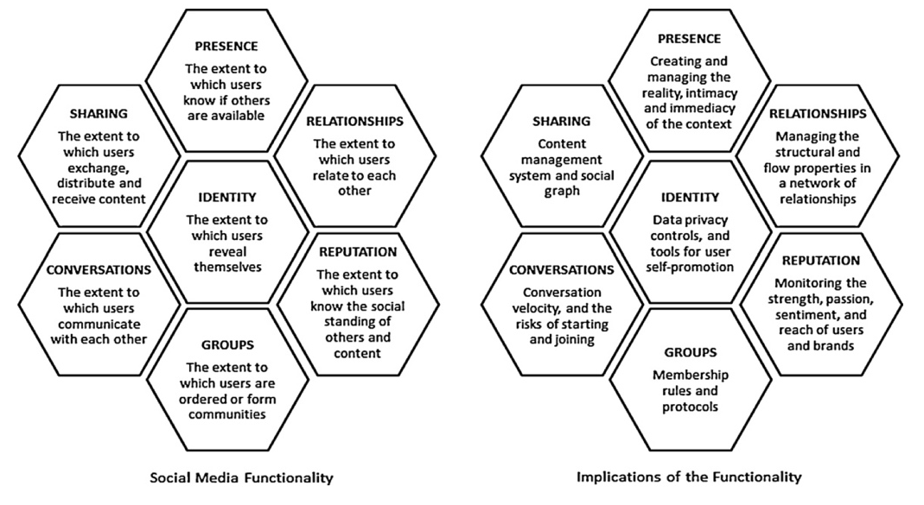
Source: Kietzmann et al. Social Media? Get Serious! Understanding the functional building blocks of social media (2011, 243)

Annex 3
Comparison table of the contents posted by Korean and Western artists in Twitter
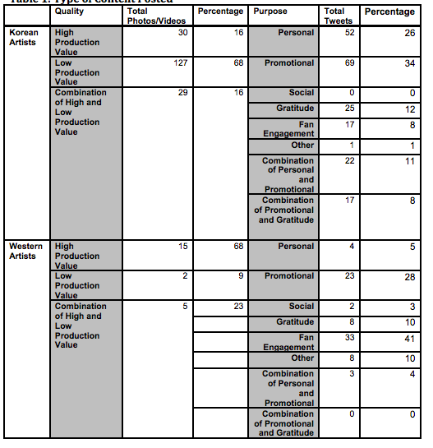
Source: Siano, T. G. Comparing Western and South Korean Celebrity Twitter Strategies (2018, 12)

Annex 4
Comeback goals for BTS’s self-produced album BE by ARMY
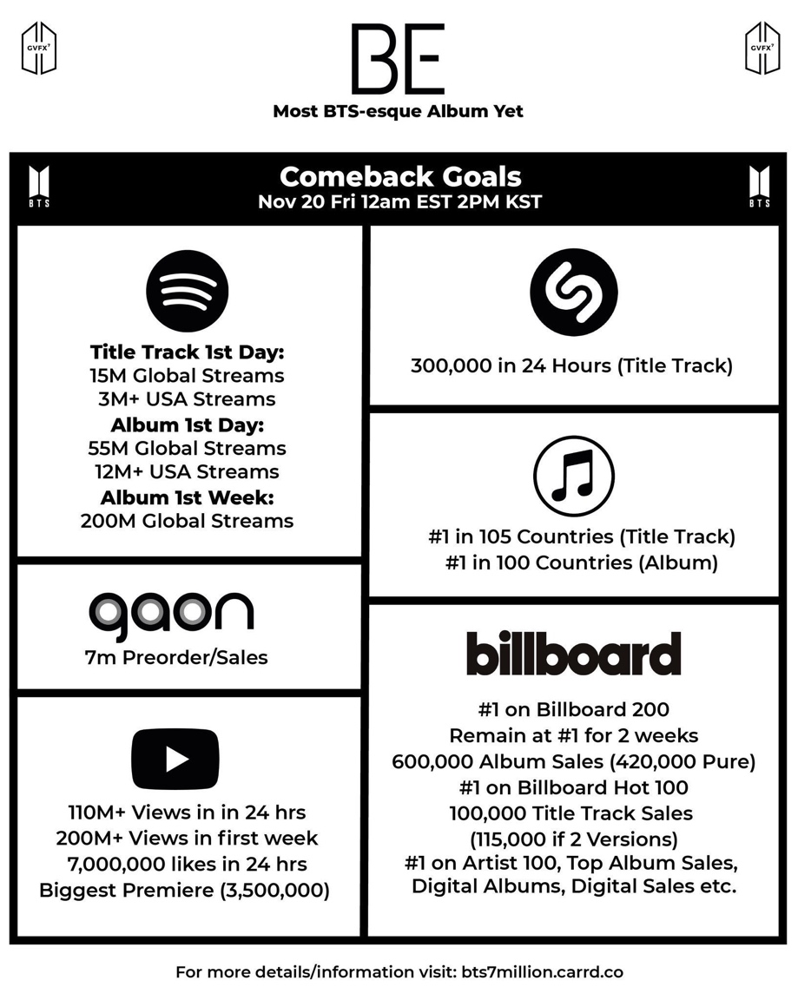
Source: [@vminggukx]. (2020, November 16) 3 DAYS BEFORE COMEBACK! PLEASE ARMY SPREAD OUR COMEBACK GOALS AS MUCH AS YOU CAN! #3DaysBEforeBE @BTS_twt. [Image attached]. [Tweet]. Twitter. https://bit.ly/3soTt3m

Annex 5
Picture uploaded to @BTS_twt after Shizuoka concert
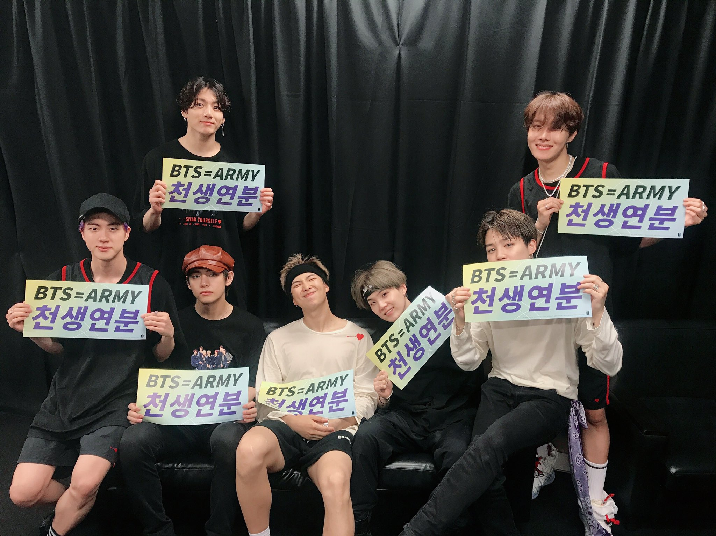

Source: BTS [@BTS_twt] (2019, July 14). Twitter. https://twitter.com/bts_Big Hit/status/1150366045284102144

Annex 6
Tweet by BTS member JIMIN.
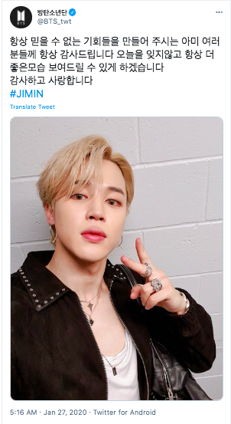
Source: BTS [@BTS_twt] (2020, January 27). Twitter. https://twitter.com/BTS_twt/status/1221648172927209472

Annex 7
Videos uploaded to YouTube channel BANGTANTV
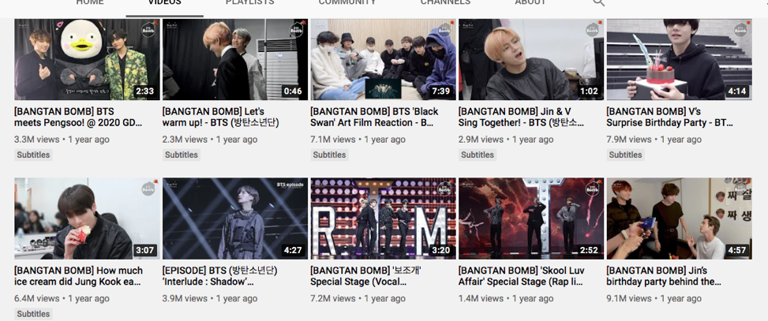
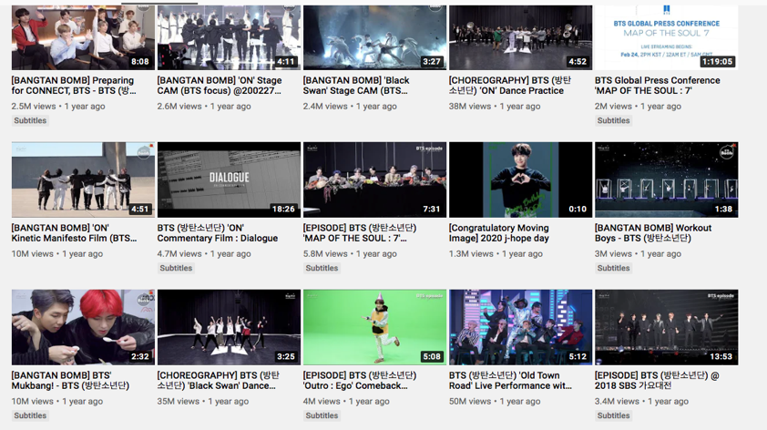
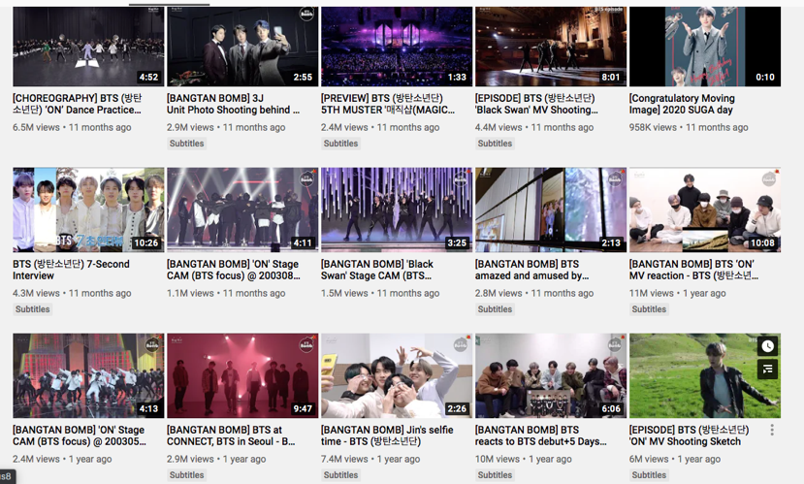

Annex 8
Videos uploaded to BTS’s VLIVE channel
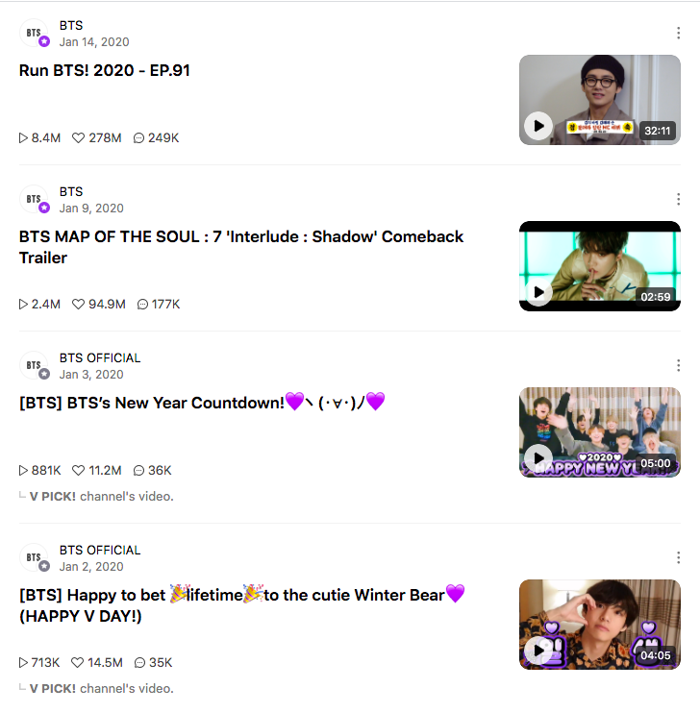
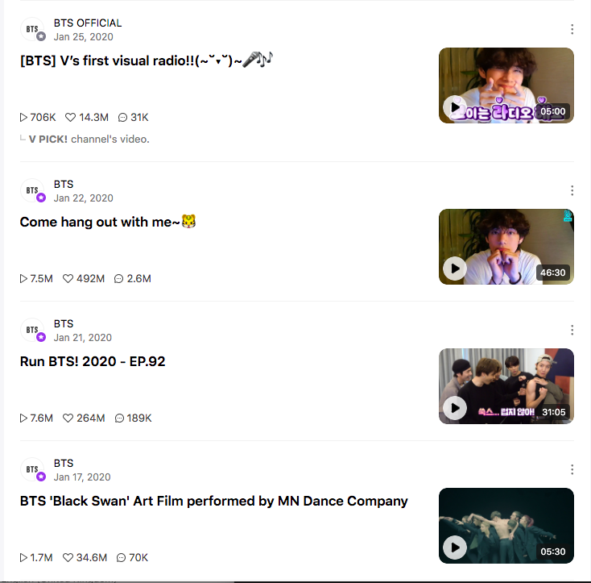

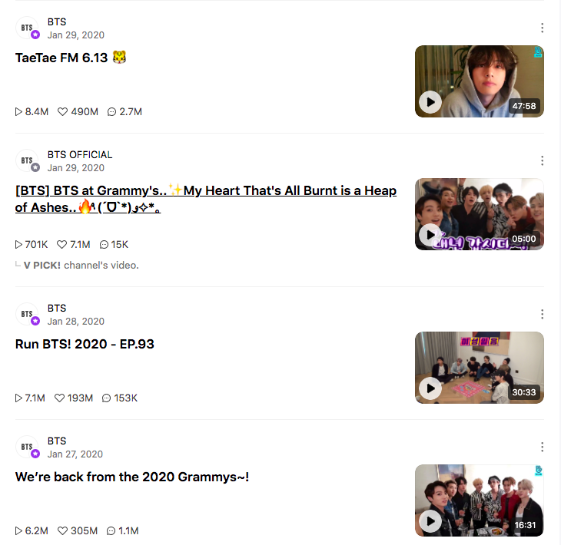
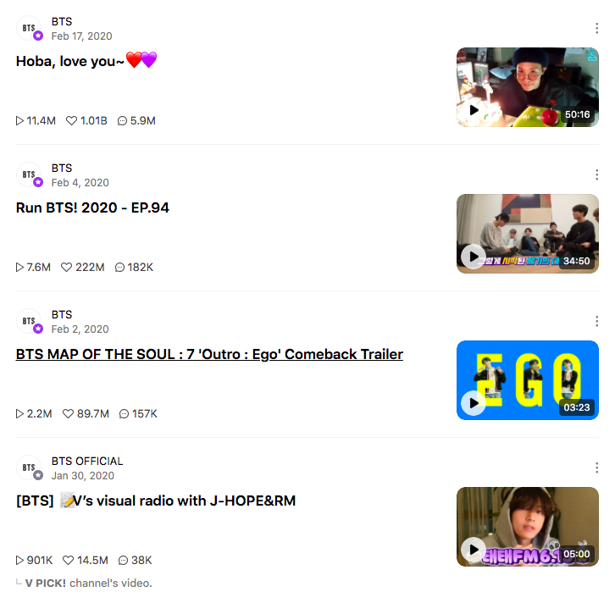
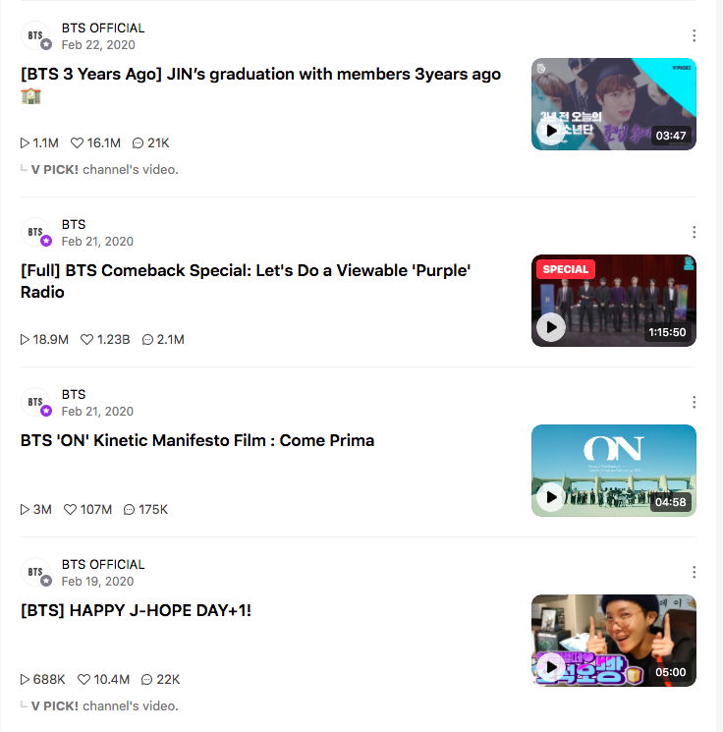

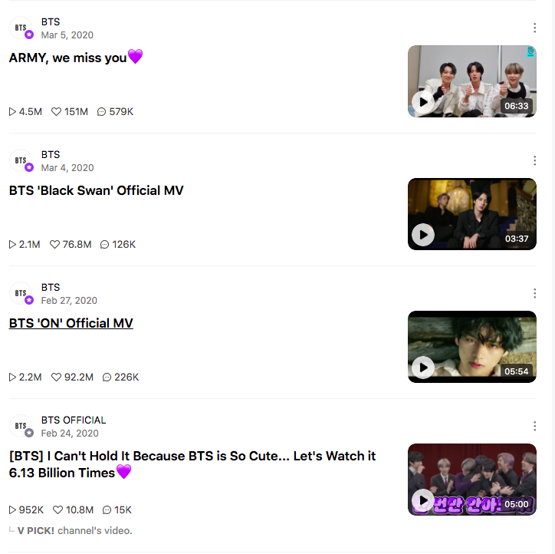
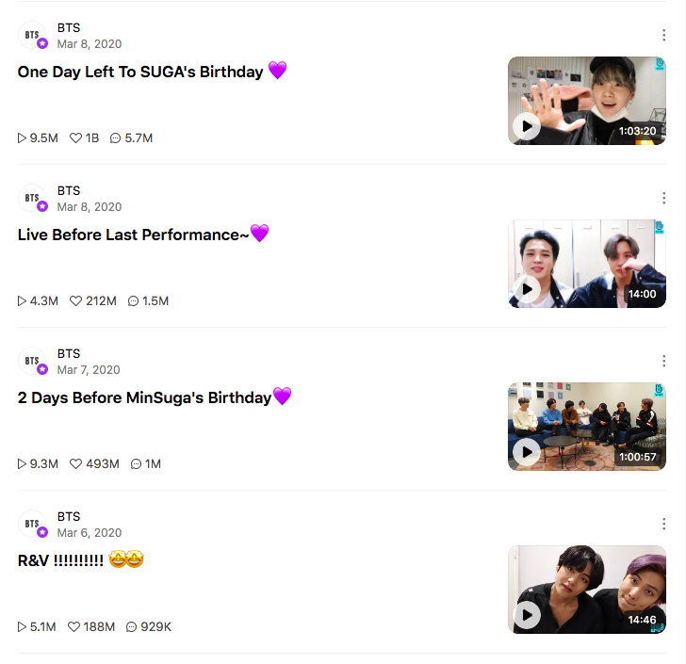
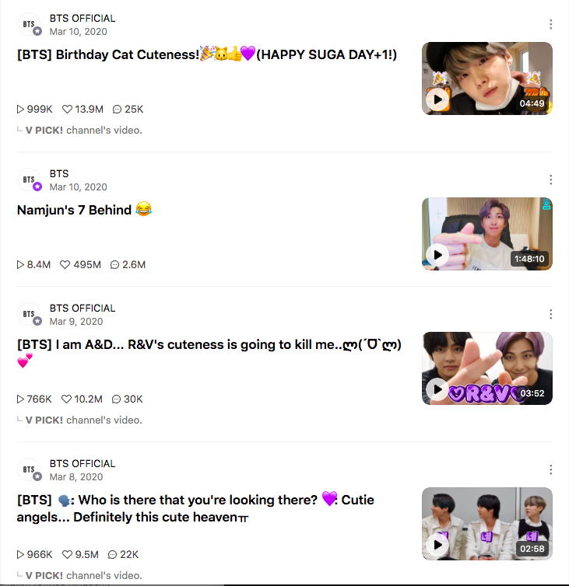

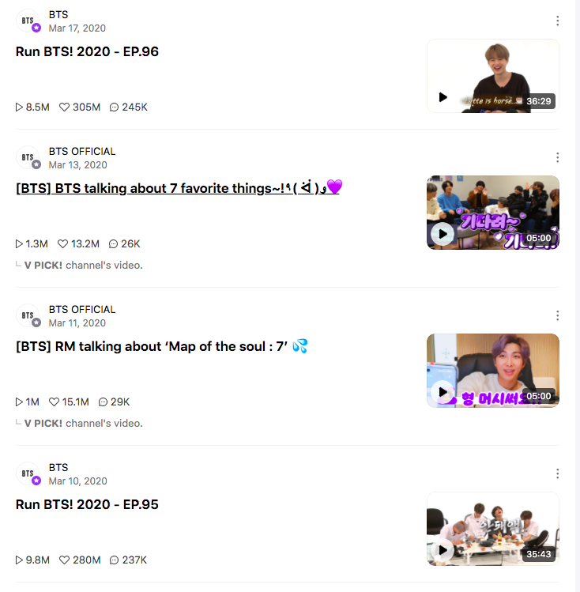

Annex 9
Graph representing the ages of the respondents to the online survey
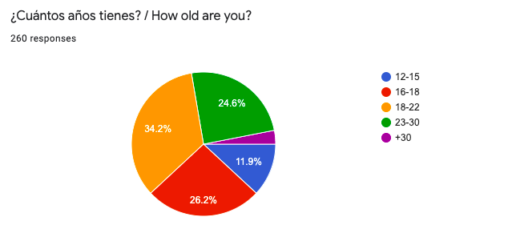

Annex 10
Graph representing the gender of the respondents to the online survey
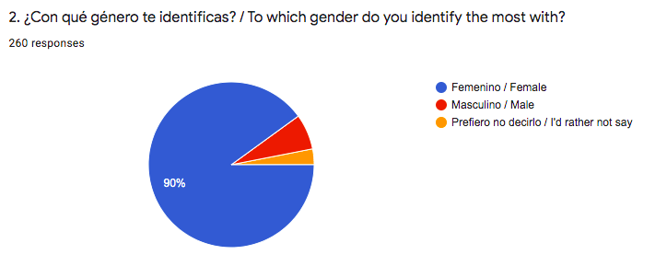

Annex 11
Graph representing the seniority in fandom of respondents to the online survey
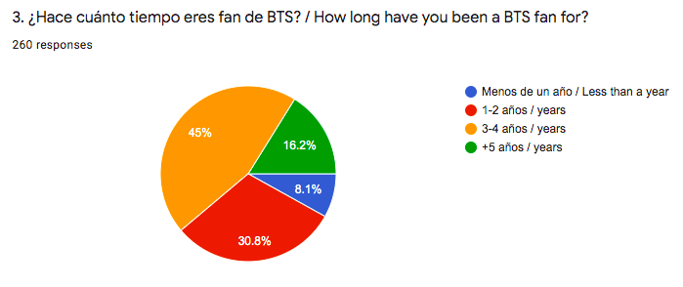

Annex 12
Graph representing the hours of BTS-related content consumed a day
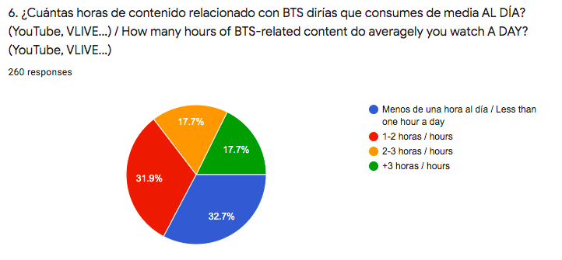

Annex 13
Graph representing the type of BTS content consumed
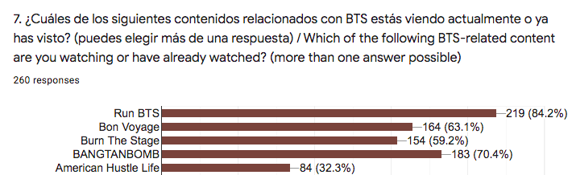

Annex 14
Graph representing which social media fans follow BTS in
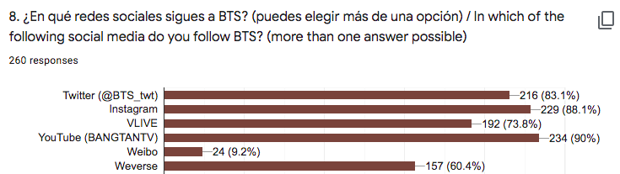

Annex 15
Graph representing responses to question 9.

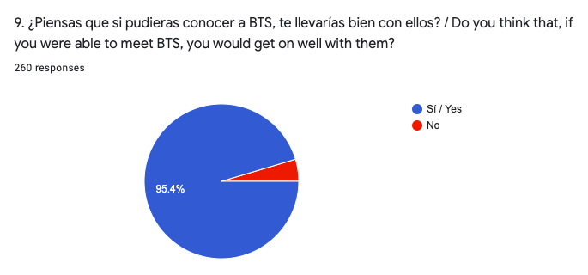

Annex 16
Graph representing responses to question 10.

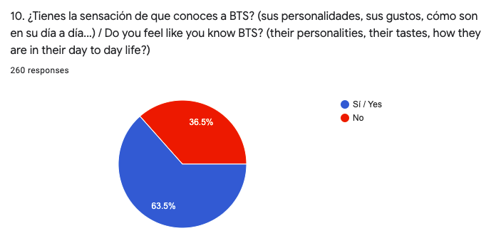

Annex 17
Graph representing answers to question 11

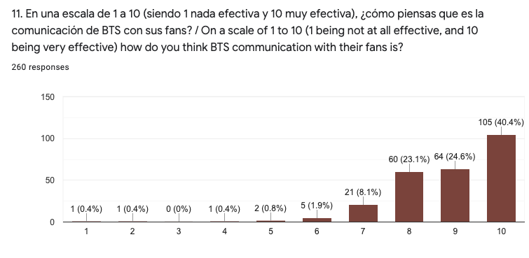

On April 2nd, 2021, Big Hit Entertainment officially changed its name to HYBE.
In the K-Pop universe, fandoms are never referred to with a “the” preceding them. It is always “ARMY” and not “the ARMY”. In addition to this, normally, BTS fans are mostly referred to as “ARMY” in general or “ARMYs”, never “ARMIES” or “Armies”.
“Stan” is an internet slang used to referred to a dedicated fan. The term was born with Eminem’s song “Stan”, about an obsessed and psychopathic fan. Having lost its negative connotations, it is used nowadays in social media to refer to fan “a BTS stan” or as verb “I stan BTS.”
BTS’s songs are almost entirely in Korean. The presented lyrics are approximate translations as translated by BTS fans.
Own translation using the Translator feature of Twitter, as the original tweet is in Korean.
“Maknae” is a term in Korean to indicate who the youngest in a group is, and the combination of this term with “golden” constitutes an inner joke in the community of BTS-ARMY that means that he is good at everything.
A mistake was made in the original survey: age ranges were 16-18 and 18-22, which may have confused respondents because 18 was mentioned twice. To correct this mistake, age ranges 16-18 and 18-22 were combined into a new range: 16-22 years old.

