CARD GAMES: A COMPLEMENTARY TOOL FOR LEARNING MATHEMATICS
S. Lantarón¹, M. López¹, J. Rodrigo²

¹Departamento de Matemática e Informática Aplicadas a la Ingeniería Civil y
Naval, Universidad Politécnica de Madrid, España.
²Departamento de Matemática Aplicada, ICAI, Universidad Pontificia Comillas, España

Abstract
When teaching mathematics, it is important to offer a variety of fun, engaging, and interesting activities that promote the students’ interaction, capture their interest, and encourage their participation. This is so much so that many countries are now incorporating these types of activities into their curricula.
Nowadays, it is well-known that games and mathematics are increasingly becoming more intertwined. Board games in general (particularly card games) make use of strategies and in many cases, concepts that are undoubtedly related to the field of mathematics.
Games are one of the most interesting resources that can be used in a classroom at all levels. They promote student engagement, which increases if the game is known and is familiar to the students. This can be seen with the games presented in this work. These games are played with cards and are based on already existing well-known games.
The most enriching aspect of using games in mathematics lessons can not only be found in the playing of the games themselves but also in the series of events that should always follow: an analysis of the resolution processes, a discussion about the solutions and the results, etc. It is not just a question of playing, but of using the game as a didactic resource. The inclusion of games must be done following some basic guidelines, which favor the success of their use in the classroom.
Given the above, why not introduce them naturally into classes? It seems evident that they can be an effective tool to engage, motivate, and reinforce certain concepts.
In this article, we analyze two card games that were invented and created by the work’s authors and which are effective in the meaningful learning of mathematics. These games specifically focus on the study of real-valued functions of real variables; a topic which is included in high school syllabi and in that first-year courses studied during technical degrees. They are considered an adequate resource for learning this part of mathematics. They are based on existing games on the market and therefore can be easy for students to get the hang of. The concepts from these games have been reworked and adapted to the topic in question. The games have been called:
- Sobrevivefun
- Lleva cartas matemático
These games are strategy-based, that is, the players must think and look for the best solutions and ways to win. What’s more, the strategies used should be supported by the knowledge that students already have about real-valued functions of real variables. With each game, the topic’s concepts are reinforced and strengthened.
Games can serve as a tool for reminding and strengthening a wide variety of mathematical concepts. This can be also beneficial for many other subjects where the cards can be adapted to the topic, but the main concepts from the games are kept the same. Therefore, they can be useful to other teachers who can use them according to their needs and the subjects they teach.

We believe that the games proposed fulfill the requirements that games must meet in order to be effective as didactic tools:
- To have simple rules and be brief.
- To be attractive in presentation and development.
- To not be a game of chance.
- To be a game that the students know and that can be "mathematized".
Keywords: Gamification, Mathematical teaching methodologies, Card games, Educative innovation, Real-valued functions.
- INTRODUCTION
The authors of this article belong to the Educational Innovation Group (GIE) at the Universidad Politécnica de Madrid called "Pensamiento Matemático” (“Mathematical Thinking”). This group has been working for years on applying the dynamics, components, and mechanics of games in order to motivate students and improve learning and performance in mathematical subjects at all levels. In this work, we aim to offer the educational community a series of card games (designed and invented by the GIE) that represent new methodological tools for mathematical subjects.
Play is part of human beings’ daily activities. Being linked to leisure, entertainment, and enjoyment, it also serves as a valuable educational resource. It favors the development of logical thinking by means of enhancing different methods, techniques, and intellectual strategies, as well as improves attitudes, procedures, and habits, which are useful for a person's ability to function in society. Specifically, this work offers a mathematical perspective to card games in order to explore their recreational and didactic possibilities at different teaching levels. Through a few games created by the authors, fundamental concepts linked to the study of real-valued functions of real variables are presented. They range from elementary concepts to other strategies aimed at going that one-step further.
We have chosen cards because they are among the most widespread games and are played by large groups of the population. It is common that our students know the rules of various card games and some of these games can be used directly in our mathematics classes. Other games can be adapted to take full advantage of the mathematical potential while keeping the essentials of the games’ rules. Decks of cards represent a resource that can be used in the classroom to reinforce numerical, geometric, and algebraic skills as well as other skills.
The games created are designed for multiple players and are based on card games known to students. This will make the dynamics and mechanics easy to assimilate and will prevent wasting time and effort on explanations. These are games of logic and strategy in which, in order to win, the players have to make use of their mathematical knowledge, specifically their knowledge of the characteristics and properties of real-valued functions, as well as the relationships between the properties. We present two games that we have called:
• Sobrevivefun
• Lleva cartas matemático
Both are aimed at students in final years of high school and those in their first years of a technical degree. The play materials developed can be adapted for use by teachers who teach other levels and subjects.
- THE GAMES
2.1. Sobrevivefun
The design of this game is based on the game Virus (Figure 1). We wanted to adapt the idea of this game to the framework of the study of real-valued functions of real variables.
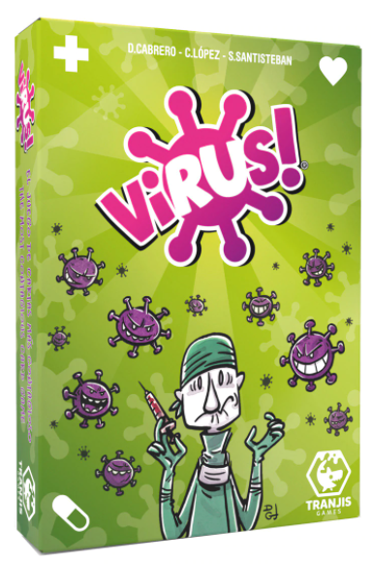
Figure 1: The card game “Virus”
In our game, the player’s goal is to complete a grid as shown in Figure 2. To do so, a function must be acquired with each of the characteristics indicated. The first to do it wins.
The game is complicated by the fact that participants can put obstacles in the way of the opponent(s) in order to prevent them from succeeding.
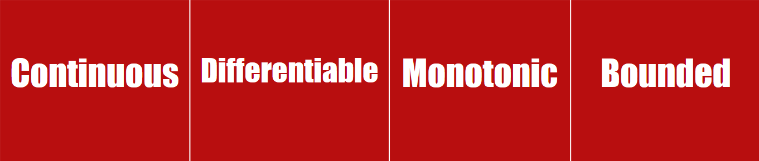
Figure 2: Grid to be completed by each player.
Development of the game:
The deck of cards contains the following elements (figure 3):
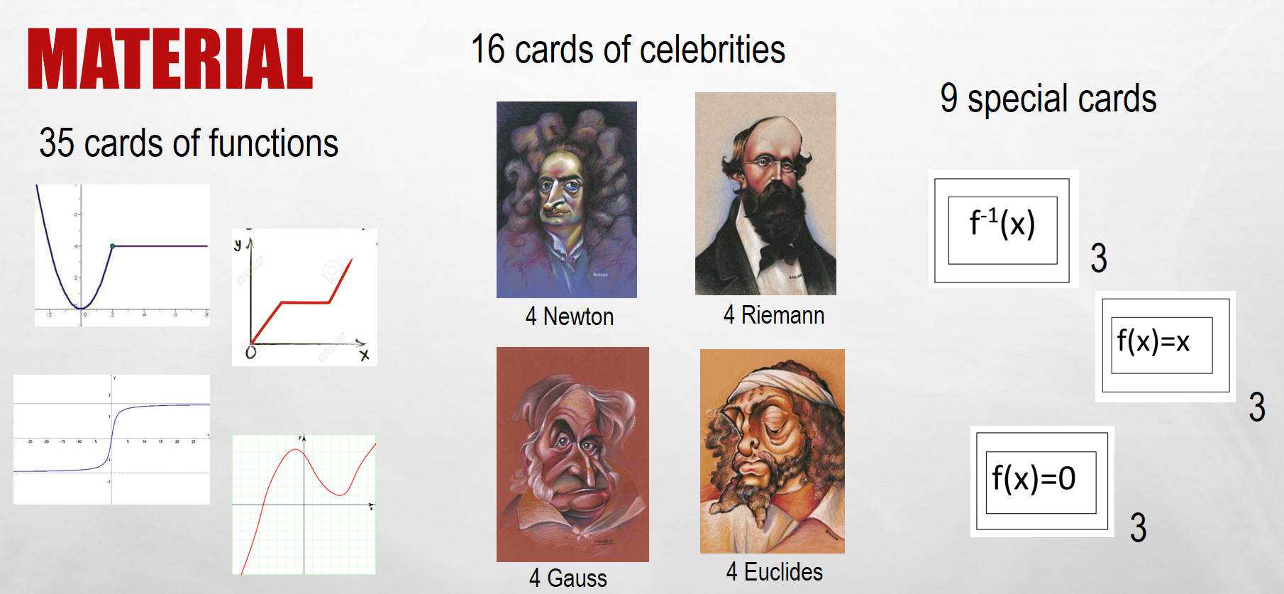
Figure 3: Deck of cards
- Each player is given a grid.
- All cards (all three types) are shuffled and three cards are dealt to each player. The rest of the cards are left in a deck face down in the center of the table.
- The turn begins. The first player draws a card from the deck and may:
  - If it is a function the player is interested in, put it on their grid in the position that fits to start completing it. If it is a protection card and the player is interested, put it on their grid.
  - Place a card on an opponent's card to remove it from their (¿his/her?) grid and prevent them (¿him/her?) from completing it.
  - Keep the card in player’s hand and discard another, or discard it altogether. The player must place a card face up next to the center deck (discard pile). Each player must always have three cards. If at any time the deck is finished, the discarded pile is turned over.
- The player passes their turn to the next player who repeats the steps described for the previous player.
The goal is to complete the grid with an appropriate function in each box.
How to play your cards?
- A card with a characteristic that is contrary to a different card, eliminates it. For example, if a player places a NON-continuous function on top of a continuous one, it allows them to discard the continuous function and remove it from their opponent's grid.
- The cards with the inverse function: f⁻¹(x) allow players to swap a card with an opponent.
- The cards with the identity function: f(x)=x allow players to play again (play twice in a row).
- The cards with the null function: f(x)=0 allow players to remove a card from an opponent.
- The mathematician cards protect the player’s functions. Having a mathematician card placed on one of the functions forces the opponents to put two cards with opposite characteristics to the player's function; the first to remove the protector and the second to remove the function.
- The Euclide card gives bounded functions immunity. The Newton card gives monotonic functions immunity. The Gauss card gives continuous functions immunity. The Riemann card gives differentiable functions immunity.
- If a function is protected by two mathematicians it remains untouchable, the opponent can no longer remove it.
Teaching Objectives
- To review the characteristics and properties that a real-valued function of a real variable can have.
- To learn to recognize characteristics from function graphs.
- To understand the geometric meaning and implications of different function properties.
- To choose the appropriate strategy according to the functions available to complete the grid. Some functions may fit in more than one part of the grid.

2.2. Lleva cartas matemático
The game is based on a card game with many names, including the name "War". In this game, all the cards of a Spanish deck are dealt in equal parts among the participants (from 2 to 4), who have them in a covered deck. Everyone reveals their first card and puts it in front of their deck. If a player sees that their card beats an opponent's card (one card beats another if it is of the same suit and a higher number), they declare it (for example: 7 of cups wins against 5 of cups). They then take both cards and put them next to their own deck. If the player makes a mistake (if the card is not of the same suit or the player's card is of lesser number), the opponent may take the card if they realize the mistake made (if they do not realize the mistake, but a different player does, that other player can also take the card). A player can take a series of cards from the opponents (for example, 7 of cups wins against 5 of cups which wins against 3 of cups), but they must declare it in decreasing order. If they fail to do so, they make a mistake, which, if noticed by the opponents, means that the cards are taken away from the player by the player who realizes the mistake.
If there is no prevailing card among the revealed cards, each player draws a new card and places it on top of the previous card. When a player steals a card from an opponent, the cards that are revealed below can be used for further stealing.
The game is played with two jokers which can be given any value (the number and suit that suits the uncovered cards). If the jokers are played at the same time, one can beat the other if the player speaking gives the right value to the two jokers.
The game is played fast (as the cards are revealed, the fastest player speaks first) and in case of a tie, the first tied player sitting to the right of the card dealer speaks (esto hay que quitarlo, porque era para.el juego lento).
Observations:
1) The winner is the player who has taken the most cards after all have been played.
2) Players can play with two decks of cards to make the game last longer.
Adaptation of the game. Development.
To adapt the above game to "lleva cartas matemático", 20 cards with function properties have been created (more can be made if they are considered to be sufficient function properties). For example:
- Functions of one variable may be: polynomial, differentiable, continuous, integrable...
- Multivariable functions may: be continuous, have continuous partial derivatives, be differentiable, have partial derivatives...
- When to declare? If a player sees that their card corresponds with that of an opponent (for example, differentiable implies continuous).
- How does a player make a mistake in declaring? When the player gives an incorrect implication (for example, continuous implies differentiable).
- When does a player take a series of cards from the opponents? When the player declares a series of implications (for example, differentiable implies continuous implies integrable).
- What (¿When?) can players not declare? If there are no implications among the revealed cards.
The two "joker" cards have the portraits of famous mathematicians on them (Gauss and Sophie Germain)
Note: The logical thing to do is to give the joker the strongest property that corresponds with the revealed cards.
The first player to spot an implication speaks.
Examples of the cards are shown in Figures 4-11:
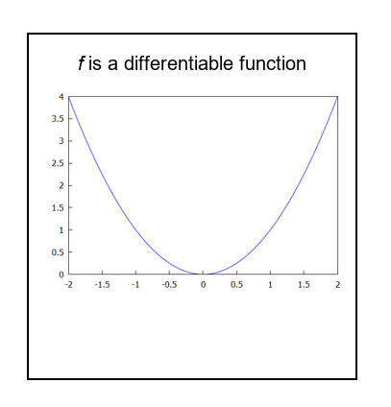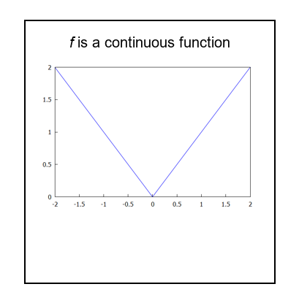
Figure 4: Differentiability property Figure 5: Continuity property for
for one variable functions one variable functions
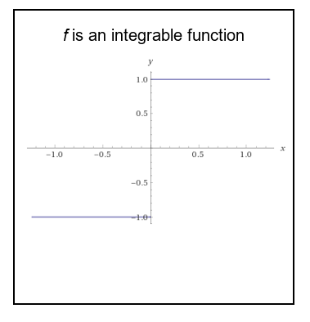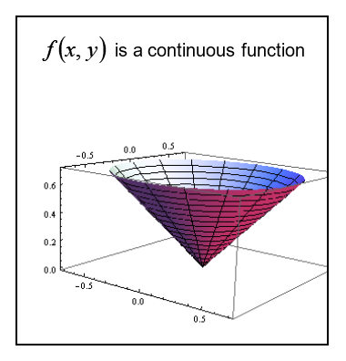
Figure 6: Integrability property Figure 7: Continuity property for
for one variable functions two variable functions
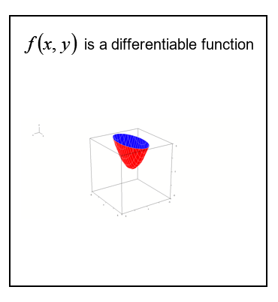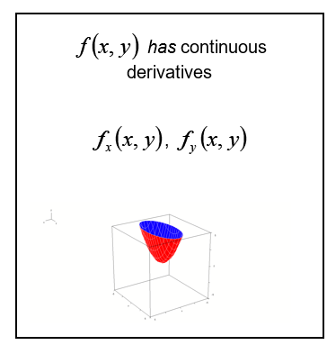
Figure 8: Differentiability property Figure 9: Differentiability property
for two variable functions of class 1 for two variable functions
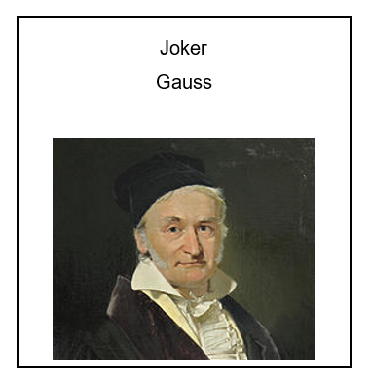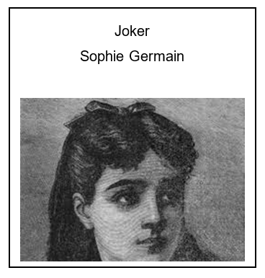
Figure 10: Joker (Gauss) Figure 11: Joker (Sophie Germain)

Teaching Objectives
- To enable the students to handle the relationships and implications between the properties that real-valued functions of real variables can have, in a fluid way. This fulfills the objective of recognizing and reviewing the properties that came up in the game Sobrevivefun.
- To familiarize the university students with the implications that there can be among the properties of real-valued functions of several independent variables.
- To work on the logical concepts of necessary condition and sufficient condition that are often not well interpreted by students.
- To revive interest in history’s great mathematicians, such as those presented as the jokers.

- RESULTS AND CONCLUSIONS
With the project carried out and the games developed, we looked to incorporate the advantages of gamification into maths classes by using card games. With this, the following is achieved:
• A positive attitude towards learning from students who have been allowed to play. Games help improve students' interest in subjects that seem boring or complicated, such as mathematics, in such a way that they are motivated and positively inclined towards them. This not only stimulates the enjoyment of problem-solving, but also helps build a positive attitude towards the subject that has been gamified.
• Making subjects more fun: learning by gamification makes students perceive subjects as less boring, whilst also improving their attitude towards them.
• Improved attention and concentration.
• Encouragement in the use of strategy and logic for problem-solving: including games in mathematics helps students to make decisions, apply logic, use different strategies, and propose innovative ideas. All of this will contribute to the development of individuals both within and outside the academic environment.
• Improved academic results: in this case, in the context of an important topic such as functions. The graphic interpretation of the properties of the functions and their prevalence is enhanced by the use of the cards, which helps students to increase their performance.
• Improved communication skills: Games always require an interrelationship between the players who participate, and this allows for the promotion of communication and socialization skills where students exchange ideas with their peers.
• Possession of some very versatile tools. The games developed are a didactic resource that can easily be adapted both to different levels of difficulty within the same course or for different ages, to different topics, and to different subjects.

REFERENCES
- J.M. Chamoso, J. Durán, F. García, J. Martín & M. Rodríguez, “Análisis y experimentación de juegos como instrumento para enseñar matemáticas”, Suma, vol. 47, pp. 47-58, 2004.
- F. Corbalán. “Juegos Matemáticos para Secundaria y Bachillerato”. Madrid: Síntesis, 1994.
- M. Edo & J. Deulofeu. “Investigación sobre juegos, interacción y construcción de conocimientos matemáticos”, Enseñanza de las Ciencias, vol. 24, no. 2, pp. 257-268, 2006.
- K. Gallagher, “Problem solving through recreational mathematics” in Problem solving in School Mathematics, Yearbook (S. Krulik and R. E. Reys eds.), 169-177, Reston/Virginia: NCTM, 1980.
- A. G. González, J. G. Molina & M. Sánchez, “La matemática nunca deja de ser un juego: investigaciones sobre los efectos del uso de juegos en la enseñanza de las matemáticas”, Educación Matemática, vol. 26, no. 3, pp. 109-133, 2014.
- M. Guzmán, Tendencias innovadoras en educación matemática. Editorial Popular, 1993.
- K. Katsaliaki & N. Mustafee, “Edutainment for Sustainable Development: A survey of Games in the Field”, Simulation y Gaming, vol. 46, no.6, pp. 647-672, 2014.
- S. Lantarón, M. López, S. Merchán & J. Rodrigo, “Gamification actions in the teaching of mathematics at every educational level”, EDULEARN18 Proceedings, 304-312, 2018.
- S. Lantarón, M. López, S. Merchán & J. Rodrigo, “Analysis of logical and strategical games as a tool for the teaching and approach to mathematical concepts”, INTED2019 Proceedings, 7963-7969, 2019.
- S. Lantarón, M. López, S. Merchán, J. Rodrigo & Nerea Casas Bernas. Binary who is who? Mathematical adaptation of a classical game for the improvement of the teaching of mathematical concepts. INTED2020 Proceedings163-170, 2020.
- G. Liarakou, E. Sakka, C. Gavrilakis & C. Tsolakidis, “Evaluation of serious games, as a tool for education for sustainable development”, EURODL, pp. 96-110, 2012.
- V. Marín, “La Gamificación educativa. Una alternativa para la enseñanza creativa”, Digital Education review, vol. 27, 2015.
- J. Martí-Parreño, E. Méndez-Ibáñez, E. Giménez-Fita & C. Queiro-Ameijeiras, “El uso de la gamificación en la educación superior: propuesta de una ficha de análisis ludológico-narratológico”, Actas de las XII Jornadas Internacionales de Innovación Universitaria Educar para transformar: Aprendizaje experiencial,103-111, 2015.
- D. Michael & S. Chen, Serious Games: Games that Educate, Train and Inform. Boston/MA: Thomson, 2005.

